A NOTE TO THE EDUCATOR:
In Part II of “No Turning Back,” we learn about sit-ins organized by civil rights demonstrators and taking place at lunch counters across the South. The news of the sit-ins sparks a range of responses from Greenwood’s Black citizens, including inspiration and heightened awareness of the risks of standing up to Jim Crow.

In this activity, students will examine a photograph taken at a sit-in at the Jackson, Mississippi, Woolworth’s lunch counter in 1963. Using a procedure that invites students to look closely at the photograph’s details, students will reflect on what a variety of people in Woolworth’s that day might have been feeling or thinking, and they will make connections to what they are learning from the game about the community of Greenwood.

Note that the document-based activity immediately following this one is centered on a passage from Anne Moody’s memoir that takes students more deeply into the May 28, 1963 Jackson sit-in. Moody is one of the protestors that appears in this photograph. You might consider using these activities simultaneously with half the class analyzing the photograph while the other half analyzes the Moody passage. Students can then meet in jigsaw fashion to share their documents.

Steps to Complete
- Observe Before Analyzing
Especially with powerful images like this one of the sit-in that Anne Moody describes in the passage from her memoir in Source #1, it is important to help students look slowly and carefully at the image before proceeding to analyze it and draw conclusions. You might simply ask students to take a few minutes individually or in pairs to look at the photo and list observations of people, faces, clothing, objects and words. Without telling a story about the image, what do they see?

For a more structured “close viewing” activity, you might use the “Crop It” strategy. Students can use their fingers or a homemade paper cropping tool to highlight parts of the image in response to the following prompts:
- Identify the part of the image that first caught your eye.
- Identify a part of the image that shows what this image is about.
- Identify a part of the image that shows a tension, problem, or dilemma.

Working in pairs, students can share the parts of the image they identified after each prompt and explain their choice.

- Provide Context
After students have had the opportunity to make preliminary observations, share the following context with them about the photograph. Make clear that this photograph is from the same sit-in that Anne Moody describes in her memoir in the previous document:

On May 28, 1963, students and faculty from Tougaloo College staged a sit-in at the Woolworth’s lunch counter in Jackson, Mississippi. For three hours, the group endured insults and attacks by an increasingly violent white mob. [They] slapped the protesters, hit them with items from the lunch counter, and even burned cigarettes on their skin. Others dumped drinks on the protesters or laughed as others covered them in sugar, mustard, and ketchup. Jackson Daily News photographer Fred Blackwell took the now iconic photo of the sit-in that depicted the anger of the white mob.

- Analyze and Make Connections with the Photograph
Finally, have students answer the following questions in writing or a class discussion. The questions also appear on the student handout:
- What is happening in this photo? One of the civil rights activists pictured at the counter is named Anne Moody. Name three things Anne would have smelled, felt, and heard from this photo.
- Activists trained for hours to learn how to participate in sit-ins without reacting. What are some reasons it would have been important to movement activists to not react to what was happening?
- How might the citizens of Greenwood who you have met in “No Turning Back” respond to seeing this photograph in the newspaper? Who would the photograph inspire? Excite? Frighten? Anger? What other responses might different Greenwood citizens have?

Name________________________ Date: __________________

Step One:
Take a few minutes to look at the photo below and jot down any observations you have about the people, faces, clothing, objects and words you see. Without interpreting the photograph, what do you see? After you jot down your observations, following the prompt below the photograph.

Source: Photograph of Jackson, Mississippi, Sit-in in 1963

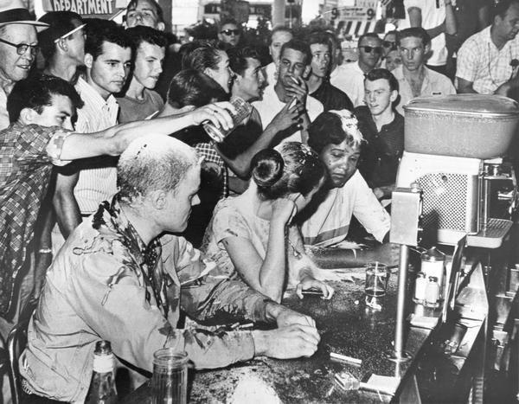
(AP, Jackson Daily News, photographer Fred Blackwell)

Step Two
- Identify the part of the image that first caught your eye. Draw a circle or box around it, and label it #1. Explain below why that part of the image stood out to you.

- Identify a part of the image that you think shows what this image is about. Draw a circle or box around it, and label it #2. Explain below why you think this part of the image is so central to the story the photo is telling.

- Identify a part of the image that shows a tension, problem, or dilemma. Draw a circle or box around it, and label it #3. Explain below the tension, problem or dilemma that you think this part of the image shows. What is it about? Who is involved? What might they be thinking?

Step Three:
Respond to the following questions. Be prepared to share your answers in a class discussion.

- What is happening in this photo? One of the civil rights activists pictured at the counter is named Anne Moody. Name three things Anne would have smelled, felt, and heard from this photo.

- Activists trained for hours to learn how to participate in sit-ins without reacting. What are some reasons it would have been important to movement activists to not react to what was happening?

- How might the citizens of Greenwood who you have met in “No Turning Back” respond to seeing this photograph in the newspaper? Who would the photograph inspire? Excite? Frighten? Anger? What other responses might different Greenwood citizens have?

https://www.zinnedproject.org/news/tdih/jackson-woolworth-sit-in/
https://www.wisconsinhistory.org/Records/Image/IM2381

