A NOTE TO THE EDUCATOR:
In “No Turning Back,” when Sam Block and SNCC arrive in Greenwood, one of their primary activities is to offer citizenship classes where Black Greenwood residents can come for help preparing for the voter registration application and literacy test they must complete and pass in order to vote. Students can reach a deeper understanding of the ways in which Mississippi’s Jim Crow era voter registration system was used and abused to keep Black voters off the rolls from a close examination of an actual voter registration application. In this activity, students will analyze the application using a Library of Congress primary source analysis protocol, reflect on how the registration process stacked the deck against African Americans, and make connections back to the game.

Steps to Complete
- Analyze with Observe-Reflect-Question Protocol
Share the Voter Registration Form with students and invite them to do an initial analysis of the document independently or in pairs using the Library of Congress’s Observe-Reflect-Question protocol:

Observe: Students identify and note details about the document. (What did you notice first? What did you notice that surprised you? How is the text arranged on the page? What is something small but interesting that you noticed?)

Reflect: Students generate and test hypotheses about the document. (Who made this document and why? What is the larger story or context going on at the time this document was created? What parts of the document reveal its purpose?)

Question: Students ask questions to lead to deeper analysis and reflection. (What does this document make you wonder? Who? What? When? Where? How?)

Because they are playing “No Turning Back,” students should use information and context they learned from the game to help them complete this initial analysis.
- Lead a Guided Exploration of the Document
After students have familiarized themselves with the voter registration form, lead the whole class on a guided exploration of the document. As you step through the document ask students to look out for which questions would be easy for most Mississippians to answer in 1955 and especially for questions that state officials could use or abuse in order to disqualify Black citizens from registering to vote.

The Civil Rights Movement Archive provides a detailed analysis of this form and how it was used to exclude Black Mississippians from the voting rolls. You can use this information to plan the class exploration of the document.

Make sure to help students notice and understand the importance of the following questions:
Questions 5 & 6: Black citizens knew that the information the form requires them to provide about their employer would be passed along to the local White Citizens Council. The Citizens Council could then, in turn, pressure employers to fire any Black citizens who attempted to register to vote.

Questions 18 & 19: These questions require the applicant to copy a section from the Mississippi state constitution onto their form, and then to write an explanation of the section’s meaning. Some sections of the state constitution were only a few words long and had very simple meanings, while others were very long and complicated. It was up to the clerk at the voter registration office to choose which section the applicant was required to copy, and therefore could ensure Black applicants were rejected by assigning them sections of the constitution that few citizens would be able to explain.

- Make Connections with “No Turning Back”
After students have explored and analyzed the document, have them respond to the following questions to help them connect what they have learned back to “No Turning Back”:
- How did examining the Mississippi Voter Registration Application and Literacy Test deepen your understanding of the challenges Black citizens of Sunflower County and Greenwood, Mississippi, in “No Turning Back”?
- What is the purpose of the citizenship classes that the NAACP is offering to Black citizens in Greenwood? What do the classes have to do with the voter registration form you examined?
- In “No Turning Back,” Verna works with someone from the community to help them prepare to fill out the voter application. How does Mr. Block respond when faced with their questions and concerns?

Name: ______________________ Date:__________________

Instructions: Take a few moments to look closely at the primary source document below, and then respond to the questions in the chart after the document.

Mississippi Voter Registration Application and Literacy Test, 1955

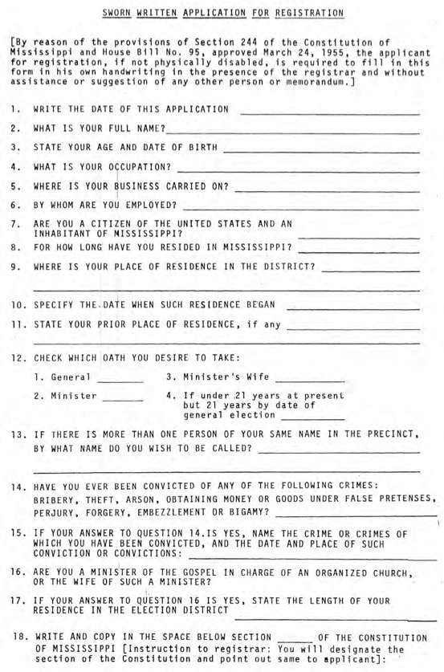
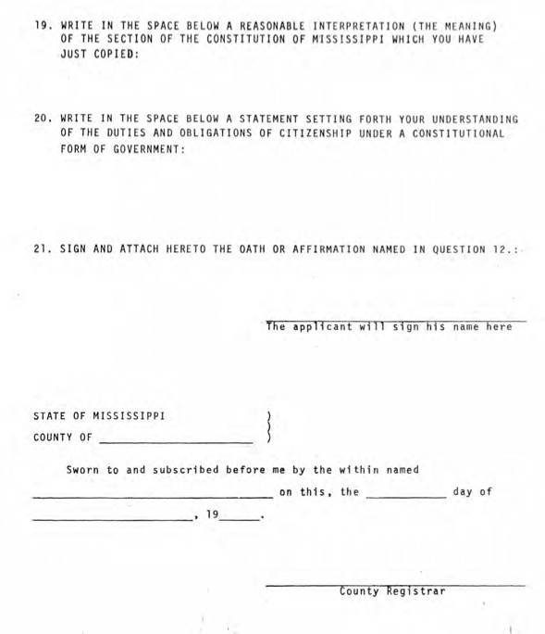

Source: https://www.crmvet.org/info/ms-littest55.pdf

Observe  Record any important observations you have about the document. What did you notice first? What did you notice that surprised you? How is the text arranged on the page? What is something small but interesting that you noticed? | Reflect  What conclusions can you draw about this document? Who made it and why? What is the larger story or context going on at the time this document was created? What parts of the document reveal its purpose? | Question  What questions need to be answered so you can more fully understand the significance of this document? What does this document make you wonder? Who? What? When? Where? How?

Discussion Questions:
- How did examining the Mississippi Voter Registration Application and Literacy Test deepen your understanding of the challenges Black citizens faced in Sunflower County and Greenwood, Mississippi, in “No Turning Back”?

- What is the purpose of the citizenship classes that the NAACP is offering to Black citizens in Greenwood? What do the classes have to do with the voter registration form you examined?

- In “No Turning Back,” Verna works with someone from the community to help them prepare to fill out the voter application. How does Mr. Block respond when faced with their questions and concerns?

Analysis of these application adapted from “Voter Registration in Mississippi Before the Voting Rights Act” (Civil Rights Movement Archive).

