A NOTE TO THE EDUCATOR:
In “No Turning Back,” students meet a variety of African American business owners in Greenwood who offer crucial support to the Black community in a variety of ways. They not only provide jobs and economic support, but many also support the work of civil rights activists while carefully managing the risk of retribution by white residents who are invested in maintaining Jim Crow segregation. In this activity, students will reflect on the network of support provided by Black-owned businesses by learning about Peggy Jean O’Connor, who was the owner of Jean’s Beauty Shop in Hattiesburg, Mississippi, during the Civil Rights Movement. Students will read and analyze an excerpt from an oral history recorded by O’Connor in the 2010s, while evaluating the strengths and limitations of oral history as a source of historical information.

Steps to Complete
- Introduce Peggy Jean O’Connor’s Story
Take a moment to invite students to name some of the Black-owned businesses in Greenwood that they encountered in “No Turning Back.” Who owns them? What business-oriented services do they provide? What other roles do the business and their owners play in the Black community of Greenwood?

Then share the photograph “Jean’s Beauty Shop” with the class. Tell them that this is a photo of a Black-owned business in Hattiesburg, Mississippi, in the 1950s. Hattiesburg is in Southeast Mississippi, about 180 miles from Greenwood. Share the following context about Jean’s Beauty Shop from the American Social History Project:

In 1953, Peggy Jean Connor became the owner of her family’s beauty shop in Hattiesburg, Mississippi at the age of 21. Her father owned a shoe shine parlor in the front of her shop. Connor did not personally have experience in activism work, but in 1962, two SNCC organizers, Curtis Hayes and Hollis Watkins, arrived in Hattiesburg and opened a Council of Federated Organizations (COFO) office across the street from her beauty shop. Connor decided to get involved. She learned how to teach local residents to register to vote and eventually played a pivotal role in the actions of Freedom Summer. Connor’s story demonstrated the important roles Black small business owners played in supporting and sustaining the movement.

- Read O’Connor’s Oral History
Share with students the excerpt from Peggy Jean O’Connor’s oral history. Begin by reading the introduction to the excerpt together as a class. If necessary, introduce the idea of oral histories to students, and explain that what they will read is a transcription of a conversation between two or more people.

Choose an approach for reading the transcript that is most appropriate for your students. Because reading a transcript of spoken, conversational language is very different from reading the written word, students may find it challenging to fully understand what the speakers mean. Be prepared to go slowly and help students understand key passages. Reading the transcript aloud to your students might be helpful.

The Library of Congress includes an audio recording of O’Connor’s entire oral history. Consider playing the audio that corresponds to the passage here. It can be helpful and engaging for students to hear her authentic voice.

Note that in her oral history, O’Connor describes how she helped the women in Hattiesburg pay their poll taxes. If necessary, take a moment to explain poll taxes before students begin to read.

- Discuss the Oral History
After reading the testimony, have students discuss the following questions (also included at the end of excerpt) in small groups or as a whole group:
- How did it make Peggy Jean feel to take all of her clients’ poll tax documentation to the voter registration office? Why might she feel that way?
- Why might a woman want to pay her poll tax at the beauty salon instead of going down to the voter registration office?
- How did Peggy Jean O’Connor’s oral history help you better understand some of the people from Greenwood you have met in “No Turning Back”?
- When was O’Connor’s oral history recorded? Do you think when she told her story could have impacted how she told her story? If so, how?
- How was reading/hearing part of O’Connor’s story in her own words different from learning about the past from a historian or history book? What are the advantages and disadvantages of each type of source?

Name: ________________ Date:_____________

Step One:
Take a few minutes to look at the photo below and jot down any observations you have about the people, faces, clothing, objects and words you see. Without interpreting the photograph, what do you see? Then read the excerpt from O’Connor on the next page and answer the questions that follow.

Peggy Jean O’Connor’s Beauty Shop
​​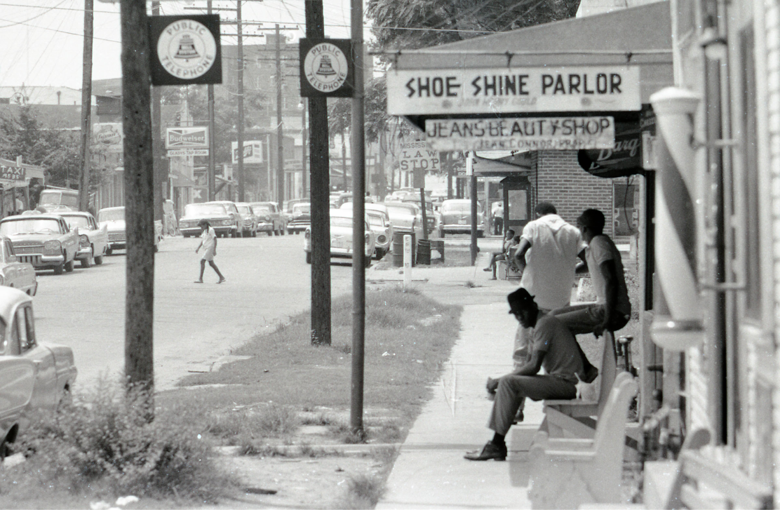
Photo: Jean’s Beauty Shop
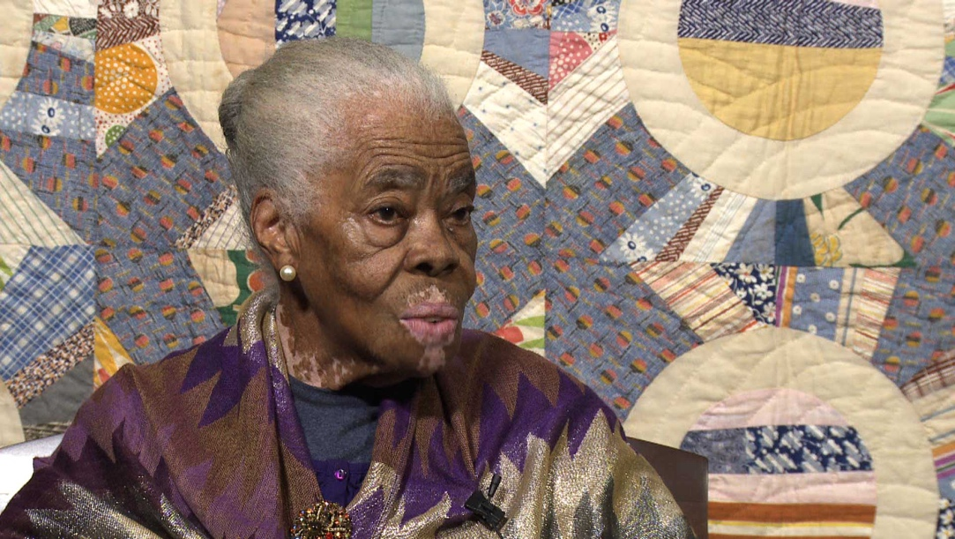
Black businesses were not only an important source of jobs and opportunity in Black communities—they also played a key role in the civil rights movement’s strategy. Read the following excerpt of an oral history from Peggy Jean Connor, a small Black business owner in Hattiesburg, Mississippi, during the civil rights movement. Historian Emilye Crosby conducted this interview with Peggy Jean Connor on November 30, 2015, in Hattiesburg, Mississippi, as part of the Civil Rights History Project.

This Civil Rights History Project, authorized by Congress on May 12, 2009, was intended to create a nationwide database of oral histories of individuals involved in the civil rights movement, both organizing existing interviews and conducting new ones. The project resulted in more than 1200 entries, digitized and available to the public, via the Library of Congress and Smithsonian Institute.

Peggy Jean Connor (PJC): My mother was quiet. I think I was at one time [laughter], and very shy when I was in school. Made good grades, but I never volunteered to answer nothing, you know. I had a teacher, Mrs. R. M. Tademy…She taught me seventh grade. The first semester was citizenship, and in that she really put a lot of emphasis on registering to vote. That was something in that day. In the second semester we had literature. But I remember her telling us, “When you get twenty-one years old, you go to the courthouse, to the circuit clerk’s office, and register to vote.” That stuck with me, and I started trying to register early. It took me about ten years to get it, to become registered.

Emilye Crosby (EC): Did you try the first time when you were twenty-one?

Peggy Jean Connor (PJC): I did, mm-hmm…And another thing, you had to pay poll tax, two years, I mean, for two years, two dollars. Poll tax. I would pay poll tax, and I would collect poll tax in my beauty shop for patrons that wanted and was afraid to go themselves. Now you paid poll tax during the time between January and April like you paid your taxes, before you have to pay penalties on your taxes. So I would take a list up there, and it would just do me all the good in the world. When I get there, I was standing. People behind me had to wait until I turned all those poll, those names in and had receipts for everyone. [Laughter] I just loved that.

Discussion Questions
- How did it make Peggy Jean feel to take all of her clients’ poll tax documentation to the voter registration office? Why might she feel that way?

- Why might a woman want to pay her poll tax at the beauty salon instead of going down to the voter registration office?

- How did Peggy Jean O’Connor’s oral history help you better understand some of the people from Greenwood you have met in “No Turning Back”?

- When was O’Connor’s oral history recorded? Do you think when she told her story could have impacted how she told her story? If so, how?

- How was reading/hearing part of O’Connor’s story in her own words different from learning about the past from a historian or history book? What are the advantages and disadvantages of each type of source?

Source: https://snccdigital.org/people/peggy-jean-connor/
Excerpt from Oral History of Peggy Jean Connor

