A NOTE TO THE EDUCATOR:
This activity is intended to help students reflect on two important aspects of what they learned about in “No Turning Back” and the related activities in this teacher’s guide: (1) The variety of sources of support and inspiration that members of the civil rights movement relied upon, and (2) the variety of ways that community members—even those who did not directly participate in marches, sit-ins, canvassing, and other activities—provided crucial support to the movement.

Students will first brainstorm some of the sources of support and inspiration that helped Verna find strength in “No Turning Back.” Then they will explore a collection of art, photography, poetry, and music lyrics from the civil rights era and choose one piece that they think connects in some way with a source of support or inspiration that Verna experienced in the game. They will write a 2-3 sentence caption for their selection explaining the connection.

Debrief this activity with a whole group discussion that invites students to reflect on the connection between support, inspiration, and creative expression. The reflection questions listed at the end of the student handout can help shape this discussion.

There are a variety of ways you might consider extending this activity:
- Set up a gallery walk with the creative pieces students chose and their captions. Give students time to tour the gallery, and then follow up with a short discussion of what they noticed about each other’s choices. What patterns did they notice? What differences? What new ideas did they glean from their classmates?
- Use creative works beyond those provided in this guide. Searching online will turn up numerous additional options that can be added to the collection of creative works students explore. Especially consider music, as recordings from the civil rights era can easily be found in archival websites and streaming music services.
- Give students the opportunity to make connections to contemporary social movements and youth activism. Students can research the sources of support and inspiration that young changemakers today draw upon, and then they can look for connections with what they learned about the civil rights era.
- Give students the option to make their own creative pieces, instead of choosing and captioning an existing piece of art. Students can work in a wide variety of genres, including visual art, photography, poetry, or musical recording/performance.

Name:_______________________ Date:________________

Instructions:
In this final project, you will be drawing upon your experience playing “No Turning Back” to respond to the following question:

Where did Verna and the civil rights campaigners she joined in “No Turning Back” find support and inspiration as they worked for voting rights in Greenwood?

Step One: Reflect on Verna’s Sources of Support and Inspiration
In “No Turning Back,” Verna is faced with difficult decisions and disappointing setbacks as she adjusts to Greenwood and becomes involved in the campaign for voting rights there. How does she keep going despite the challenges she faces? What actions does she take that make her feel like she has power? Where does she find support? Who or what inspires her? What activities give her strength?

Brainstorm a list of the people and activities that provided support and inspiration to Verna.

Think about the following as you brainstorm:
- Verna’s interactions with people in the game
- The game dashboard (badges, community connectios)
- Your responses to the writing responses you completed

The primary sources you explored while playing “No Turning Back” can provide additional examples of the sources of support and inspiration civil rights activists experienced.

List of sources of inspiration and support:

Step Two: Make a Creative Connection
Numerous artists, writers, musicians, and photographers have honored the experiences of Americans who persevered through Jim Crow and took action in the civil rights movement to bring about a more just and equal society. With your brainstorm about Verna’s sources of inspiration and support, review the collection of art, photography, poetry, and song lyrics. Choose one piece from the collection that you think connects to a source of inspiration or support that Verna experienced, and then write a 2-3 sentence caption for the piece that explains why you chose it.

Source information
Record the name, artist(s), and other available source information (such as the year it was created) about the piece you have chosen:

Caption
Write a 2-3 sentence caption that explains how this piece shows or connects to a source of support and inspiration Verna experienced in “No Turning Back”:

Reflection Questions:

- What was your experience like of choosing a piece from the collection to connect with Verna’s experience? What did you think about as you made your choice? Did any of the works of art, photography, poetry, or music prompt you to think differently about what you learned in “No Turning Back”?

- Most of the creative works you reviewed were published during the years of the civil rights movement, and many were created by members of the movement. What role do you think art, photography, music, poetry, and other forms of creative expression can play in a social movement? Can creative expression itself be a form of protest?

- What did you learn from “No Turning Back” about what it takes to work for a more just society? What did you learn about the different kinds of actions one can take to offer support to a social movement?

Source #1
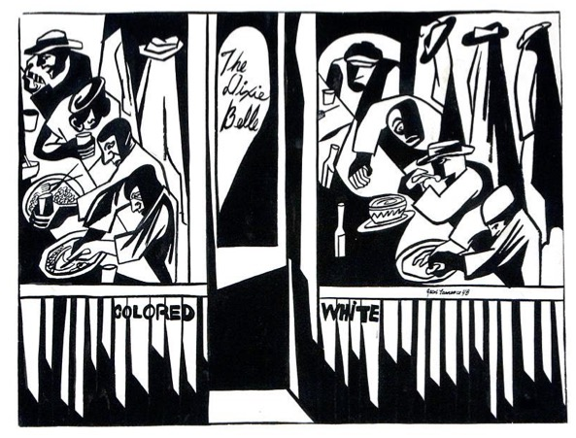
Jacob Lawrence, "Dixie Cafe" 1948
© 2022 The Jacob and Gwendolyn Knight Lawrence Foundation, Seattle / Artists Rights Society (ARS), New York

Collection of the Smithsonian National Museum of
African American History and Culture, Gift of Margaret
and Michael Asch, © 2015 The Jacob and Gwendolyn
Knight Lawrence Foundation, Seattle / Artists Rights
Society (ARS), New York

Source #2

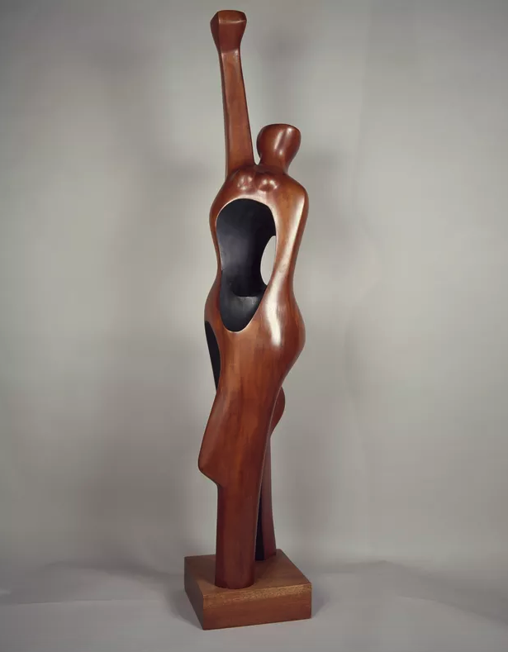

Elizabeth Catlett, Homage to My Young Black Sisters, (1968)
© 2022 The Jacob and Gwendolyn Knight Lawrence Foundation, Seattle / Artists Rights Society (ARS), New York

Source #3

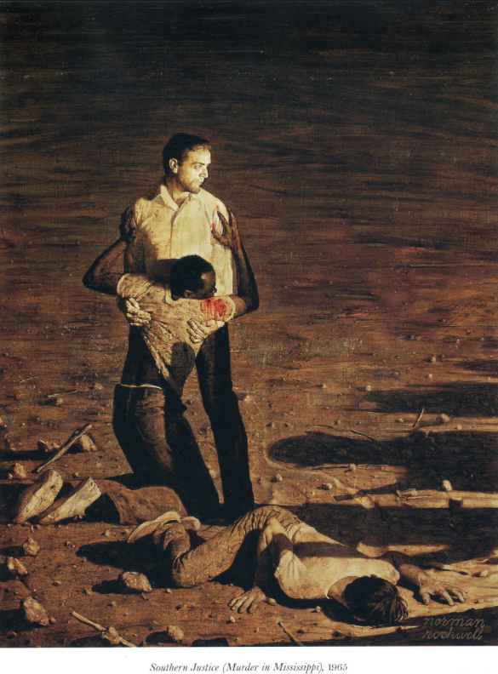

Southern Justice (Murder in Mississippi), 1965 by Norman Rockwell

Source #4

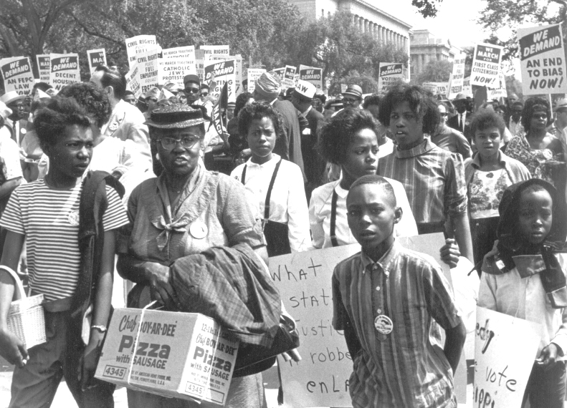

March on Washington, 1963

Photograph by John Kouns
Courtesy of the Tom & Ethel Bradley Center at California State University, Northridge

Source #5

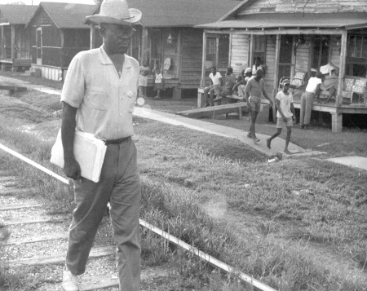

Volunteer Jim Nance, a minister, heading into the Black community to do voter registration canvassing.

Photograph by Herbert Randall

Source #6

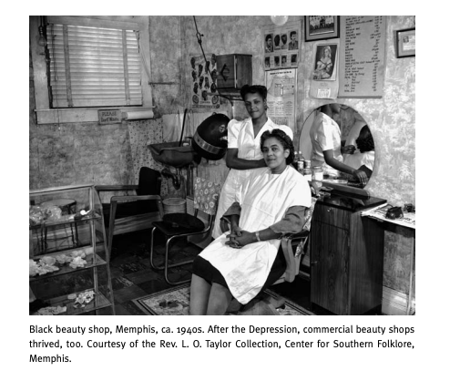

Source #7

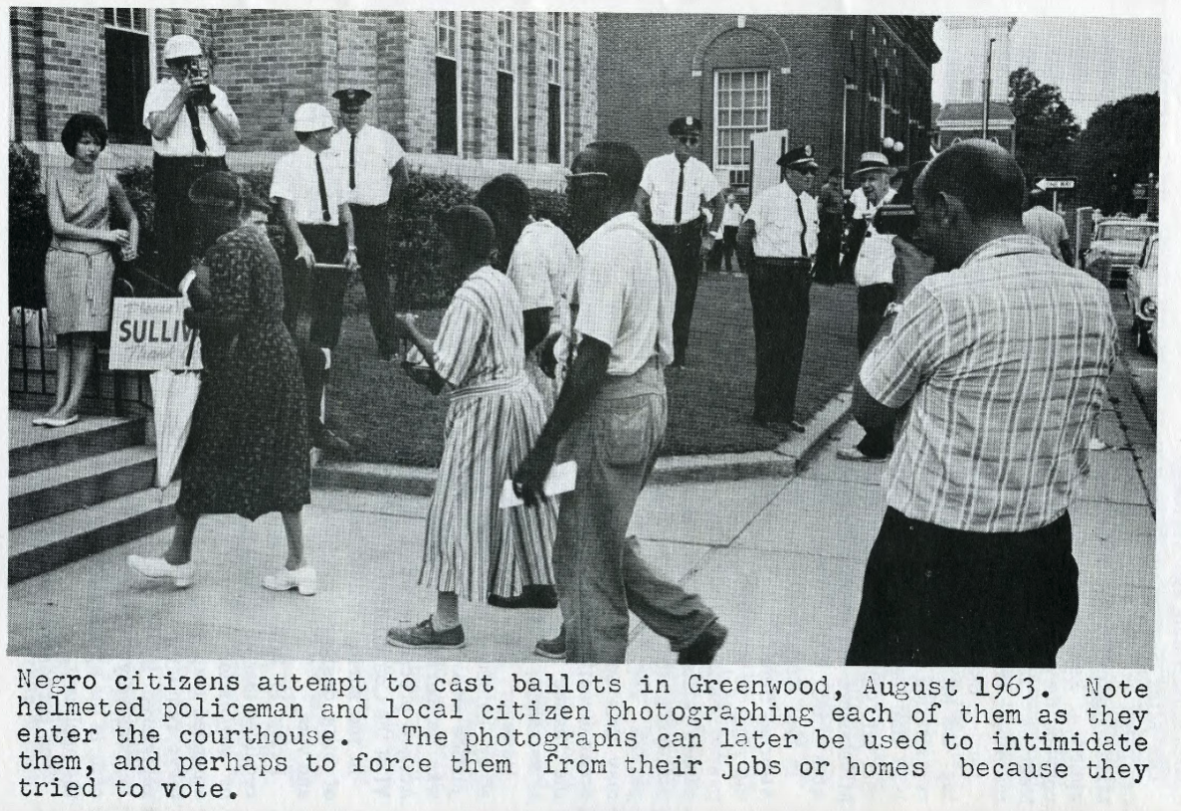

Photograph printed in the SNCC brochure entitled, 'Mississippi: Subversion of the Right to Vote.' (1964)

Source #8

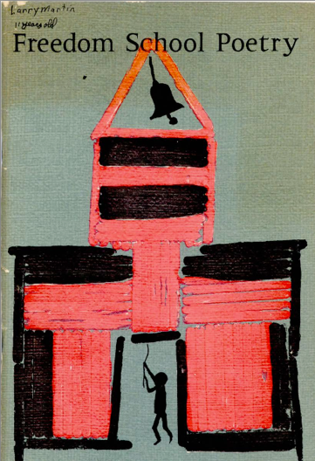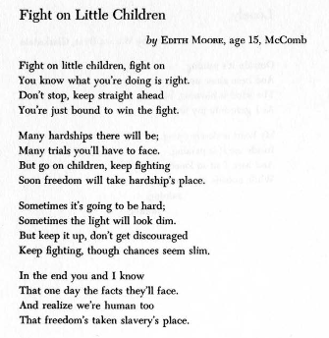

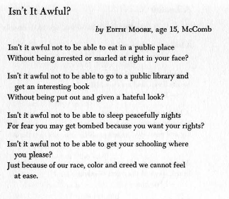

Credit: Excerpts from Letters from Mississippi, edited by Elizabeth Sutherland Martínez. Original edition copyright © 1965 and renewed 1993 by Elizabeth Sutherland Martínez. New edition copyright © 2002 by Elizabeth Sutherland Martínez. Used with the permission of The Permissions Company, LLC on behalf of Zephyr Press, zephyrpress.org. All rights reserved.

Source #9

Uncloudy Day (song)

They tell me of a home far beyond the skies
And they tell me of a home far away
They tell me of a home where no storm clouds rise
They tell me of an unclouded day

The land of cloudless days
The land of an unclouded sky
They tell me of a home where no storm clouds rise
They tell me of an unclouded day

Performed by The Staple Singers
Written by Roebuck Staples

Source #10
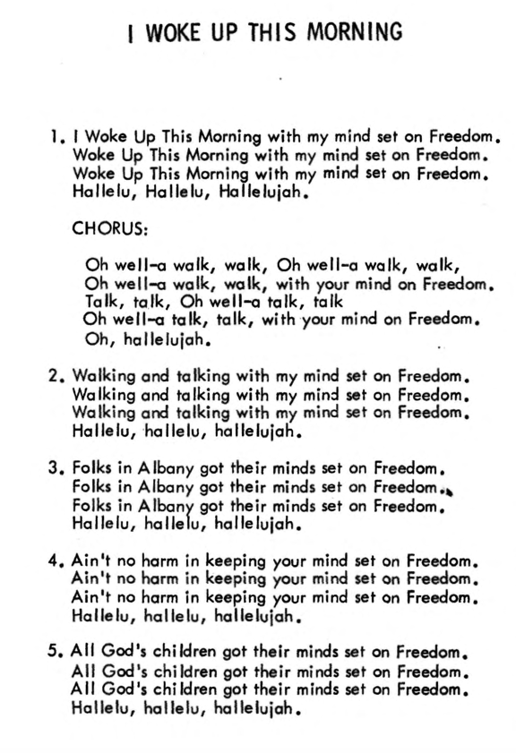

Lyrics published in Sit-In Songs (C.O.R.E., 1962). Recording of performance by Fannie Lou Hamer can be found at Smithsonian-Folkways.

