About The Mission

The mission takes place in northern Kentucky and southern Ohio, and begins in summer 1848. The game is divided into five parts, as well as a framing prologue and epilogue.

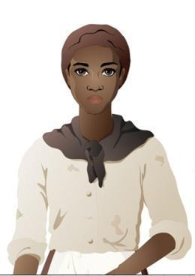
Students playing the game assume the role of Lucy. As the game opens, Lucy is a young enslaved African American on the King family’s plantation outside of Lexington.

When students are reading a traditional text, such as the chapter of a book or a magazine article, all students are presented with the same information. However, as students play “Flight to Freedom,” their experiences may differ slightly based on the choices they make and their behavior as Lucy. As students make their way through the mission, they receive “badges” signifying the characteristics, values, and skills of their particular version of “Lucy.”

In the prologue, players learn Lucy recently turned fourteen. She lives in the slave quarters of the hemp plantation with her mother, Nell, and her younger brother, Jonah. Lucy’s father has been sold away to a neighboring plantation after a poor harvest. On the occasion of her birthday, Nell told Lucy she is now grown up, and life will be getting harder.

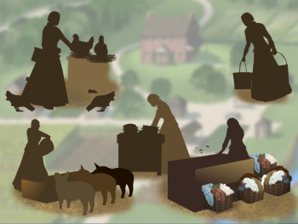
In Part One, “Behind the Big House,” Lucy awakens to her mother and another enslaved African American on the plantation, Henry, talking. After receiving a beating for allegedly damaging a piece of farming equipment, Henry plans to run away. Lucy is asked to complete a variety of tasks, some for her family and community and some for the plantation owner. Before the end of the day, Mr. Otis, the plantation’s overseer, will add on to her already sizeable workload. One of these tasks will be to tend the fire in the smokehouse. Lucy will complete chores across the plantation, encountering Jonah, Sarah King, her master’s daughter, and fellow enslaved African Americans like Esther, the cook, along the way.

Later that night, the smokehouse burns to the ground. Mr. Otis blames Lucy and Henry, insisting they’re sabotaging the plantation. At this point, knowing that a harsh beating, or worse, shipment “down south” is inevitable, Lucy decides to run away. She will have a short time to prepare for her escape, potentially gathering food, useful items, or information. But should she and Henry run away together?

In Part Two, “Runaway!,” Lucy runs away from the King Plantation. Depending on her choices, such as whether or not she’s collected extra food, stolen an axe, or obtained other special items, Lucy’s escape can take a variety of forms. Lucy travels through towns and wilderness in northern Kentucky, hoping to reach safety across the Ohio River. Along the way, she might encounter slave catchers, people suspicious of her activity (whites and blacks alike), and, if she’s lucky, abolitionists.
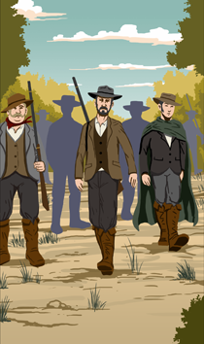
Lucy must make important decisions along the way. Should she travel in more settled areas, with better roads but more people, or in wooded areas that are difficult to navigate but have less chance of being spotted? What should she say if she encounters a slave catcher? What will she wish she had taken from the plantation? Each of these decisions will impact whether Lucy successfully makes her way north or is captured and re-enslaved.

Part Three, “Free and Not Free,” takes place about a year later. Lucy is living near the town of Ripley, Ohio. With the help of Reverend John Rankin, she is lodging with two free African Americans, Abigail and Morgan Wright, under the guise that she is their niece. Aunt Abigail and Uncle Morgan run a laundry business, and Lucy has been able to save $37 over the course of a year working there. She desperately misses her family and wishes she could see them.

Fears increase when T.C. Bercham, a slave catcher, arrives in town. Although she is in a free state, Lucy must be wary of people, especially T.C. Bercham. Lucy learns that Henry, her old friend from the King Plantation, has escaped to Ripley and is being hidden by abolitionist John Parker. Concerns about her family increase when she learns the King family is planning to sell many of their enslaved African Americans. Determined to find a way to secure her family’s freedom, Lucy decides to attend an abolitionist meeting in Ripley that night.

In Part 4, “Gathering Forces,” Lucy attends the abolitionist meeting at the Red Oak Church. Reverend Rankin, John Parker, and schoolteacher Millie Hatcher discuss various anti-slavery activities in the community. Benjamin Harrison, a local politician, presents a speech about colonization of enslaved African Americans.

After the meeting, Rankin, Parker, and Millie Hatcher discuss with Lucy plans to move Henry to safety, as well as potential ways to rescue Jonah and her mother from the King Plantation before they are sold. While attempting to move Henry, the group is confronted by T.C. Bercham, who almost succeeds in taking Henry, but is missing a critical document that makes his capture legal.

Lucy is reunited with Henry, who reveals that her mother has been sold south to New Orleans. Henry decides he must flee to Canada in order to truly be free.
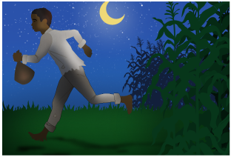
Through the network known as the Underground Railroad, Lucy is able to help Jonah escape from the King Plantation and make his way to Ripley.

In Part 5, “New Times, New Troubles,” which occurs one year later, in 1850, Lucy’s “uncle,” Morgan Wright, is captured by slavecatchers. Though Morgan is a free man who has never been enslaved, the Fugitive Slave Act has made slavecatchers increasingly aggressive. Lucy and her fellow abolitionists in Ripley must try to prove that Morgan is free.

Later, Lucy is identified as a runaway by T.C. Bercham. She is jailed, and visited by Sarah King, her former master’s daughter. Sarah’s family is deeply in debt, and she decides to sell Lucy for much-needed money.

Lucy is taken to Maysville, Kentucky, and auctioned to the highest bidder.
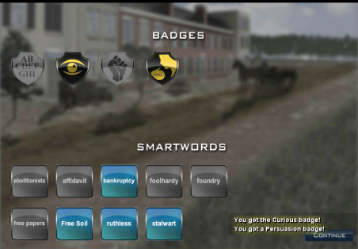
In the Epilogue, players learn what happened to Lucy after the auction. Using the badges they have collected throughout the mission, players make choices that determine Lucy’s ultimate path. As Lucy’s fate unfolds, the player learns how the mounting regional tensions addressed in the game thrust the United States into the Civil War.

During the Mission, students play through several “days” of Lucy’s life. Each day focuses on different modes of resistance to the institution of slavery, as well as elements of daily life in antebellum America. Each student playing the game will have a unique gameplay experience based on individual choices, skill, and understanding of the period.

