[Resources] Primary Source Documents

Kentucky Slave Codes (1794-1850)

Beginning in the colonial era, slaveholders frequently passed laws, known as “slave codes” to restrict the movements and activities of the enslaved population. As the selection of laws from Kentucky shows, slave owners were especially concerned with preventing runaways and rebellions.

1794 Any slave who is freed by their master must carry a certificate of freedom

1798 Slaves cannot leave a plantation without a written note from their master
Slaves cannot carry any type of weapon
Slaves cannot trade goods without the written consent of their master
Slaves are classified as real estate for inheritance matters

1811 Conspiracy among enslaved blacks is punishable by death; enslaved or free blacks guilty of poisoning were also to be put to death.
1823 No slave can work on a steamboat.
1831 Boats cannot transport slaves across the Ohio River without a note from
their master; ship owners must pay a $200 violation for breaking this law.
1834 No person shall sell or give liquor to slave.
1840 There is a 10pm curfew for slaves.
1846 The penalty for tempting blacks to run away or rebel is imprisonment.
County patrols must ride through the county on horseback at night to enforce slave laws.
1850 Any slaves freed by their masters had to leave the state. Their owners had to
provide money to pay for their transportation out of Kentucky, and one year’s
subsistence.
Source: J. Winston Coleman, Slavery Times in Kentucky (1940), Marion B. Lucas, A History of Blacks in Kentucky: From Slavery to Segregation, 1760-1891 (2003), and Ivan McDougle, Slavery in Kentucky, 1792-1865 (1918).

The United States School Primer (1844)
Very few areas in the southern United States offered public education in the years before the Civil War. Individuals, churches and some communities established schools for girls as well as boys. Most children if educated at all were taught at home from primers such as this. After the Nat Turner uprising in 1831, enslaved African Americans across the south were prohibited from being taught to read or write.
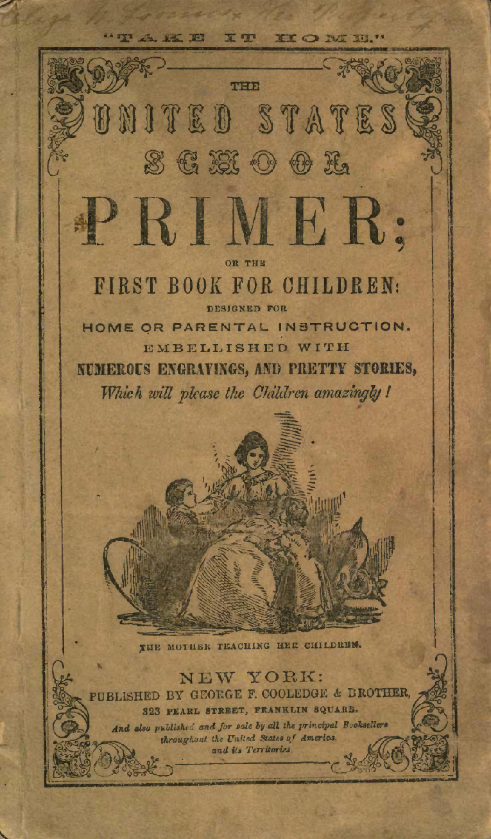

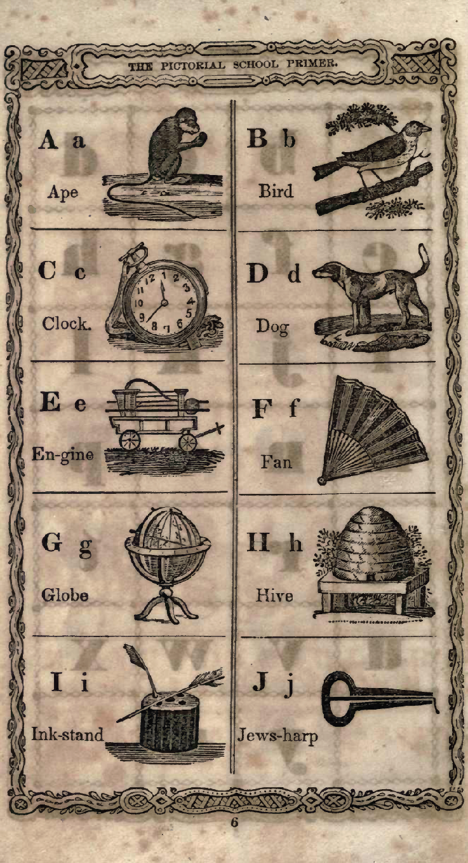
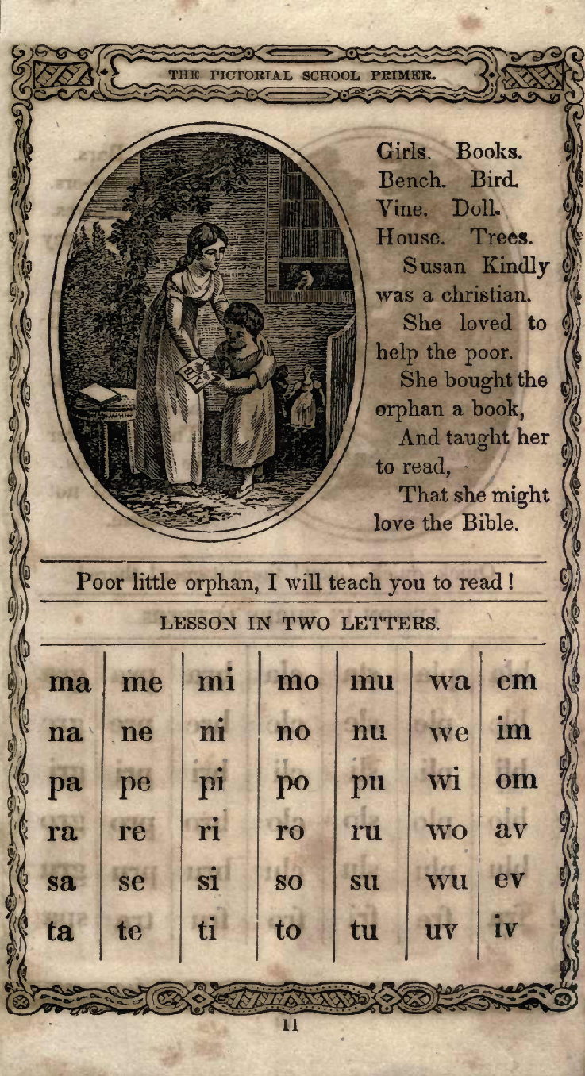

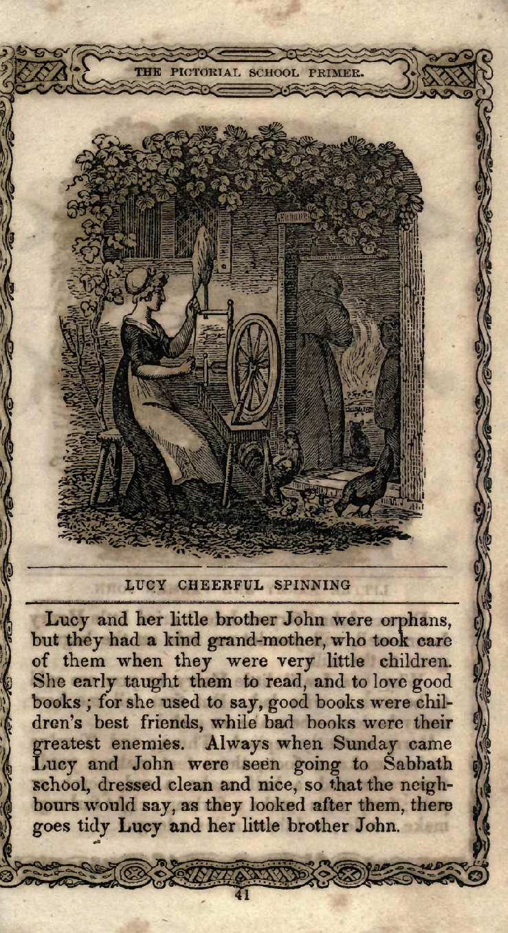
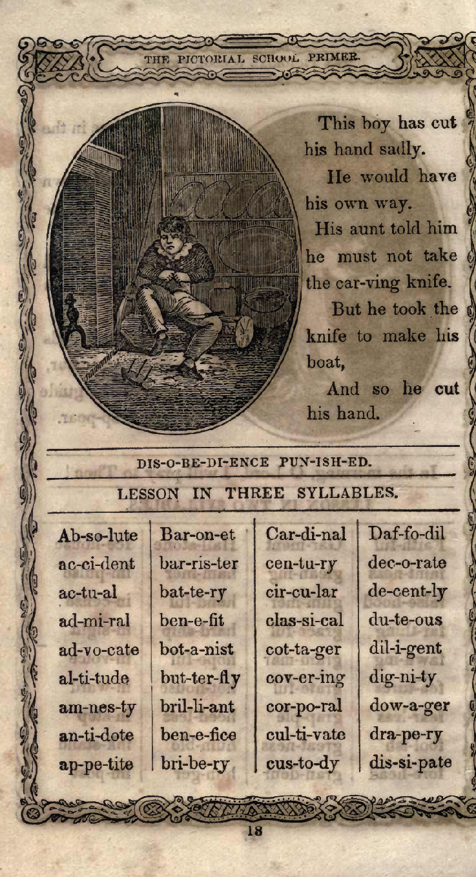
Source: The United States School Primer of the First Book for Children, George F. Cooledge & Brother, 1844, Internet Archive, http://www.archive.org/details/unitedstatesscho00newyiala

“A History of the Amistad Captives” Advertising Broadside (1840)

In 1839, captive West Africans revolted and took control of the Spanish slave ship Amistad. They ordered the crew to return them to Africa, but were waylaid by a U.S. Navy vessel off the coast of New York. The Africans were charged with murdering the captain, and put in jail in New Haven, Connecticut. Abolitionists came to their support, and after a long legal battle, in 1841 the U.S. Supreme Court ruled that the men had acted in self-defense and should be freed. A year later the men returned to Africa
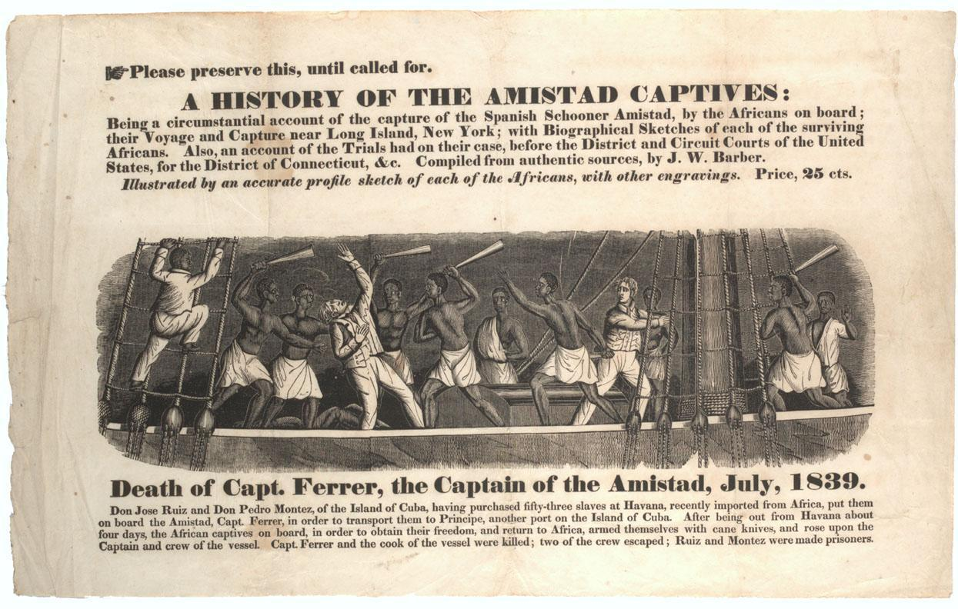
A HISTORY OF THE AMISTAD CAPTIVES:
Being a circumstantial account of the capture of the Spanish Schooner Amistad, by the Africans on board; their Voyage and Capture near Long Island, New York; with Biographical Sketches of each of the surviving Africans. Also, and account of the Trials had on their case, before the District and Circuit Courts of the United States, for the District of Connecticut, &c. Compiled from authentic sources, by J. W. Barber.
Illustrated by an accurate profile sketch of each of the Africans, with other engravings. Price, 25 cts.
Death of Capt. Ferrer, the Captain of the Amistad, July, 1839.
Don Jose Ruiz and Don Pedro Montez, of the Island of Cuba, having purchased fifty-three slaves at Havana, recently imported from Africa, put them on board the Amistad, Capt. Ferrer in order to transport them to Principe, another port on the Island of Cuba. After being out from Havana about four days, the African captives on board, in order to obtain their freedom, and return to Africa, armed themselves with cane knives, and rose upon the Captain and crew of the vessel. Capt. Ferrer and the cook of the vessel were killed; two of the crew escaped; Ruiz and Montez were made prisoners.
Source: Advertising broadside for J.W. Barber, "A History of the Amistad Captives," featuring woodcut, "The Death of Capt. Ferrer," 1840. Gilder Lehrman Institute of American History, New York, NY.

Godey’s Lady Book (1848)

Godey’s Lady Book was one of the country’s most popular magazines in this era. It advised middle-class white women on domestic matters, including how to maintain a beautiful home, raise healthy and well-behaved children, and dress in the latest European styles.
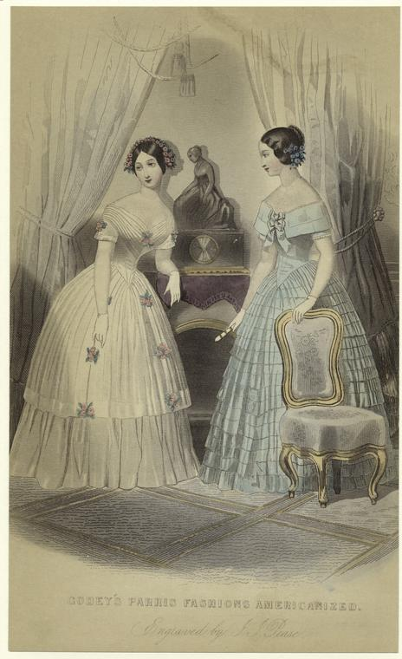
Source: Godey’s Paris Fashions Americanized, engraved by Joseph Pease, 1848, from New York Public Library’s Digital Gallery, http://digitalgallery.nypl.org/nypldigital/id?802276

Slave Pass (1852)

Enslaved African Americans were often sent out on errands to other plantations, farms, or towns. Laws required them to carry a pass if they traveled without their owners. Unlike more official documents, such as certificates of freedom, passes were handwritten and informal. The pass below was for a enslaved African American named Barney in Missouri who tried to escape using the pass, but was captured.

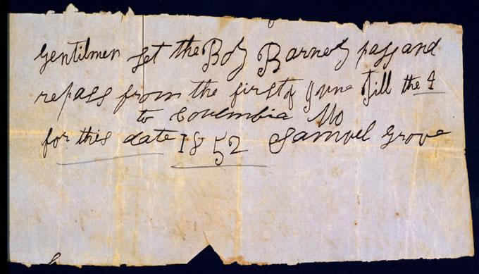

Text:
Gentilmen let the Boy Barney pass and repass from the first of June till the 4 to Columbia Mo for this date 1852 Samuel Grove

“Sale of Slaves and Stock” Poster (1852)

Enslaved African Americans were considered property by their owners and by law and could be sold with no regard for family ties. The 1850s witnessed one of the nation’s largest geographic shifts in the enslaved African American population as the internal slave market sold thousands of enslaved African Americans from the upper south to the lower south. The death of a slave owner could result in the break up of numerous families.
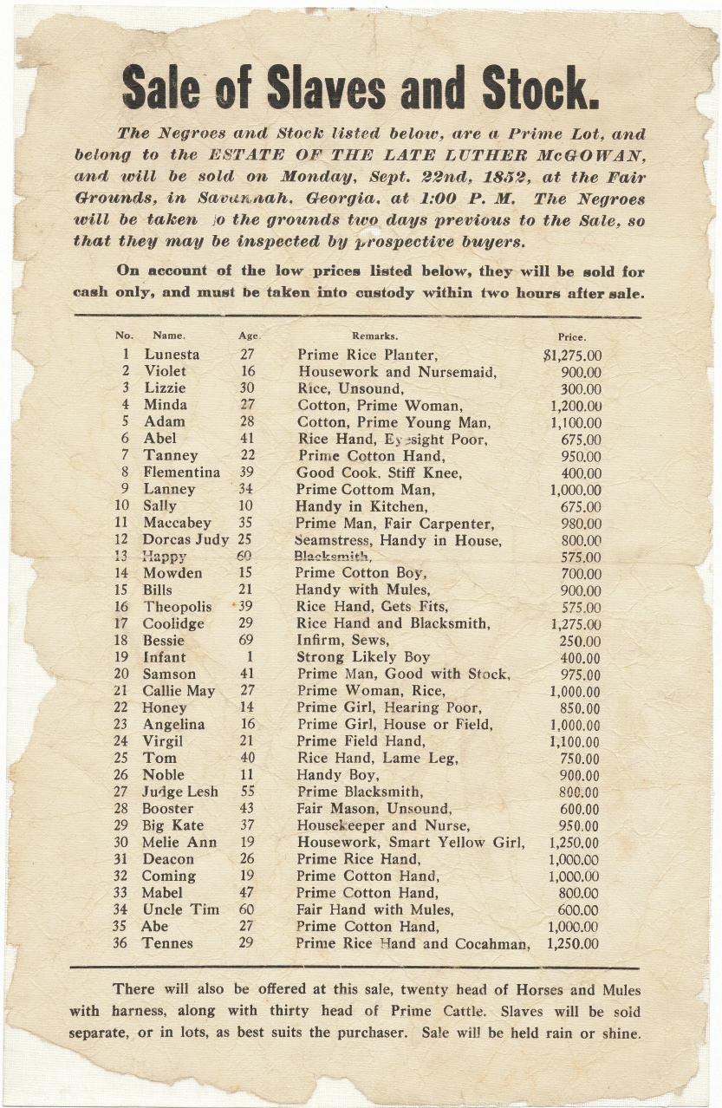
Source: Chicago History Museum

“$1200 to $1250 Dollars! For Negroes!!” Poster (1853)

After 1807, enslaved African Americans could no longer be imported into the United States from Africa or the Caribbean. Plantation owners were dependent on the domestic slave trade and the natural increase in population for their labor. By the 1850s, the western expansion of cotton meant that the demand for slave labor exceeded the supply in certain regions. Slave traders used advertising, as seen here, to encourage slave owners in the Upper South---where demand for labor was decreasing—to sell enslaved African Americans to masters in the Deep South where the demand for labor was highest.

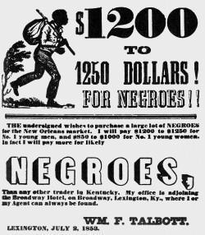

Text:
$1200 to $1250 Dollars! For Negroes!!
The undersigned wishes to purchase a large lot of NEGROES for the New Orleans market. I will pay $1200 to $1250 for No. 1 young men, and $850 to $1000 for No. 1 young women. In fact I will pay more for likely NEGROES, Than any other trader in Kentucky. My office is adjoining the Broadway Hotel. on Broadway, Lexington, Ky., where I or my Agent can always be found.
WM. F. Talbott

LEXINGTON, JULY 2, 1853
Source: Coleman Collection, University of Kentucky Special Collections, printed in Marion B. Lucas, A History of Blacks in Kentucky: From Slavery to Segregation, 1760-1891 (2003), 91.

“INFAMOUS!” Kentucky Newspaper Editorial (1847)
Only a small number of enslaved African Americans in Kentucky managed to escape north, and an even smaller number escaped via the Underground Railroad. Yet Kentucky slave owners were furious any time an abolitionist “slave stealer” was found to have provided encouragement or safe haven for enslaved African Americans seeking freedom. The following report describes a real incident in which Kentucky slave catchers attempted to recapture freedom seekers living in Michigan, but instead were arrested on kidnapping charges. The judge in the ensuing trial was a known abolitionist, and found that the Kentuckians did not have the correct paperwork. The slave catchers returned to Kentucky empty-handed, while the fugitives made their way to Canada. This event helped rally southern support for the passage of the 1850 Fugitive Slave Law.
It will, perhaps be remembered, that several weeks ago we announced the elopement of some 20 or 30 Slaves from this county.
A short time since information was received by their owners, that the runaways were colonized in a small town in the southern part of Michigan.
A party of some 12 or 15 gentlemen, composed principally of those who had sustained the loss, immediately repaired to that place, and succeeded in finding and recapturing their slaves without difficulty. But no sooner had they taken them into custody than they were surrounded by a furious mob of several hundred abolitionists who treated them with every indignity which cowardly brutality could invent, rescued the slaves from them by force, and had a mock trial before a Judge who had previously sworn that they should not take the negroes away in any event, the result of which was that the slaves were immediately turned loose and the Kentuckians confined and forced to give bail under charges of kidnapping, rioting &c. We intend to publish next week a full narrative of this most atrocious piece of abolition villainy, the details of which cannot fail to make the blood of every honest man boil in his veins. Things have indeed come to a startling condition when such conduct is not only allowed to pass unpunished, but actually receives the sanction of public approval in the North. The time may come when those cowards and sons of cowards will again, as during the last war, turn their imploring eyes to Kentucky and to Kentuckians for protection from the ravages of a foreign foe; and they may find that Kentucky as no more Shelby’s Johnsons Dudleys and Clays, to march to their frontier at the head of her heroic and devoted armies, for the protection of a vile den of Negro thieves and recreants to every principle of honor and common honesty––to say nothing of gratitude.
Source: Licking Valley Register, September 3, 1847, p. 2.

“Negro Stealing” Kentucky Newspaper Editorial (1847)
As this article shows, slaveholders in Kentucky felt threatened by free blacks who were not subject to the same tight supervision as enslaved African Americans. In particular, whites feared that free Blacks would conspire with northern abolitionists to encourage enslaved African Americans to escape from or rebel against their owners. In 1850, Kentucky passed a new state Constitution which discouraged slave owners from freeing enslaved African Americans by requiring all newly freed African Americans to be transported out of state at the owner’s expense.
Notwithstanding the number of servants that have been inveigled from their owners in this community, there seems to be an unaccountable neglect on the subject. All agree that we have abolitionists among us, who probably encourage our Negroes to abscond; yet there is no proper effort to detect them, not to arrest the real actors in this nefarious system of robbery; for in point of property or private rigts [sic], they might as well steal our horses or any thing else….One thing is certain, we have too many free Negroes among us, who have constant Intercourse with our servants, and with both sides of the River. These interlopers are most likely to be the immediate instrument of those detestable incendiaries, who like their master, the Devil, are always zealous in mischief.
Those Negroes ought to be removed by law, if convenient, but at all events to be removed and kept away. If they are legally free, let them enjoy freedom among their benevolent friends; the free states are wide enough to accommodate them, and they are not wanted in this community. Other states have laws against the intrusion of free Negroes, and if our laws are not sufficiently explicit to protect our property, let us have them improved without delay.
The loss of our servants is a serious inconvenience, and to have them contaminated and stolen away, is an outrage not to be endured with impunity. From the tone of feeling in this vicinity, something must and will be done very soon on this subject. WATCH!
Source: Licking Valley Register, October 22, 1847, p. 3.

Slave Narrative by Henry Bibb about Running Away (1849)
Henry Bibb was born in Kentucky to Kentucky state senator, James Bibb, and his mother who was enslaved. He was hired out at a young age and while he was away his brothers and sisters were sold off. Bibb was traded frequently, and he lived in at least seven southern states. After trying to escape several times, he finally reached Canada in 1837. However, he returned to Kentucky a year later for his wife and child and was recaptured. He made a final, successful escape in 1841 and became an active abolitionist in Detroit. Following the passing of the Fugitive Slave Act of 1850, he fled to Canada where he founded a school, church, and several antislavery societies. He also established the Voice of the Fugitive, Canada's first African American newspaper. Bibb's autobiography, Narrative of the Life and Adventures of Henry Bibb, An American Slave was published in 1849

Among other good trades I learned the art of running away to perfection. I made a regular business of it, and never gave it up, until I had broken the bands of slavery, and landed myself safely in Canada, where I was regarded as a man, and not as a thing.
The first time in my life that I ran away, was for ill treatment, in 1825. I was living with a Mr. Vires, in the village of Newcastle. His wife was a very cross woman. She was every day flogging me, boxing, pulling my ears, and scolding, so that I dreaded to enter the room where she was. This first started me to running away from them. I was often gone several days before I was caught. They abuse me for going off, but it did no good. The next time they flogged me, I was off again; but after awhile they got sick of their bargain, and returned me back into the hands of my owners.
By this time. Mr. White had married his second wife. She was what I call a tyrant. I lived with her several months, but she kept me almost half of my time in the woods, running from under the bloody lash. While I was at home she kept me all the time rubbing furniture, washing, scrubbing the floors; and when I was not doing this, she would often seat herself in a large rocking chair, with two pillows about her, and would make me rock her, and keep off the flies. She was too lazy to scratch her own head, and would often make me scratch and comb it for her. She would at other times lie on her bed, in warm weather, and make me fan her while she slept, scratch and rub her feet; but after awhile she got sick of me, and preferred a maiden servant to do such business.
I was then hired out again; but by, this time I had become much better skilled in running away, and would, make calculation to avoid detection, by taking with me a bridle. If any body should see me in the woods, as they, have, and asked "what are you doing here sir? you are a runaway?"--I said, "no, sir, I am looking for our old mare;" at other times, "looking for our cows." For such excuses I was let pass. In fact, the only weapon of self defence that I could use successfully, was that of deception. It is useless for a poor helpless slave, to resist a white man in a slaveholding State. Public opinion and the law is against him; and resistance in many cases is death to the slave, while the law declares, that he shall submit or die.
The circumstances in which I was then placed, gave me a longing desire to be free. It kindled a fire of liberty within my breast which has never yet been quenched.… I believed then, as I believe now, that every man has a right to wages for his labor; a right to his own wife and children; a right to liberty and the pursuit of happiness; and a right to worship God according to the dictates of his own conscience.

Source: [Henry Bibb], Narrative of the Life and Adventures of Henry Bibb, An American Slave (1849), 15-17.

John Parker on the Challenges of Running Away

Nearly everything we know about John Parker comes from his autobiography. According to the memoir, Parker was born in 1827 in Norfolk, Virginia. His father was a wealthy white man; his mother was enslaved, like Parker. He spent the first 18 years of his life enslaved, and earned a reputation as a troublemaker for regularly trying to escape. In 1845 he purchased his freedom. In 1848 he married and moved to Ripley, Ohio the next year. It was in Ripley, a center of abolitionist activity, that he began his work on the Underground Railroad. By his own count, he helped over 400 enslaved African Americans to freedom. In addition to his abolitionist work, Parker was a successful iron worker and businessman; in 1865 he purchased an iron foundry, and he patented several popular inventions. John Parker's autobiography was transcribed by the journalist Frank Moody Gregg in the 1880s.

Every precaution was taken to prevent the fugitive from successfully passing through this forbidden land. The woods were patrolled nightly by constables, and any man black or white had to give a good account of himself, especially if he were a stranger. Every ford was watched, while along the creeks and river, the skiffs were not only pulled up on shore, but were padlocked to trees, and the oars removed. There were dogs in every dooryard, ready to run down the unfortunates.
Once word came from further south that runaways were on the way, the whole countryside turned out, not only to stop the fugitives, but to claim the reward for their capture. Everything was organized against the slaves’ getaway.
But in spite of the odds against them, there were a surprising number who did make good their escape. This must be said for the slaves who took to the woods, they were above the average slave in intelligence and courage, otherwise they would never have started. Once they were started, no obstacle was too great for them to overcome.

Source: John P. Parker, His Promised Land, reprint, edited by Stuart Seely Sprague (W.W. Norton, 1996).

“Plantation Police” in Mississippi, 1863

This scene of white patrollers examining “Negro passes” in Mississippi illustrates the constraints placed on all African Americans in the South. This news illustration captured a scene during the Civil War, when slave owners in Mississippi feared that large numbers of enslaved African Americans would escape to freedom behind Union lines and organized patrols to closely monitor the movements of enslaved African Americans.

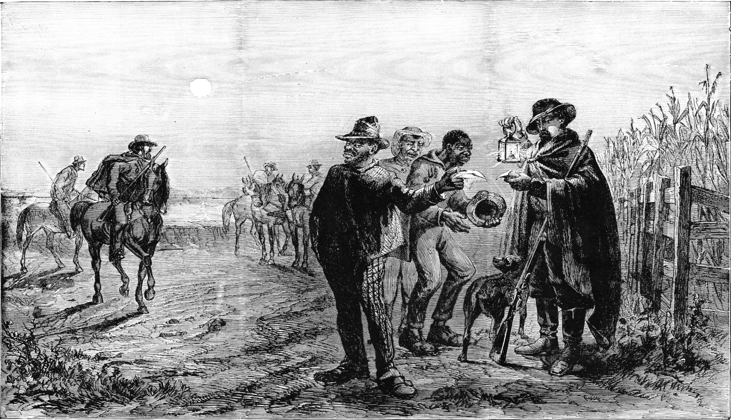

Source: Frank B. Schell, “Plantation Police, Vicksburg, Miss.,” Frank Leslie’s Illustrated Newspaper, 11 July 1863.

Interview with a former Kentucky slave about escape and capture

The following excerpt is from an oral history interview with Peter Bruner who was ninety-one years old in 1936 when the interview was conducted by Evelyn McLemore. This interview was part of the Federal Writer's Project of the Works Progress Administration (WPA) in the 1930s that resulted in the Slave Narrative Collection, at the Library of Congress. The collection consists of more than two thousand interviews with formerly enslaved African Americans, most of them first-person accounts of life that describe in their own words what it felt like to be an enslaved African American in the United States.
Peter Bruner, was born in Winchester, Kentucky, Clark Co., in 1845. His master was John Bell Bruner, who at that time treated him fairly well. When Peter was 10 years of age his master brought him and his sister to Irvine. After arriving in Irvine, Peter’s master was very cruel to him. They only got cornbread, fat meat and water to eat. If his master’s hunger was not satisfied, he would even take this little from them….Often he was whipped because his mistress said the washing was not clean when it was….
Peter, endured torture as long as he could and finally decided to escape. He went to Richmond, Kentucky on to Lexington. On his way he made a contract with a man to drive his horses to Orleans, but was caught while in Lexington. On his way they caught him and took him to jail and he remained until his master came for him. This did not down him, for just as soon as he could he escaped again, and this time got as far as Xenia, Ohio, but was again caught and brought back. This time he was severely beaten for three hours.
When 17 years old, Peter was hired out to Jimmy Benton, who was more cruel than John Bruner, but was again brought back. It was then he tried again to escape. This time he went through Madison County near Sugar Creek. This was about the year 1861, when the war had begun. Again he was caught and taken back, but this time by Joe Bruner. He escaped several times, but never could seem to get anywhere. Once when he and another slave, Phil, escaped they were caught and made to walk the entire distance barefoot. After this Peter, was chained each night to a chair. One morning while eating his breakfast he heard a knock at the door and on opening it he found a troop of Union Home Guards. Jim Benton and John Bruner were taken to prison…Soon after John was released from Prison, Peter escaped again. This time he had joined a regiment in the [Civil] war.” (p. 88-89)

Source: Kentucky Slave Narratives from the Federal Writer’s Project. 1936-38 (Applewood Books, Library of Congress)

William Lloyd Garrison, The Liberator: “I WILL BE HEARD” (1831)

Through his newspaper, The Liberator, William Lloyd Garrison spoke out against slavery and for the rights of black Americans for 35 years. The tone of the paper was established in the first issue of the paper with Garrison's editorial, "To the Public," in which he boldly called for the immediate emancipation and enfranchisement of enslaved African Americans. Later in life, Garrison acknowledged John Rankin as the primary influence in his decision to devote his life and career to abolitionism.
….Assenting to the "self-evident truth" maintained in the American Declaration of Independence, "that all men are created equal, and endowed by their Creator with certain inalienable rights -- among which are life, liberty and the pursuit of happiness," I shall strenuously contend for the immediate enfranchisement of our slave population. In Park-street Church, on the Fourth of July, 1829, in an address on slavery, I unreflectingly assented to the popular but pernicious doctrine of gradual abolition. I seize this opportunity to make a full and unequivocal recantation, and thus publicly to ask pardon of my God, of my country, and of my brethren the poor slaves, for having uttered a sentiment so full of timidity, injustice and absurdity….My conscience in now satisfied.
I am aware, that many object to the severity of my language; but is there not cause for severity? I will be as harsh as truth, and as uncompromising as justice. On this subject, I do not wish to think, or speak, or write, with moderation. No! no! Tell a man whose house is on fire, to give a moderate alarm; tell him to moderately rescue his wife from the hand of the ravisher; tell the mother to gradually extricate her babe from the fire into which it has fallen; -- but urge me not to use moderation in a cause like the present. I am in earnest -- I will not equivocate -- I will not excuse -- I will not retreat a single inch -- AND I WILL BE HEARD. The apathy of the people is enough to make every statue leap from its pedestal, and to hasten the resurrection of the dead.
Source: William Lloyd Garrison, The Liberator, January 1, 1831

William Lloyd Garrison, The Liberator: “On the Constitution and Union” (1832)

In this editorial from The Liberator, Garrison denounces the Constitution and its framers for upholding the institution of slavery and all its accompanying evils. Though the words “slave” or “slavery” do not appear in the Constitution, there were several provisions in the document that served the interests of slave owners and sanctioned the ownership of human property. Among these were the three-fifths clause that increased southern representation by counting enslaved African Americans as “three-fifths of a person;” a prohibition on states from freeing “a person held to service of labour” in another state; and the assurance not to enact a federal ban the international slave trade until 1808.

There is much declamation about the sacredness of the compact which was formed between the free and slave states, on the adoption of the Constitution. A sacred compact, forsooth! We pronounce it the most bloody and heaven-daring arrangement ever made by men for the continuance and protection of a system of the most atrocious villany ever exhibited on earth. Yes—we recognize the compact, but with feelings of shame and indignation, and it will be held in everlasting infamy by the friends of justice and humanity throughout the world. It was a compact formed at the sacrifice of the bodies and souls of millions of our race, for the sake of achieving a political object—an unblushing and monstrous coalition to do evil that good might come. Such a compact was, in the nature of things and according to the law of God, null and void from the beginning. No body of men ever had the right to guarantee the holding of human beings in bondage. Who or what were the framers of our government, that they should dare confirm and authorise such high-handed villany—such flagrant robbery of the inalienable rights of man—such a glaring violation of all the precepts and injunctions of the gospel—such a savage war upon a sixth part of our whole population?—They were men, like ourselves—as fallible, as sinful, as weak, as ourselves. By the infamous bargain which they made between themselves, they virtually dethroned the Most High God, and trampled beneath their feet their own solemn and heaven-attested Declaration, that all men are created equal, and endowed by their Creator with certain inalienable rights—among which are life, liberty, and the pursuit of happiness. They had no lawful power to bind themselves, or their posterity, for one hour—for one moment—by such an unholy alliance. It was not valid then—it is not valid now. Still they persisted in maintaining it—and still do their successors, the people of Massachusetts, of New-England, and of the twelve free States, persist in maintaining it. A sacred compact! A sacred compact! What, then, is wicked and ignominious?

Source: William Lloyd Garrison, The Liberator, December 29, 1832

Editorial from Anti-Abolitionist Newspaper in Ohio (1842)

Cincinnati, Ohio was located just across the Ohio River from Kentucky. Its residents were sharply divided over the issue of slavery and civil rights for African Americans. Some were committed to the abolitionist movement and active in the Underground Railroad which helped fugitive slaves from the South make their way safely to Canada. Others in Cincinnati, as this editorial shows, strongly opposed the abolitionist movement and supported southern slaveholders view of slaves as property that should be returned.

One among the most mischievous consequences of modern Abolition, is that it certainly tends to excite the most injurious prejudices, heart burnings and jealousies of the South against the North, and the North against the South. That such has already been the case, will not be denied by the most casual observer, and if their schemes are persevered in, the result must inevitably be the severance of this our happy Union, and all the unspeakable calamities which would result from it. It becomes then every friend of his country to oppose with all his might the spread of such pernicious doctrines: to watch their movement with Argus eyes and ceaseless vigilance, and be ever ready to oppose them, and to stay their mad career….

It is the bounden duty of every man to examine into the subject who feels the least desire for the welfare of our common country. The spirit of abolitionism is the spirit of the devil cloaked under the garb of love and philanthropy! No good spirit would do as they have done, and are doing. Have they not advised the slave to steal, to runaway from his master, to use brute force. Out of their own mouths they stand convicted of these awfully heinous crimes, for day after day do they send forth their emissaries loaded with papers, books and pamphlets, publishing their own damming deeds to the world.
Source: Cincinnati Post and Anti-Abolitionist, February 26, 1842

[http://www.teachushistory.org/second-great-awakening-age-reform/resources/pro-slavery-letter-cincinnati-post-anti-abolitionist]

Proslavery Letter from Anti-Abolitionist Newspaper in Ohio (1842)

This letter was written by S. Trott, a resident of Virginia, and printed in the Cincinnati Post and Anti-Abolitionist, a proslavery newspaper in the North. Cincinnati, Ohio was located just across the Ohio River from Kentucky. Cincinnati was home to many stations in the Underground Railroad and Harriet Beecher Stowe, author of Uncle Tom’s Cabin. But many city residents were sympathetic to southern slaveholders and wanted to limit the rights of free blacks in the North.
For nothing better can I consider the present abolition rage. Not that I would consider the simple idea of extending liberty to the slaves, fanaticism, when and where it can be done consistently with the general good – But what are the prominent features of abolitionism? They are no other than the avowed determination to force the freedom of the slaves, regardless of the injury herby inflicted on them, in opposition to the providence of God, to the constitutional compact by which the states have been confederated, and to the good of society….
But let us briefly review some of these positions. –
1st. Abolitionist, whether successful or not, is injurious to the slaves. It scatters discontent, and therefore unhappiness among them in their present state; it increases their insubordination, and thus subjects them to severer usage: should it free them from bondage, it would at the same time free their masters from the care of providing for them, and leave them an improvident class unprovided for, to suffer in rags and starvation, or under crime and its effects.
2nd. The scheme is in opposition to the providence of God. It requires but little acquaintance with the blacks as a people, to be convinced that by nature, they are fitted for greater usefulness, and the enjoyment of more comfort, in a state of bondage than in a state of freedom. In this state the providence of God had placed them among us, before we became a nation, and the same providence which brought us into existence as a nation, and gave us the most perfect and favorable form of government on earth, left them in their bondage, with the masters control over them guaranteed by the Constitution. Until, therefore, God by his providence deprives us of our happy form of government, or disposes the slave States to engage in the work of emancipation, these abolitionists are fighting against the indications of providence.
3rd. Abolitionist is injurious to society at large, because it seeks to remove the slaves, without benefiting them, from a state of subjection in which they are useful producers, and to throw them loose, to squander their time in idleness, and to live by stealth upon the labors of others.
Source: Cincinnati Post and Anti-Abolitionist, April 16, 1842 [ we got the source from http://www.teachushistory.org/second-great-awakening-age-reform/resources/pro-slavery-letter-s-trott]

Free Soil Party Platform (1848)
In 1848, a new political group, the Free Soil Party, formed in upstate New York to oppose the expansion of slavery. Unlike its predecessor the Liberty Party, the Free Party focused on stopping the spread of slavery in western states and territories, rather than abolishing slavery where it currently existed.
Whereas, We have assembled in Convention, as a union of freemen, for the sake of freedom, forgetting all past political differences in a common resolve to maintain the rights of free labor against the aggressions of the Slave Power, and to secure free soil to a free people.
And Whereas, The political Conventions recently assembled…have dissolved the National party organizations heretofore existing, by nominating for the Chief Magistracy of the United States, under the slaveholding dictation, candidates, neither of whom can be supported by the opponents of Slavery Extension without a sacrifice of consistency, duty and self-respect;
And whereas, These nominations so made, furnish the occasion and demonstrate the necessity of the union of the people under the banner of free Democracy, in a solemn and formal declaration of their independence of the slave power, and of their fixed determination to rescue the Federal Government from its control;
Resolved, therefore, That we, the people here assembled, remembering the example of our fathers, in the days of the first Declaration of Independence, putting our trust in God for the triumph of our cause, and invoking his guidance in our endeavors to advance it, do now plant ourselves upon the National platform of Freedom in opposition to the sectional platform of Slavery.
Resolved, That Slavery in the several States of this Union which recognize its existence, depends upon State laws alone, which cannot be repealed or modified by the Federal Government, and for which laws that government is not responsible. We therefore propose no interference by Congress with Slavery within the limits of any State.
Resolved, That the Proviso of Jefferson, to prohibit the existence of Slavery after 1800, in all the Territories of the United States, Southern and Northern; the votes of six States and sixteen delegates, in the Congress of 1784, for the Proviso, to three States and seven delegates against it; the actual exclusion of Slavery from the Northwestern Territory, by the Ordinance of 1787, unanimously adopted by the States in Congress; and the entire history of that period, clearly show that it was the settled policy of the Nation not to extend, nationalize or encourage, but to limit, localize and discourage Slavery; and to this policy, which should never have been departed from, the Government ought to return...
Resolved, That in the judgment of this Convention, Congress has no more power to make a Slave than to make a King; no more power to institute or establish Slavery than to institute or establish a Monarchy: no such power can be found among those specifically conferred by the Constitution, or derived by just implication from them.
Resolved, That it is the duty of the Federal Government to relieve itself from all responsibility for the existence or continuance of slavery wherever the government possesses constitutional authority to legislate on that subject, and it is thus responsible for its existence.
Resolved, That the true, and in the judgment of this Convention, the only safe means of preventing the extension of Slavery into Territory now Free, is to prohibit its extension in all such Territory by an act of Congress.
Resolved, That we accept the issue which the Slave power has forced upon us; and to their demand for more Slave States, and more Slave Territory, our calm but final answer is, no more Slave States and no more Slave Territory. Let the soil of our extensive domains be kept free for the hardy pioneers of our own land, and the oppressed and banished of other lands, seeking homes of comfort and fields of enterprise in the new world.
Resolved, That the bill lately reported by the committee of eight in the Senate of the United States, was no compromise, but an absolute surrender of the rights of the Non-Slaveholders of all the States; and while we rejoice to know that a measure which, while opening the door for the introduction of Slavery into Territories now free, would also have opened the door to litigation and strife among the future inhabitants thereof, to the ruin of their peace and prosperity, was defeated in the House of Representatives, its passage, in hot haste, by a majority, embracing several senators who voted in open violation of the known will of their constituents, should warn the people to see to it, that their representatives be not suffered to betray them. There must be no more Compromises with Slavery; if made they must be repealed.
Source: Horace Greeley and John F. Cleveland, eds., A Political Text-Book for 1860 (New York: Tribune Association, 1860), 17-18.

“The Transportation of Free Blacks to Africa” (1850)
In 1850, Kentucky enacted a new state constitution that required newly freed blacks to leave the state (free blacks were considered a threat to slave holding interests). The change helped to revive interest in “colonization,” a plan to settle formerly enslaved African Americans in the African colony of Liberia. This editorial from a Maysville, Kentucky newspaper in favor of colonization was reprinted in the Ripley Bee in Ohio.

The Maysville Eagle…contains a well written article on the subject of the Transportation of Free Blacks to Africa. The Eagle thinks that considerations of policy, as well as of justice and humanity should induce the next Legislature to appropriate an annual sum, say $20,000, to this purpose.
We think the suggestion a good one….The rigorous provisions which have been incorporated into the New Constitution, relative to the emancipation of slaves, would seem to render something of this sort, if not necessary, at least highly expedient and proper. The Convention having established a decree of unconditional expatriation against all emancipated slaves, it would seem to be due to justice and humanity, that having denied them a place on own soil, where they were born, we should adopt some measure towards providing them a refuge and home elsewhere.
Every consideration forbids that we should desire to impose upon our sister States a class of population which we consider a dangerous and mischievous element of our own community. We have no right to suppose that other States will submit to have this nuisance thrust upon them. We know they will not. They ought not, and it does not become us to ask it of them.
Where, then, are the liberated Blacks to go? Are they to have no home? Are they, after a laborious life of servitude spent for our advantage, to be thrust forth houseless vagrants on the face of the earth? Justice to the poor negro himself, as well as respect for our own character, forbids the idea. Humble though he may be, the slave has claims upon our justice and humanity, which ought not to be disregarded.
If an arrangement can be made by which, without material inconvenience to the Public Treasury, an annual sum could be set apart and appropriated to the settlement of our liberated slaves in Liberia, we hope it will be done.
Source: Maysville Post Boy, reprinted in Ripley Bee, November 2, 1850, p. 3.

Excerpt from Frederick Douglass Autobiography

Frederick Douglass was born into slavery in Maryland. Douglass attempted to runaway several times and finally succeeded in 1838 at the age of 20. Once North, he became a leader of the anti-slavery movement, editor of the abolitionist newspaper The North Star and, after the Civil War, a diplomat for the U.S. government. This excerpt is from Douglass’ autobiography, which received wide acclaim and became a bestseller in 1845.

It is impossible for me to describe my feelings as the time of my contemplated start drew near. I had a number of warm-hearted friends in Baltimore,--friends that I loved almost as I did my life, --and the thought of being separated from them forever was painful beyond expression. It is my opinion that thousands would escape from slavery, who now remain, but for the strong cords of affection that bind them to their friends.
….Besides the pain of separation, the dread and apprehension of a failure exceeded what I had experienced at my first attempt. The appalling defeat I then sustained returned to torment me. I felt assured that, if I failed in this attempt, my case would be a hopeless one — it would seal my fate as a slave forever.
I could not hope to get off with any thing less than the severest punishment, and being placed beyond the means of escape. It required no very vivid imagination to depict the most frightful scenes through which I should have to pass, in case I failed. The wretchedness of slavery, and the blessedness of freedom, were perpetually before me. It was life and death with me. But I remained firm, and, according to my resolution, on the third day of September, 1838, I left my chains, and succeeded in reaching New York without the slightest interruption of any kind. How I did so, — what means I adopted, — what direction I travelled, and by what mode of conveyance, — I must leave unexplained, for the reasons before mentioned.
I have been frequently asked how I felt when I found myself in a free State. I have never been able to answer the question with any satisfaction to myself. It was a moment of the highest excitement I ever experienced. I suppose I felt as one may imagine the unarmed mariner to feel when he is rescued by a friendly man-of-war from the pursuit of a pirate. In writing to a dear friend, immediately after my arrival at New York, I said I felt like one who had escaped a den of hungry lions.
This state of mind, however, very soon subsided; and I was again seized with a feeling of great insecurity and loneliness. I was yet liable to be taken back, and subjected to all the tortures of slavery. This in itself was enough to damp the ardor of my enthusiasm. But the loneliness overcame me. There I was in the midst of thousands, and yet a perfect stranger; without home and without friends, in the midst of thousands of my own brethren — children of a common Father, and yet I dared not to unfold to any one of them my sad condition. I was afraid to speak to any one for fear of speaking to the wrong one, and thereby falling into the hands of money-loving kidnappers, whose business it was to lie in wait for the panting fugitive, as the ferocious beasts of the forest lie in wait for their prey.
The motto which I adopted when I started from slavery was this — “Trust no man!” I saw in every white man an enemy, and in almost every colored man cause for distrust. It was a most painful situation; and, to understand it, one must needs experience it, or imagine himself in similar circumstances.
Let him be a fugitive slave in a strange land — a land given up to be the hunting-ground for slaveholders — whose inhabitants are legalized kidnappers — where he is every moment subjected to the terrible liability of being seized upon by his fellowmen, as the hideous crocodile seizes upon his prey! — say, let him place himself in my situation — without home or friends — without money or credit — wanting shelter, and no one to give it — wanting bread, and no money to buy it, — and at the same time let him feel that he is pursued by merciless men-hunters, and in total darkness as to what to do, where to go, or where to stay, — perfectly helpless both as to the means of defence and means of escape, — in the midst of plenty, yet suffering the terrible gnawings of hunger, — in the midst of houses, yet having no home, — among fellow-men, yet feeling as if in the midst of wild beasts, whose greediness to swallow up the trembling and half-famished fugitive is only equalled by that with which the monsters of the deep swallow up the helpless fish upon which they subsist, — I say, let him be placed in this most trying situation, — the situation in which I was placed, — then, and not till then, will he fully appreciate the hardships of, and know how to sympathize with, the toil-worn and whip-scarred fugitive slave.
Frederick Douglass, Narrative of the Life of Frederick Douglass, an American Slave. Written by Himself. Boston: Anti-Slavery Office, 1845, p. 106-09.

Summary of the Fugitive Slave Law

The Fugitive Slave Law was enacted on September 18, 1850 as part of the Compromise of 1850––a set of Congressional measures intended to prevent a sectional crisis between the North and South. Slaves owners successfully lobbied for a new Fugitive Slave Law with stricter enforcement than earlier laws dating back to 1790. It denied a jury trial to anyone accused of escaping slavery, gave marshals tremendous leeway to pursue enslaved African Americans seeking freedom into free states, and empowered the federal government to prosecute northern whites who shielded runaways. The law was fiercely denounced by abolitionists, who organized opposition against it, but also by some white southerners who thought that it did not go far enough to protect their “property.”

The main provisions of the law were as follows:

- Slave owners (or their representatives) could pursue and reclaim fugitives in free states, either by procuring a warrant, or by seizing and arresting fugitives and taking them before a court, judge, or commissioner.
- Federally-appointed commissioners were given jurisdiction over local authorities in all matters relating to fugitive slaves. Commissioners were responsible for deciding who was a fugitive, and enforcing the return of fugitives to their owners.
- Local law enforcement (marshals and deputy marshals) were required to enforce the Fugitive Slave Law or face fines of $1000, and if a fugitive escaped under the watch of a marshall, he was personally liable for the value of the fugitive slave.
- Bystanders and “good citizens” in free states were required to assist law enforcement in the recapture of fugitive slaves as needed
- Anyone accused of being a fugitive slave could not testify on their own behalf.
- Any person who interfered with the arrest of a fugitive, or aided in a fugitive’s escape or concealment, could be fined one thousand dollars, and imprisonment not exceeding six months. If the fugitive escaped, he or she was also required to reimburse the owner one thousand dollars for each fugitive so lost
- Commissioners were paid $10 for every fugitive returned south, and $5 if fugitive was freed.
Source: American Social History Project/Center for Media & Learning

“Caution!! Colored People of Boston” Anti-Slavery Poster (1851)

After the passage of the Fugitive Slave Law, abolitionists tried to warn fugitives in the North about the new dangers to their safety. This poster was created by Boston abolitionist Theodore Parker.
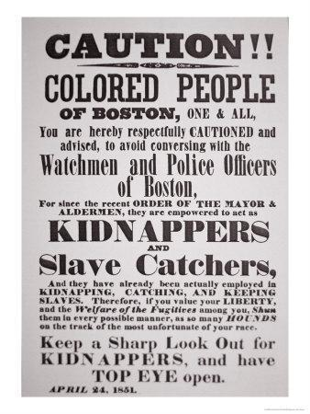
Source: Boston Public Library

“Great Sale of Slaves” Auction Poster (1855)

The twenty-three people to be sold belonged to a Kentucky planter named John Carter. He decided to “liquidate his assets” before moving to the free state of Indiana. Cheapside, the area of Lexington mentioned in the auction notice, was the largest slave trading district in the state. Slave traders established offices, residences, and slave pens in cities throughout the South in order to be located near transportation and business hubs. It was not uncommon to see slave auctions take place in public markets and squares.

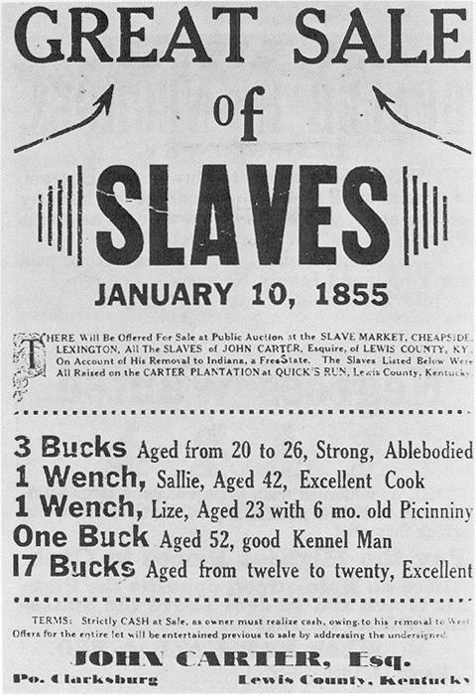

Source: John Winston Coleman, Slavery Times in Kentucky, 1940.

“A Bold Stroke for Freedom,” Print (1855)

On Christmas Eve, 1855, patrollers finally caught up with a group of teenaged enslaved African Americans who had escaped by wagon from Loudon County, Virginia. But the posse was driven off when Ann Wood, leader of the group, brandished weapons and dared the pursuers to fire. The fugitives continued on to Philadelphia. Although proponents of the Fugitive Slave Law hoped it would reduce the number of enslaved African Americans escaping to the North, the law fueled abolitionist sentiment. Popular opposition in cities like Boston and Philadelphia, which at times led to the emancipation by force of captured freedom seekers, at times made the law unenforceable.

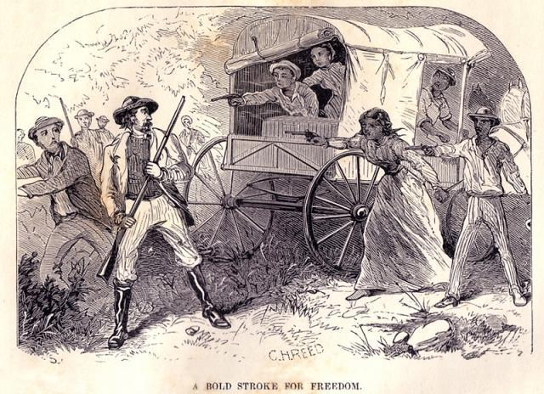

Source: William Still, The Underground Rail Road (Philadelphia: Porter & Coats, 1872), 125.

Harriet Jacobs on the Fugitive Slave Law (1861)

Harriet Jacobs escaped from her master in North Carolina in 1845, and later wrote a narrative of her experiences. After the passage of the Fugitive Slave Law, Jacobs and other fugitive enslaved African Americans in the North faced new threats to their safety and freedom. In this passage, she describes the impact of the 1850 law on the African American community of New York City.
…an event occurred of disastrous import to the colored people. The slave Hamlin [James Hamlet], the first fugitive that came under the new law, was given up by the bloodhounds of the north to the bloodhounds of the south. It was the beginning of a reign of terror to the colored population….Many families, who had lived in the city for twenty years, fled from it now. Many a poor washerwoman, who, by hard labor, had made herself a comfortable home, was obliged to sacrifice her furniture, bid a hurried farewell to friends, and seek her fortune among strangers in Canada. Many a wife discovered a secret she had never known before––that her husband was a fugitive, and must leave her to insure his own safety. Worse still, many a husband discovered that his wife had fled from slavery years ago, and as ‘the child follows the condition of his mother,’ the children of his love were liable to be seized and carried to slavery. Everywhere, in those humble homes, there was consternation and anguish. But what cared the legislators of the ‘dominant race’ for the blood they were crushing out of trampled hearts?
…I was subject to it; and so were hundreds of intelligent and industrious people all around us. I seldom ventured into the streets; and when it was necessary to do an errand for [my employer], or any of the family, I went as much as possible through the back streets and by-ways. What a disgrace to a city calling itself free, that inhabitants, guiltless of offence, and seeking to perform their duties conscientiously, should be condemned to live in such incessant fear, and have nowhere to turn for protection! This state of things, of course, gave rise to many impromptu vigilance committees. Every colored person, and every friend of their persecuted race, kept their eyes wide open.
Source: Harriet A. Jacobs, Incidents in the Life of a Slave Girl (1861)

Sojourner Truth, “Ain’t I A Woman?” Speech (1851)

Sojourner Truth was born into slavery in New York around 1797 and escaped to freedom the year before New York State’s emancipation process was complete on July 4, 1827. In 1843 Truth took on the name Sojourner Truth and began traveling around preaching for abolition of slavery and women’s rights. In 1851 she spoke at the Women’s Convention in Akron, Ohio. Her speech was well received and described in anti-slavery newspapers of the time, but no written version of the entire speech existed. Twelve years later in 1863, Frances Dana Barker Gage, an abolitionist and feminist who was present at the Akron conference, published a version of the speech that has become the most widely reprinted. The following excerpt is from Gage’s version.

That man over there says that women need to be helped into carriages, and lifted over ditches, and to have the best place everywhere. Nobody ever helps me into carriages, or over mud-puddles, or gives me any best place! And ain't I a woman? Look at me! Look at my arm! I have ploughed and planted, and gathered into barns, and no man could head me! And ain't I a woman? I could work as much and eat as much as a man - when I could get it - and bear the lash as well! And ain't I a woman? I have borne thirteen children, and seen most all sold off to slavery, and when I cried out with my mother's grief, none but Jesus heard me! And ain't I a woman? …
Then that little man in black there, he says women can't have as much rights as men, 'cause Christ wasn't a woman! Where did your Christ come from? Where did your Christ come from? From God and a woman! Man had nothing to do with Him.
If the first woman God ever made was strong enough to turn the world upside down all alone, these women together ought to be able to turn it back, and get it right side up again! And now they is asking to do it, the men better let them. . . .

Source: Internet Modern History Sourcebook, http://www.fordham.edu/halsall/mod/sojtruth-woman.asp

“Political Chart of the United States” (1856)

This 1856 Republican Party map delineates the geographic contours of slavery. A portrait of Republican presidential candidate John C. Frémont is displayed at the top of the document.

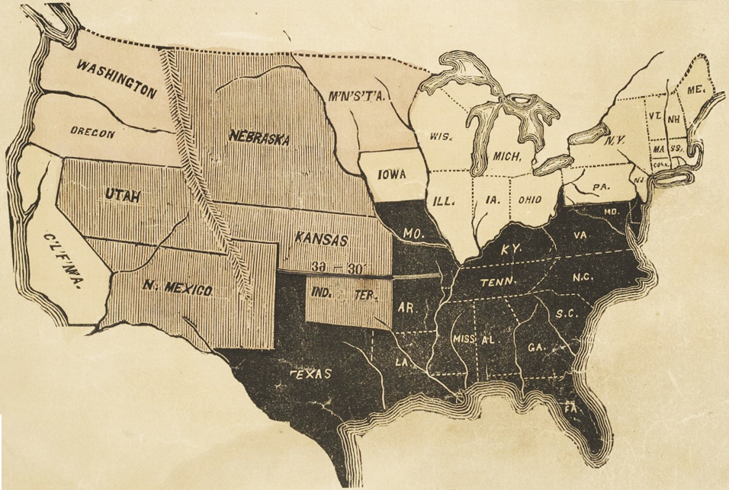

Source: Chicago Historical Society, http://lincolnat200.org/items/show/166

Letter from Participant in John Brown’s Raid on Harper’s Ferry (1859)

Among the Harpers Ferry raiders captured and sentenced to death was John Copeland, a 25-year-old free black born in North Carolina. Before joining Brown, Copeland and other Oberlin, Ohio abolitionists helped John Price, escape to Canada. Price was being held under the Fugitive Slave Law and was to be returned to slavery. Copeland wrote this letter to his brother six days before he was executed on December 16, 1859. On the way to the gallows, he was reported to have said “If I am dying for freedom, I could not die for a better cause––I had rather die than be a slave.”
Dear Brother:
….It was a sense of the wrongs that we have suffered that prompted the noble but unfortunate John Brown and his associates to give freedom to a small number, at least, of those who are now held by cruel and unjust laws, and by no less cruel and unjust men. To this freedom they were entitled by every known principle of justice and humanity, and for the enjoyment of it God created them. And, now, dear brother, could I die in a more noble cause? Could I, brother, die in a manner and for a cause which could induce true and honest men more to honor me, and the angels more readily to receive me to their happy home of everlasting joy above…?And were it not that I know that the hearts of those to whom I am attached by the nearest and most enduring ties of blood relationship––yea by the closest and strongest ties that god has instituted––will be filled with sorrow, I would almost as [soon] die now as at any time, for I feel that I am now prepared to meet my maker….
John A. Copeland

Source: Quoted in Richard J. Hinton, John Brown and His Men (New York: Funk and Wagnalls, 1894)

Map of the Slave Population of the Southern States, 1860

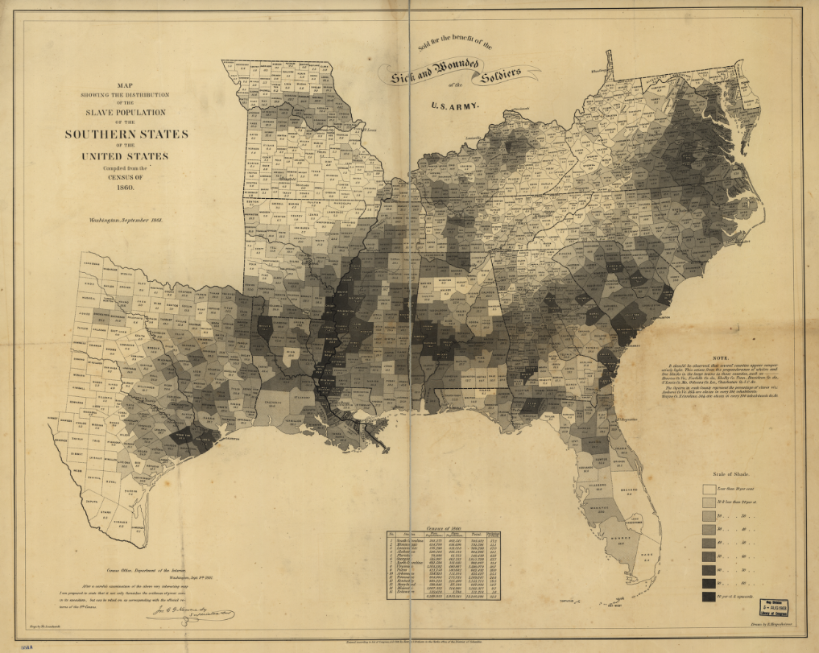

http://memory.loc.gov/cgi-bin/query/h?ammem/gmd:@field%28NUMBER+@band%28g3861e+cw0013200%29%2
http://lccn.loc.gov/99447026

Anti-Slavery Fair Poster (1857)

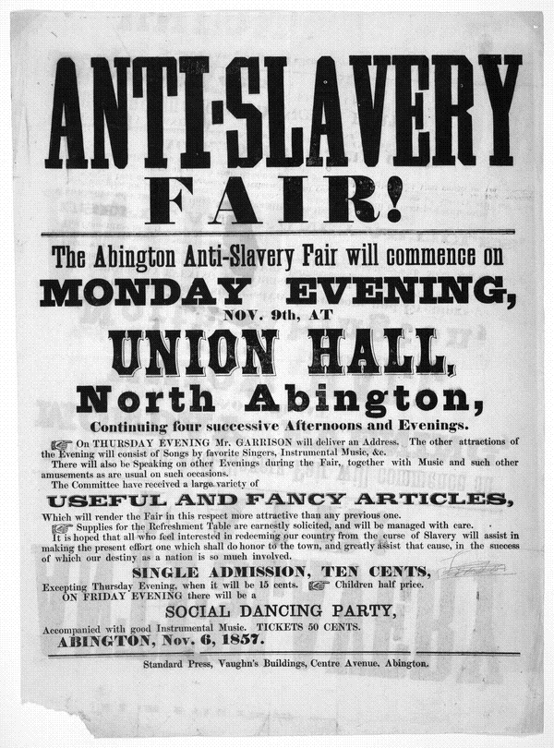
Description: Female abolitionists in Boston began organizing anti-slavery fundraisers in the 1830s. The fairs were a way to raise money and gain political support for their cause among middle-class northern whites. Fliers, such as the one below, advertised a wide selection of ladies accessories, household items, and refreshments.

Source: Library of Congress, American Memory Collection http://hdl.loc.gov/loc.rbc/rbpe.06203500

