### Character and Scene Printables

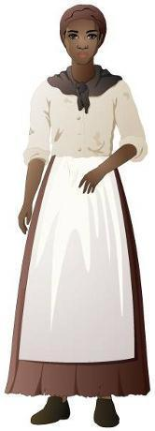

Lucy King

Jonah King

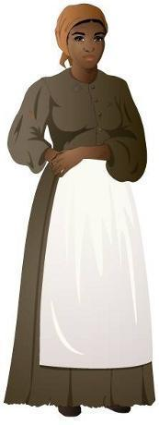

Nell King

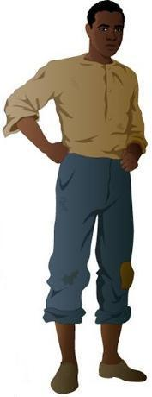

Henry

Mr. Otis

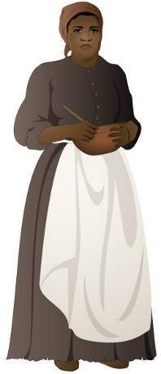

Esther

Sarah King

John Rankin

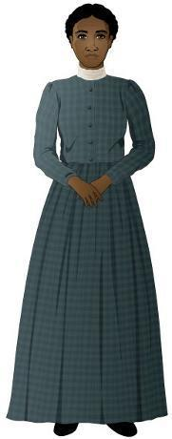

Abigail Wright

John Parker

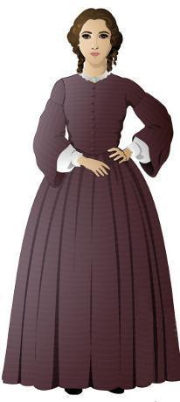

Millicent Hatcher

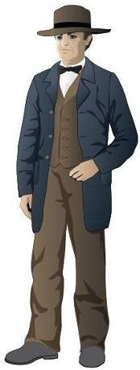

T.C. Bercham

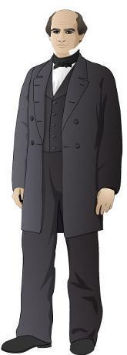

Benjamin Harrison

Slave Quarters

King Plantation

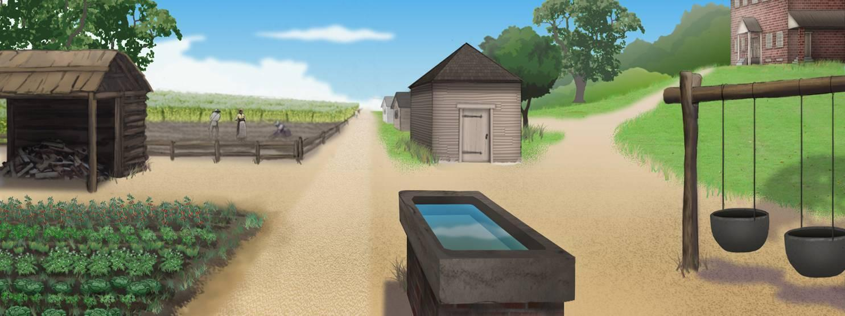

The Yard

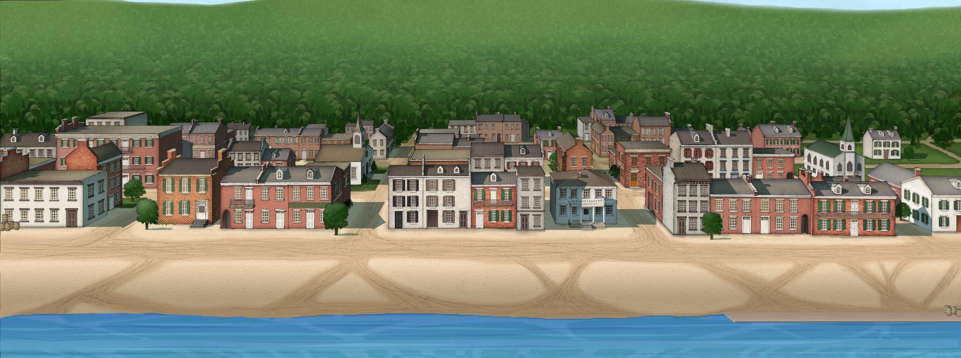

Ripley, OH