Character/Location Overview & Historical Figure Profiles

Much of “Flight to Freedom” is based on actual events, places, and people. While some characters are fictional and serve to illustrate the various components of antebellum society, others are based on actual historic figures. Brief background information is included here on the Mission’s fictional characters, as well as biographical information on the historic figures included in the game.

Characters
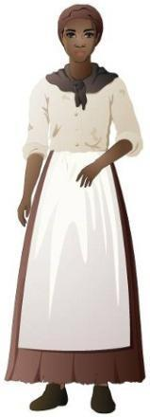
Lucy (fictional character): As the game begins, Lucy is a fourteen year old enslaved African American on Master King’s hemp plantation, located 20 or so miles from Lexington, Kentucky. Lucy is the daughter of Nell. Lucy’s father was sold away to the nearby Preston plantation after a bad harvest. She only sees her father occasionally. Lucy is strong willed and has gotten into trouble for speaking her mind. She grew up playing with the master’s daughter, Sarah, though their relationship has changed as they have grown older. Lucy works in the yard tending animals and the garden, washing clothes, toting water for field hands, and helping the cook. After being accused of burning down the plantation smokehouse, Lucy escapes to Ohio, where she is taken in by a free Black couple, and becomes involved in the abolitionist movement.

Jonah (fictional character): As the game begins, Jonah is an eight year old enslaved African American on Master King’s plantation. He is Lucy’s younger brother.

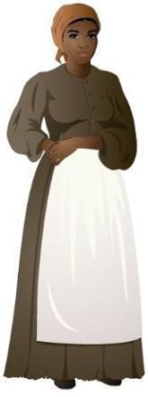
Nell (fictional character): Nell is Lucy and Jonah’s mother. Nell is a field hand on Master King’s plantation. She works planting, hoeing, weeding, harvesting, and bundling hemp. Nell has a pass which allows her to visit her husband on a neighboring plantation occasionally.
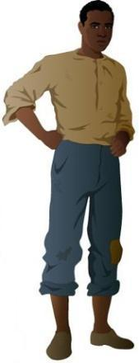

Henry (fictional character): Henry is a nineteen year old field hand on Master King’s plantation. Henry is a good friend of Lucy’s family. In addition to his duties in the fields, Henry is also responsible for tending the smokehouse – cutting wood and maintaining the fire whenever hogs have been butchered and are ready to smoke. Henry’s family was sold away from the King plantation the previous year. Henry is strong willed and has a short temper. He has run off for days at a time over the past year. As the game begins, Henry has been beaten for possibly breaking some equipment on the plantation.
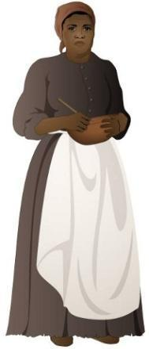
Esther (fictional character): Esther is an enslaved cook who works in the home on Master King’s plantation. Because she spends her days in the “Big House,” Esther overhears much of Master King’s business and passes information along to other enslaved African Americans. Esther also travels to Lexington to shop for the household and gathers information from other enslaved workers and free Blacks at the Lexington market.
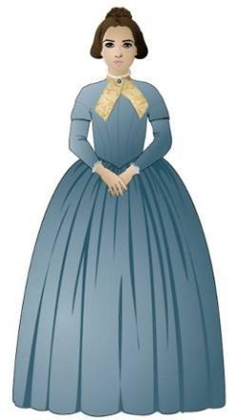

Sarah King (fictional character): Sarah is the fifteen year old daughter of Tobias King (Lucy’s master). Sarah grew up playing with Lucy, but now views herself as an adult and mistress. Sarah’s primary interest is finding a suitable husband and marrying within in the next few years. She is an avid reader of ladies’ magazines and follows the latest fashions.

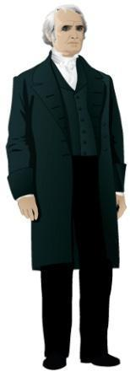
Mr. Otis (fictional character): Mr. Otis is the overseer on Master King’s plantation. Mr. Otis manages the labor and farming operations for Master King. Unlike Lucy and her family, Mr. Otis is paid a salary. He is a harsh supervisor who uses punishment—and fear of it-- to force more labor from enslaved African Americans.

Reverend John Rankin (historical figure): John Rankin (1793-1886) was a Presbyterian minister who started out preaching in Tennessee, but was forced to leave when he made his anti-slavery views public. Rankin became an outspoken abolitionist in Ripley, Ohio, where he was extremely active in the Underground Railroad. His “Letters on Slavery” greatly influenced William Lloyd Garrison, Henry Ward Beecher, Harriet Beecher Stowe, and other abolitionists around the country. Rankin lived in a house high on a hill in Ripley, overlooking the village and the Ohio River. During the forty years preceding the Civil War, it is estimated over 2,000 slaves passed through Ripley, many of whom were assisted by the Reverend Rankin and his family. Rankin’s house is currently a National Historic Landmark.

John Parker (historical figure): John Parker (1827-1900) was a former slave who escaped from slavery in Alabama, was recaptured, and eventually purchased his own freedom. He moved to Ripley, Ohio in 1849, where he became active in the Underground Railroad. Parker was known to venture into Kentucky to help slaves across the Ohio River. He was a skilled iron worker, and one of the few African Americans to hold multiple patents during the 19th century. Parker eventually owned his own foundry, where he designed and manufactured farm tools. His Ripley house is also a National Historic Landmark.
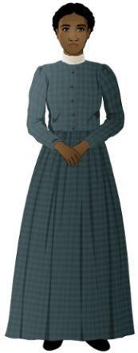

Abigail and Morgan Wright (fictional characters): Abigail and Morgan Wright are a free African American couple living in Red Oak, Ohio, just north of Ripley. Their ancestors were Virginia slaves freed after the American Revolution and resettled by their owners in the Ohio River Valley. The Wrights own and operate a laundry business for individuals and businesses in the area. Abigail and Morgan are abolitionists, and active in the Underground Railroad. When Lucy escapes from the King plantation, they take her in and claim she is their niece from Pennsylvania.

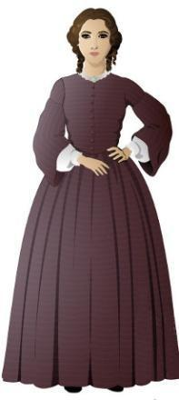
Millie Hatcher (fictional character): Millicent Hatcher is a twenty-one year old teacher who studied at the Hartford Female Seminary under Harriet Beecher Stowe. An outspoken abolitionist, she moved west to Ohio to teach in the Red Oak School under the supervision of Reverend Rankin.

T.C. Bercham (fictional character): T.C. Bercham is a slave catcher based in Lexington, Kentucky, who is hired by Master King to track down Lucy and Henry.

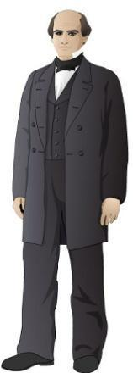
Benjamin Harrison (fictional character): Benjamin Harrison is a politician and member of the Free Soil Party from Cincinnati, Ohio. He is running for office as a state representative. Harrison opposes the expansion of slavery to the western territories, but does not advocate the immediate abolition of slavery. He believes freed slaves could never become equal citizens in the United States, and instead supports the idea of government financed colonization, which means sending freed slaves to Liberia, Africa..

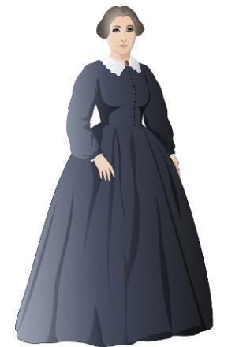
Sheriff McKee (fictional character): Ripley’s sheriff, who is responsible for maintaining law and order. He is not an abolitionist, but sympathizes with fugitives who are trying to escape. He does not enjoy returning them to slavery.

Mrs. Porter (fictional character): Mrs. Porter manages the Ripley Hotel with her husband. The hotel is located across from the ferry dock on the Ohio River. Originally from Kentucky, Mrs. Porter believes slavery is beneficial to both slaves and slave owners. Many of the hotel’s customers come from Kentucky.

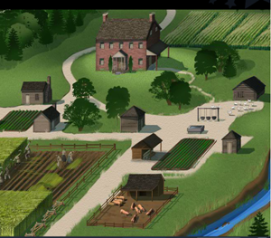
Locations
King Plantation, Bourbon County, Kentucky: The King Plantation a medium size farm growing hemp and corn as cash crops. The farm also raises hogs, chickens, cows, and growing vegetables for sustenance. The hemp crop is sold to factories in Lexington that turn it into rope and baling fabric to be sold to cotton plantations in further south. Likewise, most of the corn crop is sold south as food grain. Master King owns fifteen enslaved African Americans. He has been selling off some of his enslaved African Americans to the New Orleans slave markets in recent years to offset bad harvests.

Auction House, Maysville, Kentucky: When the importation of enslaved laborers from overseas was outlawed, and as cotton production in the Deep South expanded, enslaved African Americans became one of Kentucky’s most valuable exports. Slave traders and auction houses in Kentucky and other slave states sought out enslaved African Americans that could be sold “down the river” to the cotton growers further south. Some enslaved African Americans sold in Kentucky were also sold to slave states further west, such as Missouri.

The Ohio River: The Ohio River is the dividing line between the slave-owning state of Kentucky and the non-slave state of Ohio. The Ohio River is a main transportation artery for delivering goods from the Ohio Valley to southern ports along the Mississippi. Many steam boats, ferries, and flat boats navigate the river, and it is heavily patrolled on both sides by slave catchers. The river’s current is very strong and swimming across can be very dangerous. Boats on both sides of the river are required to be kept locked to prevent fugitive enslaved African Americans from stealing them.

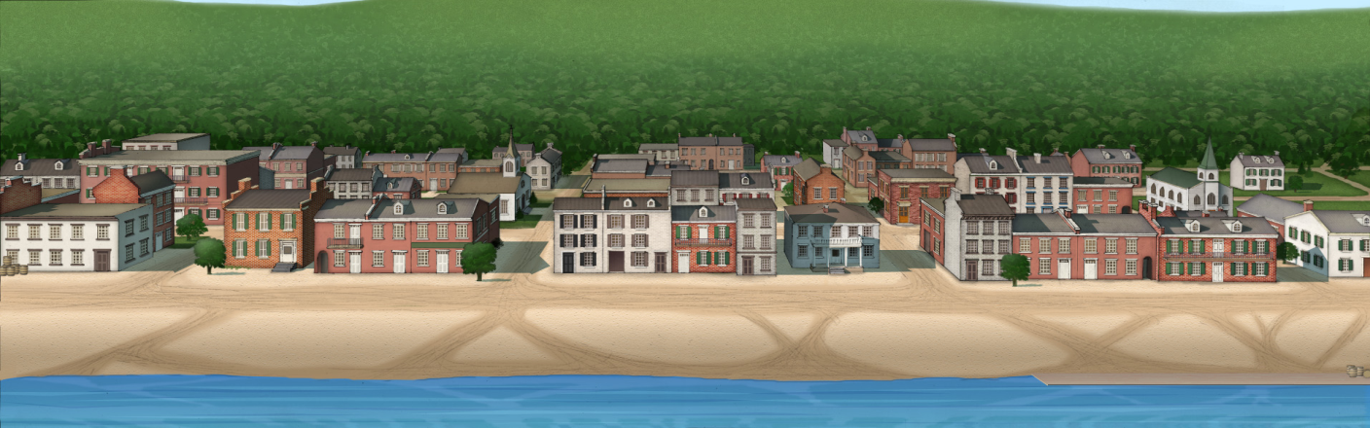
Ripley and Red Oak, Ohio: Ripley is a small, bustling town just across the Ohio River from Kentucky. Ripley served as a port for the shipping of pork headed south and tobacco headed north. Warehouses, markets, and boat builders lined the waterfront. The population of Ripley was divided over the issue of slavery, with many outspoken opponents as well as many pro-slavery residents. Red Oak was a small settlement slightly north of Ripley, where the Reverend John Rankin led a church and school serving free blacks as well as whites.

