Pre-Game Activities
A NOTE TO THE TEACHER:
“Flight to Freedom” is largely about cause and effect, emphasizing how choices—to comply with authority or resist in some manner—may impact an individual's life, the lives of others, and the nation. At the same time, the game and classroom materials demonstrate how national events, such as the Fugitive Slave Act, have implications on the lives of individuals. Ultimately, “Flight to Freedom” will show students that through acts of resistance, Americans—both white and black, free and enslaved—shaped the world in which they lived.

Pregame Activities:
Part I: Have students use the game badges as a pre-game activity.
Part II asks students to think historically, examining acts of resistance across different eras of US History.

Part I:
As students play “Flight to Freedom” and make choices for Lucy, they will earn badges representing different qualities or characteristics their “version” of Lucy has exhibited. The badges represent different ways that enslaved African Americans, individually and together, responded to the conditions of slavery, in ways that ultimately helped hasten its end. Some badges represent choices that helped preserve Family and Community in the face of enslavement. Others represent choices to develop skills of reading, writing and speaking (Literacy/Persuasion/Leadership) that helped formerly enslaved African Americans and freedmen become a powerful force for abolishing slavery. Some badges reflect efforts to survive slavery by avoiding direct confrontation with slave masters’ power. Others represent choices to directly Resist or break the rules of the slave system, by being Self-Reliant, engaging in Sabotage, or otherwise showing a Fighting Spirit. This activity sets the stage for the badge system students will encounter in the game.

Review the “Badges Earned” organizer as a group. Ask your students how their choices exhibit particular traits or characteristics.

Part II:
The goal of Part II is to provide historical context for cause, effect, and resistance. The activity illustrates that throughout U.S. History, there have been times when people felt so deeply about a political or social cause, they resisted the status quo in some manner. While playing “Flight to Freedom,” students will see how both enslaved African Americans and those in the antislavery movement resisted slavery.

In Part II of the Pre-Game Activity, teachers will show students several pictures of resistance throughout American history. Though students may have not yet studied the historical eras presented, you can ask students questions about the pictures, such as:
- What do you think these people are resisting?
- Why do you think they are resisting?
- Do you think they were successful?
- Is this action important even if it does not succeed?
- What are some possible positive or negative outcomes of this form of resistance?

After completing both of these exercises, students will better understand how acts of resistance can lead to social or political change. As your students start to play “Flight to Freedom,” ask them to focus on how Lucy and the various people she encounters resist the institution of slavery, how they earn badges in the game, and why.

Badges Earned

Student Organizer

As you play MISSION US “Flight to Freedom,” you will earn badges in the game for the decisions you make as Lucy. As you review the scenarios accompanying this organizer, think about which badge listed below you might earn for each choice you make.

Possible Badges | Badge Description | Scenario and Choice That Might Earn This Badge  (list the Scenario Number and the letter of Your Choice)
Play It Safe | You do not engage in any acts of resistance and stay on the good side of authority figures, avoiding punishment for you and your loved ones.
Resistance | You take direct action against rules and policies you don’t support. When times are tough you rally by taking action against your oppressors.
Family Matters | You care deeply about keeping your family together and safe. You turn to your family in your times of need.
Sabotage | You take every available action possible against those trying to oppress you, demonstrating active resistance – even if this means harm or destruction.
Fighting Spirit | You actively struggle against those who may be trying to harm or deceive you.
Self-Reliant | You trust yourself more than others and prefer to work on your own. You take actions that demonstrate your survival instinct.
Persuasion | You have a way with words and you can convince people of your position or get what you want by speaking.
Hard Bargain | You turn to money or bribery to convince people to do what you want.
Literacy | You value reading and education, and show a passion for leaning new words, trying new things, and picking up new skills.
Leadership | You show initiative and can easily lead community efforts.
Community | You turn to others in your community in hard times, and will rely on the support of your community to save another community member.
Escape Master | Thanks to a combination of skills, wit, and luck, you are able to easily escape difficult environments.

Part II: Resistance in U.S. History
Distribute copies of the following images or project them onto a screen for your students. Provide students with the location, date, and the “hint” related to each image. Then ask your students the following questions about the images:
- Do you know what this event is?
- What do you think these people are resisting?
- What words would you use to describe their resistance? Is it peaceful or violent? Is it destructive or calm?
- Why do you think they are resisting?
- Do you think they were successful? Why or why not?

(Image 1 is the Boston Tea Party, Image 2 is the New York City Draft Riots during the Civil War, Image 3 is a suffragist being arrested after chaining herself to the White House fence, Image 4 is a labor protest/work slowdown at an automotive plant, Image 5 is a lunch counter sit-in during the Civil Rights movement, and Image 6 is a man advocating boycott of an oil company in the wake of a recent spill.)

After reviewing the images, tell your students that as they play “Flight to Freedom,” they should pay special attention to how Lucy and the people she encounters resist the institution of slavery.

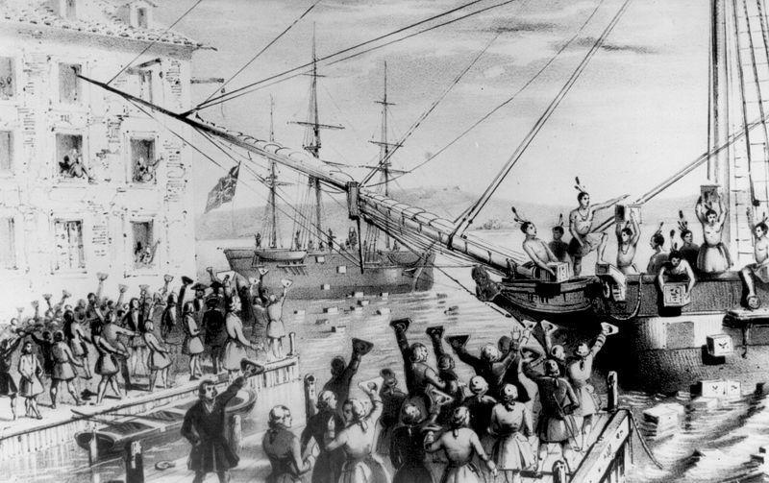
Boston, Massachusetts 1773
Hint: The Indians aren’t real, and there’s tea in those crates.

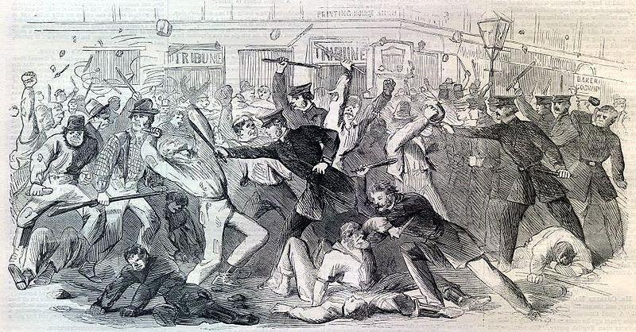
New York City, 1863
Hint: Some of the people in the picture were unhappy with the government’s policies for drafting men into the army.

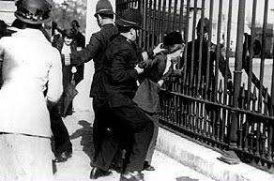
Washington, DC 1917
Hint: This woman chained herself to this fence at the White House. She did not vote for the President because she couldn’t.

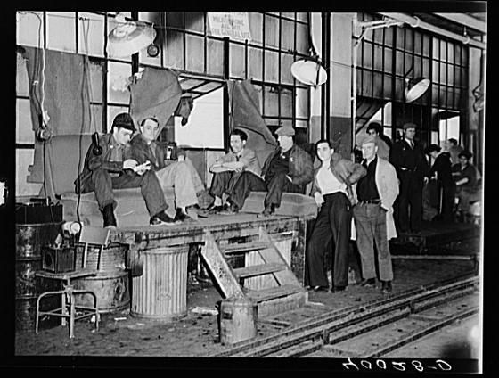
Flint, Michigan 1936
Hint: These men are where they work. It’s the middle of the work day.
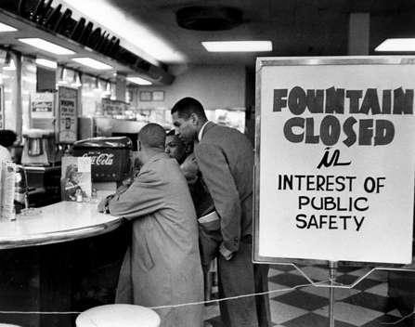
Nashville, Tennessee 1960
Hint: The store is refusing to serve the men seated at the counter. And they won’t leave.

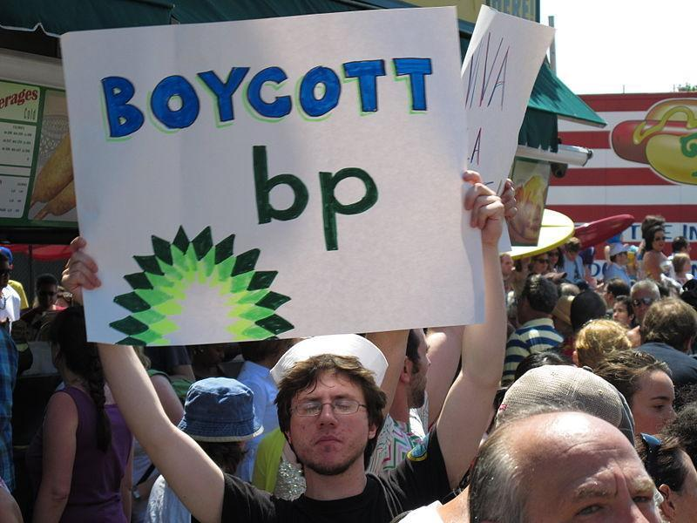
Brooklyn, New York 2010
Hint: Remember the oil well explosion that released millions of barrels of oil into the Gulf of Mexico?

Pre-Game Activity: Cause and Effect

A Note to the Teacher
In addition to supporting a variety of National Standards listed elsewhere in the classroom materials, MISSION US: “Flight to Freedom” provides teachers and students with an opportunity to explore complex historical thinking.

A core element of “Flight to Freedom” is the notion of “cause and effect” in history. Throughout the game, students will understand how the choices and actions of both individuals and groups impact historical events.

This activity will ask students to consider the idea of “cause and effect” in history, and develop their understanding of the following:

- Events have multiple causes, and some causes are more important than others;
- Individuals shape historical events, but events are also shaped by larger political, social, economic, and environmental forces;
- Just because one event happens before another event doesn’t necessarily mean it caused it;
- Actions can have unintended consequences.

Steps to Complete
1) Make copies of the “Cause and Effect Cards” that follow this activity. Cut the copies in half, so that you have a pile of “Cause” cards and a pile of “Effect” cards. Be sure to make enough copies so that you have exactly enough cause and effect cards for each student in your classroom to receive one.

2) Explain to your students that “Flight to Freedom” examines how the idea of cause and effect impacts history. Ask your students for an example of “cause and effect” from their studies of history.

3) Explain to your students that a “cause” is one action or event which results in another action or event, or “effect.”

4) Tell your students you will now be taping a small piece of paper to each of their backs. The paper will either have a “cause” or an “effect” on it. Explain to students they are not permitted to remove the paper from their backs or ask a classmate what it says. They are permitted, however, to read what other students have taped to their backs. Be sure that each time you tape a “cause” to one student, you tape the corresponding “effect” to another student (i.e. if you tape the cause “The Titanic hit an iceberg” to one student, be sure to tape the effect “The Titanic sank to the bottom of the ocean” to another student). Depending on the size of your class, you may not use all of the available “Cause and Effect” cards.

5) Tell students that each of them now has a “cause” or “effect” on his or her back. Some of the cause and effect relationships in the room focus on historical events. Some of the cause and effect relationships in the room focus on events that might happen to you in your daily life. Their challenge now is to determine if they are a cause or effect, and to find their corresponding partner in the room. If they are a cause, they are looking for the effect they triggered. If they are an effect, they are looking for their cause. Explain to students that they may only ask “yes” or “no” questions of each other in order to find their corresponding cause or effect.

6) Provide your students with an example, telling students a potential cause is “I flipped the light switch.” Ask students what the corresponding effect would be? (“The lights came on.”)

7) Remind your students they may only find their corresponding cause or effect by asking “yes” or “no” questions. If they see two people who belong together, they are permitted to put them together. Tell students that once they think they have found their partner, they should ask a classmate to check their work and confirm that they are with the correct person.

8) Give your students some time to find their corresponding cause or effect partner. While your students are finding their partners, write the four “cause/effect” statements on the board:

- CAUSE: The Titanic hit an iceberg. EFFECT: The Titanic sank to the bottom of the ocean.
- CAUSE: Thomas Jefferson purchased the Louisiana Territory from France. EFFECT: Thomas Jefferson doubled the size of the United States.
- CAUSE: You finished your dinner. EFFECT: You got dessert.
- CAUSE: Bill bought a lottery ticket. EFFECT: Bill won the lottery, and now he’s a millionaire.

9) After your students have found their partners, ask them to reveal their causes and effects to the class. Explain to your students that sometimes cause and effect relationships can be more complex than they seem. Tell students that you are going to look at some specific examples from this activity to explore that idea more closely.

10) As a class, consider the following statement: “CAUSE: The Titanic hit an iceberg. EFFECT: The Titanic sank to the bottom of the ocean.” Ask your students if the ship hitting the iceberg was the only cause of it sinking. Were there other causes? What might they have been? Lead your students to understand that events have multiple causes, and some causes are more important than others.

11) As a class, consider the following statement: “CAUSE: Thomas Jefferson purchased the Louisiana Territory from France. EFFECT: Thomas Jefferson doubled the size of the United States.” Ask your students if they think Thomas Jefferson was the only person responsible for the Louisiana Purchase? What other causes for the Louisiana Purchase existed? Lead your students to understand that individuals shape historical events, but events are also shaped by larger political, social, economic, and environmental forces.

12) As a class, consider the following statement: “CAUSE: You finished your dinner. EFFECT: You got dessert.” Ask your students to raise their hand if finishing their dinner is a necessary requirement for getting dessert in their home. Ask your students if sometimes they get dessert even when they haven’t finished their dinner. Lead your students to understand that just because one event happens before another event doesn’t necessarily mean it caused it.

13) As a class, consider the following statement: “CAUSE: Bill bought a lottery ticket. EFFECT: Bill won the lottery, and now he’s a millionaire.” Ask your students if Bill’s buying of the lottery ticket caused him to win the lottery. Why not? Lead your students to understand that sometimes causes and effects are impacted by chance, the unexpected, and the irrational.

14) On the board, write the following. “EFFECT: Slavery was abolished in the United States.” Ask your students to consider what they know about the end of slavery in the United States. What was the cause—or causes—of slavery being abolished? Ask students to consider everything they’ve learned about “cause and effect” relationships as they provide their answers. Accept all answers, and write student responses on the board.

15) Ask your students to consider how “cause and effect” relationships—and their complexities-- contributed to the end of slavery as they play through MISSION US: “Flight to Freedom.”

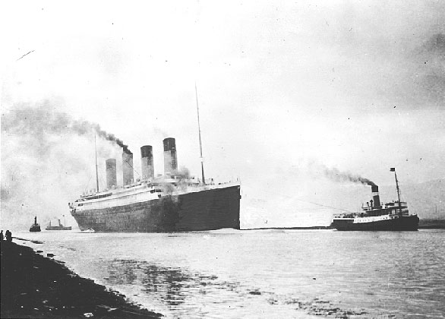
CAUSE: The Titanic hit an iceberg.

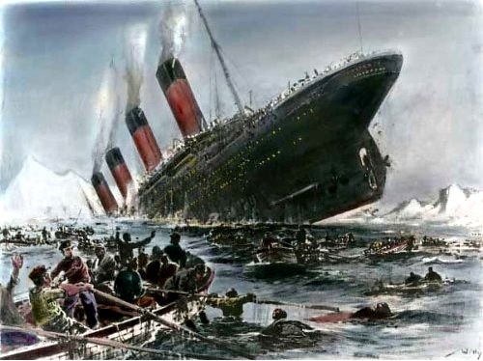
EFFECT: The Titanic sank to the bottom of the ocean.

CAUSE: Apple announced it is releasing a new iPhone.

EFFECT: Tens of thousands of people went online to order Apple’s new iPhone.

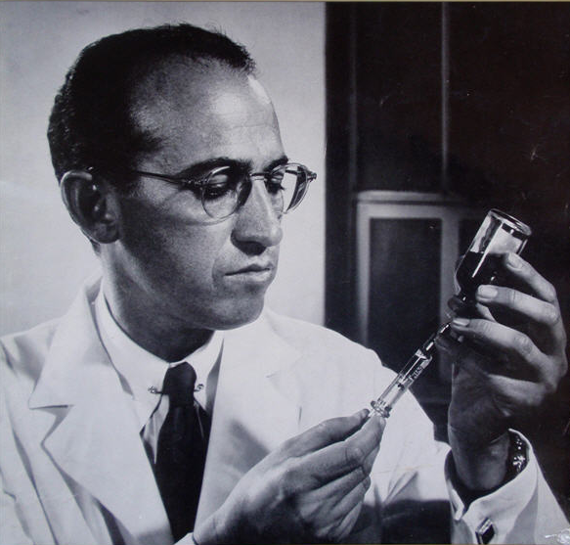
CAUSE: Jonas Salk and Albert Sabin developed a vaccine for polio.

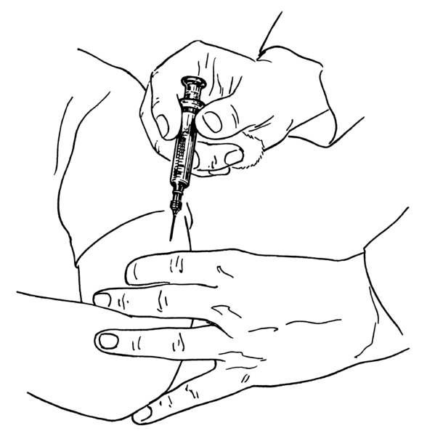
EFFECT: Polio has been eliminated from most countries in the world.

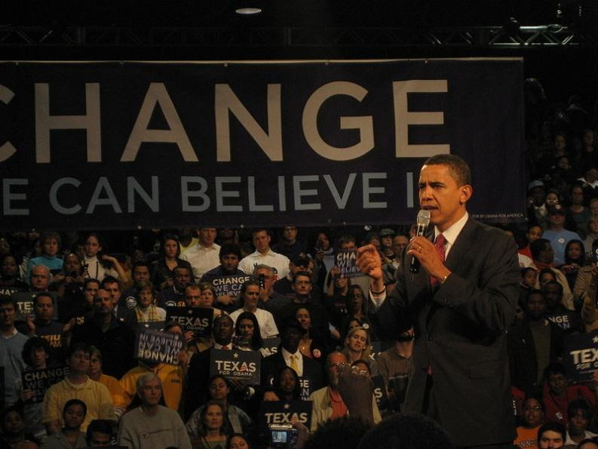
CAUSE: Barack Obama won the US presidential election in November 2008.

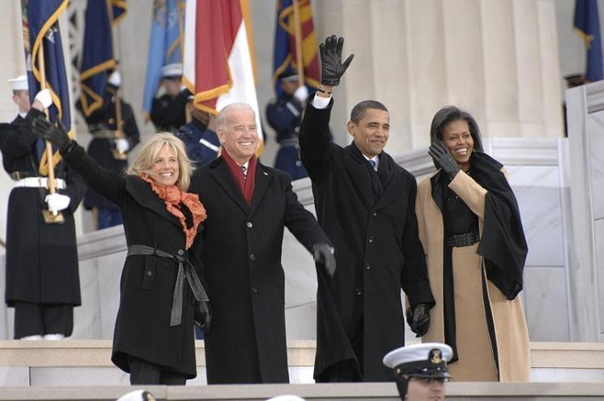
EFFECT: Barack Obama became President of the United States in January 2009.

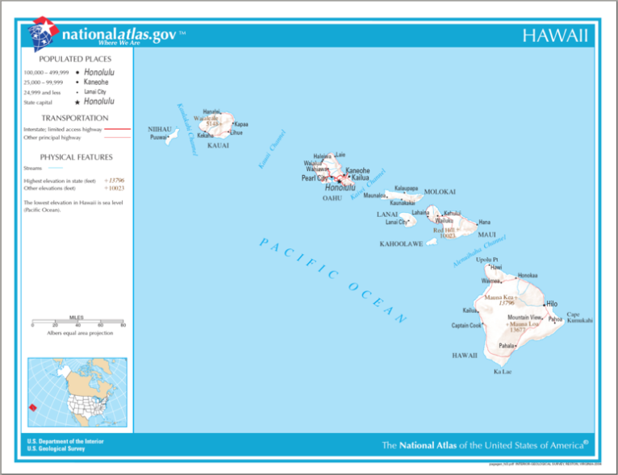
CAUSE: Hawaii became the 50th state of the United States.

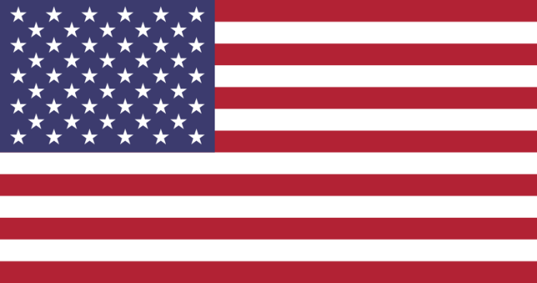
EFFECT: The US flag was changed to include 50 stars.

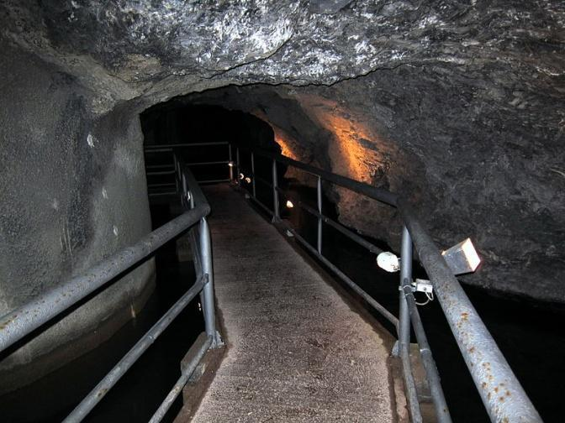
CAUSE: 33 miners were trapped in a mine in Chile.

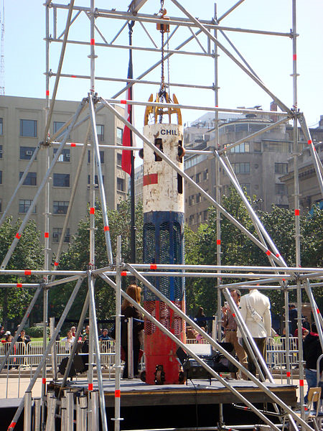
EFFECT: NASA and the Chilean Navy created a rescue capsule which successfully brought 33 trapped miners to safety.

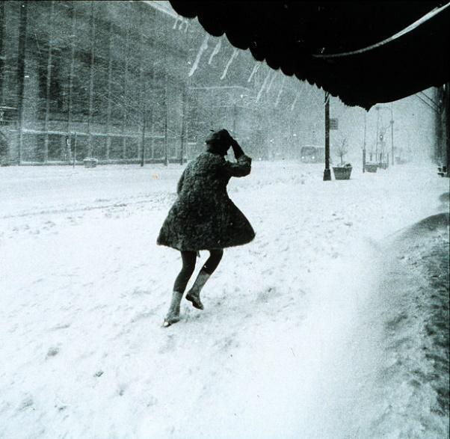
CAUSE: There was a terrible snowstorm in your hometown.

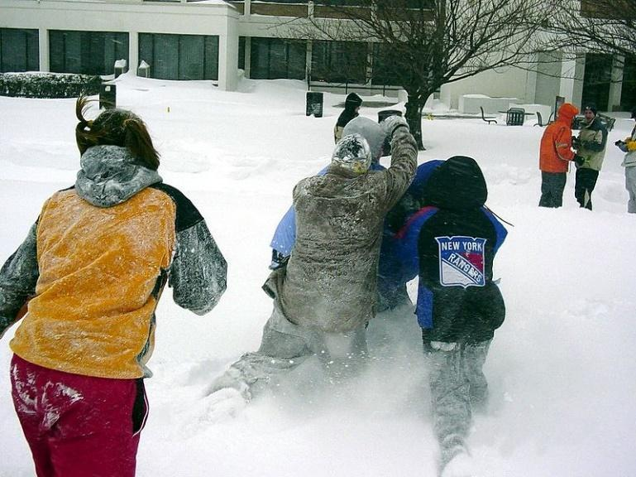
EFFECT: Your school is closed for the day.

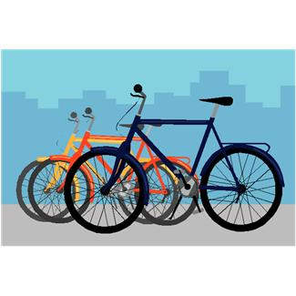
CAUSE: You ran over a nail on your bike.

EFFECT: You got a flat tire.

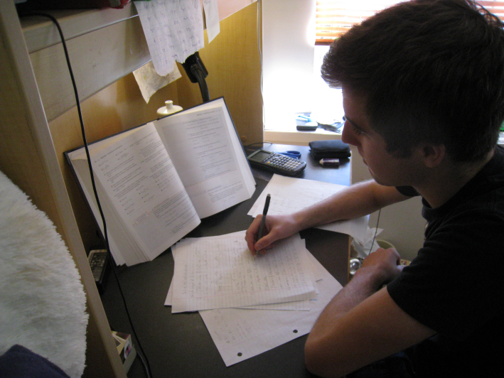
CAUSE: You studied hard for your social studies test.

EFFECT: You got an “A+” on your social studies test.

CAUSE: Your favorite television show got very low ratings.

EFFECT: Your favorite television show was cancelled.

CAUSE: There was a terrible drought in the Southwest.

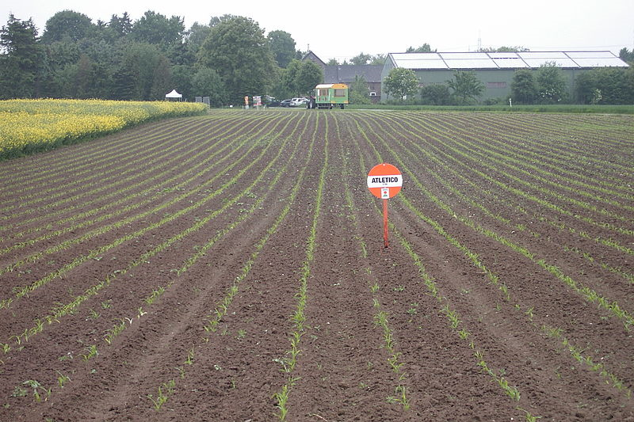
EFFECT: Crops in the Southwest failed.
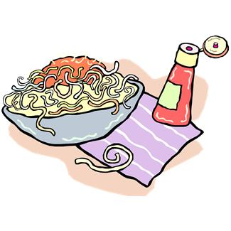
CAUSE: You finished your dinner.

EFFECT: You got dessert.

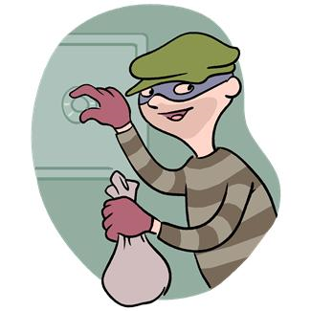
CAUSE: A man robbed a bank and was arrested.

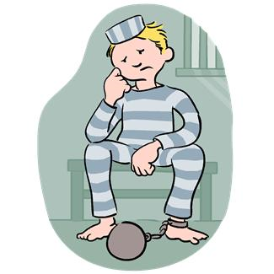

EFFECT: A man went to jail for bank robbery.

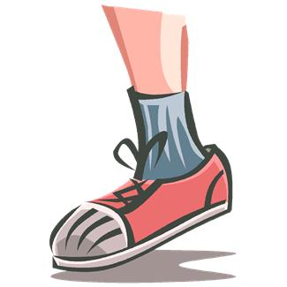
CAUSE: Your shoes were too tight.

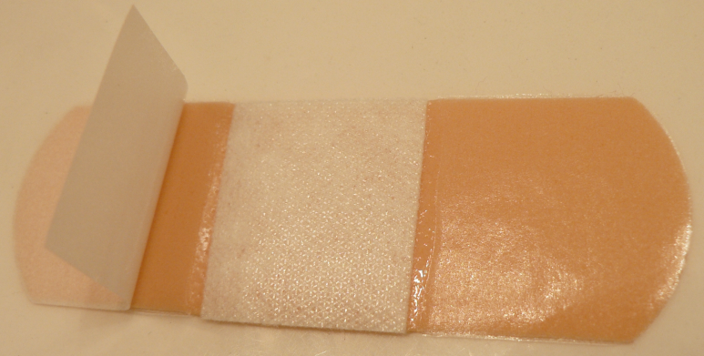
EFFECT: You got a blister on your foot.

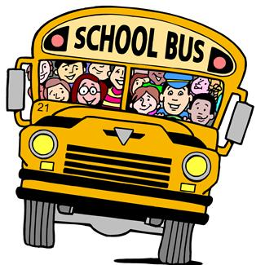
CAUSE: You didn’t check the weather before you left for school.

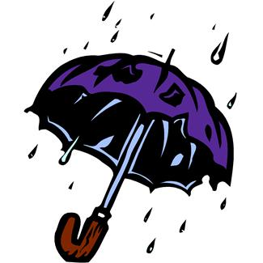

EFFECT: Your clothes are soaked because you were caught in a sudden rainstorm.

CAUSE: Your basketball team practiced hard every day after school.

EFFECT: Your basketball team won the championship.

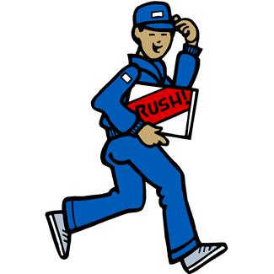
CAUSE: You got a job after school.

EFFECT: You were able to save enough money to buy an iPad.

CAUSE: Jim was caught cheating on his science test.

EFFECT: Jim was suspended from school.

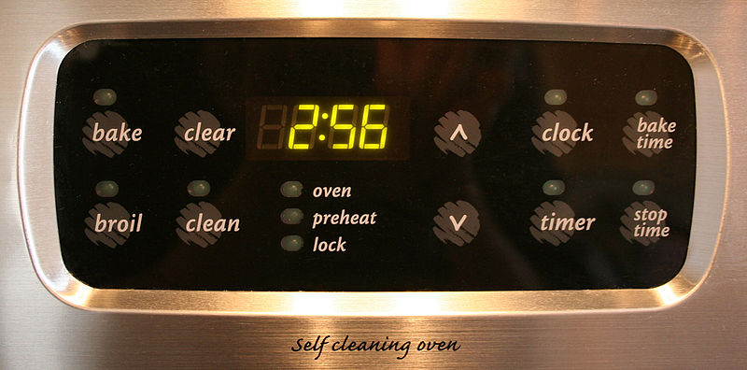
CAUSE: You forgot to set the timer on the oven.

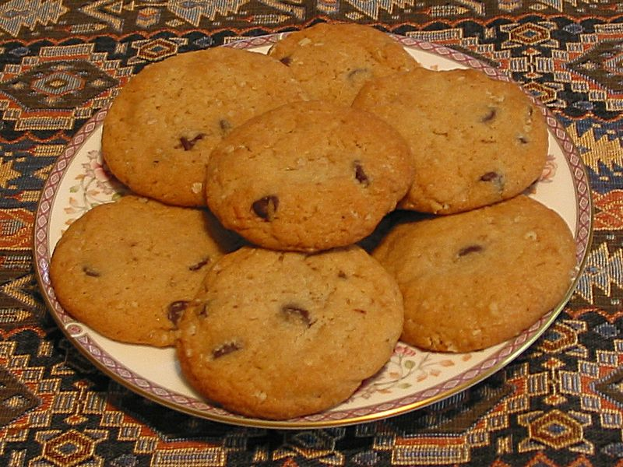
EFFECT: The cookies you were baking got burned.
CAUSE: You brush and floss your teeth twice every day.

EFFECT: When you go to the dentist, you never have any cavities.
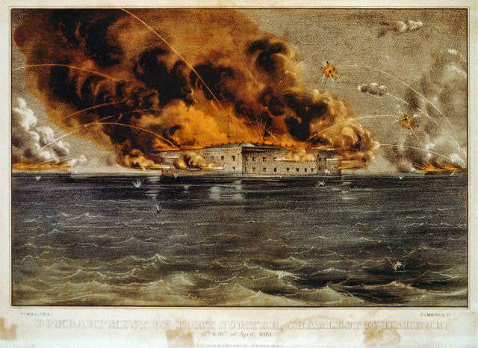
CAUSE: The Confederacy attacked Fort Sumter in Charleston, South Carolina.

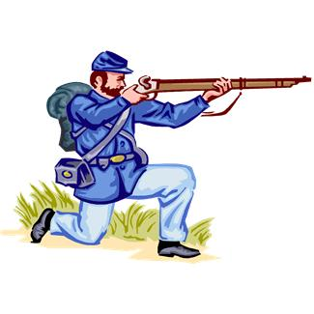
EFFECT: The American Civil War began.
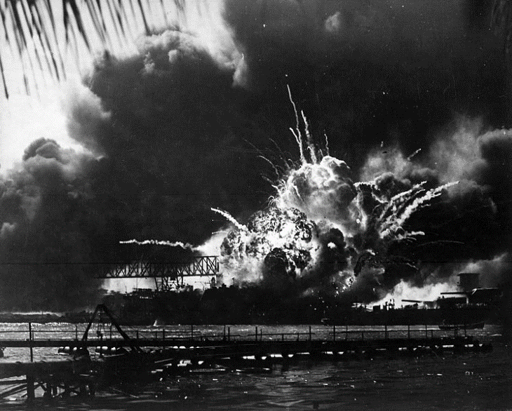
CAUSE: The Japanese Army attacked the United States naval base at Pearl Harbor, Hawaii.

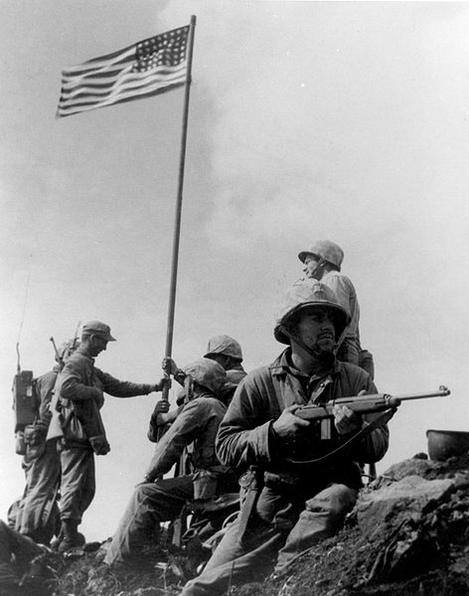
EFFECT: The United States entered World War II.

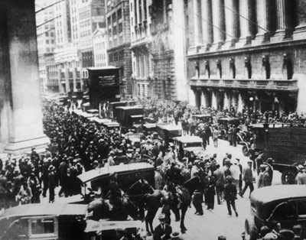
CAUSE: The stock market crashed in 1929.

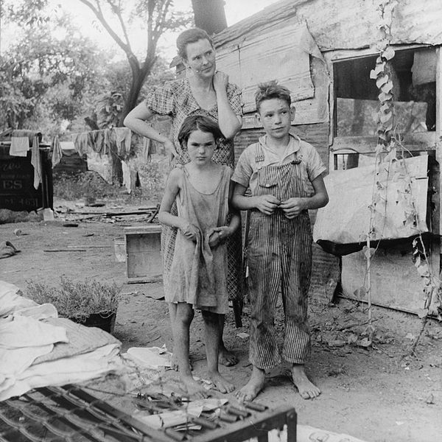
EFFECT: The United States entered the Great Depression.
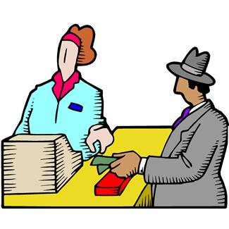
CAUSE: Bill bought a lottery ticket.

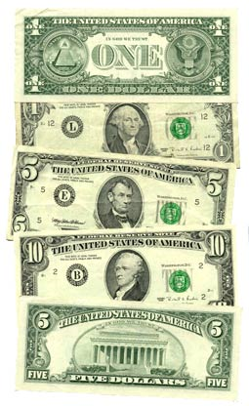

EFFECT: Bill won the lottery, and now he’s a millionaire.

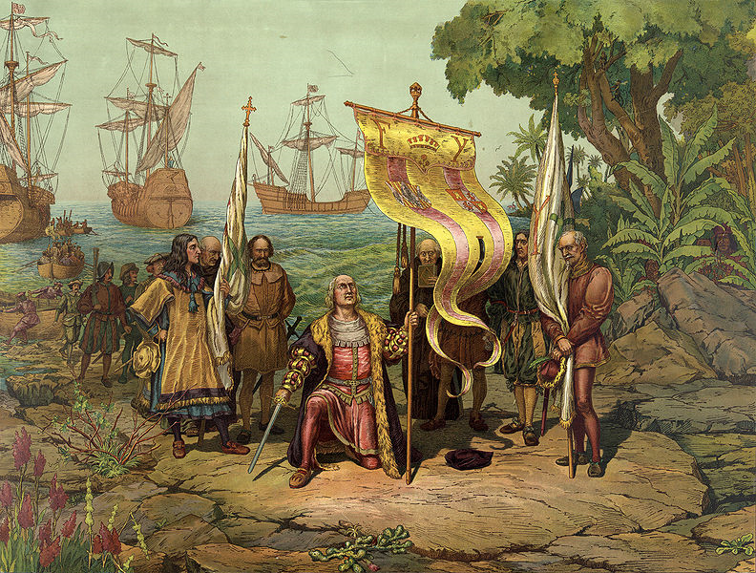
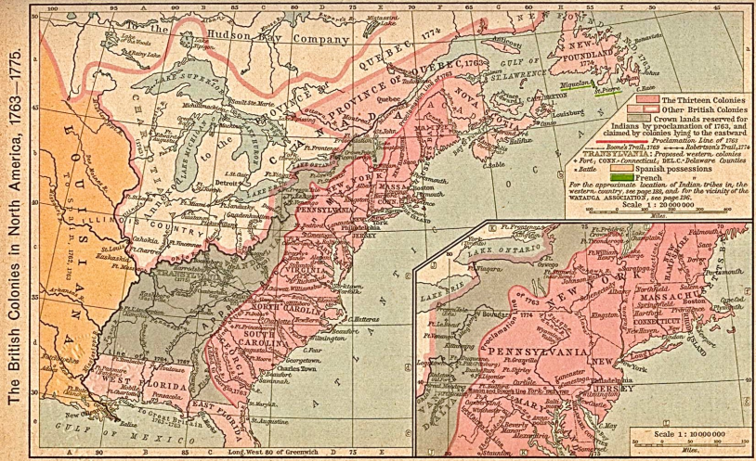
CAUSE: Christopher Columbus “discovered” the “New World.

EFFECT: European countries established colonies in North America.

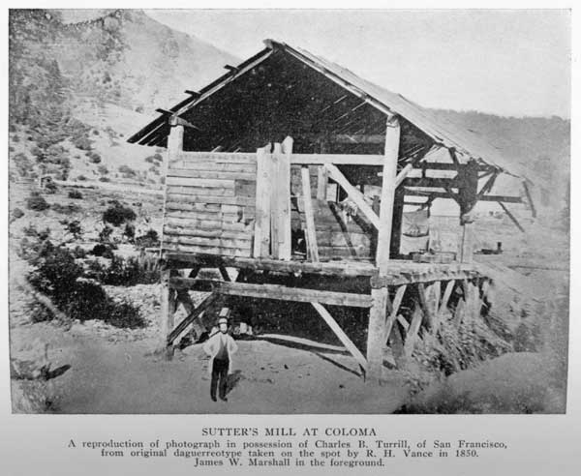
CAUSE: In 1848, gold was discovered in California.

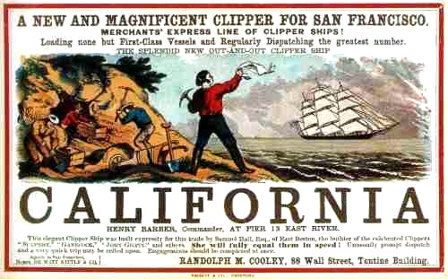
EFFECT: Thousands of settlers poured into California seeking gold.

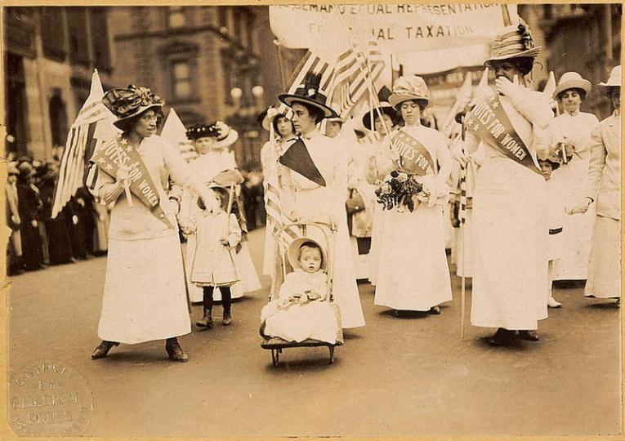
CAUSE: The United States ratified the 19th Amendment.

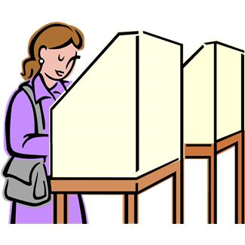

EFFECT: Women in the United States began voting in elections.

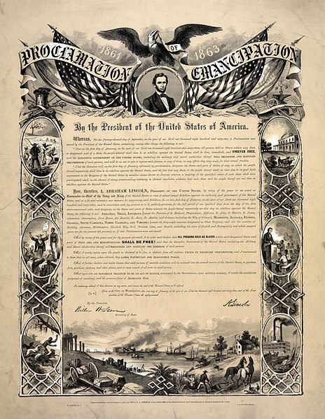
CAUSE: Abraham Lincoln issued the Emancipation Proclamation.

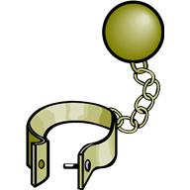
EFFECT: There is no more slavery in the United States.

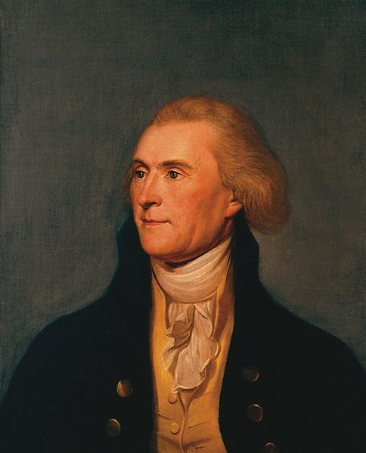
CAUSE: Thomas Jefferson purchased the Louisiana Territory from France.

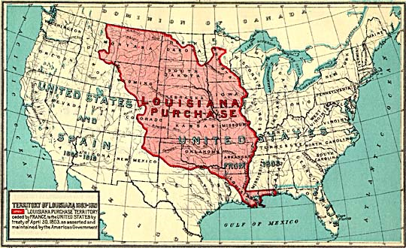
EFFECT: Thomas Jefferson doubled the size of the United States.

CAUSE: You accidentally hit your thumb with a hammer.

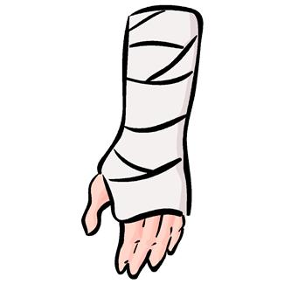
EFFECT: Your thumb really, REALLY hurts.

Pre-Game Document-Based Activity: Slavery By the Numbers

A Note to the Teacher
This document contains background historical information for teachers, and an activity using data and primary source information to increase student understanding of slavery.

Students, and even some teachers, can initially be put off by charts, tables and graphs, but we would strongly encourage you to help your students get their feet wet. With just a little guidance and practice, middle school students become adept at seeing patterns. At that point, it becomes very satisfying for them to look at a line of numbers and narrate the story they tell. In addition to getting practice with statistics, there are opportunities here for teachers to capitalize on that inclination, and at the same time, encourage students to see when there is room for more than one interpretation of data.
You should decide if you will use the activity, based on what your students know or don’t know coming into the “Flight to Freedom” unit, and also how easy or difficult it will be for them to work with the materials.
The activity is described below:

"What Other Work Did the Enslaved Do?" The goal of this activity is to have students gain information from a primary source document showing that not all enslaved African Americans, even in the South, picked crops in the hot sun. Students will practice the skill of reading from a chart, and learn about other occupations enslaved African Americans had. This is a straightforward activity, appropriate for 5th grade and up.

Activity: Reading a Chart: What Other Work Did the Enslaved Do?
Teacher Directions: Project the "Charleston List of Manual Operations, 1848" or make copies and distribute them. Allow some time for each student to read the list. Define for students, or ask them to research, the occupations that sound unfamiliar. Then, ask them to consider the discussion questions you feel are most important or most relevant. You will see that some are more literal, while others require more skill at making inferences. You might provide some choice or assign them as journal entries first, so students who work at different rates have time to think through their responses.
For all of the following, ask your students NOT to include “Domestics” and “Unskilled Workers” in their tallies, because these are the more usual occupations at which enslaved African Americans worked. Also, especially if you will not take time to define terms, let students know that “Superannuated” means too old to work anymore.
Discussion Questions:
- Which of the occupations on this list could a person learn to do in less than a month (unskilled)? Which would require more than half a year of learning (skilled)? What might be the relationship between how long it takes to learn a job and how important others feel it is?

- How many different skilled jobs did enslaved African Americans work in Charleston?

- List the ten jobs at which the most enslaved African Americans worked. Why do you think these occupations were more popular or necessary than some of the others?

- Which occupations would require you to have mathematical skills? Which were more physical than mental? Which required both physical and mental strength or competence?

- At which jobs were there approximately the same number of enslaved African Americans and white workers? Why might this have been the case?

- In which occupations was there a significant difference in the number of white and enslaved African American workers? Why might this have been the case?

- What does the fact that there are “Apprentices” listed here tell you about how slaveholders thought about the ability of enslaved African Americans to learn skilled occupations?

- Why might slaveholders have had some enslaved African Americans trained in skilled labor if there were already white people in those occupations available to do that work?

- How might becoming a skilled worker have affected how an enslaved African American thought about him/herself? How might it have affected other enslaved African Americans in the community?

- Which of these occupations still exist today? Of those, which do you think are highly regarded and highly paid? Which are not? Can you think about why this is the case?

Data source: http://cghs.dade.k12.fl.us/slavery/antebellum_slavery/non_plantation_slave_life/census.htm
