[Activities for Part 1: Behind the Big House]
[Part 1] Document-Based Activity: Slave Quarter Photographs

The following photographs were taken long after the Civil War. The people seen in the photographs are most likely sharecroppers who lived lives too similar to their enslaved African Americans ancestors, but they give some idea, if not a precise one, of the conditions in which enslaved African Americans lived. Also, bear in mind the photographs taken in the 1930s represent what actual slave quarters looked like sixty years after the end of slavery, though at that time, many were still being used to house poor farm workers with minimal amenities.

A Note to the Teacher:
You should decide how to present these photographs to your students, that is, in sets for small groups or individuals, projected for the whole class to see, etc. It’s often helpful for students to have time to mull over one or two photographs by themselves. The Photo Analysis sheet will help students to be thorough in their examination of a picture.

There are many photographs of slave quarters online and, should you want to have your class complete more research about this particular aspect of slavery, they will find pictures that range from neat, sturdy brick buildings to hovels that hardly look habitable. In your discussion of the pictures, try to elicit from your students the understanding that the experience of enslaved African Americans differed in many ways from one place to another because of many factors (climate, location, the attitudes and temperament of the slaveholders, and the quarters), but there was no good slavery.
Name: ___________________ Class: __________ Date: ____________

Photograph Analysis Guide

What is the title of the photograph? | Where was the photograph taken? When was it taken?
Who is the photographer? | Who are the people in the photograph?
What objects, things, or animals do you see in the photograph? What are these things made of? | What words are in the photograph that may help you understand what the photograph is about (if there are any)?
Write about things you see that indicate when the picture was taken (clothing styles, what things look like and how they are made, etc.) What might you say about the level of technology available to people at that time and place? | What are the people (or animals) doing?
What do you infer about the people and the place from all that you notice? Do the people or objects seem posed or arranged? Does it seem as if the photographer wants you to come away with a certain feeling about what is in the picture? | I can’t make any sense of the photograph. This is probably because… (List as many reasons as you can.)

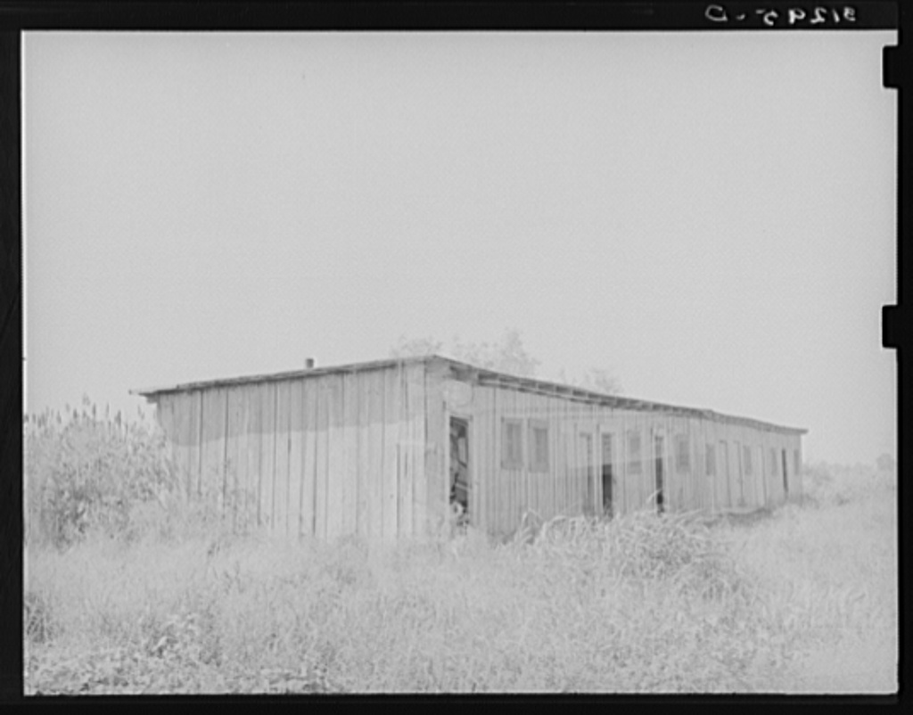

Old slave quarters near Caruthersville, Missouri.
Farm Security Administration - Office of War Information Photograph Collection
(Library of Congress)
Lee, Russell, 1903-1986, photographer.
CREATED/PUBLISHED- 1938 Aug.
http://memory.loc.gov/service/pnp/fsa/8b20000/8b20300/8b20394v.jpg

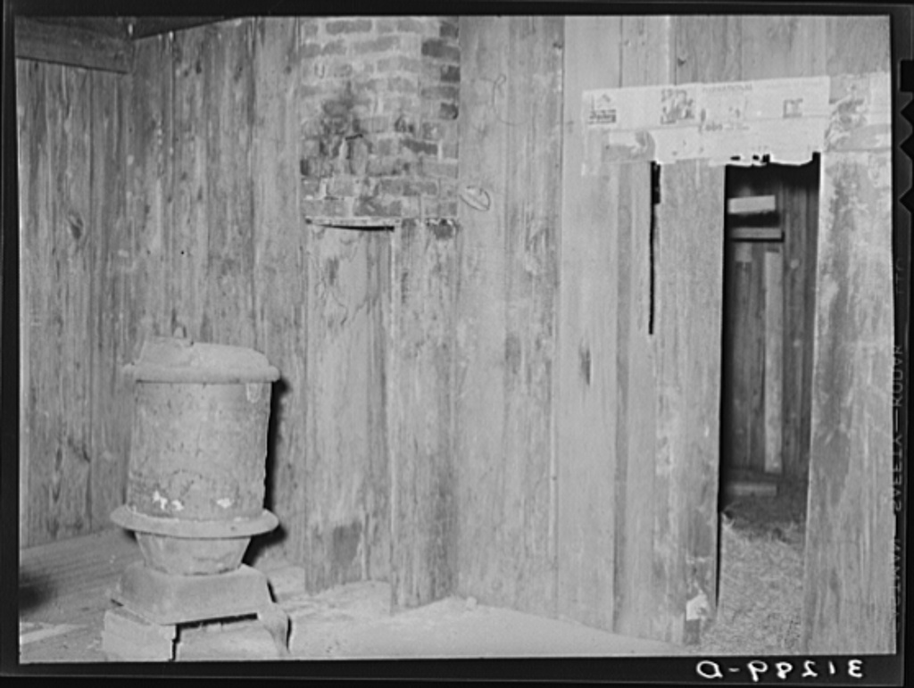

Interior of old slave quarters near Caruthersville, Missouri.
Farm Security Administration - Office of War Information Photograph Collection
(Library of Congress)
Lee, Russell, 1903-1986, photographer.
CREATED/PUBLISHED- 1938 Aug.
http://memory.loc.gov/service/pnp/fsa/8b20000/8b20300/8b20388v.jpg

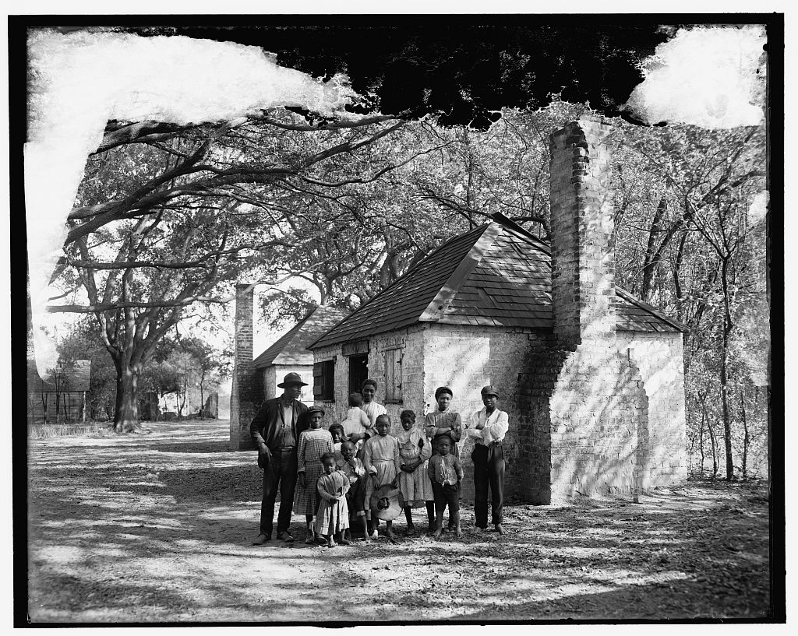

The Whole black family at the Hermitage, Savannah, Ga.
Detroit Publishing Company Photograph Collection- no. 034666
CREATED/PUBLISHED: 1907?
Gift; State Historical Society of Colorado; 1949
http://memory.loc.gov/service/pnp/det/4a10000/4a18000/4a18100/4a18122v.jpg

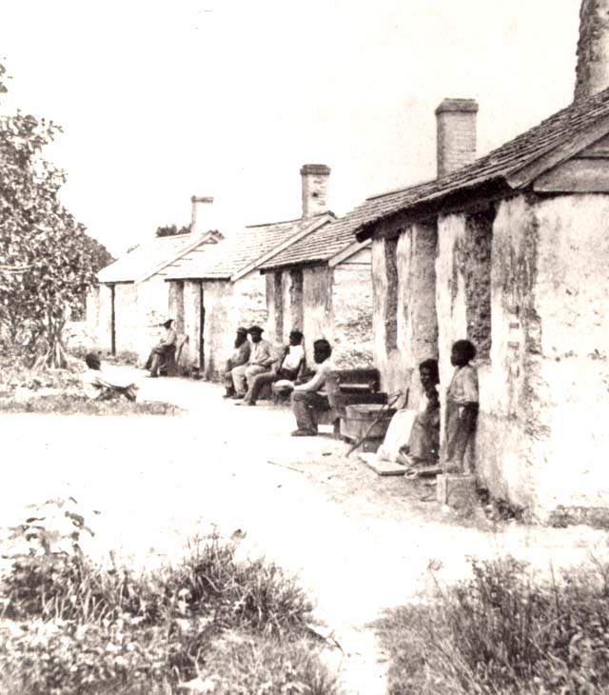
Slave quarters on St. Georges Island
Collection of the New-York Historical Society
http://www.pbs.org/wgbh/aia/part4/images/4sqsg17b.jpg
[Activities for] Part 1: Behind the Big House [continued]

[Part 1] Vocabulary Activity

A NOTE TO THE TEACHER:

On the following pages, you will find “flashcards” with terms and definitions (both combined and separate) that your students may encounter while playing Part 1 of “Flight to Freedom.” These terms and definitions can be introduced and practiced before or during the time students see or hear them in the context of Mission US or in their American history study. The discussion questions and writing prompts will provide further opportunities for students to have more practice with the words and terms.

Divide your students into small groups of four or five, and ask each group to review the terms and definitions.

After your students have had a chance to review and discuss the terms and definitions, distribute the excerpt from the reporter’s interview with Lucy. Review the directions with your students, and ask them to complete the text using the terms they studied.

Here are the terms which should be inserted into each paragraph of Lucy’s life story:
Paragraph 1- plantation, Lexington, hemp
Paragraph 2- master, enslaved African Americans, slop, chicken coop, big house
Paragraph 3- slave quarters, plantation, road pass, overseer
Paragraph 4- hemp-break, “sold south”
Paragraph 5- smokehouse, auction

plantation  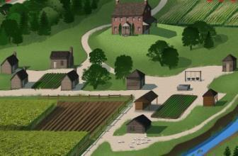  a large farm, normally specializing in the growth of one cash crop and worked by enslaved African Americans | Lexington  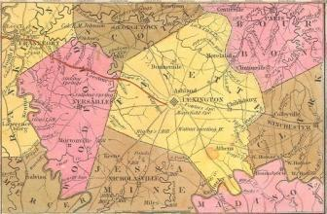  a city in northern Kentucky, located about 80 miles from the Ohio border
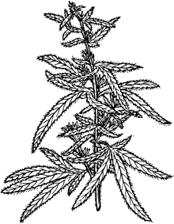  hemp  a plant, the coarse fibers of which can be used to make rope, clothing, or paper | master  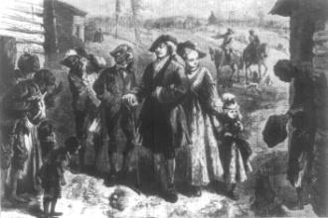  a person who owned a slave/enslaved African Americans
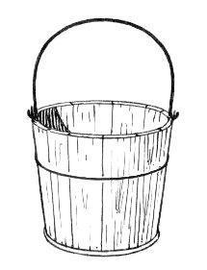  slop  bran or cornmeal mixed with water and fed to pigs and other livestock | slaves/enslaved African Americans  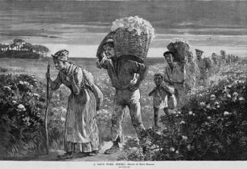  people owned by and forced to work for someone else, not earning money or reward for their effort
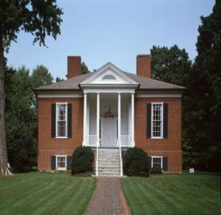  Big House  a reference to the plantation owner’s home, the biggest house on the plantation | 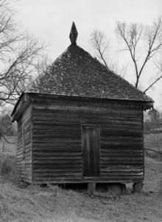  chicken coop  a shed or other enclosure where chickens are kept and raised

road pass  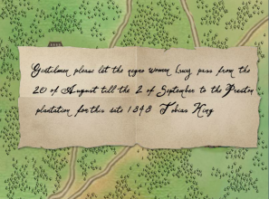  a pass needed by enslaved African Americans (and sometimes by free blacks) giving them legal permission to travel in the South | slave quarters  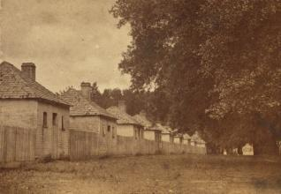  the housing for enslaved African Americans, oftentimes small shack-like houses with very few comforts
hemp-break  a machine used to separate hemp fibers from the plant’s stalk | overseer  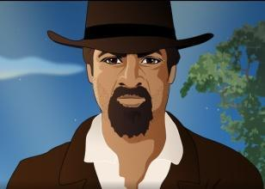  a person, usually white, who was in charge of the day-to-day operations of a plantation, including the discipline of enslaved African Americans
smokehouse  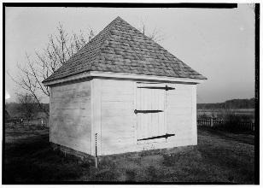  a place to “smoke,” or preserve, meat | “sold south”  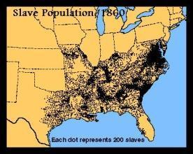  the term used when slave owners decided to sell either disobedient or nonessential enslaved African Americans further south as punishment or to make money
auction
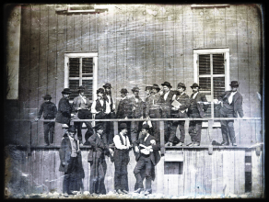
a public sale where goods or services go to the highest bidder

plantation  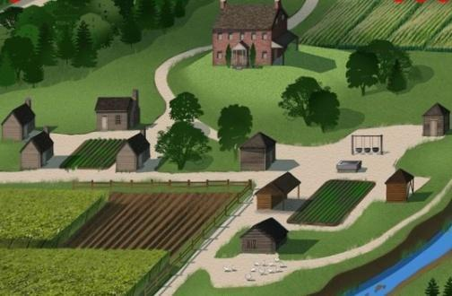 | Lexington  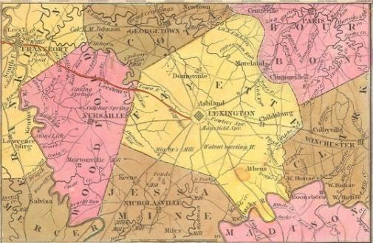
hemp  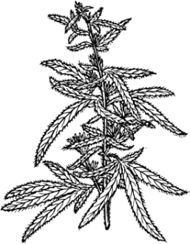 | master  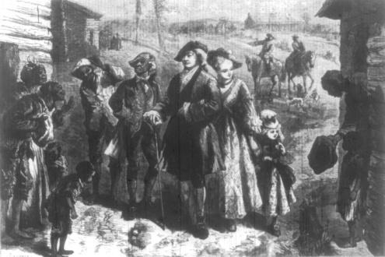
slop | slaves/enslaved African Americans  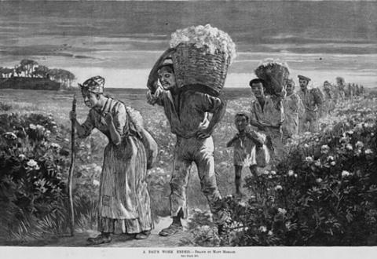
Big House  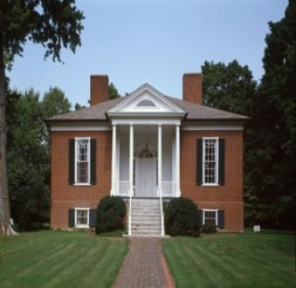 | chicken coop  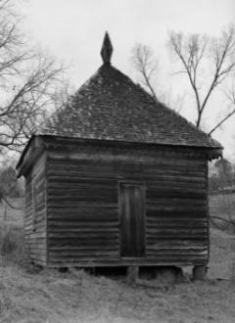

road pass  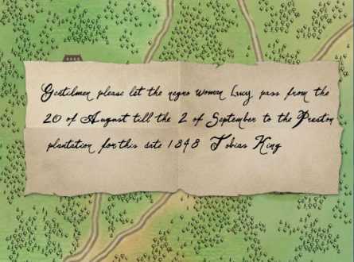 | slave quarters  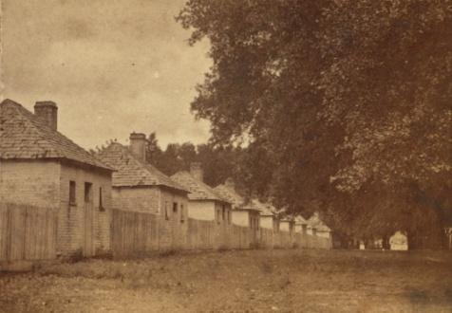
hemp break | overseer
smokehouse  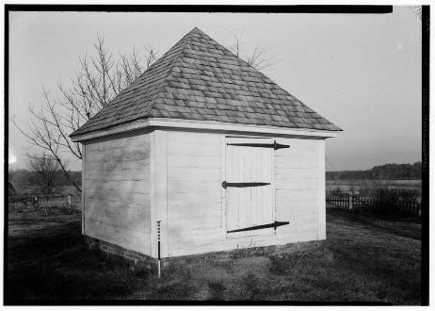 | “sold south”
auction
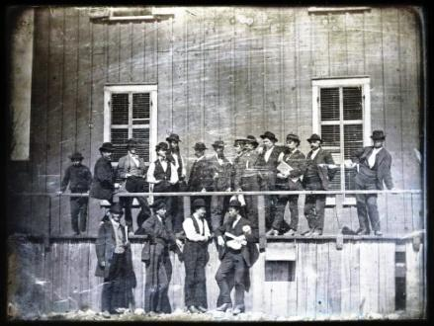

a large farm, normally specializing in the growth of one cash crop and worked by enslaved African Americans | a city in northern Kentucky, located about 80 miles from the Ohio border
a plant, the coarse fibers of which can be used to make rope, clothing, or paper | a person who owned a slave / enslaved African Americans
bran or cornmeal mixed with water and fed to pigs and other livestock | people owned by and forced to work for someone else, not earning money or reward for their effort
a reference to the plantation owner’s home, the biggest house on the plantation | a shed or other enclosure where chickens are kept and raised

a pass needed by enslaved African Americans (and sometimes by free blacks) giving them legal permission to travel in the South | the housing for enslaved African Americans, oftentimes small shack-like houses with very few comforts
a machine used to separate hemp fibers from the plant’s stalk | a person, usually white, who was in charge of the day-to-day operations of a plantation, including the discipline of enslaved African Americans
a place to “smoke,” or preserve, meat | the term used when slave owners decided to sell either disobedient or nonessential enslaved African Americans further south as punishment or to make money
a public sale where goods or services go to the highest bidder

Name: Date:

Activity: In the years following the Civil War, former enslaved African Americans celebrated the end of slavery with a holiday called “Juneteenth.” Juneteenth, held annually on June 19, commemorated the day on which enslaved African Americans in Texas learned of slavery’s abolition.

This activity imagines Lucy is telling a reporter about her life and adventures at a Juneteenth picnic in 1868, twenty years after the beginning of “Flight to Freedom.”

After reading and talking about the words and terms on the flash cards, read this excerpt from Lucy’s interview with the reporter, describing what her life was like in Kentucky. Use the cards and your memory to help you fill in the missing words and terms. Some words may be used more than once.

Auction  master  chicken coop  slave quarters | big house  hemp-brake  overseer  slop | hemp  plantation  smokehouse  enslaved African Americans | Lexington  road pass  sold south

“I was born on the King _________________, not far from the city of _________________, in northern Kentucky. The King family grew _____________, which was used to make rope. They needed lots of rope in those days, to bundle up the cotton being grown further south.

_______________ King and his family owned me and about fifteen other ______________________________________________. We worked hard, day in and day out. I had to do all sorts of work for the Kings: I had to do the laundry, give the hogs their_______________, and gather eggs from the_________________. Sometimes, I also got called up to the _________________ to answer to Miss Sarah, Master King’s daughter. I had to do any little thing she wanted, no questions asked. Miss Sarah and I were friendly when we were children, but as I grew older she ordered me around and made me work hard for her, too. I worked from the moment I got up in the morning until the moment I went to bed at night. It was a hard life.

I lived in the __________________ with my mother and my brother Jonah. My daddy lived on another _________________, a few miles away. Sometimes, we could get a __________________ from Mr. Otis to go and visit my daddy. Mr. Otis was the Kings’_________________. He was not a kind man. He would yell at me, and frighten me, and sometimes he whipped or beat the others. It was his job to make sure we did our work.

One year, not long after my fourteenth birthday, there was some big trouble. Henry had run off and been brought back. Mr. Otis thought Henry purposefully broke the __________________, to slow down the hemp harvest and cost Master King money. Henry was afraid he would be _________________, to one of the big cotton plantations, where they worked enslaved African Americans to death. He would never see any of us ever again.

I had to do Henry’s work for him, because Mr. Otis had beaten him so badly. One night, the __________________ burned to the ground, and Mr. Otis thought I’d done it. I’d never been so scared in all my life. I was sure I’d be sold at an _________________. I would never see my mother or Jonah again. I had no choice. I had to run away.”

[Part 1] Writing Prompts

A NOTE TO THE TEACHER:

You will need to decide how best to share these writing prompts with your students. You might share them all and ask students to choose one to respond to. You may assign one or more to the entire group. You might make one or more of the topics the basis for in-class discussions. Make your decisions according to the needs of your group.

You may notice that many of the topics contain some version of the phrase, “Write about a time in your life…” The intention of these prompts is twofold: first, since students remember the content of their own lives, they can more easily respond to the questions and they are more likely to want to express themselves if they feel competent to do so; second, these questions can form a meaningful bridge between what happens in the lives of ordinary people today and the lives of people in history or in historical events. For these reasons, you might decide to use some of the prompts before students encounter the history because thinking about them sets the students up to understand and to relate to it better.

Since students vary in their degree of comfort and skill in writing, you should decide when and how much students should write. We suggest that since students need to share their writing with each other to make personal and historical connections, you should encourage them to focus on content rather than on mechanical skills. Pieces can be revised and edited later if you decide they should be shared formally (such as on a bulletin board or in a newsletter).

Read through the topics first, and then choose one of them to write about. Write the title of the piece at the top of your page. Write in complete sentences. After you are finished, proofread your work.

LUCY AS SABOTEUR. In Part 1, Lucy is confronted with several instances in which she might pretend to take longer to do a task than it requires, or she might even take action to undermine the smooth running of the plantation by destroying property. In historical France, people sometimes wore wooden shoes called sabot. The intentional clatter made by sabot to distract or muddle people who were trying to work, talk or think, was called sabotage. Later, the definition extended to other contexts, such as what Lucy must sometimes consider. Why might a person in Lucy's position choose sabotage rather than some other way to protest her condition?

LUCY’S JOURNAL. Through Lucy’s eyes, think about your circumstances from the beginning to the end of this part of “Flight to Freedom.” Think about the people with whom you interacted, and what you learned from them. Think about the choices you made and the consequences of those choices. Now write a journal entry from Lucy’s point-of-view summarizing what happened to you in Part 1. You may choose to illustrate one aspect of your entry.
A NOTE TO THE TEACHER:

The purpose of these questions is to check the students’ understanding of the action of the game and the history embedded in that action. Since the outcome of gameplay can vary depending on the choices the student makes, the answers to the questions might also vary.

Some students might learn information later than others, or not at all. If you choose to discuss students’ responses as a whole group, information can be shared.

There may be more questions here than you want your students to answer in one sitting or in one evening. In that case, choose the questions you feel are most essential for their understanding of Part 1.

Feel free to copy the following pages of this activity for your students.

If you are not planning to have your students write the answers to the questions, you’ll need to modify the directions.

[Part 1] Review Questions

Name: ___________________________ Date:_____________________

Directions: After you play Part 1, read and answer these questions from the point of view of your character, Lucy. You may not know all the answers, so do the best you can. Write in complete sentences and proofread your work.

1) Lucy has a lot of work to do on the King family’s plantation. What are some of the chores and tasks she is assigned?

2) Where is Lucy’s father? Why is he there?

3) What is the King plantation like? What are some of the things you saw and heard?

4) What are some of the ways Mr. Otis punishes enslaved African Americans who break the rules or are disrespectful? What is the harshest punishment you heard about?

5) How do the enslaved African Americans help each other?

6) On this day, in addition to your mother, you may have met the following people. Make a note or two about them next to the name of each. For this question, your notes don’t have to be in complete sentences.
a. Jonah
b. Henry
c. Mr. Otis
d. Miss Sarah King
e. Esther

7) Do you think Lucy likes Miss Sarah? Why or why not?

8) Why did Lucy have to run away?

