[Part 2] Vocabulary Activity

A NOTE TO THE TEACHER:

On the following pages, you will find “flashcards” with terms and definitions (both combined and separate) that your students may encounter while playing Part 2 of “Flight to Freedom.” These terms and definitions can be introduced and practiced before or during the time students see or hear them in the context of Mission US or in their American history study. The discussion questions and writing prompts will provide further opportunities for students to have more practice with the words and terms.

Divide your students into small groups of four or five, and ask each group to review the terms and definitions.

After your students have had a chance to review and discuss the terms and definitions, distribute the excerpt from the reporter’s interview with Lucy. Review the directions with your students, and ask them to complete the text using the terms they studied.

Here are the terms which should be inserted into each paragraph of Lucy’s life story:
Paragraph 1- Ripley
Paragraph 2- Border State, border
Paragraph 3- fugitive, bounty
Paragraph 4- illiterate, slave catchers
Paragraph 5- ford
Paragraph 6- Licking River, Ohio River, ferry, surveillance

Ripley  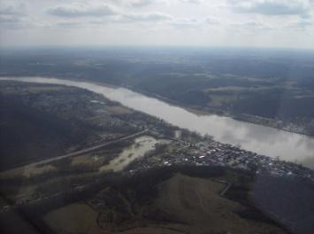  A town in Ohio, on the far side of the Ohio River from Kentucky, that served as a safe haven along the “underground railroad.” | Border State  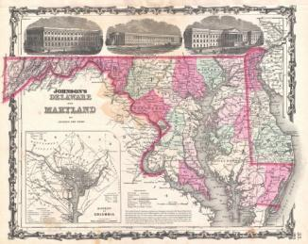  The states that were located between the “free” and “slave” states: Delaware, Maryland, Virginia, Kentucky, and Missouri. Although they were referred to as border states, each of them had slavery within their borders
border  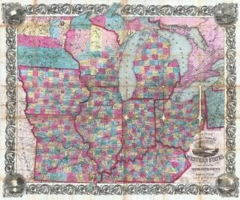  The line or area separating two geographic regions | fugitive  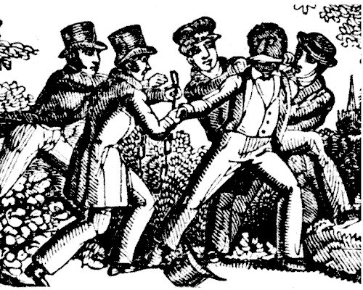  The term used to describe enslaved African Americans who ranaway; also, a person who has escaped from a place (like a jail) and is hiding
bounty  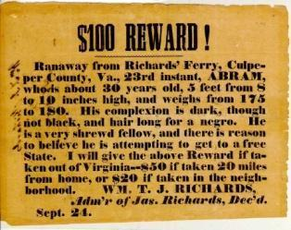  A reward put out for returning a lost item | illiterate  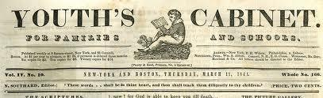  Unable to read.
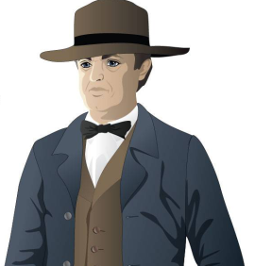  slave catchers  Men who were paid to travel in the North to find and bring back enslaved African Americans who had run away | 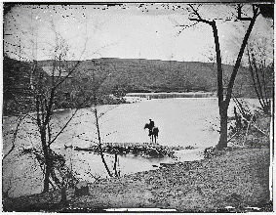  ford  A shallow place in a river where one can walk across (noun); to cross a river at a shallow place (verb)

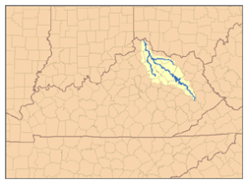  Licking River  Tributary of the Ohio river in Northeastern Kentucky | Ohio River  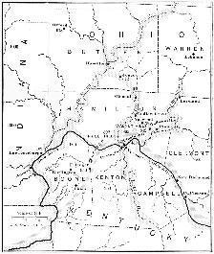  The river separating the states of Ohio and Kentucky. It begins in Pennsylvania, and is the largest tributary of the Mississippi River
ferry  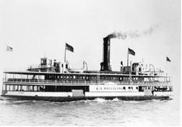  A boat or raft used to carry passengers and/or goods from one side of a body of water to another | 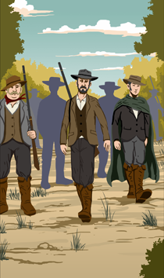  surveillance  The close observance of a person or people, especially if that person (or those people) are suspected of criminal behavior

Ripley  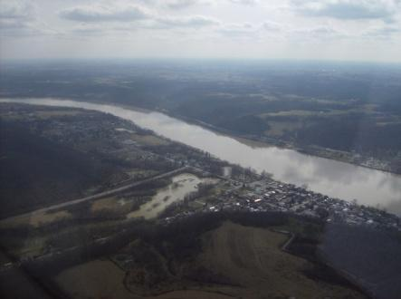 | Border State  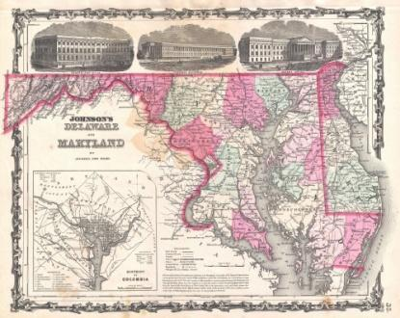
border  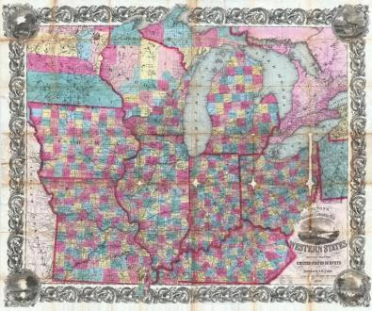 | fugitive
bounty  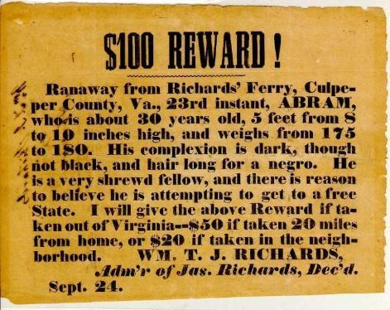 | illiterate
slave catchers  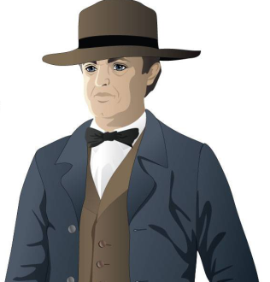 | ford  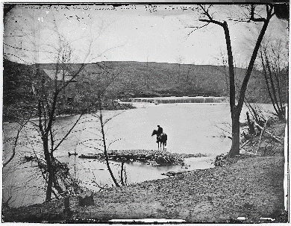

Licking River | Ohio River  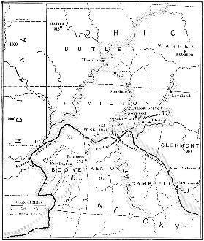
ferry | surveillance  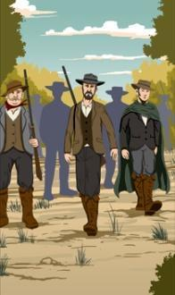

A town in Ohio, on the far side of the Ohio River from Kentucky that served as a safe haven along the “underground railroad” | The states that were located between the “free” and “slave” states: Delaware, Maryland, Virginia, Kentucky, and Missouri. Although they were referred to as Border States, each of them had slavery within their borders
The line or area separating two geographic regions | The term used to describe enslaved African Americans who escaped; also, a person who has escaped from a place (like a jail) and is hiding
A reward put out for an enslaved African American who escaped | Unable to read
Men who were paid to travel in the North to find and bring back enslaved African Americans who had run away | A shallow place in a river where one can walk across (noun); to cross a river at a shallow place (verb)

Tributary of the Ohio river in Northeastern Kentucky | The river separating the states of Ohio and Kentucky. It begins in Pennsylvania, and is the largest tributary of the Mississippi River
A boat or raft used to carry passengers and/or goods from one side of a body of water to another | The close observance of a person or people, especially if that person (or those people) are suspected of criminal behavior

Name: Date:

Activity: In the years following the Civil War, former enslaved African Americans celebrated the end of slavery with a holiday called “Juneteenth.” Juneteenth, held annually on June 19, commemorated the day on which enslaved African Americans in Texas learned of slavery’s abolition.

This activity imagines Lucy is telling a reporter about her life and adventures at a Juneteenth picnic in 1868, twenty years after the beginning of “Flight to Freedom.”

After reading and talking about the words and terms on the flash cards, read this excerpt from Lucy’s interview with the reporter, describing what her life was like when she made her escape. Use the cards and your memory to help fill in the missing words and terms. Some words may be used more than once.

border  Border State  bounty  ferry | ford  fugitive  illiterate | Licking River  Ohio River  Ripley | slave catchers  surveillance

“It is only about seventy-five miles from Master King’s plantation in Kentucky to the little town of __________________, in Ohio. But back when I ran away, those two places could not have been more different.

Kentucky, you see, was a __________________. That meant there was slavery there, but in the state just to the north of it, Ohio, there was no slavery. It seems awfully foolish to me that a person’s freedom was decided by which side of an imaginary line, or __________________, they were standing on.

The minute I left Master King’s plantation, I was a __________________. I was also a criminal. There was a __________________ offered to anyone who could recapture me. I don’t know how much it was, but people could make a nice amount of money if they managed to catch an enslaved African Americans who escaped back in those days.

Master King put up posters all over that part of the state, letting folks know I had run off. A lot of folks were __________________, and couldn’t read the posters. That helped some. I had to sleep in the woods and in caves, and spent a lot of my time trying to keep away from the __________________, who patrolled the roads looking for anyone who might be a runaway.

It seems like everywhere I turned, there was a new obstacle to prevent me from getting north. That country has more streams and rivers than I care to remember. Every time I turned around, there was a new river for me to __________________.

The first big river I had to cross was the __________________, but after I made it across, I was still in Kentucky. The ___________________ separates Kentucky from Ohio. These were big rivers, too. It would have been easiest to get across them on a _____________________, but it was often too dangerous for a runaway to try and do that. The Ohio River, especially, was under constant _______________________ by people looking for escaped enslaved African Americans.

When I made it to Ohio and the town of Ripley I thought I was free and my troubles were over. I was wrong.”

[Part 2] Writing Prompts

A NOTE TO THE TEACHER:

You will need to decide how best to share these writing prompts with your students. You might share them all and ask students to choose one to respond to. You may assign one or more to the entire group. You might make one or more of the topics the basis for in-class discussions. Make your decisions according to the needs of your group.

You may notice that many of the topics contain some version of the phrase, “Write about a time in your life…” The intention of these prompts is twofold: first, since students remember the content of their own lives, they can more easily respond to the questions and they are more likely to want to express themselves if they feel competent to do so; second, these questions can form a meaningful bridge between what happens in the lives of ordinary people today and the lives of people in history or in historical events. For these reasons, you might decide to use some of the prompts before students encounter the history, because thinking about them sets the students up to understand and to relate to it better.

Since students vary in their degree of comfort and skill in writing, you should decide when and how much students should write. We suggest that since students need to share their writing with each other to make personal and historical connections, you should encourage them to focus on content rather than on mechanical skills. Pieces can be revised and edited later if you decide they should be shared formally (such as on a bulletin board or in a newsletter).

Read through all the topics first, and then choose one to write about. Write the title of the piece at the top of your page. Write in complete sentences. After you are finished, proofread your work for correctness.

TWO’S COMPANY? One of the decisions Lucy needs to make in Part 2 in connection with her attempt to escape is whether to try her luck on her own or to go off with Henry. What do you imagine are the advantages and disadvantages of going with Henry? What might be the advantages and disadvantages of going off alone?

INDEPENDENCE AND INTERDEPENDENCE. Probably since you were a young child at school, your teachers have reported to your parents periodically about your ability to work independently and also your ability to work cooperatively with others. Both are important. At one time, school meant sitting quietly and working mostly by yourself. Then, in the last decades of the 20th century, researchers discovered that once we leave school and go into the workplace, there are more occupations in which we need to work with others interdependently than ones in which it is important to be able to work alone. Which kind of work is most difficult for you to do? What makes that kind of work so difficult? Write a letter to your parents as if you are your teacher, and describe yourself as an independent or interdependent learner. What would your teacher say about you? What are your strengths? What do you need to work? Give examples.

WHOM DO YOU TRUST? Think about the choices Lucy faces in Part 2. Many of her choices are informed by what other people tell her. While sometimes a good or bad outcome from a decision has to do with your own analysis of what is best or luck, often it’s about your decisions about whom to trust. Have you ever been in a situation where your decision had to do with whom to trust? How do you decide whether or not to trust a person? Make a list of the things that signal you to trust or not to trust someone. These things may have to do with your relationship to that person (parent, total stranger, etc.), the circumstances (a teacher, a stranger who emails you, etc.), qualities of that person (evidence he/she presents, tone of voice, etc.) If you like, include an instance of a time you decided to trust someone and tell whether you feel you made the right decision. State what, if anything, you learned from that experience.

LUCY’S JOURNAL. Through Lucy’s eyes, think about your circumstances from the beginning to the end of this part of “Flight to Freedom.” Think about the people with whom you interacted, and what you learned from them. Think about the choices you made and the consequences of those choices. Now write a journal entry from Lucy’s point-of-view summarizing what happened to you in Part 2. You may choose to illustrate one aspect of your entry.

[Part 2] Review Questions

A NOTE TO THE TEACHER:

The purpose of these questions is to check the students’ understanding of the action of the game and the history embedded in that action. Since the outcome of gameplay can vary depending on the choices the student makes, the answers to the questions might also vary.

Some students might learn information later than others, or not at all. If you choose to discuss students’ responses as a whole group, information can be shared among all.

There may be more questions here than you want your students to answer in one sitting or in one evening. In that case, choose the questions you feel are most essential for their understanding of Part 2.

Feel free to copy the following pages of this activity for your students.

If you are not planning to have your students write the answers to the questions, you’ll need to modify the directions.

Name: ___________________________ Date:_____________________

Directions: After you play Part 2, read and answer these questions from the point of view of your character, Lucy. You may not know all the answers, so do the best you can. Write in complete sentences and proofread your work.

1) What were some of the obstacles Lucy encountered on her escape?

2) Did anyone help Lucy during her escape? Who? What did they do for her?

3) Did “your” Lucy make it to freedom on the first try? If not, what stopped you?

4) Lucy’s decision to run away had an effect on many people. Describe how you think the following people may have felt about Lucy’s escape, and why they may have felt that way.
For this question, your notes don’t have to be in complete sentences.
a. Jonah
b. Henry
c. Mr. Otis
d. Miss Sarah King
e. Master King

5) What sorts of places did you visit or stay in on your journey to Ohio?

6) Why were so many people interested in capturing enslaved African Americans who ran away?

