Activities for] Part 4: Gathering Forces

[Part 4] Vocabulary Activity

A NOTE TO THE TEACHER:

On the following pages, you will find “flashcards” with terms and definitions (both combined and separate) that your students may encounter while playing Part 4 of “Flight to Freedom.” These terms and definitions can be introduced and practiced before or during the time students see or hear them in the context of Mission US or in their American history study. The discussion questions and writing prompts will provide further opportunities for students to have more practice with the words and terms.

Divide your students into small groups of four or five, and ask each group to review the terms and definitions.

After your students have had a chance to review and discuss the terms and definitions, distribute the excerpt from the reporter’s interview with Lucy. Review the directions with your students, and ask them to complete the text using the terms they studied.

Here are the terms which should be inserted into each paragraph of Lucy’s life story:
Paragraph 1- colonization, citizen
Paragraph 2- defer, Underground Railroad, conductors
Paragraph 3- brace, prowling
Paragraph 4- steward, prudence

brace  a device that clamps together to provide support (noun), to make sturdier (verb) | citizen  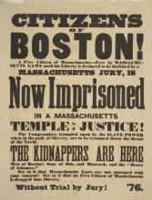  a legally recognized individual within a city, state, or nation who has rights, like voting and land ownership
colonization  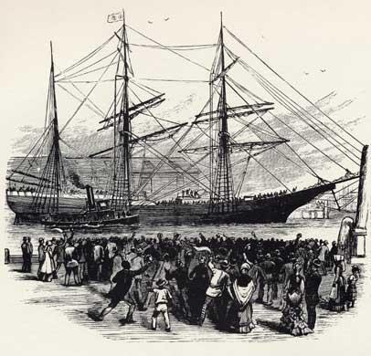  a movement in the 1800s to transport free African Americans to Africa | conductors  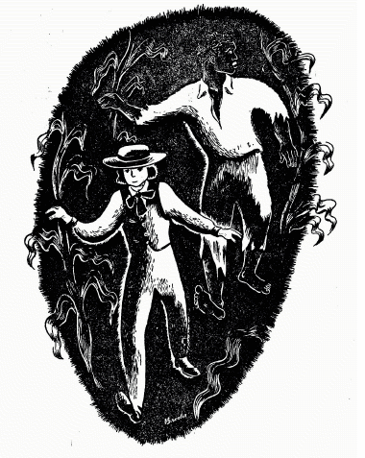  people who helped transport freedom seekers along the Underground Railroad
defer  to accept someone else’s opinion or judgment on a particular topic or situation out of respect for that person | prowling  to move about in a sneaky manner, like an animal searching for its prey
prudence  caution | steward  a person in charge of taking care of passengers and the food supply  on a ship, train, bus, etc.
Underground Railroad
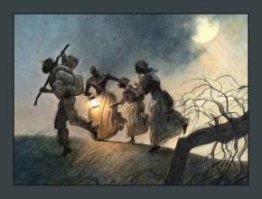
the loose, informal network of individuals, hideaways, and safe havens that assisted freedom seekers as they tried to escape to freedom

brace | citizen
colonization | conductors
defer | prowling
prudence | steward
Underground Railroad

a device that clamps together to provide support (noun), to make sturdier (verb) | a legally recognized individual within a city, state, or nation who has rights, like voting and land ownership
a movement in the 1800s to transport free African Americans to Africa | people who helped transport freedom seekers along the Underground Railroad
to accept someone else’s opinion or judgment on a particular topic or situation out of respect for that person | to move about in a sneaky manner, like an animal searching for its prey
caution | a person in charge of taking care of passengers and the food supply  on a ship, train, bus, etc.
the loose, informal network of individuals, hideaways, and safe havens that assisted freedom seekers as they tried to escape to freedom

Name: Date:

Activity: In the years following the Civil War, former enslaved African Americans celebrated the end of slavery with a holiday called “Juneteenth.” Juneteenth, held annually on June 19th, commemorated the day on which enslaved African Americans in Texas learned of slavery’s abolition.

This activity imagines Lucy is telling a reporter about her life and adventures at a Juneteenth picnic in 1868, twenty years after the beginning of “Flight to Freedom.”

After reading and talking about the words and terms on the flash cards, read this excerpt from Lucy’s interview with the reporter, describing what her life was like after she made her escape. Use the cards and your memory to help you fill in the missing words and terms. Some words may be used more than once.

brace  citizen  colonization | conductors  defer  prowling | prudence  steward  Underground Railroad

“One day I attended an antislavery meeting and although everyone there was against slavery, one of the speakers, Benjamin Harrison, was in favor of the foreign _______________ of freed slaves. He wanted to free enslaved African Americans and send them to Africa. I agreed about freeing the enslaved, but Harrison made me mad when he said those who were freed should be sent to Africa. I did not want to be sent there. Although I wasn’t an American _________________, America’s where I was born and raised.

After the meeting, a few of us talked about moving Henry to safety and helping my mother and brother escape. I wanted to go back and get my mother and brother myself, but I decided to ________________ to the opinion of my elders, who told me I would be putting myself in too much danger. That’s when I learned about the ___________________, and how individual men and women served as _________________, helping enslaved African Americans escape to freedom.

That night, I saw Henry. He had been hurt badly when he fell out of a tree during his escape, but a white hunter found him and put a ______________ on his injured leg. What luck! Henry told me he was going to leave Ripley and head to Canada. I wished he didn’t have to go, but I knew he couldn’t be safe in Ohio, with slave catchers like T.C. Bercham ______________ the streets, looking for him. Henry told me my mother had been auctioned. That made me very sad.

Then, one day, something wonderful happened. My brother Jonah arrived. I was so happy to see him! He had quite an adventure during his trip to Ripley. He even had to dress like a girl, so people wouldn’t recognize him. A woman pretended she was Jonah’s master and led him safely to a ship, where the ___________________ made sure he had food and water. I was so glad Jonah was able to make it to Ripley. Although we were together, I knew if we wanted to remain safe, we would have to use __________________ on a daily basis.

[Part 4] Writing Prompts

A NOTE TO THE TEACHER:

You will need to decide how best to share these writing prompts with your students. You might share them all and ask students to choose one for response. You might assign one or more to the entire group. You might make one or more of the topics the basis for in-class discussions. Make your decisions according to the needs of your group.

You may notice that many of the topics contain some version of the phrase, “Write about a time in your life…” The intention of these prompts is twofold: first, since students remember the content of their own lives, they can more easily respond to the questions and they are more likely to want to express themselves if they feel competent to do so; second, these questions can form a meaningful bridge between what happens in the lives of ordinary people today and the lives of people in history or in historical events themselves. For these reasons, you might decide to use some of those prompts before students encounter the history, because thinking about them sets the students up to understand it and to relate to it.

Since students vary in their degree of comfort and skill in writing, you should decide when students write and how much students should write. We do suggest, though, that since students need to share their writing with each other to make personal and historical connections, you encourage them to focus on content rather than on mechanical skills. Pieces can be revised and edited later if you decide they should be shared more formally (such as on a bulletin board or newsletter).

Read through all the topics. Then choose one of them to write about. Write the title of the piece at the top of your page. Write in complete sentences. After you are finished, proofread your work for correctness.

COLONIZATION: In Part 4, Lucy hears the politician Benjamin Harrison address a gathering of abolitionists. What does his political party—the “Free Soil Party” stand for? Does Harrison consider himself an abolitionist? Does he believe in racial equality between black and whites? Describe the “colonization” policy he proposes. Was there any precedent in American history to sending formerly enslaved African Americans back to Africa? Do you think people like Harrison may have played a role in ultimately abolishing slavery despite their beliefs about racial equality?

THE PRICE OF FREEDOM: In Part 4, Millicent Hatcher rejects the idea of buying Lucy’s mother and brother’s freedom, insisting that it would be supporting the system of slavery. Do you agree? If not, why not? If so, would you still agree if she were talking about your own mother and brother? Certainly John Parker would argue that the purchase of his own freedom was money well spent, enabling him to help others find freedom. There is often a gap between what we believe is right in principle and what we find necessary to do in life itself; bridging that gap is a process called compromise—a concept which often carries negative connotations, but which often enables progress or resolution. Assuming Lucy could have saved enough money to purchase her mother and brother legally, what advantages would there have been to doing so rather than attempting to help them to escape as she had?

LUCY’S JOURNAL. Through Lucy’s eyes, think about your circumstances from the beginning to the end of this part of “Flight to Freedom.” Think about the people with whom you interacted, what you learned from them. Think about the choices you made and the consequences of those choices. Now write a journal entry from Lucy’s point-of-view summarizing what happened to you in Part 4. You may choose to illustrate one aspect of your entry.

[Part 4] Review Questions

A NOTE TO THE TEACHER:

The purpose of these questions is to check the students’ understanding of the action of the game and the history embedded in that action. Since the outcome of game play can vary depending on the choices the student makes, the answers to the questions might also vary.

Some students might learn information later than others, or not at all. If you choose to discuss students’ responses as a whole group, information can be shared among all.

There may be more questions here than you want your students to answer in one sitting or in one evening. In that case, choose the questions you feel are most essential for their understanding of Part 3.

Feel free to copy the following pages of this activity for your students.

If you are not planning to have your students write the answers to the questions, you’ll need to modify the directions.

Name: ___________________________ Date:_____________________

Directions: After you play Part 4, read and answer these questions from the point of view of your character, Lucy. You may not know all the answers, so do the best you can. Write in complete sentences and proofread your work.

1) What are some of the ways the abolitionists are trying to end slavery? What happens at the abolitionist meeting?

2) What else do you think the antislavery community in Ohio could do to assist enslaved African Americans seeking freedom?

3) Describe Benjamin Harrison’s idea of “colonization.” How do the abolitionists at the meeting feel about colonization?

4) What does Lucy give the abolitionists regarding Henry? Will it help or hurt him? How?

5) What is the abolitionists’ plan for rescuing Lucy’s family? Do you think the plan will work? Why or why not?

6) What is the Underground Railroad? How does it help enslaved African Americans seeking freedom?

7) What has happened to Lucy’s mother?

8) How did Henry ultimately escape from the King Plantation?

9) Why do many enslaved African Americans who escaped move to Canada?

10) How does Jonah escape from the King Plantation?

