Badges Earned

Student Organizer

As you play MISSION US “Flight to Freedom,” you will earn badges in the game for the decisions you make as Lucy. As you review the scenarios accompanying this organizer, think about which badge listed below you might earn for each choice you make.

Possible Badges | Badge Description | Scenario and Choice That Might Earn This Badge  (list the Scenario Number and the letter of Your Choice)
Play It Safe | You do not engage in any acts of resistance and stay on the good side of authority figures, avoiding punishment for you and your loved ones.
Resistance | You take direct action against rules and policies you don’t support. When times are tough you rally by taking action against your oppressors.
Family Matters | You care deeply about keeping your family together and safe. You turn to your family in your times of need.
Sabotage | You take every available action possible against those trying to oppress you, demonstrating active resistance – even if this means harm or destruction.
Fighting Spirit | You actively struggle against those who may be trying to harm or deceive you.
Self-Reliant | You trust yourself more than others and prefer to work on your own. You take actions that demonstrate your survival instinct.
Persuasion | You have a way with words and you can convince people of your position or get what you want by speaking.
Hard Bargain | You turn to money or bribery to convince people to do what you want.
Literacy | You value reading and education, and show a passion for leaning new words, trying new things, and picking up new skills.
Leadership | You show initiative and can easily lead community efforts.
Community | You turn to others in your community in hard times, and will rely on the support of your community to save another community member.
Escape Master | Thanks to a combination of skills, wit, and luck, you are able to easily escape difficult environments.

Resistance in U.S. History

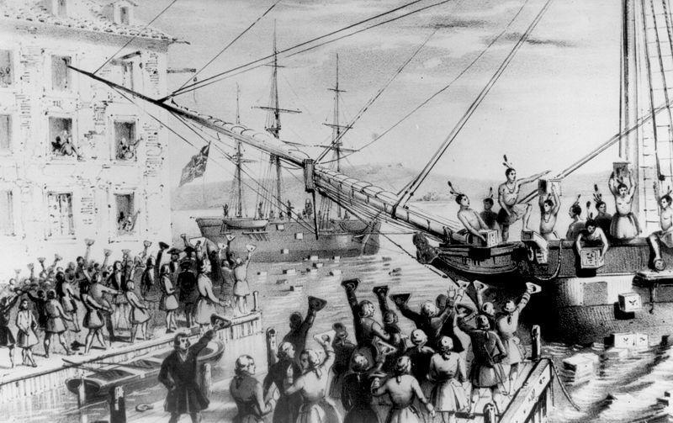
Boston, Massachusetts 1773
Hint: The Indians aren’t real, and there’s tea in those crates.

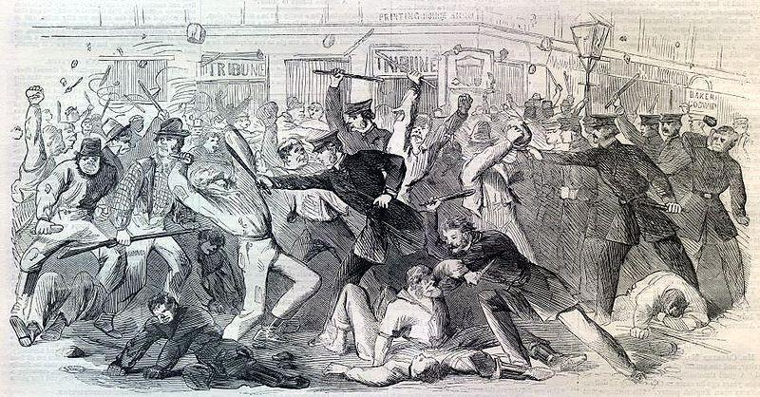
New York City, 1863
Hint: Some of the people in the picture were unhappy with the government’s policies for drafting men into the army.

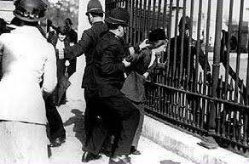
Washington, DC 1917
Hint: This woman chained herself to this fence at the White House. She did not vote for the President because she couldn’t.

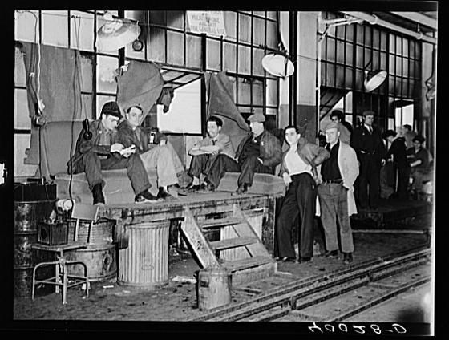
Flint, Michigan 1936
Hint: These men are where they work. It’s the middle of the work day.
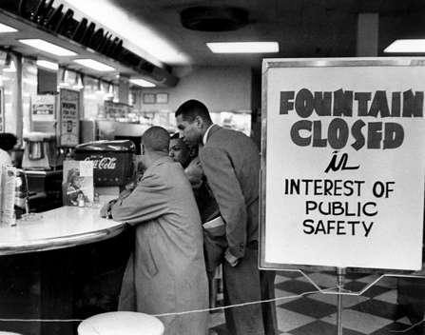
Nashville, Tennessee 1960
Hint: The store is refusing to serve the men seated at the counter. And they won’t leave.

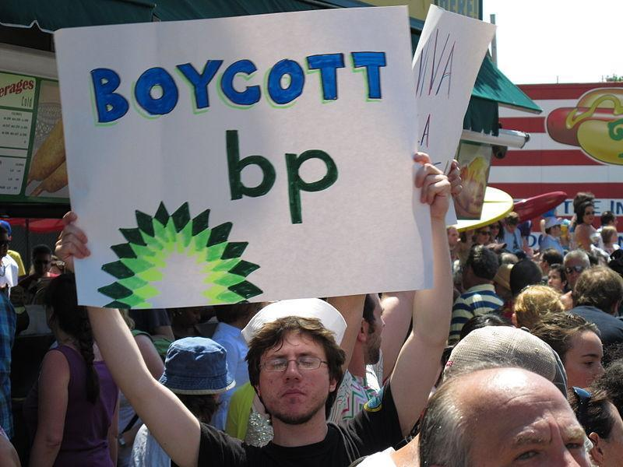
Brooklyn, New York 2010
Hint: Remember the oil well explosion that released millions of barrels of oil into the Gulf of Mexico?

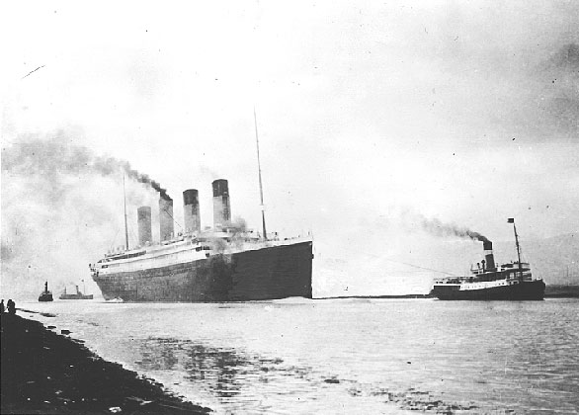
CAUSE: The Titanic hit an iceberg.

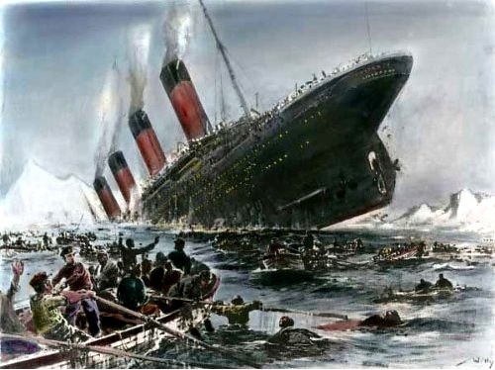
EFFECT: The Titanic sank to the bottom of the ocean.

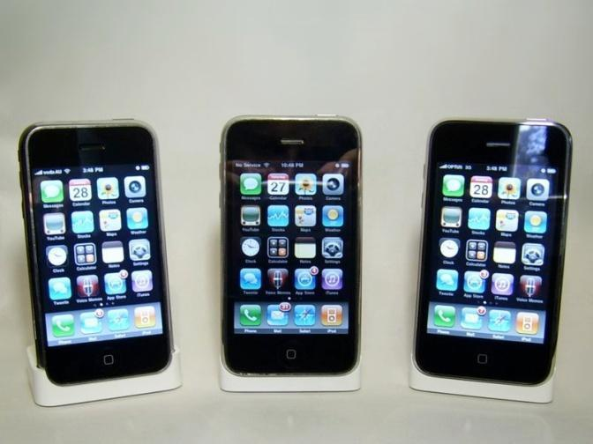
CAUSE: Apple announced it is releasing a new iPhone.

EFFECT: Tens of thousands of people went online to order Apple’s new iPhone.

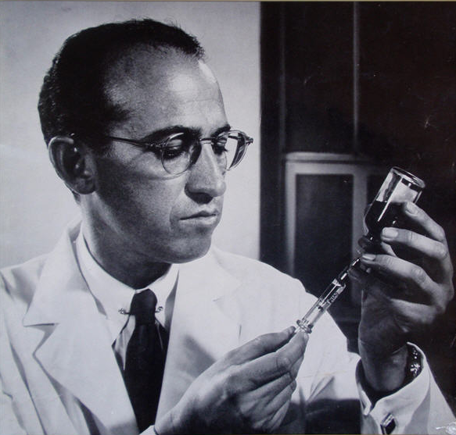
CAUSE: Jonas Salk and Albert Sabin developed a vaccine for polio.

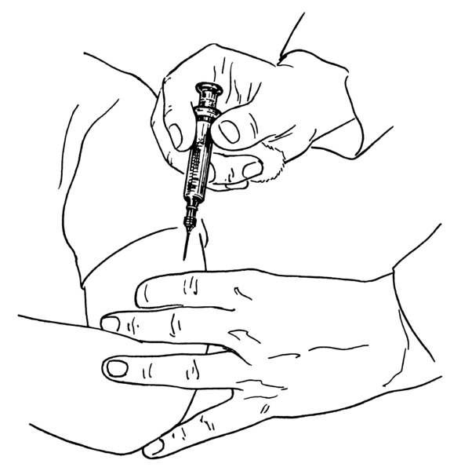
EFFECT: Polio has been eliminated from most countries in the world.

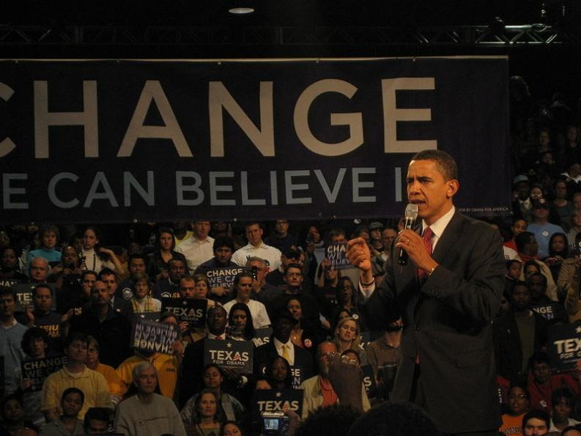
CAUSE: Barack Obama won the US presidential election in November 2008.

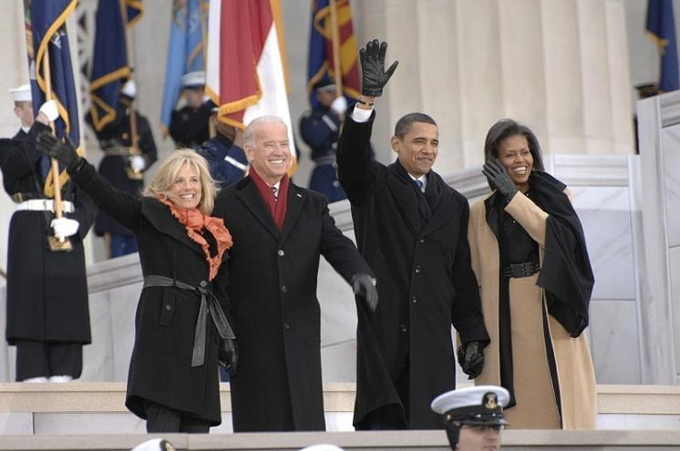
EFFECT: Barack Obama became President of the United States in January 2009.

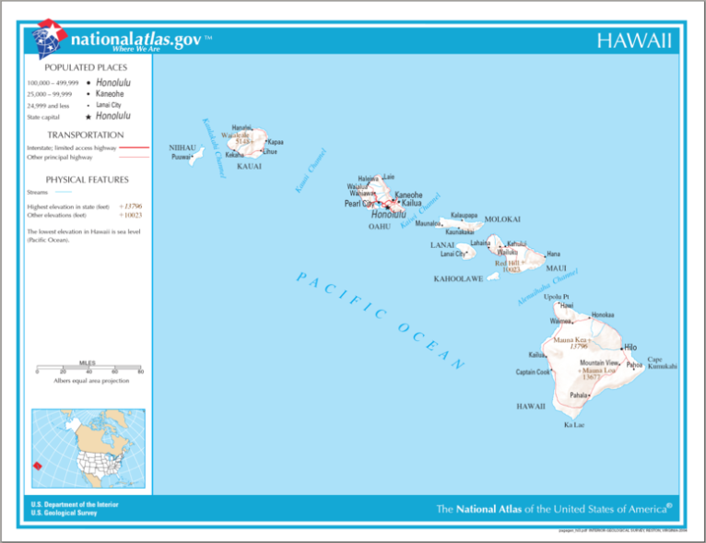
CAUSE: Hawaii became the 50th state of the United States.

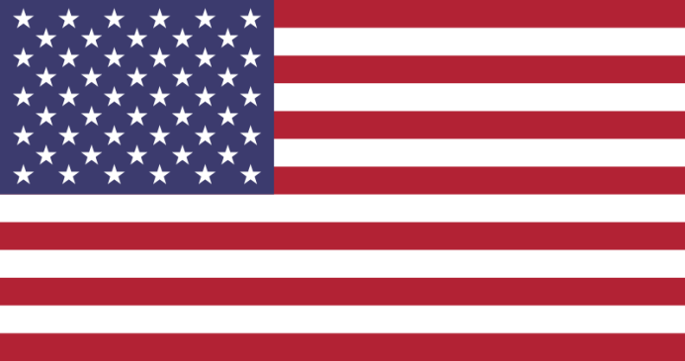
EFFECT: The US flag was changed to include 50 stars.

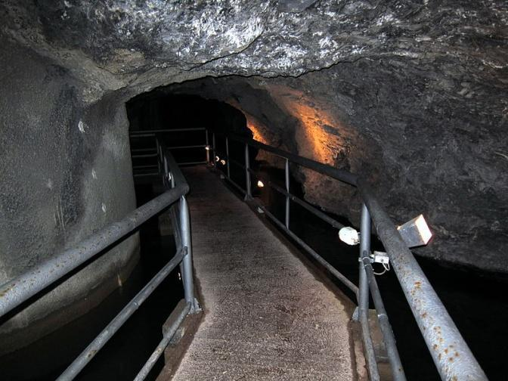
CAUSE: 33 miners were trapped in a mine in Chile.

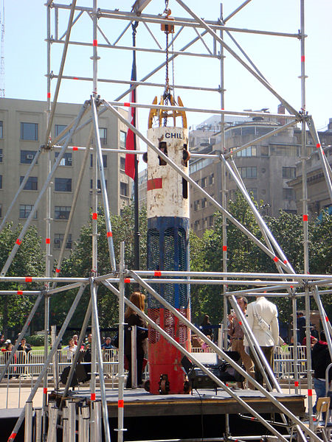
EFFECT: NASA and the Chilean Navy created a rescue capsule which successfully brought 33 trapped miners to safety.

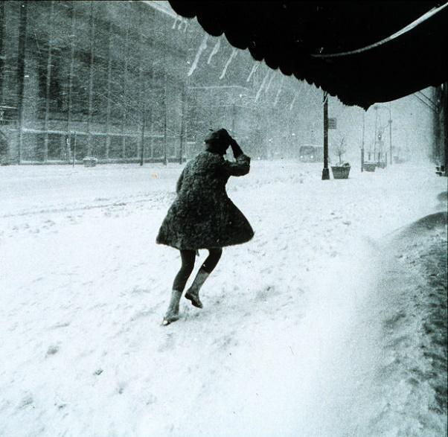
CAUSE: There was a terrible snowstorm in your hometown.

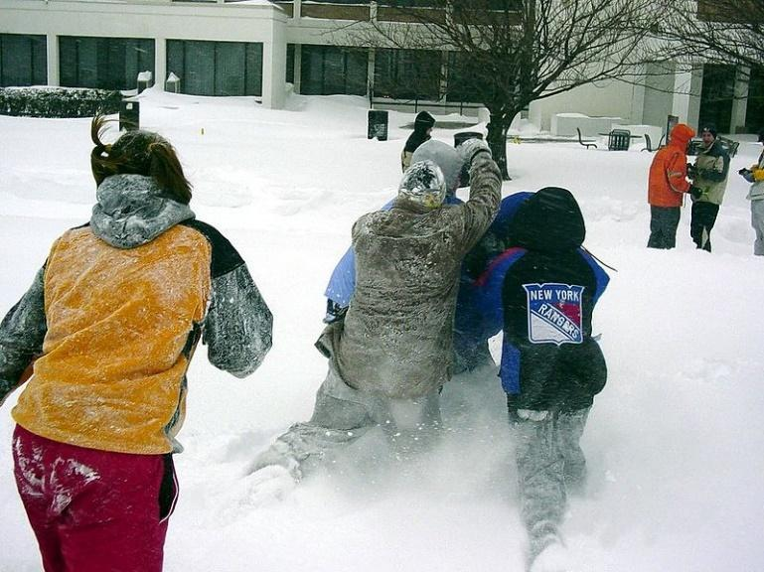
EFFECT: Your school is closed for the day.

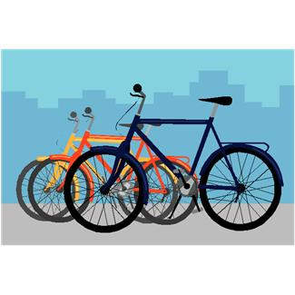
CAUSE: You ran over a nail on your bike.

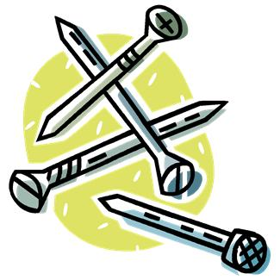

EFFECT: You got a flat tire.

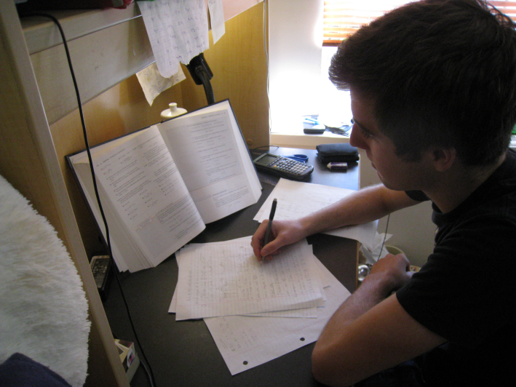
CAUSE: You studied hard for your social studies test.

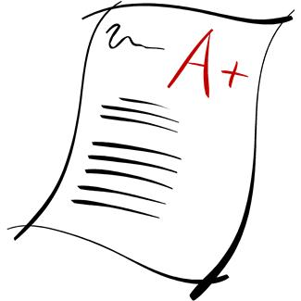
EFFECT: You got an “A+” on your social studies test.

CAUSE: Your favorite television show got very low ratings.

EFFECT: Your favorite television show was cancelled.

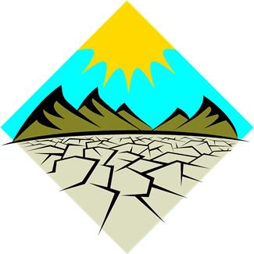
CAUSE: There was a terrible drought in the Southwest.

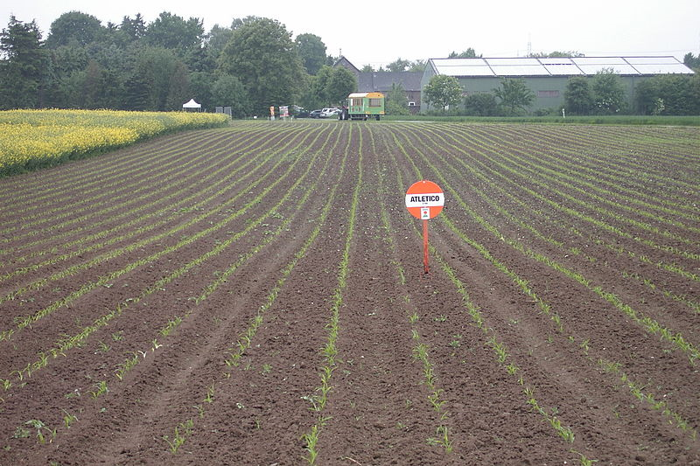
EFFECT: Crops in the Southwest failed.
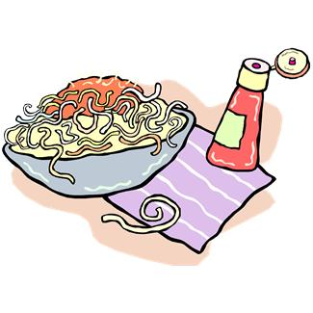
CAUSE: You finished your dinner.

EFFECT: You got dessert.

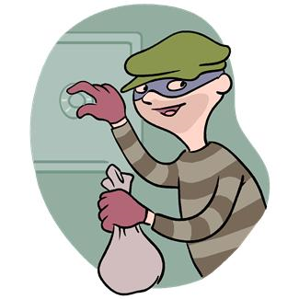
CAUSE: A man robbed a bank and was arrested.

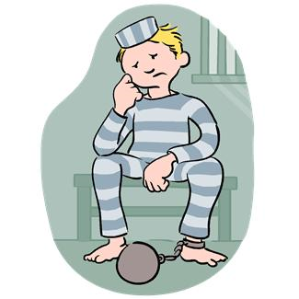

EFFECT: A man went to jail for bank robbery.

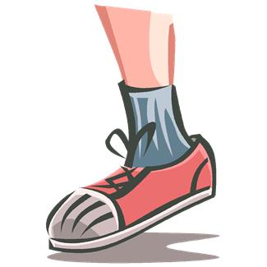
CAUSE: Your shoes were too tight.

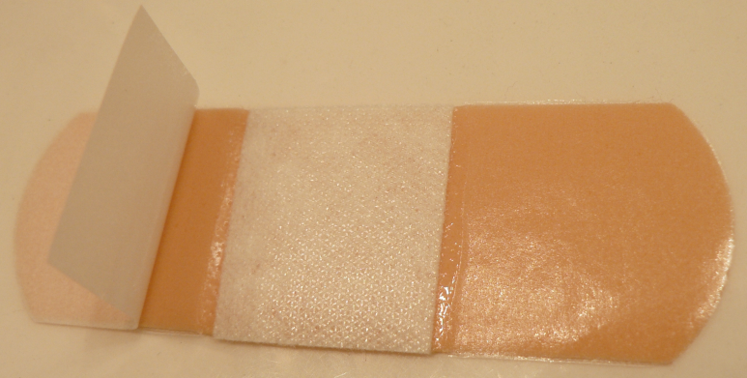
EFFECT: You got a blister on your foot.

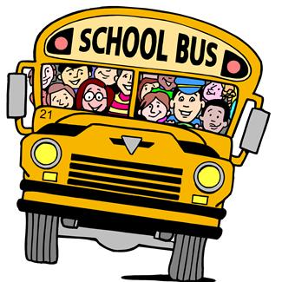
CAUSE: You didn’t check the weather before you left for school.

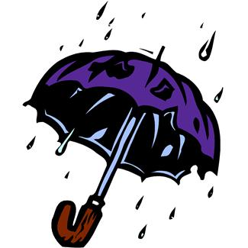

EFFECT: Your clothes are soaked because you were caught in a sudden rainstorm.

CAUSE: Your basketball team practiced hard every day after school.

EFFECT: Your basketball team won the championship.

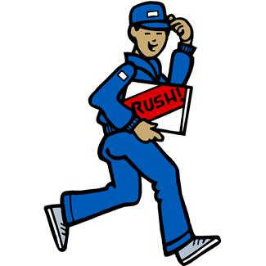
CAUSE: You got a job after school.

EFFECT: You were able to save enough money to buy an iPad.

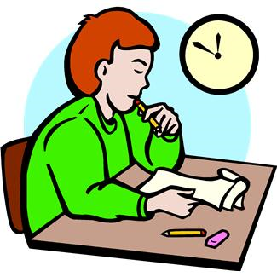
CAUSE: Jim was caught cheating on his science test.

EFFECT: Jim was suspended from school.

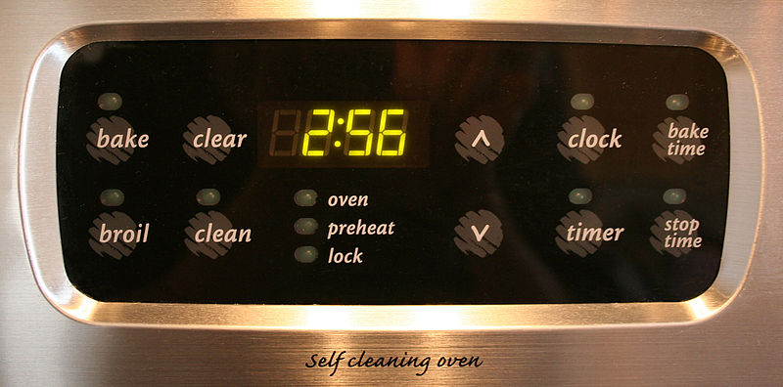
CAUSE: You forgot to set the timer on the oven.

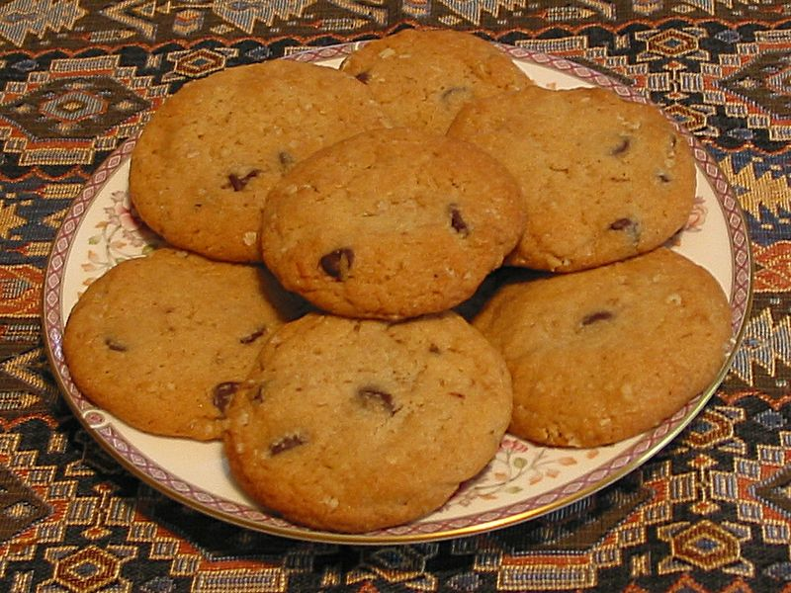
EFFECT: The cookies you were baking got burned.
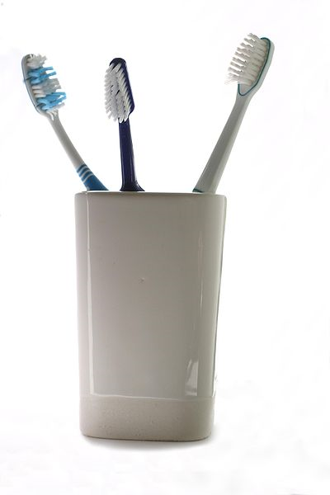
CAUSE: You brush and floss your teeth twice every day.

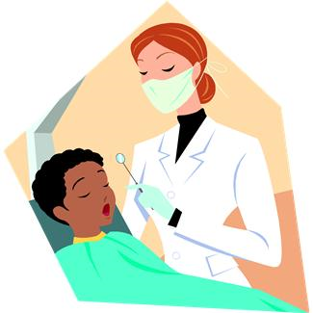

EFFECT: When you go to the dentist, you never have any cavities.
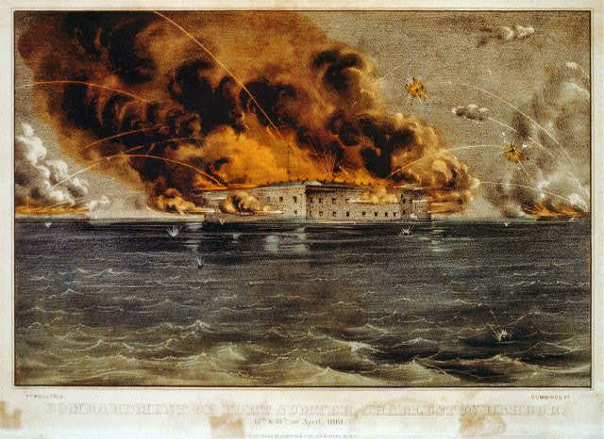
CAUSE: The Confederacy attacked Fort Sumter in Charleston, South Carolina.

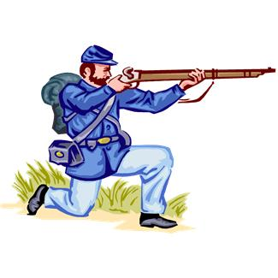
EFFECT: The American Civil War began.
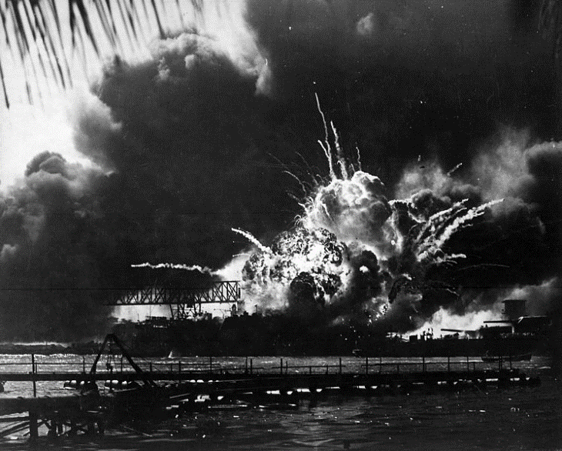
CAUSE: The Japanese Army attacked the United States naval base at Pearl Harbor, Hawaii.

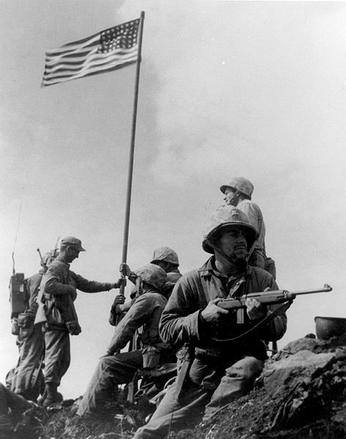
EFFECT: The United States entered World War II.

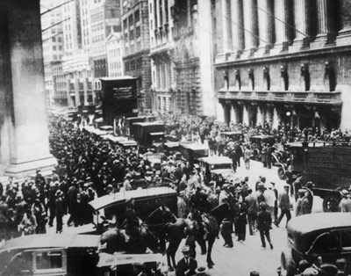
CAUSE: The stock market crashed in 1929.

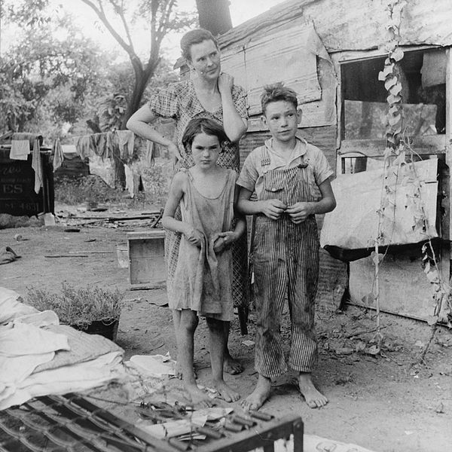
EFFECT: The United States entered the Great Depression.
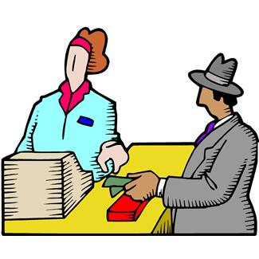
CAUSE: Bill bought a lottery ticket.

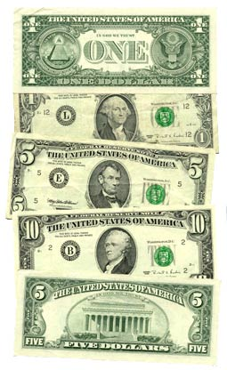

EFFECT: Bill won the lottery, and now he’s a millionaire.

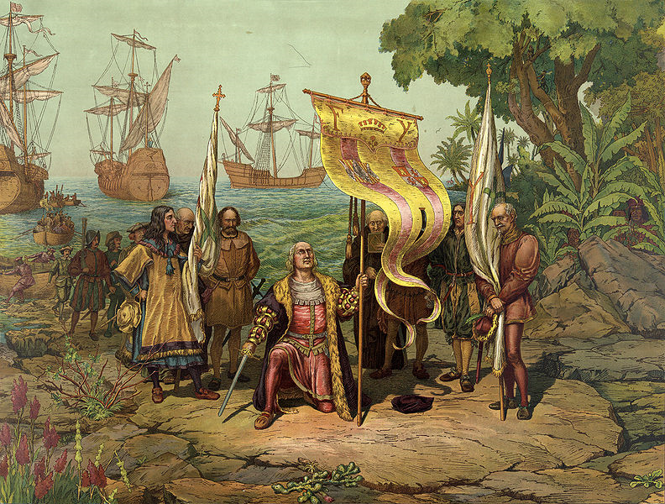
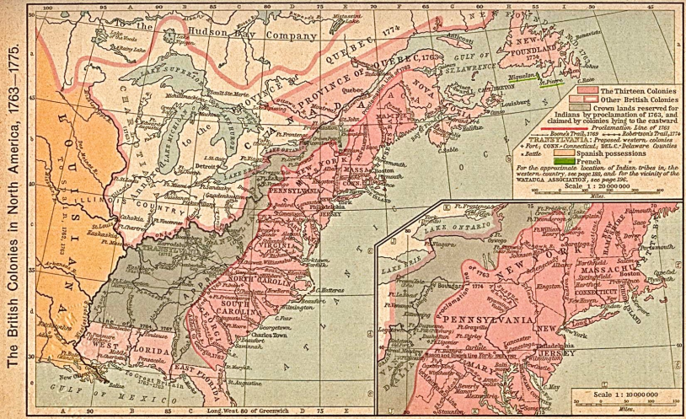
CAUSE: Christopher Columbus “discovered” the “New World.

EFFECT: European countries established colonies in North America.

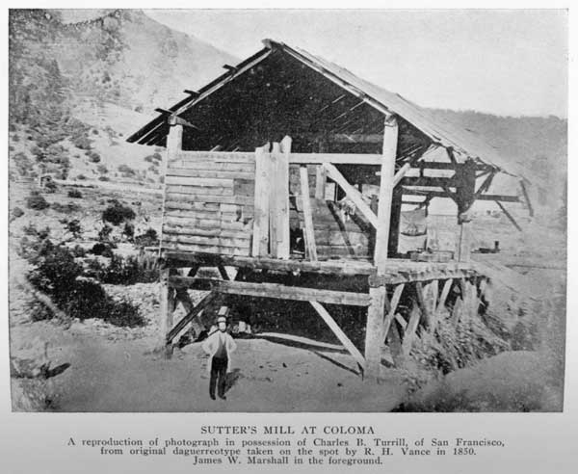
CAUSE: In 1848, gold was discovered in California.

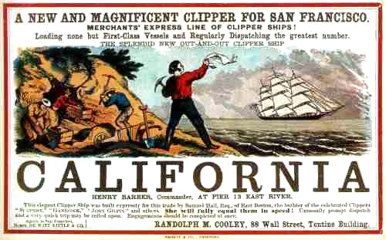
EFFECT: Thousands of settlers poured into California seeking gold.

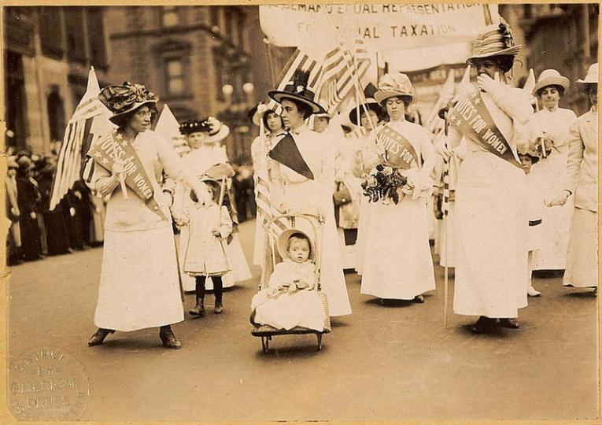
CAUSE: The United States ratified the 19th Amendment.

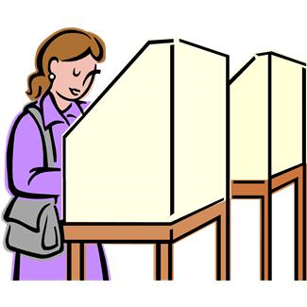

EFFECT: Women in the United States began voting in elections.

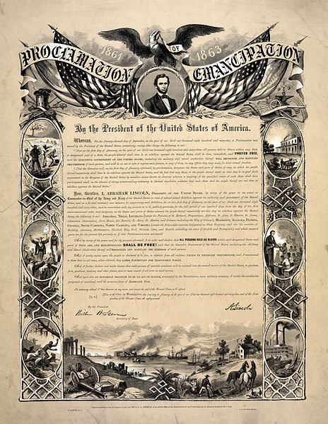
CAUSE: Abraham Lincoln issued the Emancipation Proclamation.

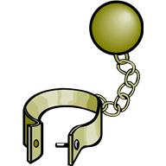
EFFECT: There is no more slavery in the United States.

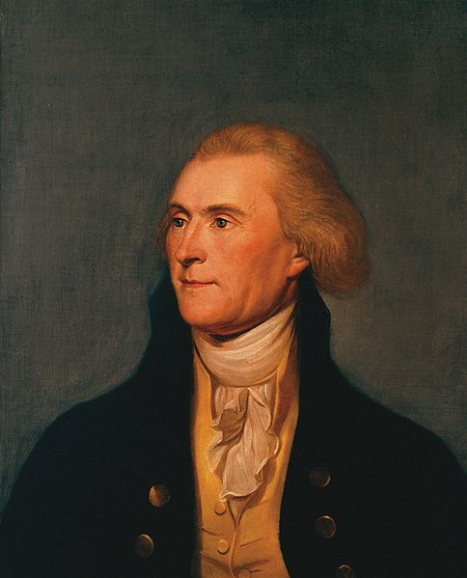
CAUSE: Thomas Jefferson purchased the Louisiana Territory from France.

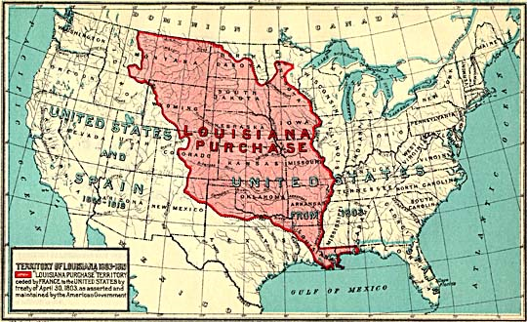
EFFECT: Thomas Jefferson doubled the size of the United States.

CAUSE: You accidentally hit your thumb with a hammer.

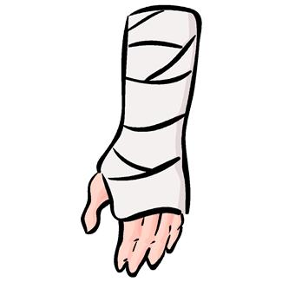
EFFECT: Your thumb really, REALLY hurts.

Slavery By the Numbers

Discussion Questions:
- Which of the occupations on this list could a person learn to do in less than a month (unskilled)? Which would require more than half a year of learning (skilled)? What might be the relationship between how long it takes to learn a job and how important others feel it is?

- How many different skilled jobs did enslaved African Americans work in Charleston?

- List the ten jobs at which the most enslaved African Americans worked. Why do you think these occupations were more popular or necessary than some of the others?

- Which occupations would require you to have mathematical skills? Which were more physical than mental? Which required both physical and mental strength or competence?

- At which jobs were there approximately the same number of enslaved African Americans and white workers? Why might this have been the case?

- In which occupations was there a significant difference in the number of white and enslaved African American workers? Why might this have been the case?

- What does the fact that there are “Apprentices” listed here tell you about how slaveholders thought about the ability of enslaved African Americans to learn skilled occupations?

- Why might slaveholders have had some enslaved African Americans trained in skilled labor if there were already white people in those occupations available to do that work?

- How might becoming a skilled worker have affected how an enslaved African American thought about him/herself? How might it have affected other enslaved African Americans in the community?

- Which of these occupations still exist today? Of those, which do you think are highly regarded and highly paid? Which are not? Can you think about why this is the case?

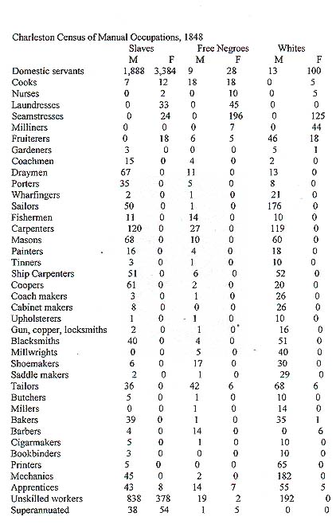
Data source: http://cghs.dade.k12.fl.us/slavery/antebellum_slavery/non_plantation_slave_life/census.htm

