[Part 5] Vocabulary Activity

ambush  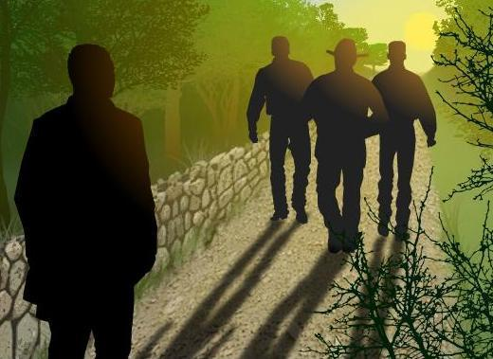  to attack by surprise | cholera  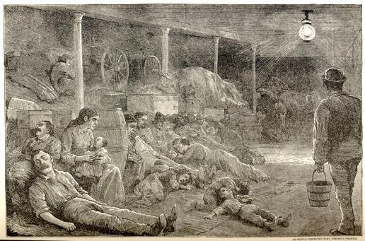  a life-threatening disease of the small intestine, which causes severe diarrhea, vomiting, and muscle cramps
commissioner  a person who has been hired to perform a business or duty for the government | Fugitive Slave Act  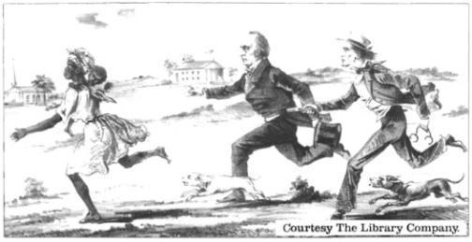  part of the Compromise of 1850, providing slave catchers with increased powers to return freedom seekers to the South and requiring northerners, and their legal officials, to assist in this process.
opportunist  a person who takes advantage of a situation, often with little thought to consequences or principles involved | quandary  a state of uncertainty; a predicament
runaway  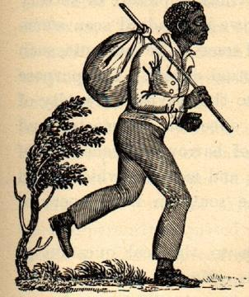  a enslaved African American trying to escape his or her owners so that he could be free | testify  to make a statement based on personal knowledge or belief
vigilant  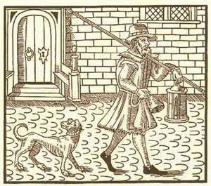  keeping careful watch for danger or trouble | witness  someone with personal knowledge of something

ambush | cholera
commissioner | Fugitive Slave Act  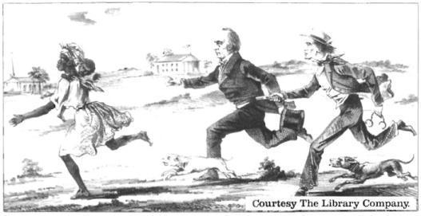
opportunist | quandary
runaway | testify
vigilant | witness

to attack by surprise | a life-threatening disease of the small intestine, which causes severe diarrhea, vomiting, and muscle cramps
a person who has been hired to perform a business or duty for the government | part of the Compromise of 1850, providing slave catchers with increased powers to return freedom seekers to the South and requiring northerners, and their legal officials, to assist in this process
a person who takes advantage of a situation, often with little thought to consequences or principles involved | a state of uncertainty; a predicament
an enslaved African American trying to escape his or her owners so that he could be free | to make a statement based on personal knowledge or belief
keeping careful watch for  danger or trouble | someone with personal knowledge of something

Name: Date:

Activity: In the years following the Civil War, formerly enslaved African Americans celebrated the end of slavery with a holiday called “Juneteenth.” Juneteenth, held annually on June 19th, commemorated the day on which enslaved African Americans in Texas learned of slavery’s abolition.

This activity imagines Lucy is telling a reporter about her life and adventures at a Juneteenth picnic in 1868, twenty years after the beginning of “Flight to Freedom.”

After reading and talking about the words and terms on the flash cards, read this excerpt from Lucy’s interview with the reporter, describing what her life was like after she made her escape. Use the cards and your memory to help you fill in the missing words and terms. Some words may be used more than once.

ambushed  cholera  commissioner | Fugitive Slave Act opportunists  quandary | runaway  testify  vigilant  witnesses

“Jonah and I enjoyed living with the Wrights in Red Oak. In 1850, however, things changed for the worse. Many people were sick with ________________. That was a terrible disease. I was scared Jonah, the Wrights or I might catch it. Fortunately, were all able to stay healthy.

However, one day something terrible happened to Uncle Morgan. He was _______________ by three white men, who ripped up his free papers and took him to jail. They accused him of being a _____________________. They were lying! They knew he was a free man. They were ___________________, wanting to take advantage of the __________________________, which encouraged people to find and capture fugitives.

Uncle Morgan was arrested. In order to save him, we needed to find ___________________ who could ___________________ that he was actually a free man. We had to find people very quickly, since the ____________________ was coming to town and he would make the final decision about what would happen to Uncle Morgan.

Later, the Wrights decided to move to Canada, since they thought it was too dangerous to stay in Ohio. I was in a __________________________ because I really wanted to stay and help the abolitionists in Red Oak, but I also knew that it would probably be safer to go with the Wrights. In the end, I stayed in Red Oak. I was very _________________ and careful about trying to avoid danger, but in the end my true identity was discovered and I was captured and sent to jail.

[Part 5] Writing Prompts

Read through all the topics. Then choose one of them to write about. Write the title of the piece at the top of your page. Write in complete sentences. After you are finished, proofread your work for correctness.
FUGITIVE SLAVE ACT: The Fugitive Slave Act, passed by Congress in 1850, made it a crime for any law enforcement official to not arrest an African American suspected of running away from slavery. Suspected fugitives were not given trials and could not legally challenge those claiming to be their owners. This led to many free African Americans/Blacks being kidnapped into slavery. Northerners used to thinking of slavery as a southern problem now saw their own officials responsible for enforcing it. Imagine yourself as a northern abolitionist who happened to also be a policeman or other official whose duty is to enforce the law. Would you stand against what you believed to be an unjust policy, or would you compromise your conscience in order to uphold the law of the land?

LUCY’S JOURNAL. Through Lucy’s eyes, think about your circumstances from the beginning to the end of this part of “Flight to Freedom.” Think about the people with whom you interacted, what you learned from them. Think about the choices you made and the consequences of those choices. Now write a journal entry from Lucy’s point-of-view summarizing what happened to you in Part 5. You may choose to illustrate one aspect of your entry.

[Part 5] Review Questions

Name: ___________________________ Date:_____________________

Directions: After you play Part 5, read and answer these questions from the point of view of your character, Lucy. You may not know all the answers, so do the best you can. Write in complete sentences and proofread your work.

1) What happens to Lucy’s “uncle,” Morgan Wright?

2) What are “Free Papers”? Why are they important?

3) What are some ways Lucy can help her uncle, Morgan Wright, prove he is a free man?

4) Who does Millie Hatcher say are “ideal” witnesses for Mr. Wright? Why are people like that ideal?

5) What do the Wrights decide to do to stay safe and remain free? Do you agree with their decision? Why or why not?

6) Why does Lucy stay in Ohio? Do you think this is a good idea? Why or why not?

7) Why is Lucy captured?

8) Describe how you think the following people may have felt about Lucy’s capture, and why they may have felt that way.
For this question, your notes don’t have to be in complete sentences.
a. Jonah
b. T.C. Bercham
c. Millie Hatcher
d. Miss Sarah King

