Guiding Question: How did Patriots and Loyalists understand and respond to the conflict between colonists in Boston and the British colonial government?
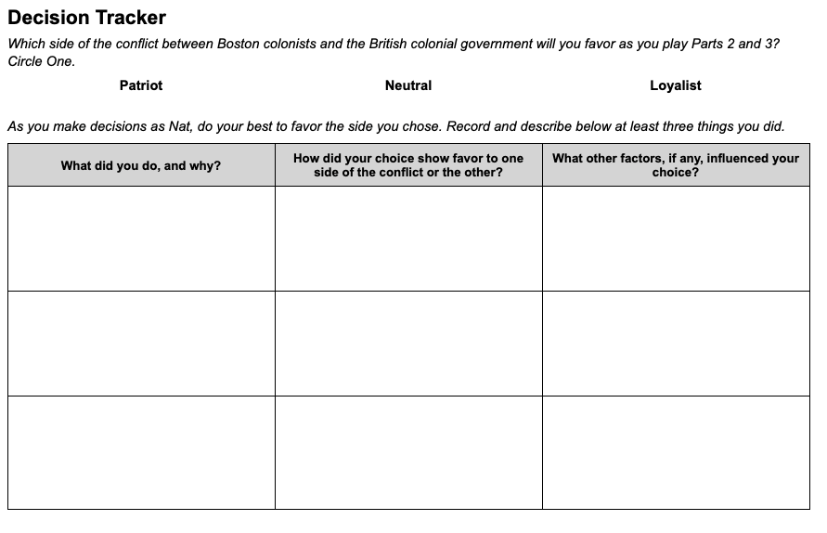 | Time: At least 20 minutes  Instructions  Explain to students that as they play Parts 2 and 3, Nat will experience many, often conflicting, demands on his decisions. Therefore, as students guide Nat, they will have to make difficult choices about how to balance their feelings about the conflict between colonists and the Crown with other priorities.  Choosing a Position  Give students copies of the Parts 2 and 3 Decision Tracker, and walk through the instructions with them. Instead of reflecting on which side they are favoring after recording their decisions on the handout (as they did previously), students will now choose a side of the conflict to favor before they play Parts 2 and 3. Encourage them to try to put that choice into action as they play the game.  On the handout, students will record the decisions they made in two situations in which their position on the conflict between colonists and the Crown comes into play. (The graphic organizer provides space for them to record an optional third decision.) We recommend that students record their decisions as they play Parts 2 and 3 rather than after they have completed them.  The Complexity of Decision Making  As they play the game, students will likely realize that consistently favoring one side of the conflict in their decisions will force them to make difficult compromises, and they may even choose to abandon their position at times for this reason. The goal is not to test or evaluate students’ abilities to stick with their chosen position, rather it is to help them experience and reflect on the complexity of decision making.  Scaffolding  Unlike the Prologue-Part 1 Decision Tracker, this version is open-ended and does not suggest which situations in the game should be the focus of the actions and choices they describe. If your students need more guidance about what to record, you can provide them one or more of the following situations:  - When Nat witnessed the protest outside the Lillies’ Shop…  - When discussing the death of Christopher Seider with Royce…  - When Nat goes to the Liberty Tree…

