**Guiding Question:** How did Patriot leaders use the media of the time to influence colonists and persuade them to support the protests against the British government?

# Document-based Writing Activity

## The Bloody Massacre and Patriot Propaganda

Leaders, groups, and governments sometimes use propaganda to get people to support a cause. *Propaganda* is shared ideas and statements that are often exaggerated, emotional, and/or false, and are spread in order to help a cause, a political leader, or a government gain popular support.

## Document and Image Analysis

Analyze Paul Revere’s engraving “The Bloody Massacre,” and a historians’ account of the event, using the questions and the chart below.

## Writing

Once you have completed the document analysis, write *three short paragraphs***:**

* **Paragraph 1**: Describe one way Paul Revere’s engraving of the Boston Massacre differs from what historians believe actually happened.
* **Paragraph 2**: Describe a second way in which Paul Revere’s engraving of the Boston Massacre differs from what historians believe actually happened.
* **Paragraph 3**: Explain how Revere’s engraving was propaganda that helped gain support for the Patriot cause throughout the colonies.

## Document 1

### The Bloody Massacre

**Creator**: Paul Revere

**Date**: March 28, 1770

**Published in**: Prints advertised and sold by Paul Revere

**Source type**: Colorized Engraving

**Introduction**: In Boston, tensions between colonists and British soldiers led to a confrontation that left five Boston workers dead when British troops fired into a crowd. Paul Revere, a well-known silversmith and a Patriot leader, published this illustration titled “The Bloody Massacre” three weeks after the incident. The event quickly became known as the Boston Massacre.

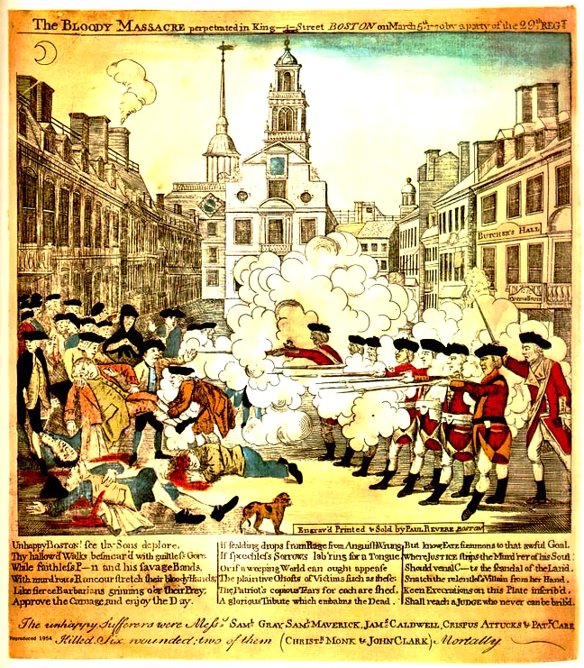

## **Caption: The bloody massacre perpetrated in King Street Boston on March 5th 1770 by a party of the 29th Regt.**

### “The Bloody Massacre” Analysis Questions

1. How does Revere help the viewer tell apart the colonists and the British soldiers?

2. How does Paul Revere portray the **COLONISTS** and their role in this event?

A. **Circle** some colonists and write a note about what you see. For example:

What positions are their bodies in?

What objects, if any, are they carrying?

What are they doing?

B. Based on your observations, how did Paul Revere want people to **think about**

the colonist’s role in the Boston Massacre?

3. How does Paul Revere portray the **SOLDIERS** and their role in this event?

A. **Circle** some soldiers and write a note about what you see. For example:

What positions are their bodies in?

What objects, if any, are they carrying?

What are they doing?

B. Based on your observations, how did Paul Revere want people to **think about**

the soldiers’ role in the Boston Massacre?

## Document 2

### Boston, March 5, 1770 — A Historian’s Account

**Creator:**American Social History Project, City University of New York

**Date:**2014

**Source type:**Historical Essay (secondary source)

**Introduction:**

After the Boston Massacre, the British soldiers and Bostonians had very different views about what had happened. The excerpt below, written in 2014, describes what historians know about that night and the days that followed.

**Document Text:**

In the winter of 1770, the residents of Boston were protesting British policies and clashed frequently with the British soldiers stationed in their city. On March 5th, feelings were still running high from the funeral of an 11-year old boy killed by a British customs official a few days earlier. Around 9 p.m., a group of young men **confronted** a British **sentry** guarding the **customs house** on King Street. As the crowd grew, the lone soldier was joined by Captain Thomas Preston and seven more soldiers, who tried to persuade the crowd to **disperse**.

Instead, the crowd (made up of about 300 people) **taunted** the British soldiers and threw snowballs and **brickbats** at them. Amid the confusion, the soldiers opened fire in a random way. In all, 11 Bostonians were hit by bullets; three died instantly, one died the next day, and one more died two weeks later. That night, Massachusetts governor Thomas Hutchinson could only convince the crowd to go home by promising that there would be a fair **inquiry** into the shootings. The next morning, Captain Preston and all eight of the soldiers were arrested.

| **Word Bank**  ***confronted*** - approached in a hostile way  ***sentry*** - a soldier standing guard at an entrance  ***customs house*** — a place where taxes are paid or collected  ***disperse*** - to break up  ***taunted*** *-* said mean or hurtful things to try to upset someone  ***brickbats*** - a piece of hard material (such as a brick); usually used to throw at a target  ***inquiry*** - official government investigation, or a study of an event |
| --- |

### Historian’s Account Analysis Questions

1. Why were there tensions between colonists and British soldiers before the night of March 5th, according to historians?
2. What actions did colonists *really* take on the night of the Boston Massacre, according to the historians?

Underline *two passages* that describe colonists’ actions, and write what they mean in your own words:

1. How would you summarize the colonists' role in the Boston Massacre?
2. What actions did soldiers *really* take on the night of the Boston Massacre, according to the historians?

Underline *two passages* that describe soldiers’ actions, and write what they mean in your own words:

1. How would you summarize the soldiers’ role in the Boston Massacre?

### “The Bloody Massacre” Analysis Graphic Organizer

| **Paul Revere’s Engraving** | **Historians’ Account** |
| --- | --- |
| How Paul Revere portrays the **colonists:** | What **colonists’** actual roles were, according to historians: |
| How Paul Revere portrays the **soldiers:** | What **soldiers’** actual roles were, according to historians: |
| What elements of Revere’s engraving make it propaganda (false, exaggerated, emotional persuasion)? | |