Guiding Question: Why did violent conflict break out between the Plains Indians and European Americans in the 1860s and 1870s? How did each side understand and respond to this conflict?

Document Analysis  “American Progress”  Examine carefully the painting American Progress by John Gast (below) and answer the questions that follow.  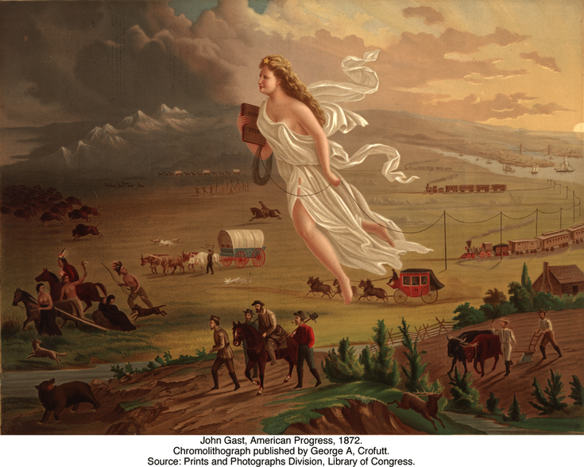  Jot down examples and observations of the following (be specific!):  Setting:  People:  Objects:  Animals:  Actions:  Discussion Questions  - What direction are all of the people, animals, and modes of transportation moving in the image? Why do you think Gast chose to paint everything moving that direction?  - There are five modes of transportation illustrated in the painting. What are they? Do you think Gast painted them in any particular order (hint: look from right to left)?  - Find the Native Americans, buffalo, and other animals in the painting. What are they doing? What is Gast saying about the future of the “wild” frontier?  - What are the men in the lower right hand corner of the painting doing? Do you think they are travelers passing through, or settlers who are planning on making their homes on this land? What makes you say that?  - The woman in the center of the painting is dressed in an ancient Greek toga. She wears the “Star of Empire” on her head, carries a schoolbook in her right hand, and is stringing a telegraph wire with her left.  - Why is she carrying a book and a telegraph wire? What is Gast saying about the benefits of westward expansion by including these objects?  - Why is the woman looking and moving westward?  - Why did Gast name his painting American Progress? Who would agree that the painting illustrates progress? Who would disagree? | Time: 30 minutes  Instructions  Goal/Intent: Students examine the painting “American Progress” by John Gast before engaging with a series of questions that guide them through a closer analysis of the image.  Building on their game knowledge and their analysis of the sources, students discuss how the painting sheds light on how both European-Americans and the Plains Indians understood and responded to the violent conflicts between them in the 19th century.  Document Analysis (10 mins)  If possible, project “American Progress” large enough so students can see the details of the landscape and the objects in the background. Here is a link to a large version.  Make sure students take time to simply observe before starting to make interpretations of Gast’s painting. Consider modeling a close reading of the image by pointing out some examples and observations that students might jot down in the table on their handouts. Then have students work in groups or individually to complete their close reading.  Discussion (20 min)  Walk students through a deeper analysis of the painting and its meaning using the discussion questions. If your students are not already familiar with the concept of manifest destiny, this is an ideal time to introduce the term.  Discuss the meaning of the word progress  in the title of this painting with students. Is progress a neutral phenomenon in this depiction, or does it benefit some at the expense of others?  Extension Activities:  Use one of the following activities to explore “American Progress” from the perspective of the Northern Cheyenne.  1. In 1866, Roman Nose, a Northern Cheyenne warrior, stated:  “We will not have the wagons [steam locomotives] which make a noise in the hunting grounds of the buffalo. If the palefaces come farther into our land, there will be scalps of your brethren in the wigwams of the Cheyennes. I have spoken.”  From “Native American Warriors Describe the Threats to their Way of Life,” HERB: Resources for Teachers, accessed August 8, 2013, http://herb.ashp.cuny.edu/items/show/1541  Analyze American Progress from Roman Nose’s point of view. What would he say about the symbolism used and the message of the painting?  2. Create a painting or drawing of your own depicting American Progress from Little Fox’s perspective. What symbols would he use, and how would he portray American westward expansion?

