Guiding Question: How did a young Cheyenne determine their future paths and roles in their communities?
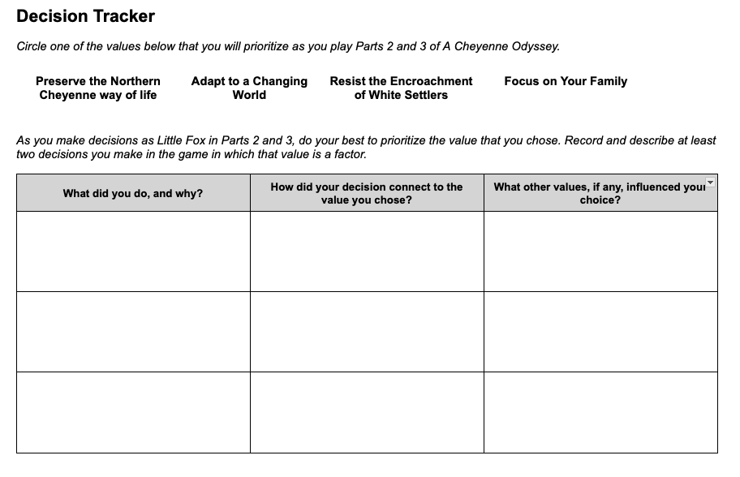 | Time: At least 20 minutes  Instructions  Explain to students that as they play Parts 2 and 3, Little Fox will experience many, often conflicting, demands on his decisions. Therefore, as students guide Little Fox, they will have to make difficult choices about how to respond to the encroachment of white soldiers and settlers.  Prioritizing a Value  Give students copies of the Parts 2 and 3 Decision Tracker, and walk through the instructions with them. Instead of reflecting on values after recording their decisions on the handout (as they did previously), students will now choose a value to prioritize before they play Parts 2 and 3. Encourage them to try to put that value into action in the choices they make in the game.  On the handout, students will record at least two decisions they made in which their prioritized value came into play. (The graphic organizer provides space for three examples.) We recommend that students record their decisions as they play Parts 2 and 3 rather than after they have completed them.  The Complexity of Decision Making  As they play the game, students will likely realize that consistently prioritizing one value in their decisions will force them to make difficult compromises, and they may even choose to abandon their prioritized value at times for this reason. The goal is not to test or evaluate students’ abilities to stick with their chosen value - rather, it is to help them experience and reflect on the complexity of decision making.

