Guiding Question: Why did violent conflict break out between the Plains Indians and European Americans in the 1860s and 1870s? How did each side understand and respond to this conflict?

Document-based Writing Activity  Different Perspectives on the Battle of the Greasy Grass  On Sunday, June 25, 1876, 263 U.S. soldiers were killed by a combined force of Lakota, Cheyenne, and Arapaho warriors along a small river called the Little Bighorn, located in present-day Montana. Much about the battle is disputed, and a matter of perspective..  To understand these differences in perspective, you and your classmates will compare and contrast first-hand accounts of the conflict that led to the battle.  Document Analysis  Use the Note-Taking Tool below to take notes on the two documents that follow.  Writing  Once you have completed the document analysis, write two short paragraphs:  - Paragraph 1: What is the point of view of source #1, and who does the author believe was most responsible for the conflict that led to the Battle of the Greasy Grass, and why?  - Paragraph 2: What is the point of view of source #2, and who does the author believe was most responsible for the conflict that led to the Battle of the Greasy Grass, and why?  Be sure to cite details from the documents to support your statement.  Discussion Questions  - Why do you think these two sources provide such different perspectives on what led to the Battle of the Greasy Grass?  - Based on what you have learned about this history from the game and other historical sources, which account do you think is closer to the truth? What makes you say that?  - In order to determine what really led to the Battle of the Greasy Grass, what other kinds of sources would you look for next?  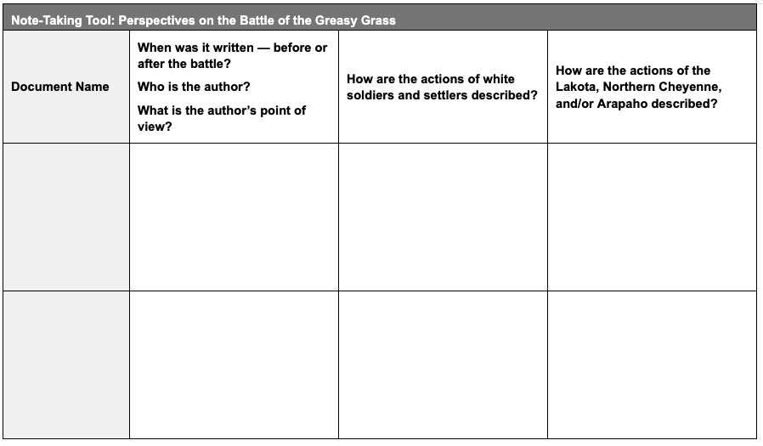  Source 1 [adapted]: Report to the Commissioner of Indian Affairs  On the 9th of November, 1875, United States Indian Inspector E. C. Watkins reported to the Commissioner of Indian Affairs:  “I am writing to tell you about the attitude of certain wild and hostile bands of Lakota Indians in Dakota and Montana that I observed during my recent tour through their country, and what I think should be the policy of the Government toward them. I refer to Sitting Bull's band and other bands of the Lakota Nation under chiefs who are not well-known, but no less untamable and hostile. These Indians roam over Western Dakota, and Eastern Montana, including the rich valleys of the Yellowstone and Powder Rivers, and make war on friendly tribes nearby.  From their central position they strike to the East, North, and West, steal horses, and plunder from all the surrounding tribes, as well as frontier settlers and luckless white hunters or emigrants who are not in sufficient force to resist them.  The best policy, in my judgment, is to send troops against them in the winter, the sooner the better, and whip them into submission. They richly deserve punishment for their neverending warfare, and their numerous murders of white settlers and their families, or other unarmed white men.”  (Source: Watkins Report cited in letter from J.D. Cameron, Secretary of War to President Grant July 8, 1876, http://www.littlebighorn.info/Articles/gra8876.htm)  Language adapted for student readability. “Lakota” has been substituted for “Sioux” to reflect the name of the tribe often preferred by its members today.  Source 2 [adapted]: Interview with a Cheyenne Indian  In 1922, Kate Bighead, a Cheyenne Indian, told the following story to Dr. Thomas Marquis, a historian of the Battle of Little Bighorn:  “Little Bighorn was not the first meeting between the Cheyennes and Long Hair [General Custer]. Early in the winter of 1868, Long Hair and the Seventh Cavalry attacked our camp on the Washita River, killing Chief Black Kettle and his band, burning their tipis, and destroying all their food and belongings.  In the spring Long Hair promised peace and moved the Cheyenne to a reservation. When gold was discovered, white people came and the Indians were moved again. My brothers and I left for the open plains where our band of Cheyenne was again attacked by white soldiers in the winter of 1875. We were forced to seek help from a tribe of Lakota. We joined Sitting Bull and the Lakota and decided to travel and hunt together as one strong group. As conditions on the reservations became worse, more and more Indians moved west joining our group.  Six tribes lived peacefully for several months, hunting buffalo, curing the meat for the winter months, and tanning buffalo hides. In the early summer, 1876 we set up camp near Little Bighorn River. Soldiers were spotted by some hunters to the south of the camp. Some young men went off to fight them and when they returned the next day they carried the bodies of several dead warriors with them.  The chiefs then decided the group should move to the mouth of the river where there was plenty of game. On the first day of camp the peace was shattered when two boys ran into camp warning of soldiers. Then shooting could be heard. Women and children went to hide in the brush, some women carried away tipis and their belongings, others just ran with their children. Old men helped the young men to put on their war paint and dress. War ponies were brought into camp from the herds and the warriors mounted them and galloped away.”  (Source: Kate Bighead, a Cheyenne Indian, told this story to Dr. Thomas Marquis in 1922. Dr. Marquis was a doctor and historian of the Battle of Little Bighorn in the 1920s. He interviewed and photographed Cheyenne Indians.)  Language adapted for student readability. “Lakota” has been substituted for “Sioux” to reflect the name of the tribe often preferred by its members today. | Time: At least 45 minutes  Goal/Intent: Building on their game knowledge, students develop their document-reading, writing, and discussion skills as they wrestle with conflicting accounts of the conflicts between the Plains Indians and white soldiers and settlers leading up to the Battle of the Greasy Grass.  These activities will help students address the guiding question: Why did violent conflict break out between the Plains Indians and European Americans in the 1860s and 1870s? How did each side understand and respond to this conflict?  Instructions  Document Analysis (15 min)  Give students at least 15 minutes to read and summarize the two documents using the Note-Taking Tool.  Writing (20 min)  Have students use their notes to write two paragraphs explaining the conflicting information provided in the two documents.  Discussion (15 min)  Have students discuss the 3 follow-up questions.  Notes on Sources  Source 1 was written in 1875, at least 6 months before the Battle of the Greasy Grass, from the point of view of a white Indian inspector for the federal government. The inspector, E.C. Watkins, describes only the behavior and supposed “untamed” nature of Lakota Indians. He says nothing about the behavior of white soldiers and settlers.  Source 2 is an oral history told in 1922, 46 years after the battle, from the point of view of a Cheyenne Indian who lived through the violent conflicts of the 1870s. Kate Bighead’s account reflects more of the interactions between Native Americans and white settlers and soldiers that students have seen in the game.  Differentiation  If your students need support in completing this activity, consider the following suggestions for scaffolding the task:  Additional Scaffolding  To scaffold the writing task, you might provide students with sentence starters or model paragraphs. Consider adapting the following series of sentence starters that make up a paragraph:  Source 1 was written by _____. He writes from the point of view of a _____. In his 1875 report, he blamed the conflict that led to the Battle of the Greasy Grass on _____. He writes that it is necessary to send troops because _____. He also accuses _____ of _____. His perspective is that _____.  Source 2 is an account told by _____. She speaks from the point of view of a _____. In her 1922 testimony, she blamed the conflict that led to the Battle of the Greasy Grass on _____. For example, she recalled that _____. She also accuses _____ of _____. Her perspective is that…  Additional Complexity  To increase the complexity of the writing task, you might ask students to write a third paragraph with the following prompt:  Paragraph 3: Which account do you think is more reliable and why? Considering both the biases and points of view of the authors and what you have learned about this history from the game in your answer.

