Guiding Question: What conditions prompt immigrants to leave their homeland and/or draw them to come to the United States, and what challenges do they face when they arrive?
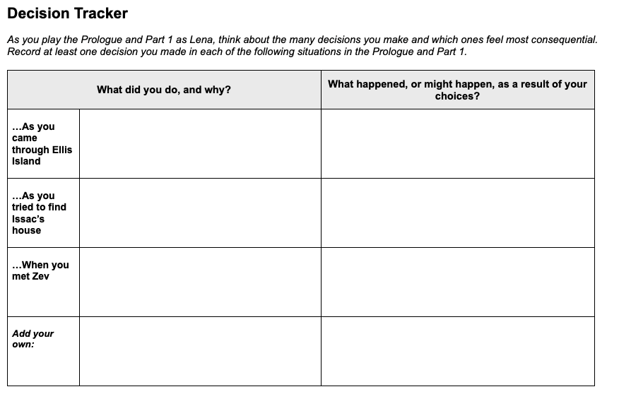  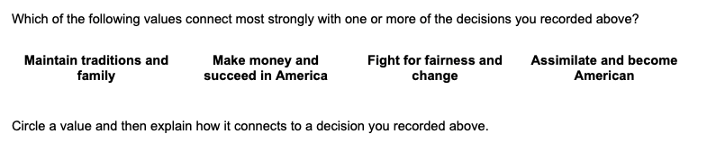 | Time: At least 20 minutes  Instructions  Making Decisions as Lena Brodsky  Explain to students that as they play City of Immigrants they will be asked to make many choices that will determine the outcome for Lena, the character they are playing. They can choose what type of person they want their Lena to be through the choices they make. Part of the fun and value of role-playing games is the ability to take on different personalities and explore different options.  Assure students that there are no right or wrong answers and that it is fine to make choices that may be considered risky or bold. Explain that the process of thinking about different choices and their possible outcomes can help them to gain empathy—an understanding of the feelings of others—especially for historical characters. Ask students to consider how Lena as a young, Jewish woman and an immigrant from Russia may make different decisions than young people today.  Introduce the Decision Tracker  Ask students to record their progress as they play the Prologue and Part 1 on this Decision Tracker (later sections of the game have different Decision Tracker handouts). They should identify at least one decision they make in each of the situations listed on the handout. They should make a short note whenever they make a key decision, pausing to think about the following:  - Why are they making that choice?  - Is this the choice they themselves would make or that they think an immigrant in 1907 would make?  - How might Lena’s gender, ethnic background, religion, or age shape the choices they make for her?  - What happened as a result of the decision?

