Guiding Question: How do immigrants balance their commitment to family, cultural, and religious traditions with their desire to assimilate or explore the new opportunities in America?
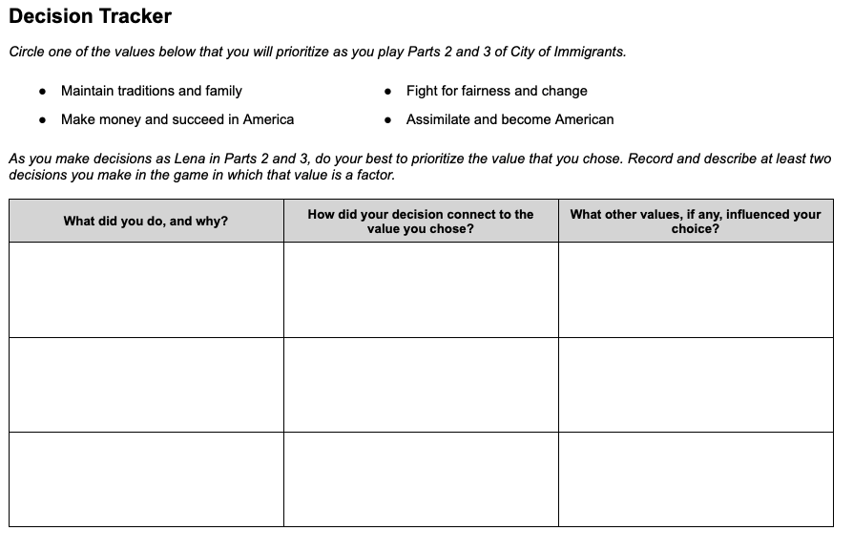 | Time: At least 20 minutes  Instructions  Explain to students that as Lena balances aspirations for her new life in America with her family obligations, her choices become more complicated. As students guide Lena, they will have to weigh conflicting priorities and sometimes make difficult trade offs.  Prioritizing a Value  Give students copies of the Parts 2 and 3 Decision Tracker, and walk through the instructions with them. Instead of reflecting on values after recording their decisions on the handout (as they did previously), students will now choose a value to prioritize before they play Parts 2 and 3. Encourage them to try to put that value into action in the choices they make in the game.  On the handout, students will record at least two decisions they made in which their prioritized value came into play. (The graphic organizer provides space for three examples.) We recommend that students record their decisions as they play Parts 2 and 3 rather than after they have completed them.  The Complexity of Decision Making  As they play the game, students will likely realize that consistently prioritizing one value in their decisions will force them to make difficult compromises, and they may even choose to abandon their prioritized value at times for this reason. The goal is not to test or evaluate students’ abilities to stick with their chosen value, rather it is to help them experience and reflect on the complexity of decision making.  Scaffolding  Unlike the Prologue-Part 1 Decision Tracker, this version is open-ended and does not suggest which situations in the game should be the focus of the actions and choices they describe. If your students need more guidance about what to record, you can provide them one or more of the following situations:  - When Lena must do the laundry and go shopping…  - When Lena is deciding how to spend her free time…

