Guiding Question: How did Patriots and Loyalists understand and respond to the conflict between colonists in Boston and the British colonial government?
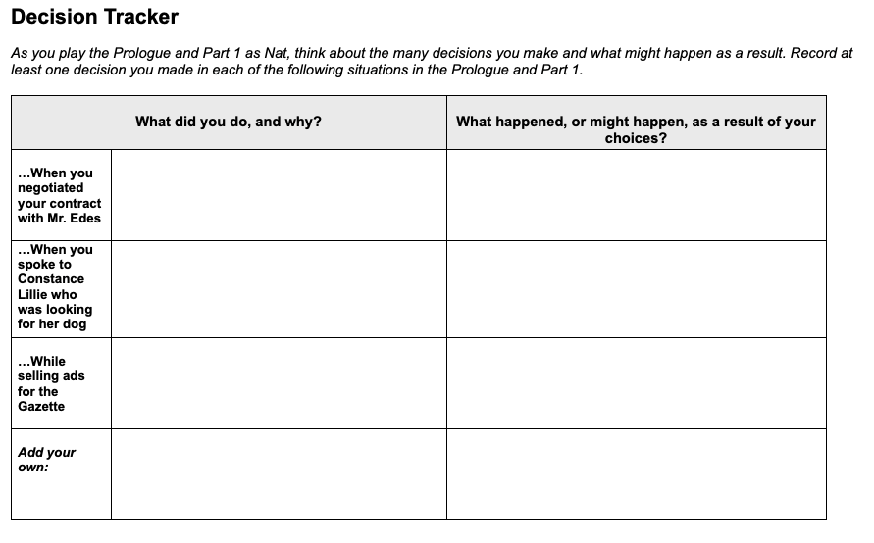  Your decisions in the game so far have begun to build your political reputation in Boston. Towards which side of the conflict between Boston colonists and the British colonial government do you find yourself leaning?  Patriot Neutral Loyalist  Circle the position you feel yourself leaning towards so far, and then explain how one or more of the decisions you recorded above does or does not support that position. | Time: At least 20 minutes  Instructions  You Are, and You Aren’t Nat  Explain to students that in For Crown or Colony? they will be asked to make many choices that will determine the outcomes for Nat, the character they are playing. They can choose what type of person they want their Nat to be through the choices they make. Part of the fun and value of role-playing games is the ability to take on different personalities and explore different options.  Assure students that there are no right or wrong answers and that it is fine to make choices that may be considered risky or bold. Explain that the process of thinking about different choices and their possible outcomes can help them to gain empathy—an understanding of the feelings of others—especially for historical characters. Ask students to consider how Nat, a teenager in 1770 Boston, may make different decisions than young people today.  Introduce the Decision Tracker  Ask students to record their progress as they play the Prologue and Part 1 on this Decision Tracker (later sections of the game have different Decision Tracker handouts). They should identify at least one decision they make in each of the situations listed on the handout. They should make a short note whenever they make a key decision, pausing to think about the following:  - Why are they making that choice?  - Is this the choice they themselves would make or that they think a teenager in 1770s Boston would make?  - How might Nat’s gender, culture, age, and other aspects of his identity shape the choices students make for him?  - What happened as a result of the decision?  Tell students that they may not find out what happened as a result of some of their decisions until near the end of Part 1, when they discuss their day with Mr. Edes.

