*Much of “A Cheyenne Odyssey” is based on actual events, places, and people. While some characters are fictional and serve to illustrate the various components of Northern Cheyenne life on the Plains, others are based on actual historical figures. Brief background information is included here on the Mission’s fictional characters, biographical information on the historical figures, and background on the real places featured in the game.*

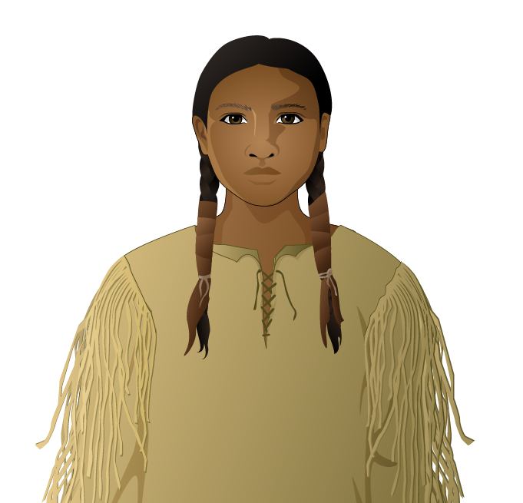

**Little Fox (fictional character)**

When the game begins, Little Fox is twelve years old. He is a member of the Northern Cheyenne tribe, one of several American Indian tribes living in the Northern Great Plains during the mid-19th century. Little Fox was born in the Powder River Valley (in what is now the state of Montana). He lives with his mother, sister, and uncle as part of a band with approximately one hundred fellow Cheyenne. Along with other young boys, he is responsible for tending and training a herd of horses. As Little Fox grows older, he will join a warrior society and participate in the buffalo hunts that his tribe depends on to survive. Little Fox’s character is based on a real person, Wooden Leg, a Northern Cheyenne warrior whose memoir describes childhood on the Great Plains and the conflicts leading up to the Battle of the Little Bighorn.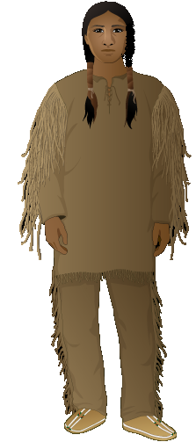

**Crooked Rabbit (fictional character)**

Little Fox’s friend, who also helps watch after the band’s horses. His father and Little Fox’s father were close friends who both belonged to the Elk warrior society. As the game begins, he is 16 years old and a bit cautious.

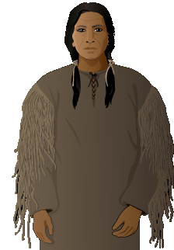

**Fire Wolf (fictional character)**

Little Fox’s uncle, a member of the Elk warrior society. Like many Northern Cheyenne, he opposes the US Army’s construction of forts along the Bozeman Trail, a wagon road for miners traveling to gold mines in western Montana. He fights with Lakota allies against US soldiers in the Battle of a Hundred Slain (Fetterman’s Massacre).

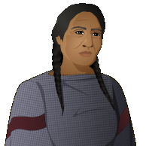

**Yellow Fox (fictional character)**

Yellow Fox is Little Fox’s mother. She is responsible for butchering and preparing all of the meat for the family, gathering wild turnips and berries, cooking all meals, maintaining the family’s lodge, and packing up the family belongings and tipi as they move from place to place.

**Calling Bird (fictional character)**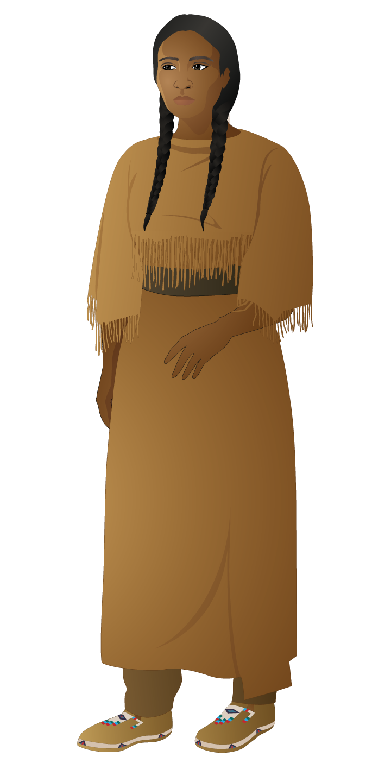

Calling Bird is Little Fox’s older sister. At the beginning of the game she is 17 years old. She is very skillful at making and decorating clothes and beading moccasins. She is being courted by two suitors, Black Moon and Many Horses.

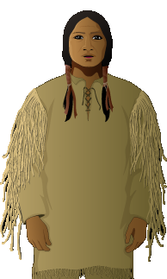

**Many Horses (fictional character)**

A Lakota warrior who is noted for his trading skills. He has made many trips to the white man’s trading post. He wants to marry Calling Bird in order to strengthen the alliance between his Lakota band and the Northern Cheyenne.

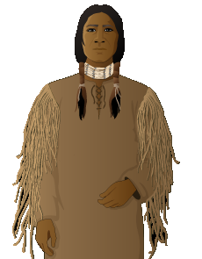

**Black Moon (fictional character)**

A Southern Cheyenne warrior whose family traveled with Southern Cheyenne Chief Black Kettle’s band. Even though Chief Black Kettle had pledged peace with the whites, US soldiers attacked his settlement at Sand Creek in 1864 and killed over one hundred Cheyenne. Black Moon managed to escape, but his entire family was killed. He has traveled north to start a new life. He hopes to marry Calling Bird.

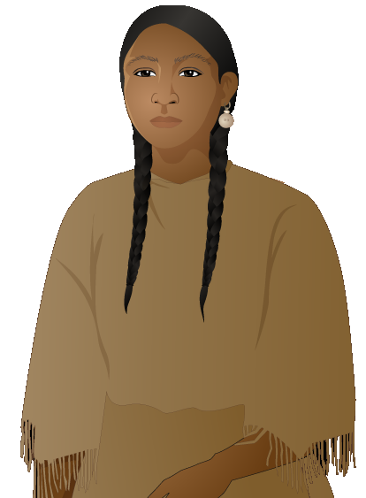

**Blue Feather (fictional character)**

Blue Feather isa young Northern Cheyenne woman who likes to ride horses and help with hunting. She knows the creeks and hills of the Powder River Valley as well as any warrior. Her family often travels with Chief Dull Knife’s band.

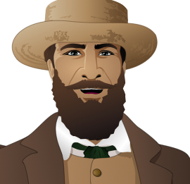

**Big Eared White Man (fictional character)**

A trader who supplies metal goods, woven cloth, guns, and ammunition to Plains Indians in exchange for buffalo hides. He has worked for the American Fur Company since the 1840s and has always maintained good relations with the Plains Indians. He is worried about the declining number of buffalo that his trade relies on.

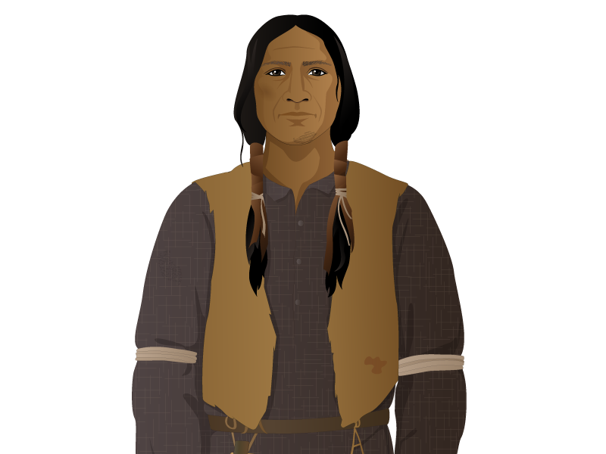

**Porcupine (historical figure, c. 1847-1929)**

A Southern Cheyenne healer and warrior. He was a member of the Dog Soldiers, a Cheyenne warrior society known for its bravery, and was active in opposing the construction of the transcontinental railroad. Porcupine gained fame through his leadership of the northern ghost dance movement in the late 1880s.

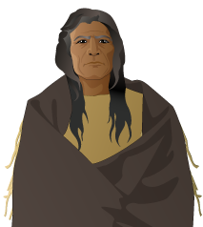

**Chief Dull Knife / Morning Star (historical figure, c. 1810-1883**)

A prominent Northern Cheyenne chief and Dog Soldier. Known as a courageous warrior, Dull Knife fought in the Battle of a Hundred Slain (Fetterman’s Massacre) and signed the Treaty of Fort Laramie in 1868. Dull Knife’s band fought in the Battle of Little Bighorn, though he did not participate himself. In 1878, Chiefs Dull Knife and Little Wolf led nearly three hundred Cheyenne on an exodus from Oklahoma, where they had been forced to relocate, back to their homeland. During the journey, Dull Knife and a band of mostly women, elderly, and children split from Little Wolf to seek refuge at Red Cloud agency in Nebraska. They were instead imprisoned by white soldiers in nearby Fort Robinson. Rather than face removal back south, they broke out of prison. Many were killed, though Dull Knife survived and lived until 1883. He is buried in Lame Deer, Montana, on land that he had helped to secure for his people.

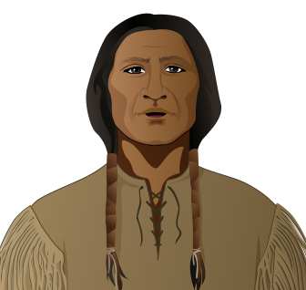

**Little Wolf (historical figure, (c.1818-1904)**

A prominent Northern Cheyenne chief. In 1868, Little Wolf was among the signers of the Fort Laramie Treaty. Little Wolf and his band were not at Little Bighorn, but they were subsequently attacked by US troops. In 1878, Chiefs Little Wolf and Dull Knife led nearly three hundred Cheyenne on an exodus from Oklahoma, where they had been forced to relocate, back to their homeland. Little Wolf and his band split from Dull Knife’s group and hid in the Nebraska Sand Hills. In 1879, Little Wolf surrendered to US troops. His band was allowed to stay on the Northern Plains. He became a scout for the US Army, and spent the rest of his years on the Northern Cheyenne reservation.

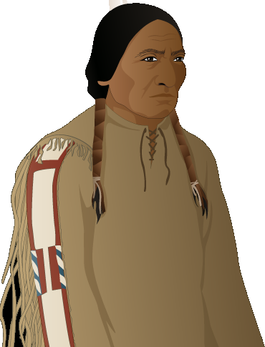

**Sitting Bull (historical figure, c. 1831-1890)**

Sitting Bull was a tribal chief of the Hunkpapa Lakota who led numerous attacks against US forts and white incursions into Lakota lands. He refused to sign the 1868 Fort Laramie Treaty, and resisted the 1875 order for all Plains Indians to report to reservations. Chief Sitting Bull was a firm ally of the Cheyenne, and a major leader at the Battle of Little Bighorn. Following the defeat of Custer, Chief Sitting Bull refused to surrender and went into exile in Canada for four years.

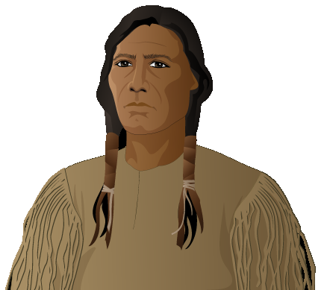

**Crazy Horse** **(historical figure, c. 1840-1877)**

Crazy Horse was a prominent war leader of the Oglala Lakota who resisted government encroachment on native lands. He fought along with Cheyenne warriors at the Battle of a Hundred Slain (Fetterman’s Massacre) and in the Battle of Little Bighorn, which defeated Custer and his forces. In 1877, Crazy Horse and other prominent Oglala leaders surrendered to the Red Cloud Agency in order to protect their fellow warriors. Crazy Horse was killed several months later.

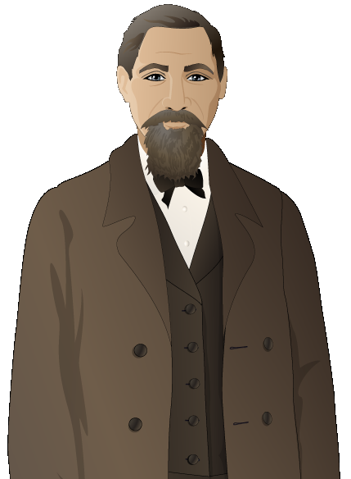

**Dr. John J. Saville (historical figure)**

A physician from Sioux City, Iowa, Saville was the Indian Agent at Red Cloud Agency from fall 1873 to late 1875. He arrived shortly after the Agency was moved to Nebraska, amid growing tensions between the army and the Lakota and Cheyenne. He requested greater military protection after the murder of an agency clerk and facilitated the construction of Fort Robinson near the Red Cloud Agency. He also played a role in the first treaty negotiations between the government and the Lakota for the Black Hills.

**Locations in Mission 3: “A Cheyenne Odyssey”**

**The Powder River Valley**

The Powder River Valley is located in an area of southeast Montana and northeast Wyoming. It was once the traditional home and hunting grounds of the Northern Cheyenne. In the 1870s, US government troops attempted to displace the Northern Cheyenne and other indigenous groups from the Powder River Valley and other locations, and place them into reservations. On March 17, 1876, U.S. troops attacked a Cheyenne encampment near Powder River, which served as the starting point for the Great Sioux War of 1876.

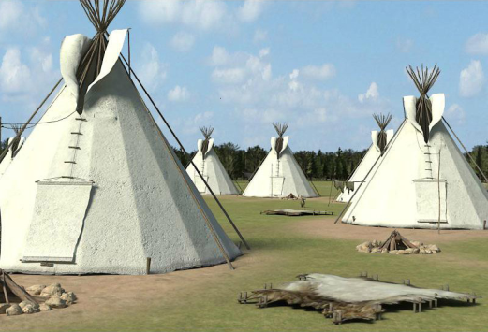

**The Trading Post**

From the 1820s through the 1860s, trading posts served as the center of exchange between Europeans, Americans, and Plains Indians. The fictional Hat Creek trading post in “A Cheyenne Odyssey” is based on Fort Union Trading Post, located further north along the North Dakota-Montana border on the Upper Missouri River, where the Cheyenne, Lakota, and other tribes traded buffalo robes for weapons, metal utensils, and woven cloth. Like most trading posts, Fort Union was run by a large company, in this case the American Fur Company, under license from the US government. Trading posts could employ up to one hundred people, and often hosted travelers as well. Each year, Plains Indians traded over 25,000 buffalo hides for $100,000 worth of merchandise at Fort Union Trading Post.

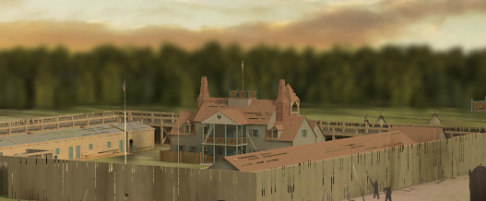

**Transcontinental Railroad**

The construction of the First Transcontinental Railroad began in 1863 and was completed in 1869. The railroad connected San Francisco Bay and the Pacific Coast with Council Bluffs, Iowa, which had access to the Eastern US railroad network. In 1868, the railroad was nearly completed, and it had already been constructed through the Great Plains, home to numerous American Indian tribes. Throughout the building process, many American Indians, including the Cheyenne, resisted the construction of railroads by sabotaging train tracks and attacking supply trains. The Cheyenne succeeded in derailing a train in 1867.

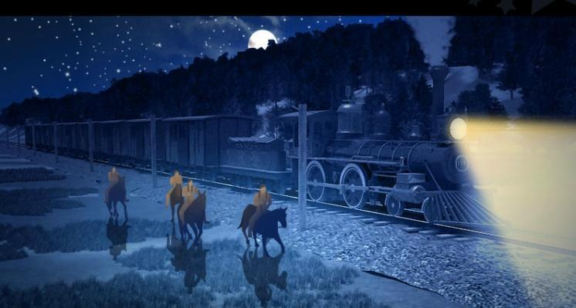

**Great Sioux Reservation**

The Great Sioux Reservation was created in the Fort Laramie Treaty of 1868 as a large expanse of land reserved for the Lakota and their allies. The reservation originally included all of western South Dakota and a small portion of Nebraska, and included the Black Hills, a region sacred to the Lakota and Cheyenne. However, with the discovery of gold in the Black Hills, the US government reduced the size of the reservation by removing the Black Hills from it in 1877.

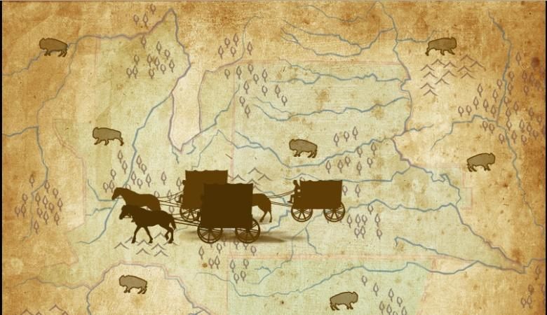

**Red Cloud Agency**

The Red Cloud Agency, created in 1871, moved to three different locations in Wyoming and Nebraska throughout its seven-year history. The agency served as a precursor to an American Indian reservation and oversaw the Oglala Lakota, Northern Cheyenne, and Arapaho tribes. The agency was involved in numerous confrontations with native tribes, most prominently in the Great Sioux War of 1876-1877. In 1878, the agency moved to South Dakota and was renamed the Pine Ridge Indian Reservation.

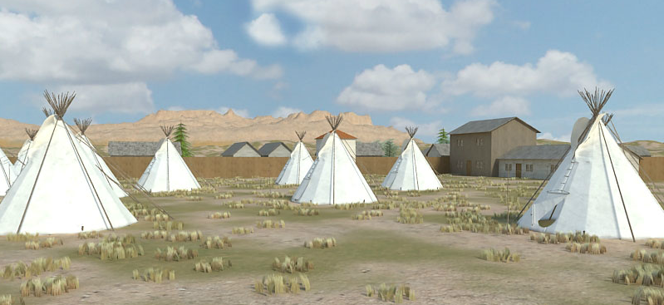

**Little Bighorn**

Little Bighorn is a river in eastern Montana, and the site of a major confrontation between the Lakota, Northern Cheyenne, and Arapaho against the US military under General George A. Custer. The famous Battle of Little Bighorn, known to the Cheyenne as the Battle of the Greasy Grass, took place on June 25th and 26th, 1876. Custer and almost all of his regiment perished in the conflict.

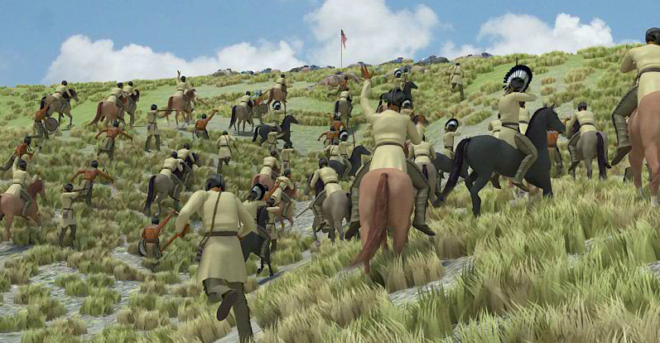

**Darlington Agency**

The Darlington Agency was established in 1868 and served the Southern Cheyenne and Arapaho tribes. One of the main purposes of the agency was to Christianize the American Indians by bringing in missionaries and constructing schools and churches. After the Battle of Little Bighorn, the Northern Cheyenne were forced to relocate to the Darlington Agency, which created overcrowding, starvation, and increased illness. In 1878, a group of Northern Cheyenne fled the agency to return to their traditional homelands in the Wyoming and Montana area.

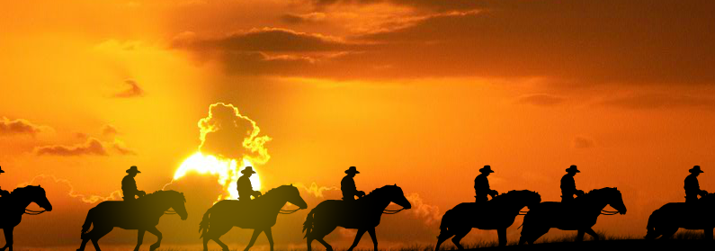

**Fort Robinson**

Fort Robinson was built in 1874 near the Red Cloud Agency in Nebraska amidst rising tensions between the agency and the Lakota Indians. In May 1877 Crazy Horse surrendered at Fort Robinson, and was killed by guards there four months later. In October 1878, most of Chief Dull Knife’s band, which had fled the Darlington Agency to return north, were captured and imprisoned in Fort Robinson. Three months later, Chief Dull Knife’s band of Cheyenne made a dramatic escape, but most were shot down within a mile of Fort Robinson.

