*Much of “City of Immigrants” is based on actual events, places, and people. While some characters are fictional and serve to illustrate the various components of New York City in the early twentieth century, others are based on actual historical figures. Brief background information is included here on the MISSION’s fictional characters, biographical information on the historical figures, and background on the real places featured in the game.*

**Lena Brodsky (fictional character)**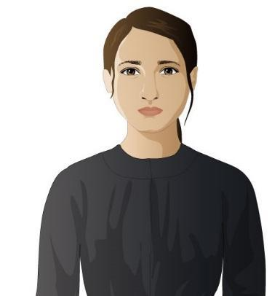

Fourteen-year-old Lena was born in Minsk, Russia, where her family suffered from the anti-Jewish violence of the pogroms. Her older brother leaves for America and sends money back for another ticket. When Lena’s younger brother was unexpectedly drafted into the Czar’s army, Lena takes his place and travels on her own to meet her older brother in New York. She hopes to save enough money to pay for tickets for her parents to leave Russia as well. In New York, many different social, educational, and work opportunities and challenges await her.

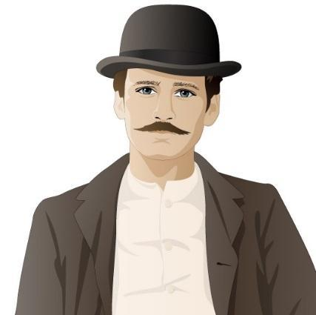

**Isaac Brodsky (fictional character)**

Lena’s older brother, who came to the United States three years earlier and is now married and living on the Lower East Side. He sells household goods from a cart on Hester Street but dreams of becoming a successful businessman with his own store.

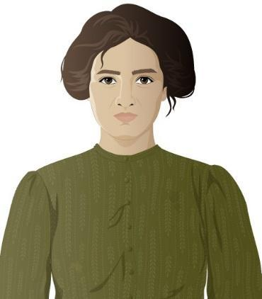

**Sonya Brodsky (fictional character)**

Isaac’s wife, who is also from Russia but met Isaac in New York. She manages the Brodsky household, caring for their baby, shopping, cleaning, and providing meals and laundry services for two boarders.

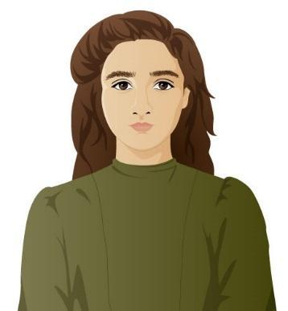

**Rosa Leone (fictional character)**

Lena’s friend, a fourteen-year old immigrant from Naples, Italy, who came to America with her family. Her family runs a small grocery store on the Lower East Side. She helps in the store and studies English at the Henry Street Settlement, all while being chaperoned by her brother. Her family plans to make money in America and then return to Italy, but Rosa is not sure that is she wants to do that. Eventually she gets a job at the Triangle Shirtwaist Company factory. Rosa and Lena meet at an English class at Henry Street.

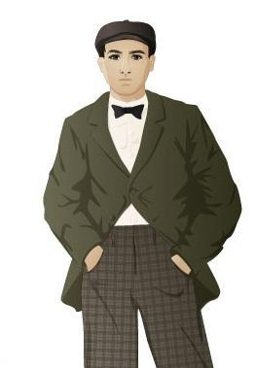

**Zev (fictional character)**

A young Russian immigrant trying to make his way in New York by helping Jewish gang members collect debts. He enjoys dancing to American popular music and hopes to take Lena to the dancehall.

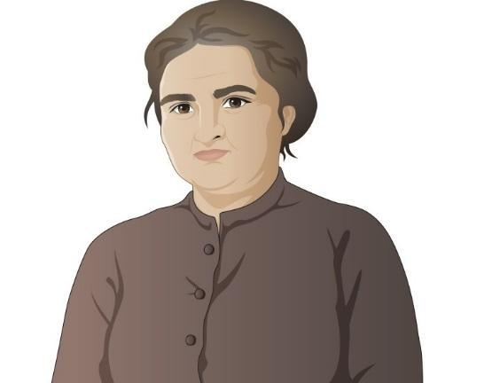

**Mrs. Orloff (fictional character)**

Lives in the same tenement as the Brodsky family and also came from Minsk. She pays close attention to the lives of all her neighbors and is a good source of neighborhood gossip.

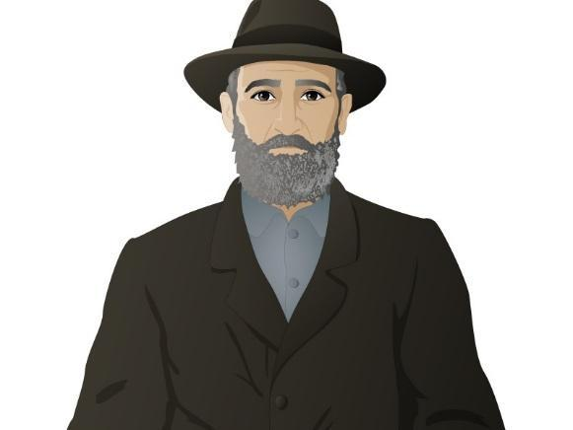

**Mr. Bernstein (fictional character)**

Arrived in New York at the same time as Lena, and they met at Ellis Island. He sells soda water at Hester Street Market and helps Lena when he can.

**James Poole (fictional character)**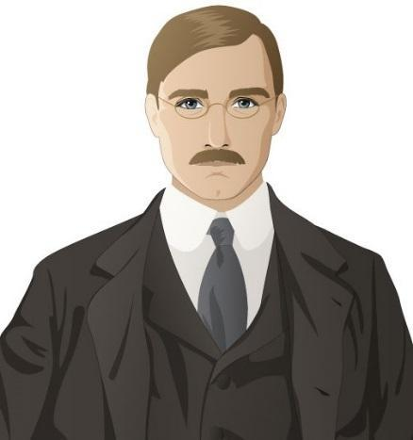

A young reporter for one of New York City’s “muckracking” newspapers. He is college educated and a pro-union reformer.

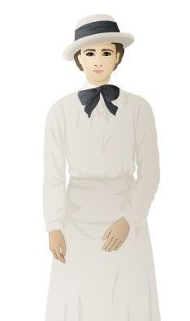

**Abigail Walker (fictional character)**

A young reformer and suffragist who chose to live and work with immigrants in the Lower East Side after completing college. She is an idealist who believes that Progressive women can improve life for immigrants by helping them to assimilate.

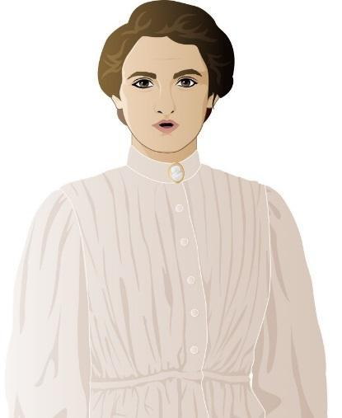

**Miss Sherman (fictional character)**

A former garment factory operator who has been promoted to forelady. She is strict and supports the factory owners in their efforts to keep young women workers focused on increasing their production.

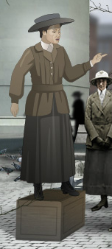

**Clara Lemlich (historical figure c. 1886 – 1982)**  
A Ukrainian immigrant, Clara Lemlich came to the United States with her family in 1903 when she was seventeen years old. She worked in the garment industry and, appalled by the working conditions in garment factories, became involved with the International Ladies’ Garment Workers’ Union (ILGWU). On November 22, 1909, Lemlich spoke to a meeting of female garment workers and urged them to strike, setting off what became known as the Uprising of 20,000, the 1909 shirtwaist workers strike in New York. A committed socialist, Lemlich fought her entire career for workers’ rights.

**Locations in MISSION 4: “City of Immigrants”**

**Ellis Island**

Opened in 1892, Ellis Island (located in New York harbor) was the nation’s busiest immigration processing station in the early twentieth century. More than 12 million immigrants passed through its doors before it closed in 1954, most during the peak years of 1900-1914. Arriving immigrants were subjected to medical and legal inspections to determine if they could enter the country. On average, the inspection process took approximately 3-7 hours, and most immigrants were allowed to enter the United States. Some, however, were detained for days or weeks and could be sent back to their home countries. 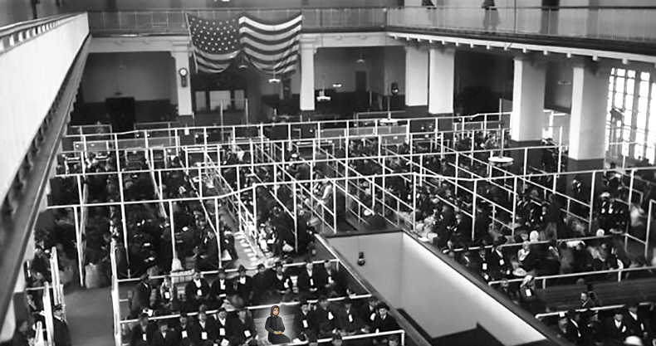

**Lower East Side**

This New York City neighborhood, located in lower Manhattan, was for much of its history the first home in America for a variety of immigrant groups. In the mid-nineteenth century, it was known as Kleinedeutschland (“Little Germany”) because of the large numbers of German immigrants who lived there. By the late nineteenth and early twentieth centuries, Germans gave way to large numbers of immigrants from southern and eastern Europe (Italian, Russian, Hungarian, Slovakian, and Polish) who occupied its tenement apartments. 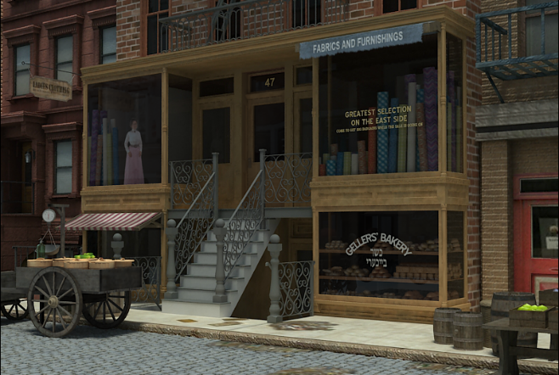

**Tenement**

A tenement was a small apartment in a multi-unit apartment building, occupied by poor, often immigrant, families and their boarders. Tenements had few windows and little natural light, and they also lacked running water. Residents shared outhouses (known as privies) for toilets and drew their water from shared wells in the building’s rear yard. In an attempt to improve living conditions for tenement dwellers, New York state passed a series of laws (in 1867, 1879, and 1901) that required tenements to have more air and light, more space between buildings, and eventually running water, toilets, and a window in every room. 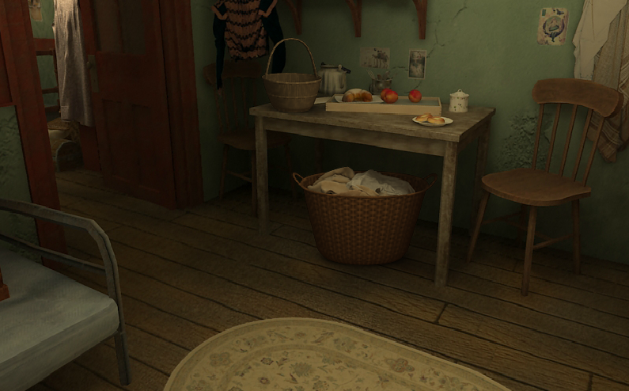

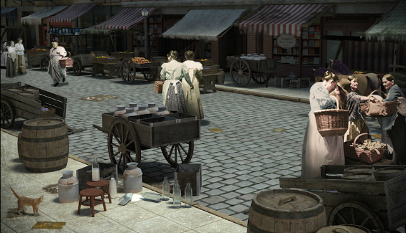

**Hester Street**

A main street in New York’s Lower East Side neighborhood, where pushcart vendors sold food, clothing, and household goods to the immigrant, largely Jewish, residents.

**Sweatshop**

A sweatshop is a factory or home workshop in the garment industry where workers are paid low wages and work long hours. In New York City in the early twentieth century, most sweatshop workers were immigrant Jewish or Italian women. They were supervised by contractors of their own nationality, mostly men, who got materials on credit from manufacturers, bought sewing machines on installment plans, and rented lofts or tenement apartments for factories. 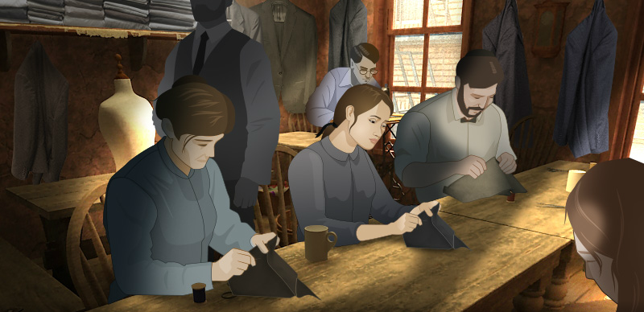

**Henry Street Settlement**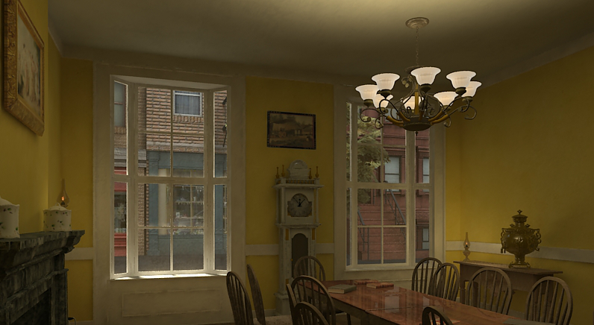

Founded in 1895 by Lillian Wald and Mary Brewster, Henry Street Settlement was established to provide nursing care at home for poor residents of the Lower East Side. The nurses and social workers of the settlement house movement were college-educated women who lived in the neighborhoods where they worked and sought to improve the lives of immigrants. In addition to nursing services, Henry Street Settlement expanded to provide classes for immigrants, a dance school, one of the nation’s first playgrounds, a kindergarten, literary societies, and a cooperative food store.

**Places of Amusement**

America’s turn-of-the-century cities were the birthplace of a new commercial culture, filled with new amusements. Nickelodeons (early movie theaters named for their five cent price of admission) and dance halls gave young people the chance to seek pleasure and independence away from their families. Amusement parks were also popular in the early 1900s, especially among the many young immigrant men and women who flocked to parks and beaches on their days off. New York's Coney Island was the most famous of the new resorts, attracting more than 20 million visitors a year. 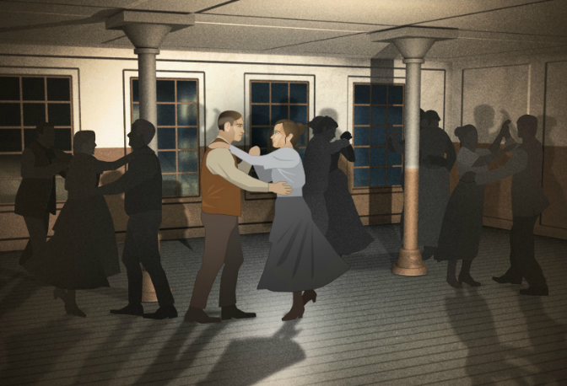

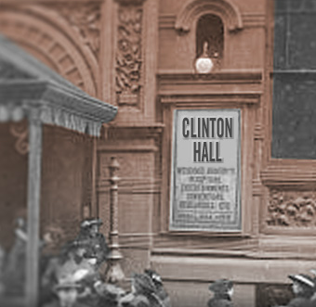

**Clinton Hall**

Located at 96 Clinton Street on the Lower East Side, Clinton Hall was the headquarters of the International Ladies’ Garment Workers’ Union Local 25, which organized the 1909 shirtwaist makers’ strike.

**Jefferson Market** **Courthouse and Jail**

The Jefferson Market Courthouse was built in 1873 on the southwest corner of 10th Street and Sixth Avenue in the Greenwich Village neighborhood, on the site of a former public market. The building included the courthouse, a fire station, a new market, and a small jail. During the 1909 garment workers’ strike, strikers and their supporters picketing the garment factories were regularly arrested and brought to Jefferson Market Courthouse to be charged and fined, and sometimes held in the jail.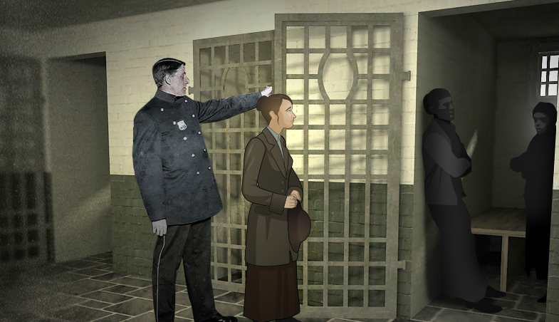

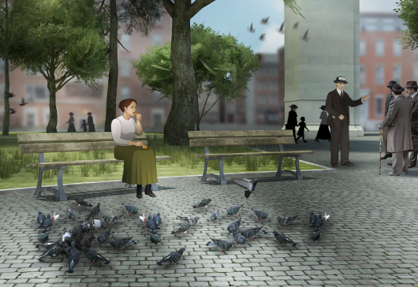

**Washington Square**

Located in Greenwich Village, Washington Square was a small park and gathering place. Several garment factories, including the Triangle Shirtwaist Company, were located nearby, and the factory girls ate lunch and heard soapbox speakers here.

**Triangle factory**

The Triangle Shirtwaist Company factory occupied the top three floors of a ten-story building at the corner of Washington and Greene streets in downtown Manhattan. Five hundred workers, mostly women, labored at Triangle to cut, baste, sew, and finish shirtwaists (women’s blouses). On March 25, 1911, a fire broke out shortly after 4:30 pm on the eighth floor and rapidly spread. Locked exit doors, a fire escape collapse, and fire ladders that reached only as high as the sixth floor left many workers unable to escape the blaze. In all, 146 workers died, most of them young Italian and Jewish women. 