Guiding Question: How did African Americans cope with and resist segregation in the South?
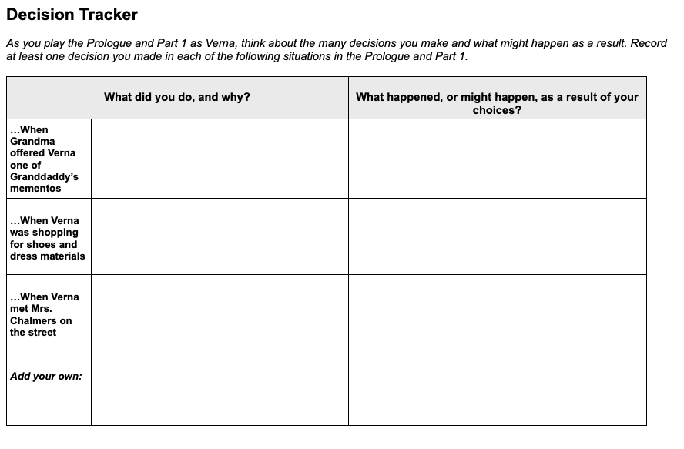Which of the following values connect most strongly with one or more of the decisions you recorded above?  Resist Jim Crow Avoid being treated like a second-class citizen, even if it sometimes involves risk. Choose Your Battles Exercise patience and composure. Seek your uncle and aunt’s approval. Support the Movement Put your skills and knowledge to work for the NAACP and SNCC. Bring new people into the Movement.  Circle a value and then explain how it connects to a decision you recorded above. | Time: At least 20 minutes  Instructions  Making Decisions as Verna  Explain to students that in No Turning Back they will be asked to make many choices that will determine the outcomes for Verna, the character they are playing. They can choose what type of person they want their Verna to be through the choices they make. Part of the fun and value of role-playing games is the ability to take on different personalities and explore different options.  Assure students that there are no right or wrong answers and that it is fine to make choices that may be considered risky or bold. Explain that the process of thinking about different choices and their possible outcomes can help them to gain empathy—an understanding of the feelings of others—especially for historical characters. Ask students to consider how Verna, a Black teenager in 1960s Mississippi, may make different decisions than young people today.  Introduce the Decision Tracker  Ask students to record their progress as they play the Prologue and Part 1 on this Decision Tracker (later sections of the game have different Decision Tracker handouts). They should identify at least one decision they make in each of the situations listed on the handout. They should make a short note whenever they make a key decision, pausing to think about the following:  - Why are they making that choice?  - Is this the choice they themselves would make or that they think a Black teenager in 1960s Mississippi would make?  - How might Verna’s gender, race, culture, age, and other aspects of her identity shape the choices students make for her?  - What happened as a result of the decision?

