**Guiding Question:** How did Jim Crow laws and customs restrict the lives of African Americans in the South?

# Document Analysis

## Capturing the Realities of Jim Crow through Photographs

### Source 1: “Outside Looking In, Mobile, Alabama, 1956.”

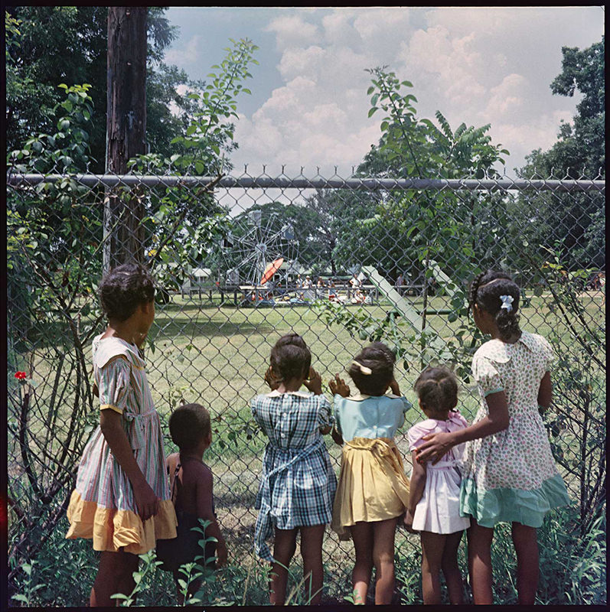

*Credit: Photograph by Gordon Parks.*

*Copyright: Courtesy of and copyright The Gordon Parks Foundation.*

## 

### Source 2: “Department Store, Mobile, Alabama,1956.”

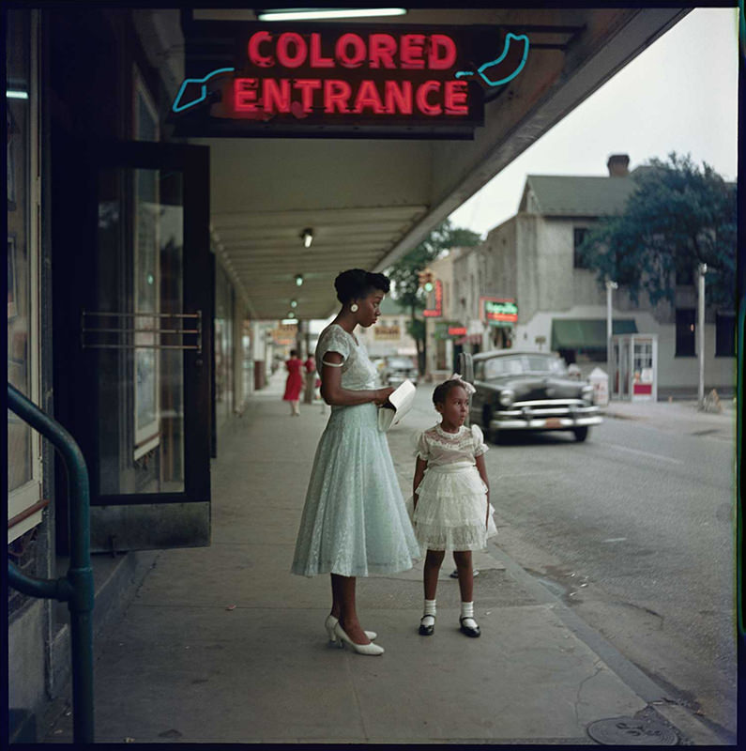

*Credit: Photograph by Gordon Parks.*

*Copyright: Courtesy of and copyright The Gordon Parks Foundation.*

### Source 3: “Ondria Tanner and Her Grandmother Window-shopping, Mobile, Alabama, 1956.”

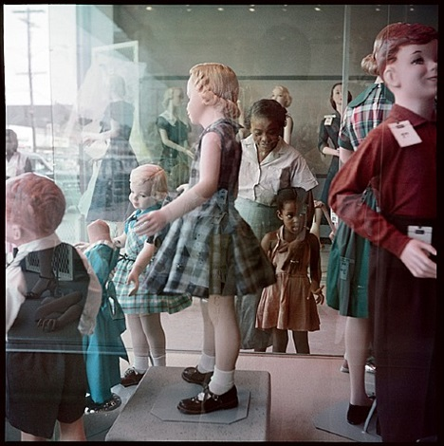

*Credit: Photograph by Gordon Parks.*

*Copyright: Courtesy of and copyright The Gordon Parks Foundation.*

## 

## Photographs of the Jim Crow South – Identify, Imagine, Connect

Directions: Respond to Gordon Parks’ photographs by completing the questions in the chart below[1]:

| Identify  *Choose one person from one of the three photographs, and describe them. Where is the person? What other people, buildings, and objects are near them? What is the person doing? What is happening around them?* | Imagine  *What do you think the person you identified might be thinking or feeling at the moment the photograph was taken? What makes you say that?* | Connect  *Make a connection between the photograph and what you have learned from the game about how Jim Crow segregation impacted peoples’ lives.* |
| --- | --- | --- |
|  |  |  |

## 

## Discussion Questions

1. How did Gordon Parks capture segregation through photography?

2. What do you notice about children’s perspectives in these photos? About adults’ perspectives?

3. To what extent do you think that we can understand what another person experienced, thought, or felt at a particular moment in history? Why do you think it is important to try to understand the perspectives of people who lived in the past?

1. This activity is adapted from Project Zero’s ["Feelings and Options"](http://www.pz.harvard.edu/sites/default/files/Feelings%20and%20Options.pdf) thinking routine.