Guiding Question: How did ordinary Americans, including many teenagers, play a role in the civil rights movement of the 1950s and 1960s?
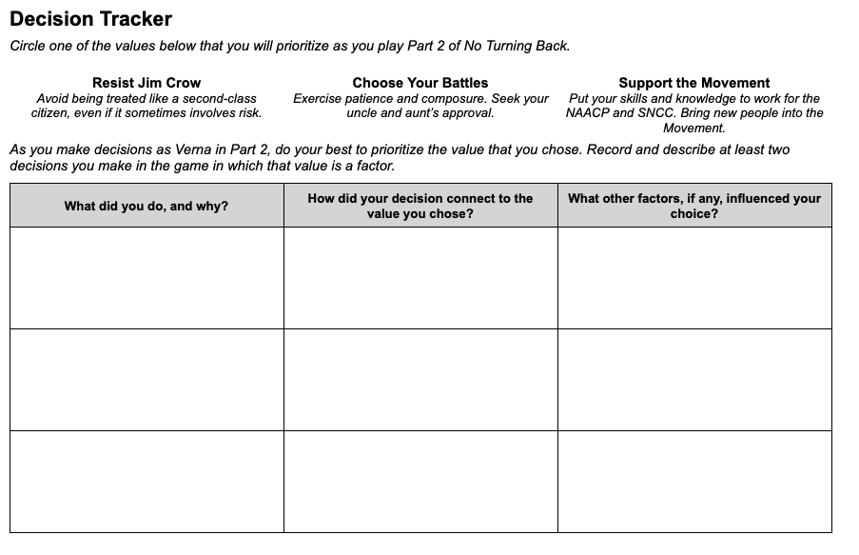 | Time: At least 20 minutes  Instructions  Explain to students that as they play Part 2, Verna will experience many, often conflicting, demands on her decisions. They will have to make difficult choices about how to balance Verna’s desire to stand up against Jim Crow, her family’s well being, and her safety.  Prioritizing a Value  Give students copies of the Part 2 Decision Tracker, and walk through the instructions with them. Instead of reflecting on values after recording their decisions on the handout (as they did previously), students will now choose a value to prioritize before they play Part 2. Encourage them to try to put that value into action in the choices they make in the game.  On the handout, students will record at least two decisions they made in which their prioritized value came into play. (The graphic organizer provides space for three examples.) We recommend that students record their decisions as they play Part 2 rather than after they have completed it.  The Complexity of Decision Making  As they play the game, students will likely realize that consistently prioritizing one value in their decisions will force them to make difficult compromises, and they may even choose to abandon their prioritized value at times for this reason. The goal is not to test or evaluate students’ abilities to stick with their chosen value - rather, it is to help them experience and reflect on the complexity of decision making.  Scaffolding  Unlike the Prologue-Part 1 Decision Tracker, this version is open-ended and does not suggest which situations in the game should be the focus of the actions and choices they describe. If your students need more guidance about what to record, you can provide them one or more of the following situations:  - While preparing and serving dinner at the Chalmers’s house…  - When you have the opportunity to recruit for the NAACP at the roller skating rink…  - Discussing the Citizens Council with Aunt Mabel or the NAACP with Uncle Curtis…

