**Guiding Question:** How did African Americans fight for their rights in the 1950s and 1960s?

# Document Analysis

Analyzing a Photograph of a Sit-in

### Source: Photograph of Jackson, Mississippi, Sit-in in 1963

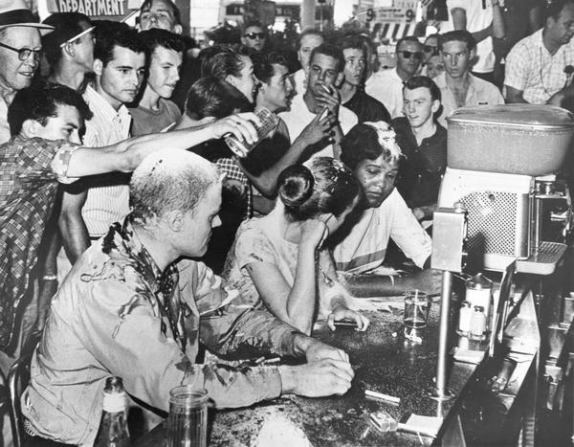

*(AP, Jackson Daily News, photographer Fred Blackwell)[1]*

### Photograph of a Sit-in: Close Viewing and Analysis

**Step One: First Look**

*Take a few minutes to look at the photo and jot down any observations you have about the people, faces, clothing, objects, actions, and words you see. Without interpreting the photograph, what do you see?*

**Step Two: A Closer Look**

*Respond to the following questions:*

1. Identify the part of the image that *first caught your eye*. Draw a circle or box around it, and label it #1. Explain below why you think that part of the image stood out to you.
2. Identify a part of the image that *shows a conflict, problem, or difficult choice* someone is making. Draw a circle or box around it, and label it #2. Explain conflict, problem, or difficult choice that you think this part of the image shows. Who is involved? What might they be thinking?
3. Identify a part of the image that you think best captures *what this image is all about*. Draw a circle or box around it, and label it #3. Explain below why you think this part of the image is so central to the story the photo is telling.

**Step Three: Analysis and Discussion**

Respond to the following questions. Be prepared to share your answers in a class discussion.

1. What is happening in this photo?
2. The civil rights activist on the right is named Anne Moody. Name three things Anne would have smelled, felt, and heard from this photo.

1. Activists trained for hours to learn how to participate in sit-ins without reacting. What are some reasons it would have been important to the people who are “sitting-in” to not react to what was happening?

1. How might the citizens of Greenwood who you have met in “No Turning Back” respond to seeing this photograph in the newspaper? Who would the photograph inspire? Excite? Frighten? Anger? What other responses might different Greenwood citizens have?

1. <https://www.wisconsinhistory.org/Records/Image/IM2381>