Guiding Question: What was it like for Japanese Americans to live, work, and go to school in prison camps like Manzanar?

Document Analysis  Photographs of Life in Manzanar Prison Camp  Collection A: Medical Care  Directions: Look closely at the images, read the captions and then answer the questions for each photo that follow.  Source 1: Photograph by Dorothea Lange Source 2: Photograph by Ansel Adams  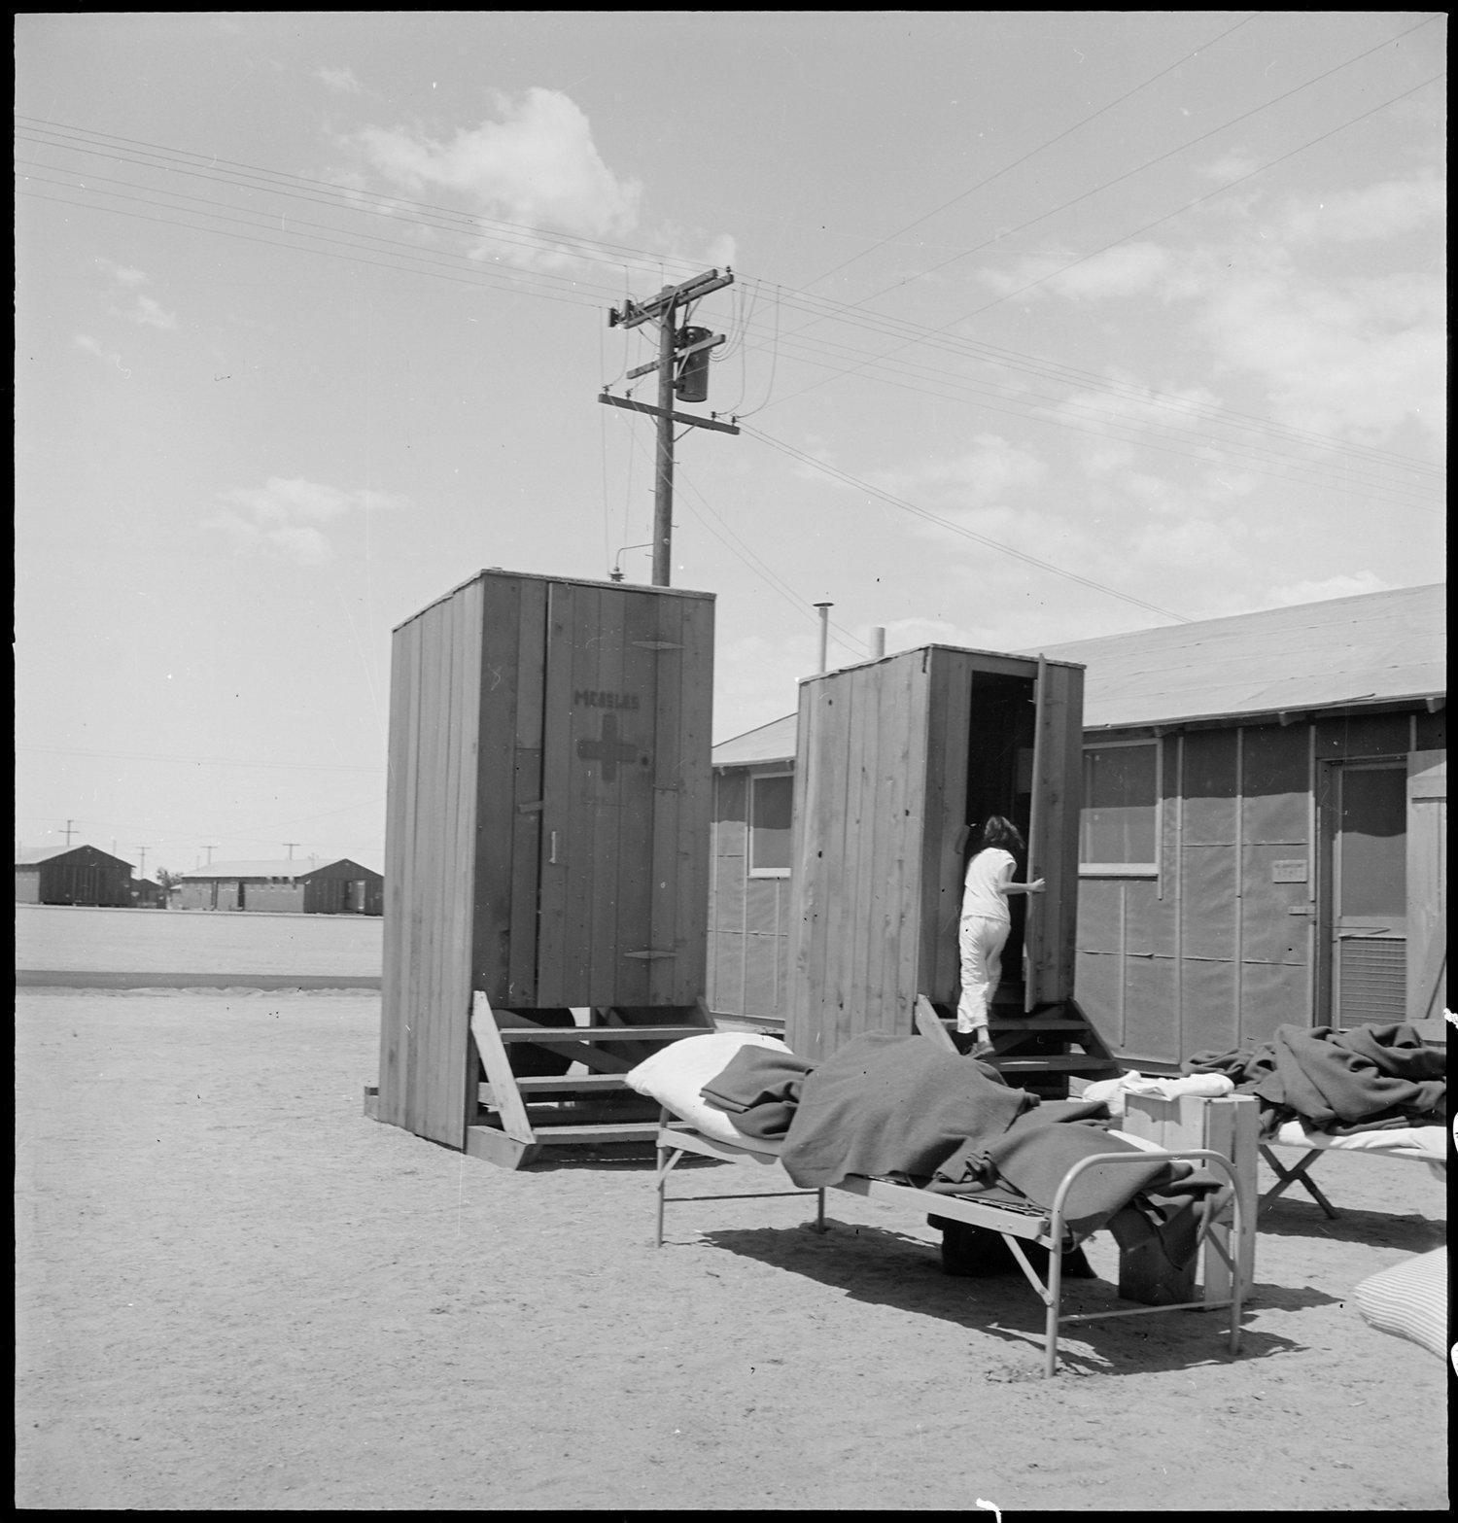 Lange’s Caption: Manzanar Relocation Center, Manzanar, California. Hospital latrines, for patients, between the barracks, which serve temporarily as wards. For the first three months of occupancy medical facilities have been meager but the new hospital fully equipped, is almost ready for occupancy. 7/1942 https://catalog.archives.gov/id/538149 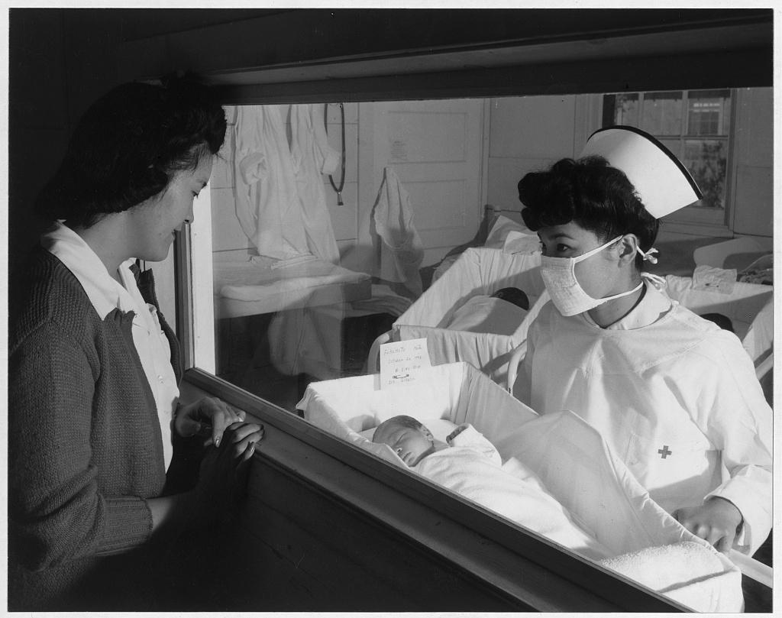 Nurse Aiko Hamaguchi, mother Frances Yokoyama, baby Fukomoto, Manzanar Relocation Center, California / photograph by Ansel Adams. 1943. https://www.loc.gov/resource/ppprs.00343/  Collection A: Photograph Analysis  Source 1: Photograph by Dorothea Lange Source 2: Photograph by Ansel Adams  Write down examples and observations in the photo of the following (be specific!): Setting: People: Objects: Actions: Write down examples and observations in the photo of the following (be specific!): Setting: People: Facial expressions: Objects: Actions:  How would you describe the tone (i.e. the mood or emotion) of this photograph? How would you describe the tone (i.e. the mood or emotion) of this photograph?  What similarities do you notice in the way that medical care in the prison camps is documented in the photographs? What differences do you see?  Collection B: School  Directions: Look closely at the images, read the captions and then answer the questions for each photo that follow.  Photograph by Dorothea Lange Photograph by Ansel Adams  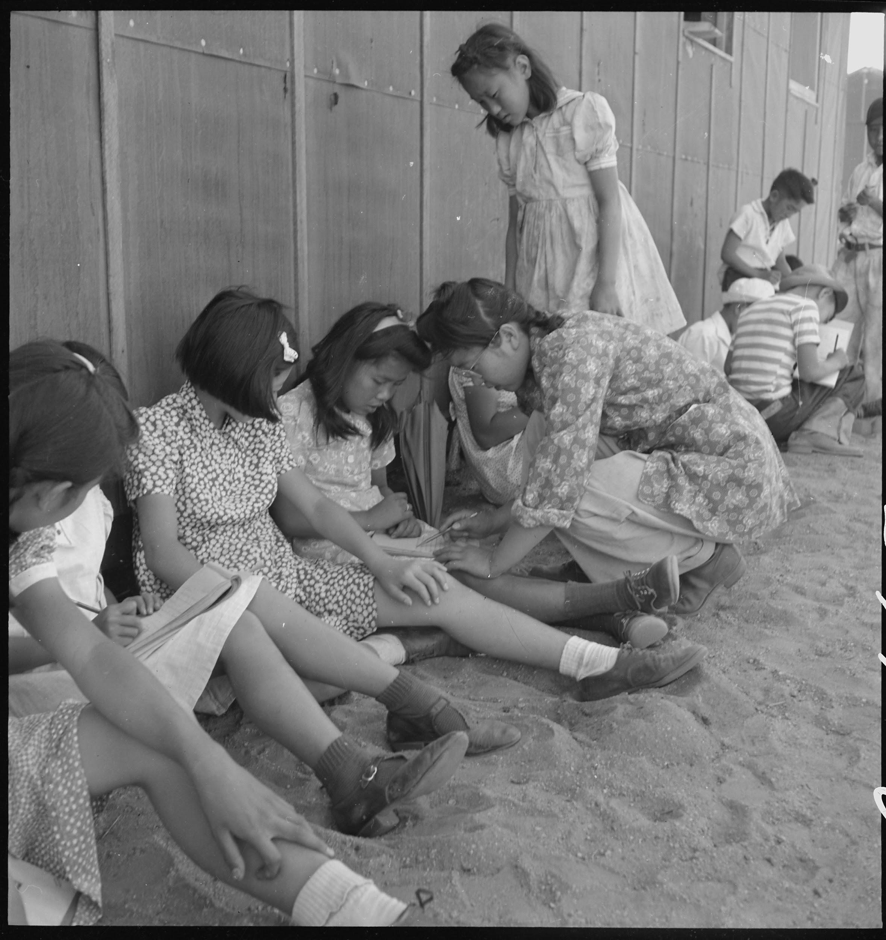 Lange’s Caption: Manzanar Relocation Center, Manzanar, California. An elementary school with voluntary attendance has been established with volunteer evacuee teachers, most of whom are college graduates. No school equipment is as yet obtainable and available tables and benches are used. However, classes are often held in the shade of the barrack building at this War Relocation Authority center. 1942. https://catalog.archives.gov/id/537962 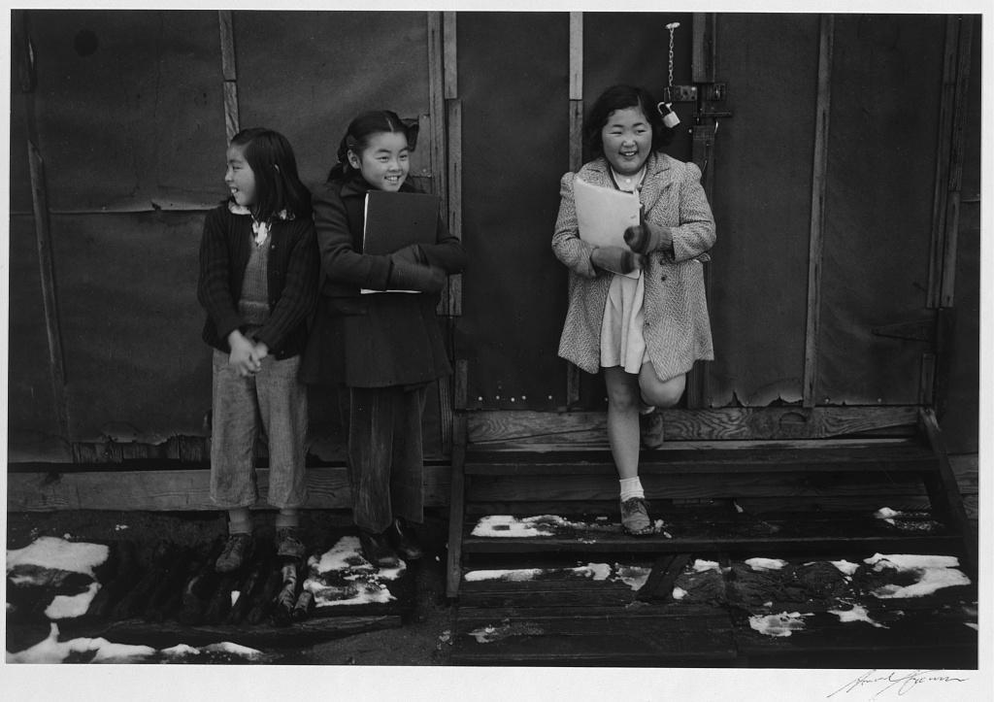 School children, Manzanar Relocation Center, California / photograph by Ansel Adams, 1943 https://www.loc.gov/resource/ppprs.00357/  Collection B: Photograph Analysis  Source 3: Photograph by Dorothea Lange Source 4: Photograph by Ansel Adams  Write down examples and observations in the photo of the following (be specific!): Setting: People: Facial expressions: Objects: Actions: Write down examples and observations in the photo of the following (be specific!): Setting: People: Facial expressions: Objects: Actions:  How would you describe the tone (i.e. the mood or emotion) of this photograph? How would you describe the tone (i.e. the mood or emotion) of this photograph?  What similarities do you notice in the way that school in the prison camps is documented in the photographs? What differences do you see?  Collection C: Buildings and Surrounding Environment  Directions: Look closely at the images, read the captions and then answer the questions for each photo that follow.  Photograph by Dorothea Lange Photograph by Ansel Adams  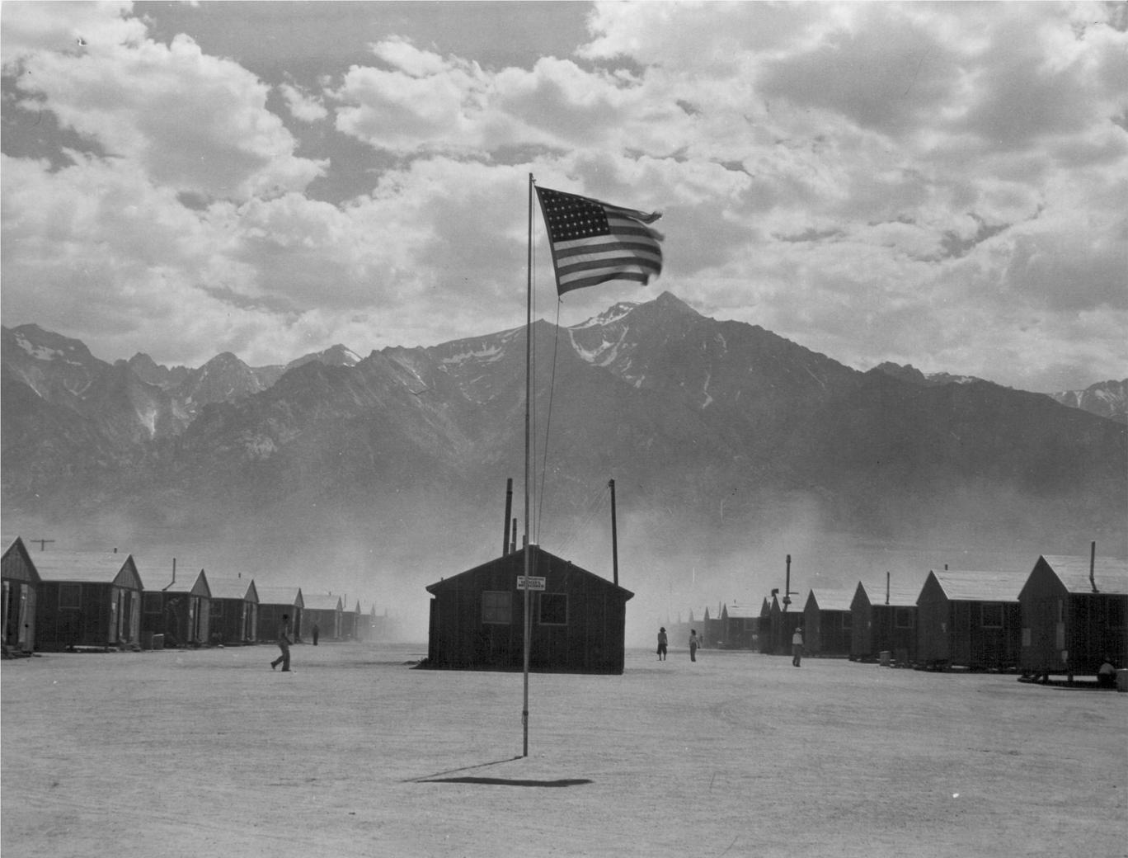 Lange’s Caption: Lange’s Caption: Manzanar, California. Dust storm at this War Relocation Authority center where evacuees of Japanese ancestry are spending the duration. https://catalog.archives.gov/id/539961 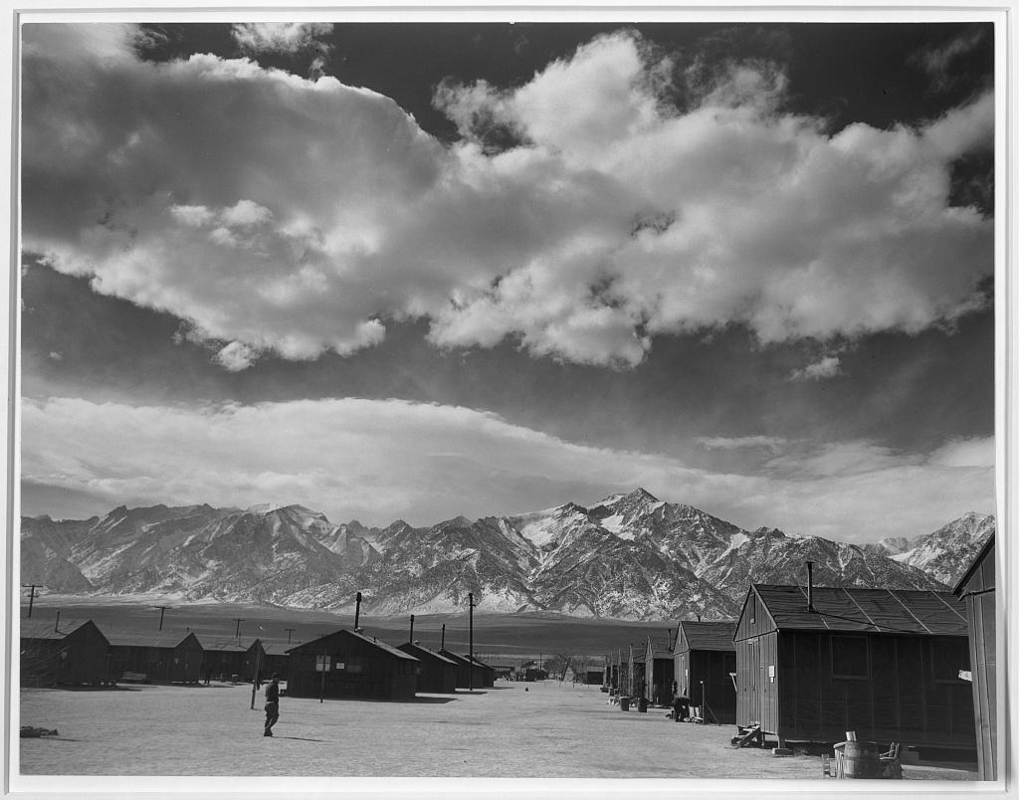 Manzanar street scene, clouds, Manzanar Relocation Center, California / photograph by Ansel Adams, 1943. https://lccn.loc.gov/2002695966  Collection C: Photograph Analysis  Source 1: Photograph by Dorothea Lange Source 2: Photograph by Ansel Adams  Write down examples and observations in the photo of the following (be specific!): Setting: People: Objects: Environmental conditions: Write down examples and observations in the photo of the following (be specific!): Setting: People: Objects: Environmental conditions:  How would you describe the tone (i.e. the mood or emotion) of this photograph? How would you describe the tone (i.e. the mood or emotion) of this photograph?  What similarities do you notice in the way that the buildings and surrounding environment in the prison camps are documented in the photographs? What differences do you see?  Discussion Questions  1. Based on your analysis, what do you think Dorothea Lange was trying to show in her photographs of Manzanar? What do you think that Ansel Adams was trying to show? How do their goals differ?  2. Lange and Adams were both commissioned by the United States government to photograph the living conditions of Manzanar Prison Camp. Lange’s photographs were not released until after World War II ended. Why do you think the government did this?  3. How do both sets of photographs help us understand the living conditions at Manzanar? Do you think one set of photographs is “more true” than the other? What makes you say that? | Time: 30 minutes  Instructions  Goal/Intent: Students analyze photographs of life in Manzanar by two different photographers. Dorothea Lange documents challenging conditions while Ansel Adams focuses on government resources and the adaptability of prisoners. By comparing and contrasting the photographers’ approaches to documenting life in the prison camp, students reflect on the ways that the photographs might reveal or obscure answers to the guiding question:  What was it like for Japanese Americans to live, work, and go to school in prison camps like Manzanar?  Image Analysis (10 mins)  The photographs are organized into three collections: (A) Medical Care, (B) School, and (C) Buildings and Surrounding Environment. There are two photographs, one by each photographer, in each collection.  Put students into groups of 2 or 3, and assign one of the photo collections to each group. In their groups, students can answer the prompts on the Photograph Analysis graphic organizer to analyze the images.  Mixed Group Sharing (optional) (10 mins)  Optionally, jigsaw the students by creating mixed groups, in which each photo collection is represented by at least one student. In these new groups, students can share the photos they analyzed in their original group.  Discussion (10 min)  Either bring the whole group back together or leave students in their mixed groups for a culminating discussion about the three questions provided.  Additional Discussion Questions:  - What connections can you make between the photographs you examined and things you observed and experienced in the game so far?  - How do photographs help us better understand events in the news or history?  - What are some ways that photographs can be misleading or hide parts of the truth?

