Guiding Question: How did Japanese Americans cope with and resist their imprisonment during World War II?
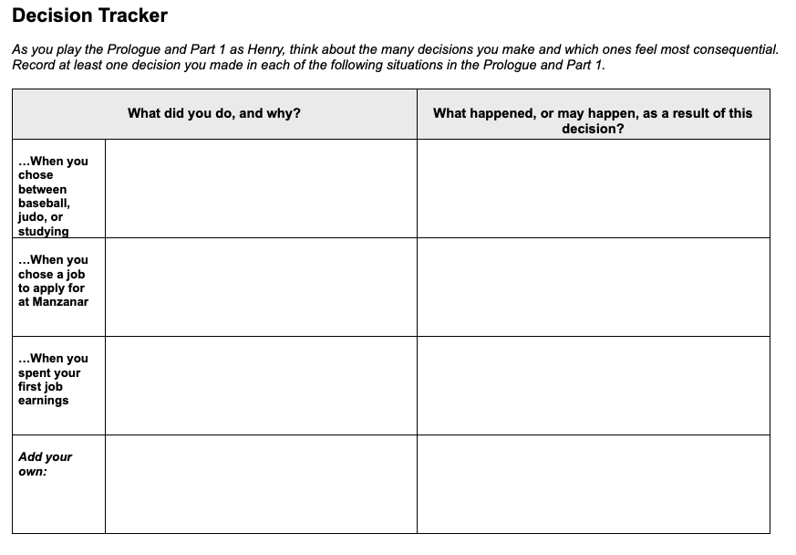  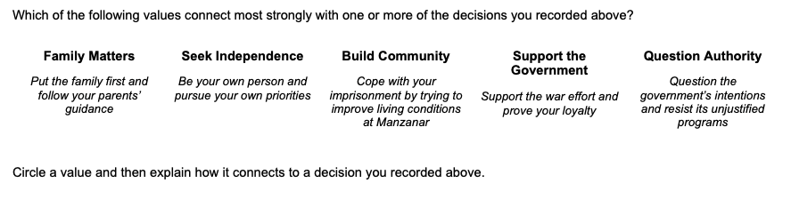 | Time: At least 20 minutes  Instructions  Making Decisions as Henry Tanaka  Explain to students that as they play Prisoner in My Homeland, they will be asked to make many choices that will determine the outcome for Henry, the character they are playing. They can choose what type of person they want their Henry to be through the choices they make. Part of the fun and value of role-playing games is the ability to take on different personalities and explore different options.  Assure students that there are no right or wrong answers and that it is fine to make choices that may be considered risky or bold. Explain that the process of thinking about different choices and their possible outcomes can help them to gain empathy—an understanding of the feelings of others—especially for historical characters. Ask students to consider how Henry, as a Japanese American enduring imprisonment during World War II, may make different decisions than young people today.  Introduce the Decision Tracker  Ask students to record their progress as they play the Prologue and Part 1 on this Decision Tracker (later sections of the game have different Decision Tracker handouts). They should identify at least one decision they make in each of the situations listed on the handout. They should make a short note whenever they make a key decision, pausing to think about the following:  - Why are they making that choice?  - Is this the choice they themselves would make, or a decision they think a Japanese American teenager in 1940s America would make?  - How might Henry’s gender, culture, age, and other aspects of his identity shape the choices students make for him?  - What happened as a result of the decision?

