Guiding Question: How did Japanese Americans cope with and resist their imprisonment during World War II?
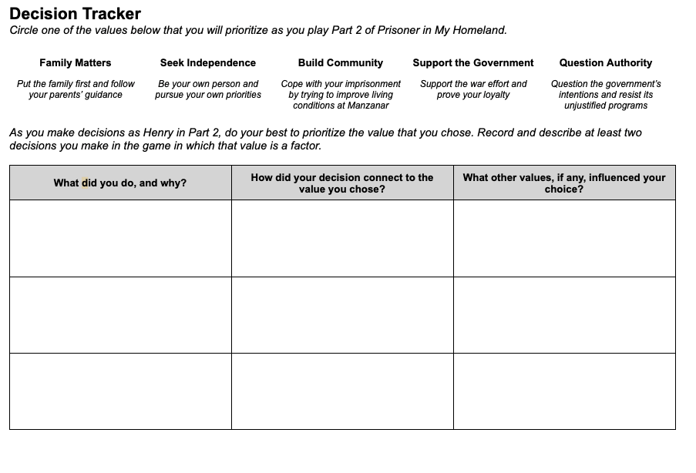 | Time: At least 20 minutes  Instructions  Explain to students that as Henry attends school, reunites with his father, gets to know Meiko, and learns about different attitudes towards cooperation and resistance, the decisions he must make will become more complicated. As students guide Henry, they will have to weigh conflicting priorities and sometimes make difficult trade offs.  Prioritizing a Value  Give students copies of the Part 2 Decision Tracker, and walk through the instructions with them. Instead of reflecting on values after recording their decisions on the handout (as they did previously), students will now choose a value to prioritize before they play Part 2. Encourage them to try to put that value into action in the choices they make in the game.  On the handout, students will record at least two decisions they made in which their prioritized value came into play. (The graphic organizer provides space for three examples.) We recommend that students record their decisions as they play Part 2 rather than after they have completed it.  The Complexity of Decision Making  As they play the game, students will likely realize that consistently prioritizing one value in their decisions will force them to make difficult compromises, and they may even choose to abandon their prioritized value at times for this reason. The goal is not to test or evaluate students’ abilities to stick with their chosen value, rather it is to help them experience and reflect on the complexity of decision making.  Scaffolding  Unlike the Prologue-Part 1 Decision Tracker, this version is open-ended and does not suggest which situations in the game should be the focus of the actions and choices they describe. If your students need more guidance about what to record, you can provide them one or more of the following situations:  - When choosing between studying and helping Miss Nelson open boxes after arriving early to class  - When choosing between doing extra credit work with Meiko and helping Mr. Ueno investigate the missing sugar ratios.

