Guiding Question: How did Japanese Americans cope with and resist their imprisonment during World War II?
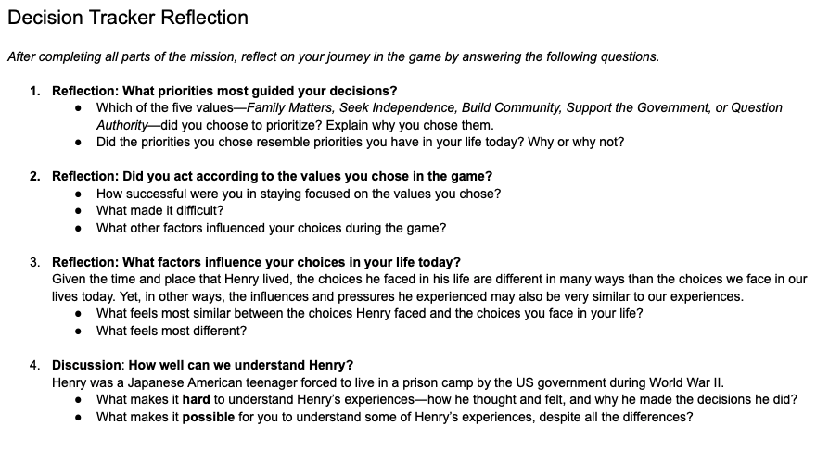 | Time: 30 minutes  Instructions  In this activity, students review their decisions as Henry throughout the game, reflect on the complexity of decision-making, and practice historical empathy.  The Decision Tracker Reflection provides a series of questions for students to respond to after completing the Decision Tracker documents from the Prologue, Part 1, and Part 2 of Mission US: Prisoner in My Homeland. Consider giving students time for independent reflection and/or partner discussions in response to Questions 1-3. Since those questions ask students to consider their own priorities and experiences, they may not be comfortable sharing their responses with the whole group. Question 4 is designed for a whole class discussion.  Notes:  - This Decision Tracker Reflection takes the place of the Decision Tracker handouts that appear in previous sections of this Teacher Guide. Since Henry continues to experience tension between the five values students choose from on the Part 2 Decision Tracker, you might choose to have students continue recording and analyzing specific decisions while they play Part 3. If so, simply provide them another blank copy of the Part 2 handout. You could give students the option to choose a new priority for their decision making in Part 3.  - Question #2 asks students how successful they think they were in acting on the priorities they set for Henry during the game. Keep in mind that many students may have played with other motives in mind (e.g., trying the most extreme choices, trying to make other characters angry, trying to “break” the game, or just choosing randomly). Therefore, #2 also asks students what other factors guided their choices. It’s good to acknowledge that games allow players freedom in how much they identify with characters.  - Question #4 asks students to consider both the importance and the limits of historical empathy. We hope that students will emerge with the conclusion that it is hard but still worthwhile to try to understand the experiences of Japanese American teenagers imprisoned by the US government during World War II (and others from the past). Here are some reasons students may give:  - Henry had to grow up much faster than most American kids today; it’s hard to know what it was like to be in such a different world.  - He was still a young person who wanted what most teens want—acceptance, connection to family, growing independence, fun.

