Much of “Prisoner in My Homeland” is based on actual events, places, and people. While some characters are fictional and serve to illustrate the various components of Japanese American incarceration, others are based on actual historical figures. Brief background information is included here on the Mission’s fictional characters, as well as biographical information on the historical figures included in the game.

Fictional Game Characters

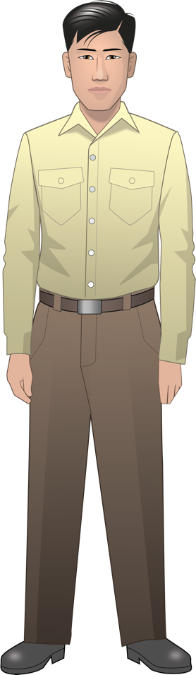
Henry Tanaka (fictional character) is a sixteen-year-old Nisei Japanese American when “Prisoner in My Homeland” begins. He was born and raised on a strawberry farm on Bainbridge Island, a short ferry ride from Seattle, Washington. He attends the local high school where his favorite subject is Chemistry. He is expected to attend Japanese school, and also help out on the farm by weeding the fields, planting and harvesting strawberry plants, and doing other chores. He keeps a diary which he illustrates with sketches. His family has a dog named Clark (named for Clark Kent, aka Superman).
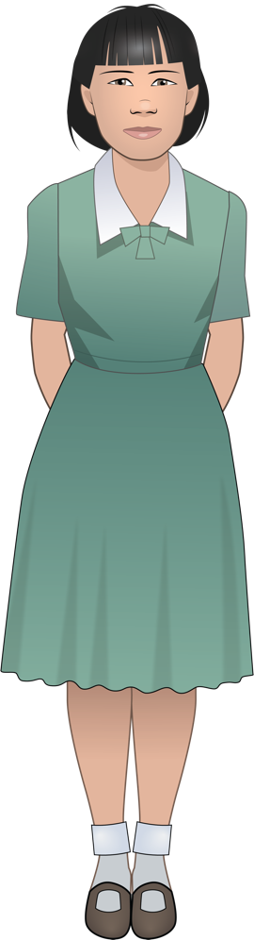
Lily Tanaka (fictional character) is Henry’s thirteen-year-old younger sister. She lives with her family on the strawberry farm on Bainbridge Island. When incarcerated at Manzanar, she joins the majorettes and practices baton throwing. Lily also appears in the game as “Great Aunt Lily,” who reads Henry’s diary along with Maya, Henry’s granddaughter.

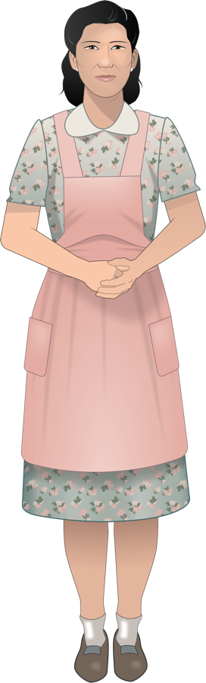
Kiyoko Tanaka (fictional character), Henry and Lily’s mother, is an Issei Japanese American in her early 40s. She manages the household, and helps with the farm. When she emigrated to the United States to get married, she brought several family heirlooms including a kimono and a tea set. She expects Henry to attend Japanese school, watch after his sister, and work on the farm.

Maya Tanaka (fictional character) is Henry’s granddaughter. In the present day, after Henry’s death, she finds his diary while cleaning out his attic. Surprised by her discovery -- her grandfather had never spoken about his incarceration during World War II -- she reaches out to Great-Aunt Lily (Henry’s sister, Lily, now an elderly woman) to learn more and is inspired to dig deeper into the past.

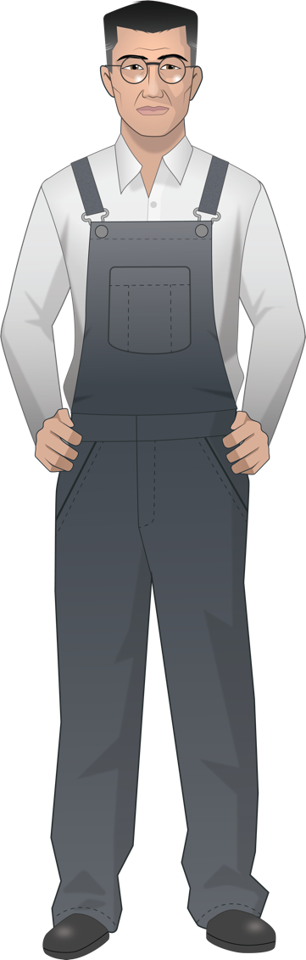
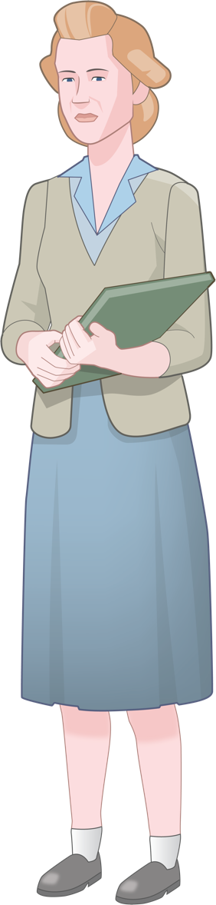
Kinzo Tanaka (fictional character), Henry and Lily’s father, is an Issei Japanese American in his late 50s. He is the head of the Tanaka household, and spends most of his time working on the strawberry farm. He is also a judo instructor at the local Japanese community center. His mother lives in Nagasaki. He hopes that Henry is the first member of the Tanaka family to go to college, and encourages him to develop both his mental and physical abilities.

Mr. Flores (fictional character) is a Filipino American who works with Mr. Tanaka on the strawberry farm. After the Tanakas are forcibly removed to Manzanar, Mr. Flores looks after the farm, but severe labor shortages limit his ability to harvest the crop.


Mr. Yamamoto (fictional character) is a Nisei Japanese American who runs a grocery store on Bainbridge Island. He is an active member of the Japanese American Citizens League (JACL). While critical of the government’s forced removal and incarceration policies, he supports strategies that demonstrate Japanese American loyalty, such as cooperating with the authorities and encouraging Nisei to serve in the armed forces.

Meiko Yamamoto (fictional character) is Mr. and Mrs. Yamamoto’s only daughter. She is smart, thoughtful and motivated to do well. Like Henry, her favorite subject is Chemistry, though she also enjoys Miss Nelson’s American history class.

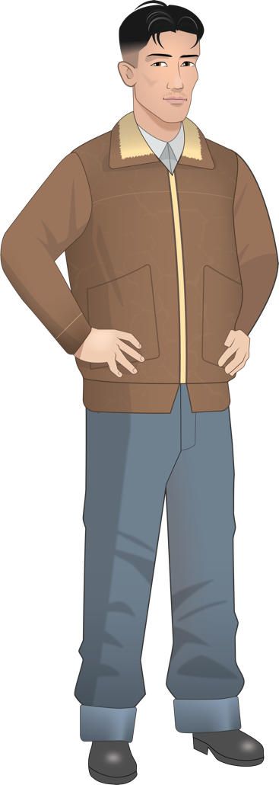
Tadashi (fictional character) is an 18-year-old Nisei Japanese American from Terminal Island whom Henry meets at Manzanar. Terminal Island is home to Japanese American fishermen and canning workers. Compared to Bainbridge Islanders, Terminal Islanders are considered tough and street-smart. Ueno lives in Block 10 and works in the mess hall.
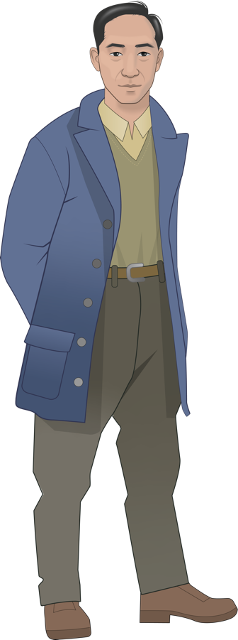
Harry Ueno (historical figure) is a 35-year old “Kibei.” Ueno was born in Hawaii and sent to Japan to be educated. As an adult, he moved to Los Angeles, started a family and sold fruit. Ueno lives in Block 22 and works in the Block 22 mess hall as a cook’s assistant.
Miss Nelson (fictional character) is a 30-year old teacher from California and a Quaker. She works as a high school teacher at Manzanar, living and working there beginning in October 1943. She is sympathetic with the young incarcerees, and encourages them to study hard. She attempts to help eligible students leave the camps for colleges on the East Coast and Midwest. This character was loosely based on Eleanor Gerard Sekerak, a teacher at the War Relocation Authority concentration camp in Topaz, Utah.

Places

Bainbridge Island is located in Puget Sound and connected to Seattle by a ferry. In the 1940s, the island was largely rural with many strawberry farms and a strawberry processing plant. In 1941, about 45 Japanese American families lived on Bainbridge Island. A Naval Radio Station was located on Bainbridge Island in 1938 and there were several military bases on nearby islands in the Puget Sound.

Manzanar Prison Camp is located about 230 miles north of Los Angeles, CA in the foothills of the Sierra Nevada mountains in a region called Owen’s Valley. The name Manzanar comes from the land’s previous use as an apple and fruit orchard (Manzanar means apple orchard in Spanish). Manzanar was the first of the ten concentration camps built to imprison Japanese Americans. It began as a temporary center and then was converted to a full prison camp with over 10,000 Japanese Americans living in 36 blocks of barracks.

Terminal Island is a largely artificial island in Los Angeles County. By the 1940s,Terminal Island had grown from a small fishing village to a vibrant Japanese American community of nearly 3,000 residents. Most worked as fishermen or in the tuna canning factories located on the island. On February 9, 1942, the FBI incarcerated all of the adult Issei males on Terminal Island and 10 days later, the remaining Terminal Islanders were given 48 hours to evacuate their homes. The Terminal Island residents were subsequently sent to prison camps and the entire Japanese American neighborhood was razed.

Department of Justice Camps: After the FBI arrested more than 5,500 Issei following the attack on Pearl Harbor, most were sent to one of ten Department of Justice (DOJ) prison camps, where they waited to appear before the Alien Enemy Hearing Board. These hearings determined whether the Issei would remain in the DOJ prison camps or be "released" to the War Relocation Authority (WRA) concentration camps. The DOJ camps also held Italian and German nationals and Japanese Latin Americans.
Tule Lake Prison Camp is located in northern California and was one of the ten concentration camps run by the U.S. government to imprison Japanese Americans. In 1943, Tule Lake was renamed the Tule Lake Isolation Center, and the facility was adapted to segregate those Japanese Americans who were deemed “disloyal” based on their responses to a questionnaire. With the shift to a segregation camp, the number of guards at Tule Lake increased from a few hundred to 930 and an eight-foot high double fence was erected. Tule Lake incarcerees responded to the harsh conditions at the prison camp with a series of protests and strikes.

