Guiding Question: How did Jim Crow laws and customs restrict the lives of African Americans in the South?

Document Analysis  Capturing the Realities of Jim Crow through Photographs  Source 1: “Outside Looking In, Mobile, Alabama, 1956.”  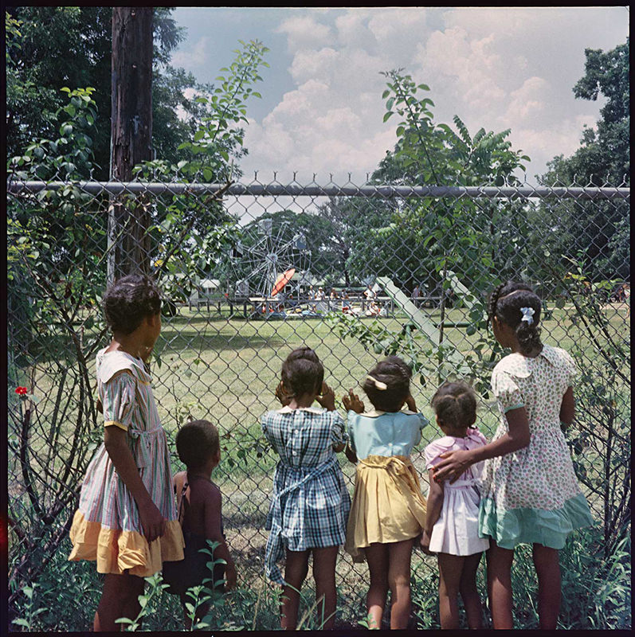  Credit: Photograph by Gordon Parks.  Copyright: Courtesy of and copyright The Gordon Parks Foundation.  Source 2: “Department Store, Mobile, Alabama,1956.”  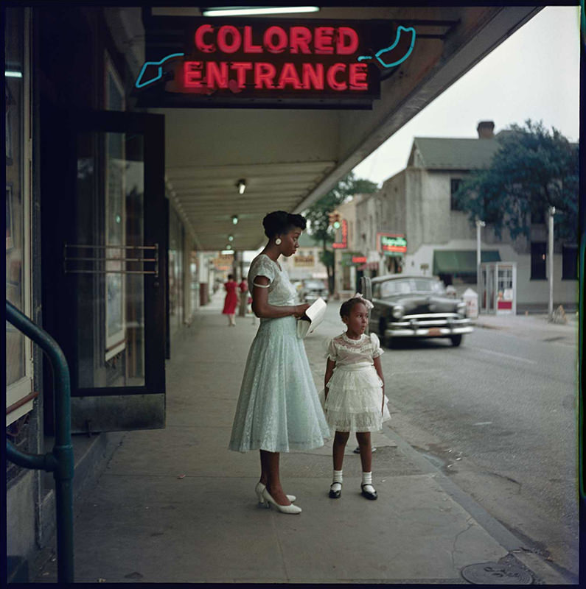  Credit: Photograph by Gordon Parks.  Copyright: Courtesy of and copyright The Gordon Parks Foundation.  Source 3: “Ondria Tanner and Her Grandmother Window-shopping, Mobile, Alabama, 1956.”  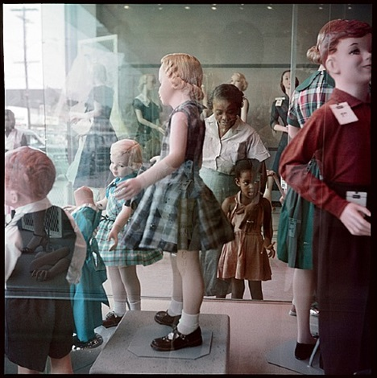  Credit: Photograph by Gordon Parks.  Copyright: Courtesy of and copyright The Gordon Parks Foundation.  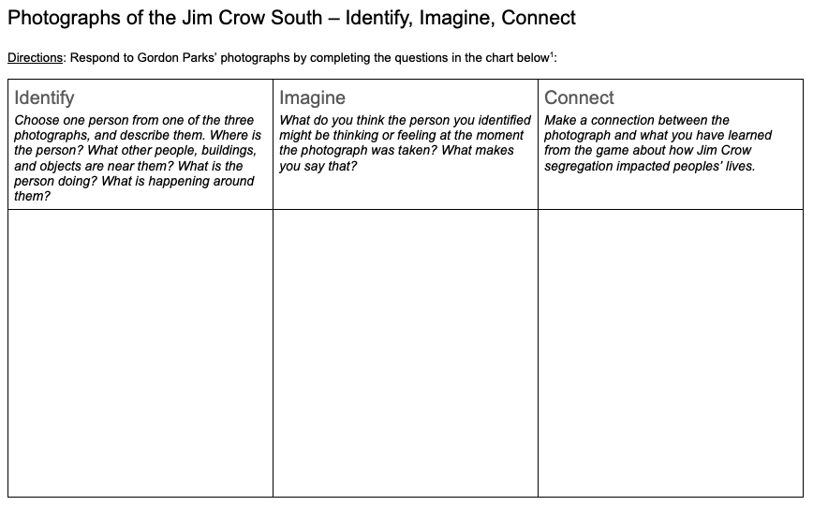  Discussion Questions  1. How did Gordon Parks capture segregation through photography?  2. What do you notice about children’s perspectives in these photos? About adults’ perspectives?  3. To what extent do you think that we can understand what another person experienced, thought, or felt at a particular moment in history? Why do you think it is important to try to understand the perspectives of people who lived in the past? | Time: 30 minutes  Instructions  Goal/Intent  Students look at three photographs taken in Alabama in 1956 by Black photojournalist Gordon Parks, and then choose one to explore more deeply. Using the Identify-Imagine-Connect analysis strategy, students have the opportunity to deepen their understanding of the experiences of African Americans during Jim Crow.  Gordon Parks, a Black photojournalist, captured the realities of Jim Crow segregation on film. The following three photographs were part of a series taken in Alabama, focusing on one multigenerational family and their experiences of segregation in 1956.  Image Analysis (20 mins)  Since the photographs are best experienced large and in color, you may wish to project for students using these links:  - Source 1  - Source 2  - Source 3  (You might also make a few color photocopies of each and set up a gallery walk so that students can move around the room to view them.)  Give students several minutes to examine the photographs in whatever format you provide them.  After viewing the photographs, students can respond to them using the Identify-Imagine-Connect chart. Students will be choosing one person from the photographs to write about in their responses. After completing the chart, students might gather in groups according to the photograph in which the person they chose appears. In those groups, they can share and discuss their Identify-Imagine-Connect responses.  Discussion (10 min)  Bring the whole group back together for a culminating discussion about the three questions provided.  Additional Discussion Questions:  - What do you think that Gordon Parks was trying to say with each of these photos? If you had to give each photo a different title, what would it be?  - What are some strengths that photographs have in helping us imagine the past? What are some weaknesses of using photographs this way?  - If you were to take a photograph that captured the essence of what it is like for you to live in your neighborhood, what would it be?

This activity is adapted from Project Zero’s "Feelings and Options" thinking routine.

