Guiding Question: How did African Americans fight for their rights in the 1950s and 1960s?

Analyzing a Photograph of a Sit-in  Source: Photograph of Jackson, Mississippi, Sit-in in 1963  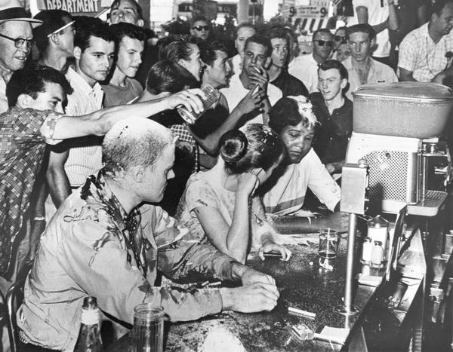  (AP, Jackson Daily News, photographer Fred Blackwell)  Photograph of a Sit-in: Close Viewing and Analysis  Step One: First Look  Take a few minutes to look at the photo and jot down any observations you have about the people, faces, clothing, objects and words you see. Without interpreting the photograph, what do you see?  Step Two: A Closer Look  Respond to the following questions:  - Identify the part of the image that first caught your eye. Draw a circle or box around it, and label it #1. Explain below why you think that part of the image stood out to you.  - Identify a part of the image that shows a conflict, problem, or difficult choice someone is making. Draw a circle or box around it, and label it #2. Explain conflict, problem, or difficult choice that you think this part of the image shows. Who is involved? What might they be thinking?  - Identify a part of the image that you think best captures what this image is all about. Draw a circle or box around it, and label it #3. Explain below why you think this part of the image is so central to the story the photo is telling.  Step Three: Analysis and Discussion  Respond to the following questions. Be prepared to share your answers in a class discussion.  - What is happening in this photo?  - The civil rights activist on the right is named Anne Moody. Name three things Anne would have smelled, felt, and heard from this photo.  - Activists trained for hours to learn how to participate in sit-ins without reacting. What are some reasons it would have been important to the people who are “sitting-in” to not react to what was happening?  - How might the citizens of Greenwood who you have met in “No Turning Back” respond to seeing this photograph in the newspaper? Who would the photograph inspire? Excite? Frighten? Anger? What other responses might different Greenwood citizens have? | Time: 35 minutes  Instructions  Goal/Intent  Students examine a photograph taken at a sit-in at the Woolworth’s lunch counter in Jackson, Mississippi in 1963. Using a procedure that invites students to look closely at the details in the photograph, students reflect on what a variety of people in Woolworth’s that day might have been feeling or thinking, and they gain a deeper understanding of some of the methods and the risks African Americans took to fight against segregation.  Close Viewing (25 mins)  Students can work individually or in pairs to complete Steps One and Two of the activity. They will first jot down their first impressions and observations about the image and then they will follow three prompts to identify specific parts of the photograph that are meaningful for different reasons.  Step One asks students to make observations without interpreting the photograph. To help them understand the difference, you might explain that an observation is something that can be plainly seen in the photograph and requires no outside information or experience to verify (e.g. “there are three people sitting at the counter,” “the people at the counter are looking down and away from the crowd behind them,” “they are not smiling”). An interpretation is a conclusion that one can draw, or a story one can tell, based on observations (e.g. “the people at the counter are afraid and unhappy,” “the crowd standing behind them is angry at them”).  Discussion (10 min)  Bring the whole group back together for a culminating discussion about the three questions provided.  As the discussion begins, or earlier in the activity if necessary, share the following context with students:  On May 28, 1963, students and faculty from Tougaloo College staged a sit-in at the Woolworth’s lunch counter in Jackson, Mississippi. For three hours, the group endured insults and attacks by an increasingly violent white mob. [They] slapped the protesters, hit them with items from the lunch counter, and even burned cigarettes on their skin. Others dumped drinks on the protesters or laughed as others covered them in sugar, mustard, and ketchup. Jackson Daily News photographer Fred Blackwell took the now iconic photo of the sit-in that depicted the anger of the white mob.  Additional Discussion Questions:  - What does this photograph tell us about what it took for individuals to join the movement against Jim Crow in the South?  - What did you think about the process we followed to analyze the photograph? How do you think that slowing down and looking at the image in stages impacted what you learned from it?  Extension  Anne Moody, seated farthest to the right in the photograph, wrote about her experience participating in this sit-in in her memoir Coming of Age in Mississippi. The passage from the book is available on the Gilder Lehrman website. Consider sharing it with your students and then revisiting the image and discussion questions. What important information does Moody’s memoir add? How does it confirm or change any of their responses during this activity?

https://www.wisconsinhistory.org/Records/Image/IM2381

