Guiding Question: What was it like for Japanese Americans to live, work, and go to school in prison camps like Manzanar?
Document Analysis - Photographs of Life in Manzanar Prison Camp

Collection A: Medical Care
Directions: Look closely at the images, read the captions and then answer the questions for each photo that follow.

Source 1: Photograph by Dorothea Lange | Source 2: Photograph by Ansel Adams
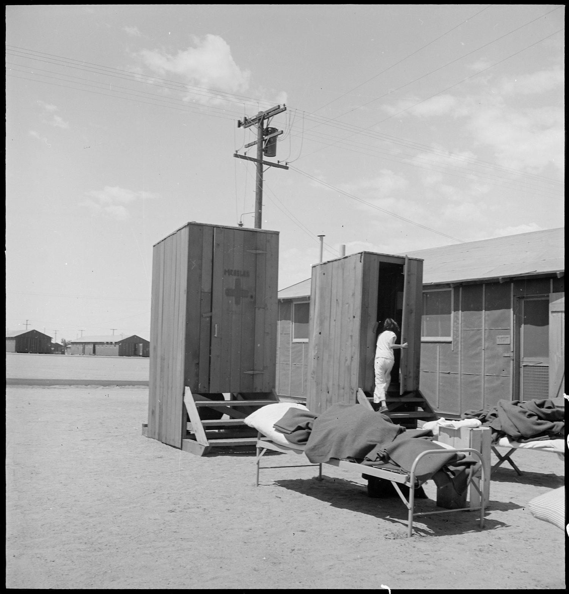  Lange’s Caption: Manzanar Relocation Center, Manzanar, California. Hospital latrines, for patients, between the barracks, which serve temporarily as wards. For the first three months of occupancy medical facilities have been meager but the new hospital fully equipped, is almost ready for occupancy. 7/1942 https://catalog.archives.gov/id/538149 | 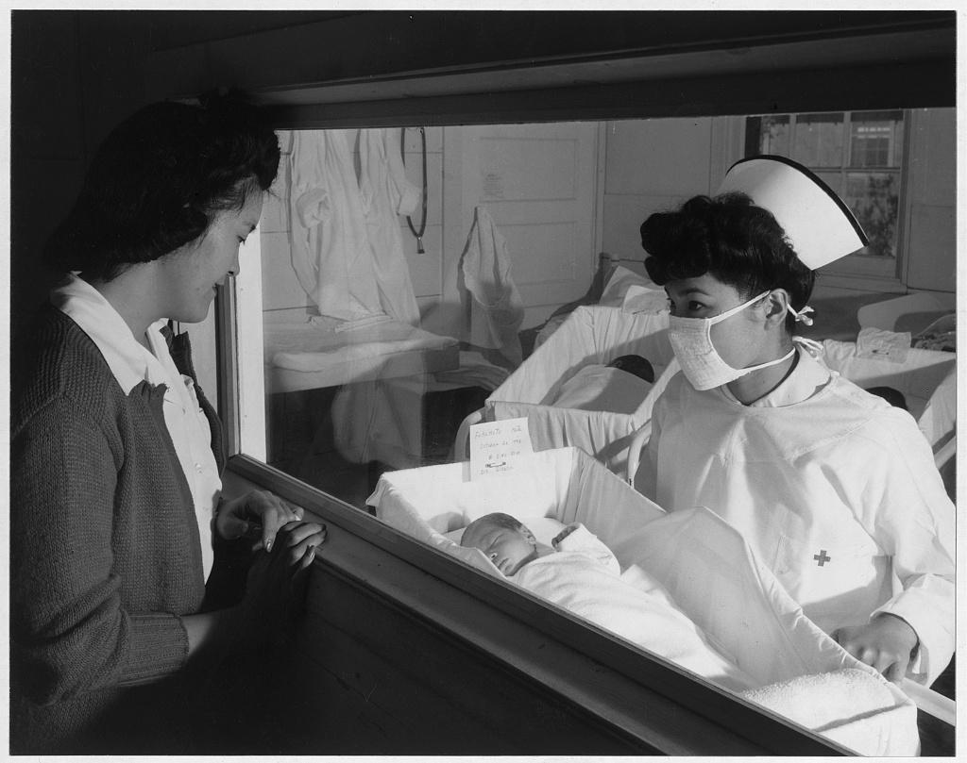  Nurse Aiko Hamaguchi, mother Frances Yokoyama, baby Fukomoto, Manzanar Relocation Center, California / photograph by Ansel Adams. 1943. https://www.loc.gov/resource/ppprs.00343/

Collection A: Photograph Analysis

Source 1: Photograph by Dorothea Lange | Source 2: Photograph by Ansel Adams
Write down examples and observations in the photo of the following (be specific!):  Setting:  People:  Objects:  Actions: | Write down examples and observations in the photo of the following (be specific!):  Setting:  People:  Facial expressions:  Objects:  Actions:
How would you describe the tone (i.e. the mood or emotion) of this photograph? | How would you describe the tone (i.e. the mood or emotion) of this photograph?
What similarities do you notice in the way that medical care in the prison camps is documented in the photographs? What differences do you see?

Collection B: School
Directions: Look closely at the images, read the captions and then answer the questions for each photo that follow.

Photograph by Dorothea Lange | Photograph by Ansel Adams
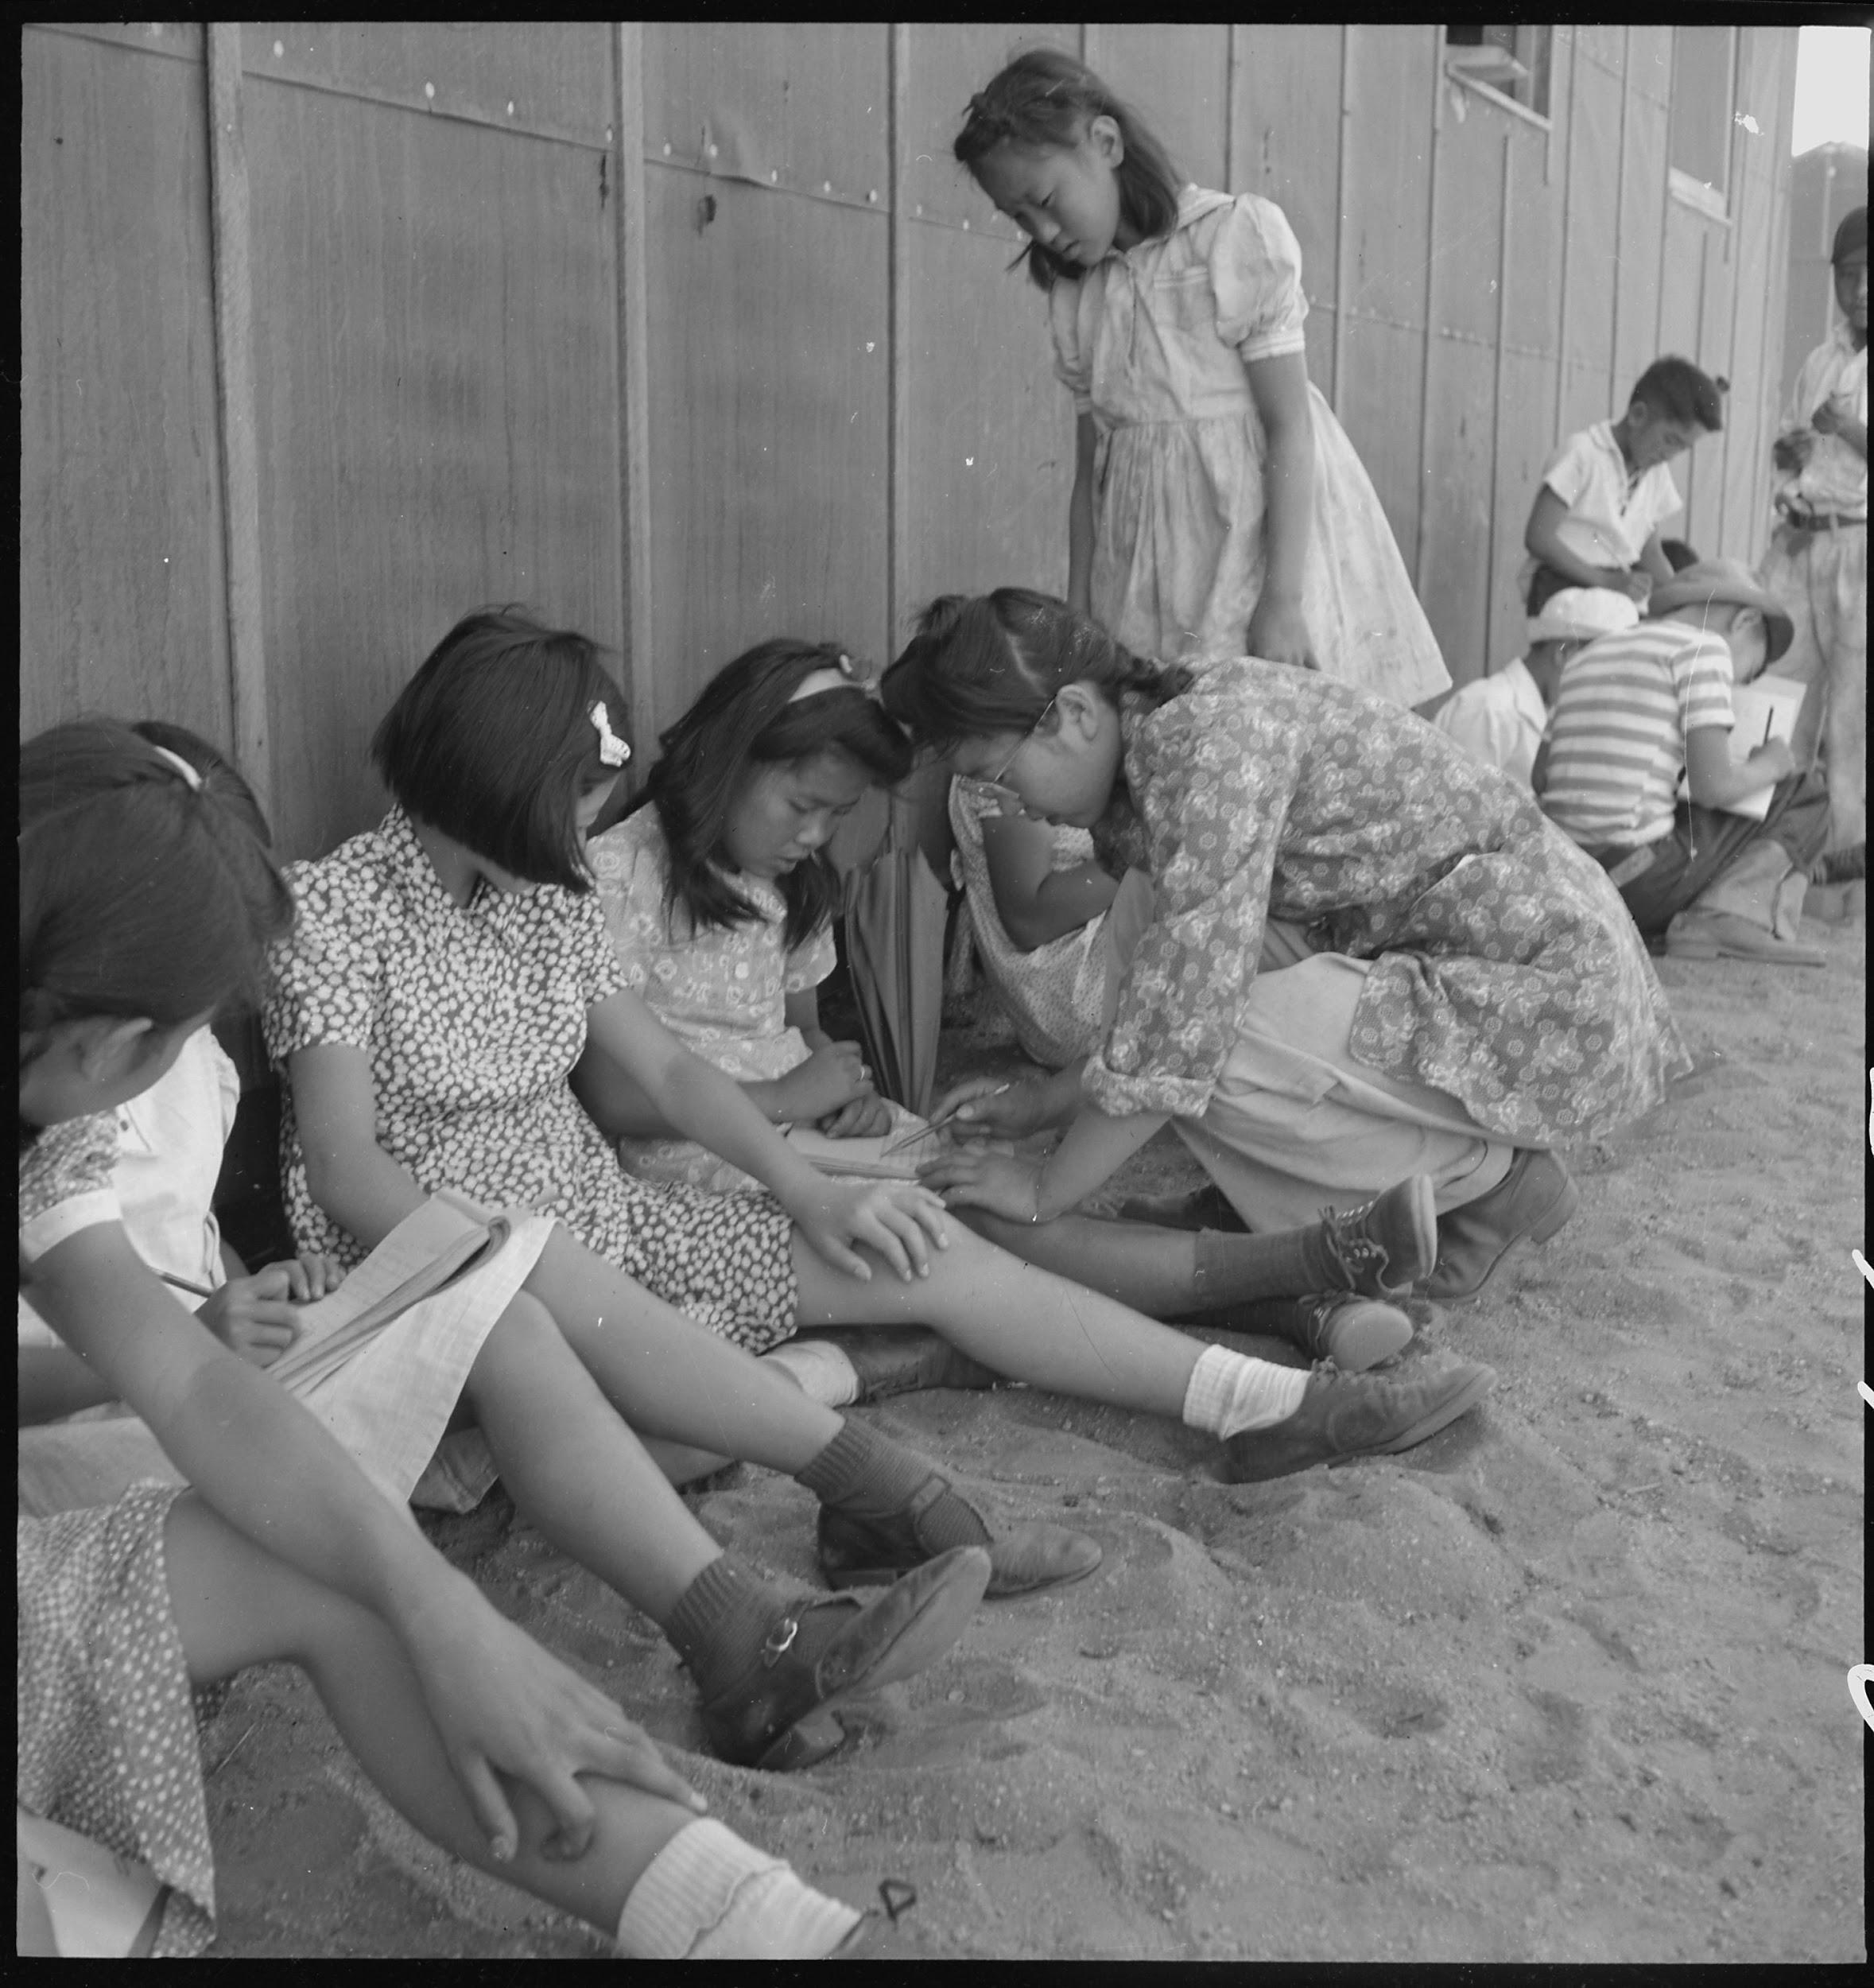  Lange’s Caption: Manzanar Relocation Center, Manzanar, California. An elementary school with voluntary attendance has been established with volunteer evacuee teachers, most of whom are college graduates. No school equipment is as yet obtainable and available tables and benches are used. However, classes are often held in the shade of the barrack building at this War Relocation Authority center. 1942.  https://catalog.archives.gov/id/537962 | 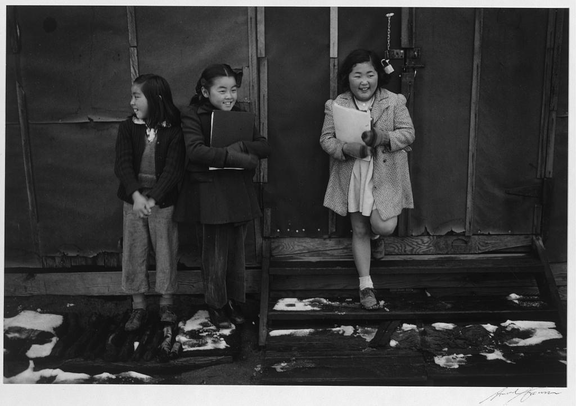  School children, Manzanar Relocation Center, California / photograph by Ansel Adams, 1943  https://www.loc.gov/resource/ppprs.00357/

Collection B: Photograph Analysis

Source 3: Photograph by Dorothea Lange | Source 4: Photograph by Ansel Adams
Write down examples and observations in the photo of the following (be specific!):  Setting:  People:  Facial expressions:  Objects:  Actions: | Write down examples and observations in the photo of the following (be specific!):  Setting:  People:  Facial expressions:  Objects:  Actions:
How would you describe the tone (i.e. the mood or emotion) of this photograph? | How would you describe the tone (i.e. the mood or emotion) of this photograph?
What similarities do you notice in the way that school in the prison camps is documented in the photographs? What differences do you see?

Collection C: Buildings and Surrounding Environment
Directions: Look closely at the images, read the captions and then answer the questions for each photo that follow.

Photograph by Dorothea Lange | Photograph by Ansel Adams
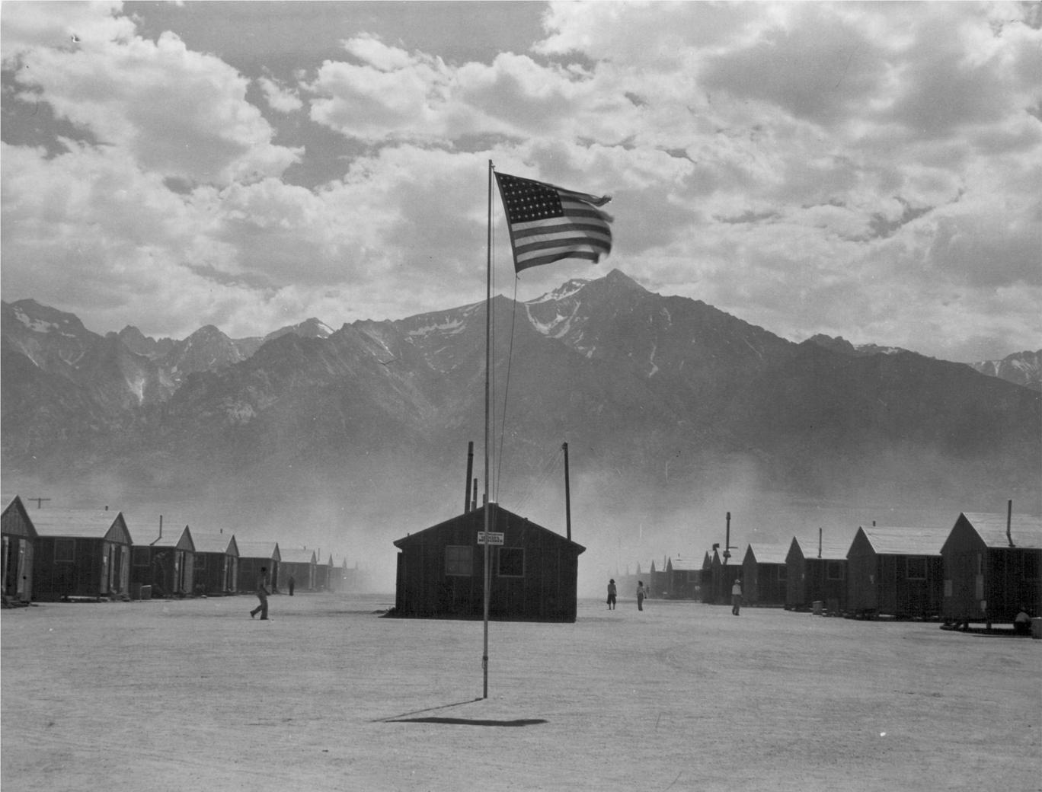  Lange’s Caption: Lange’s Caption: Manzanar, California. Dust storm at this War Relocation Authority center where evacuees of Japanese ancestry are spending the duration.  https://catalog.archives.gov/id/539961 | 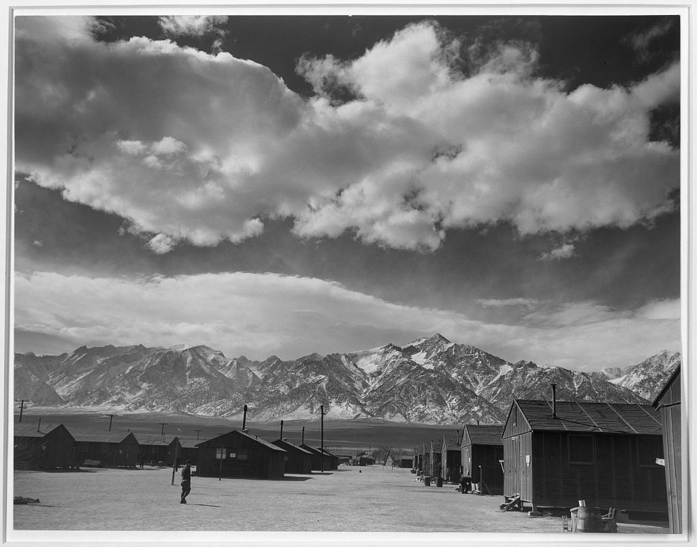  Manzanar street scene, clouds, Manzanar Relocation Center, California / photograph by Ansel Adams, 1943.  https://lccn.loc.gov/2002695966

Collection C: Photograph Analysis

Source 1: Photograph by Dorothea Lange | Source 2: Photograph by Ansel Adams
Write down examples and observations in the photo of the following (be specific!):  Setting:  People:  Objects:  Environmental conditions: | Write down examples and observations in the photo of the following (be specific!):  Setting:  People:  Objects:  Environmental conditions:
How would you describe the tone (i.e. the mood or emotion) of this photograph? | How would you describe the tone (i.e. the mood or emotion) of this photograph?
What similarities do you notice in the way that the buildings and surrounding environment in the prison camps are documented in the photographs? What differences do you see?

Discussion Questions

1. Based on your analysis, what do you think Dorothea Lange was trying to show in her photographs of Manzanar? What do you think that Ansel Adams was trying to show? How do their goals differ?

2. Lange and Adams were both commissioned by the United States government to photograph the living conditions of Manzanar Prison Camp. Lange’s photographs were not released until after World War II ended. Why do you think the government did this?

3. How do both sets of photographs help us understand the living conditions at Manzanar? Do you think one set of photographs is “more true” than the other? What makes you say that?

