**Guiding Question:** What are some economic and natural forces that make farming difficult, and how did families in the 1920s cope with these challenges?

# Document Analysis

The graphs below track the average price of wheat and annual rainfall over time. Look closely at each graph, including the historical notes, and then answer the questions that follow.

**Figure 1: Average Price of Wheat (1909–1940)**

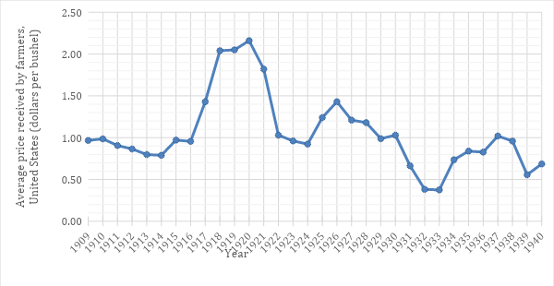

Source: *The Wheat Yearbook,* US Dept of Agriculture. <https://www.ers.usda.gov/data-products/wheat-data/>

**Figure 2: Annual Rainfall in Wheat-Producing States (1910–1940)**

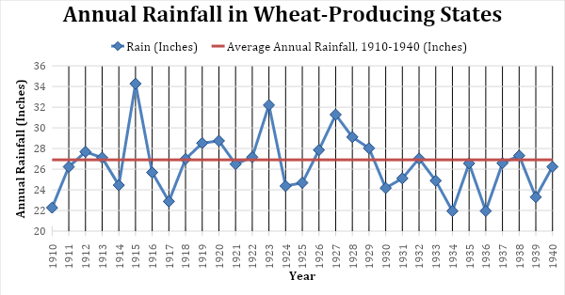

Source: *The Wheat Yearbook*, US Dept of Agriculture*.* <https://www.ers.usda.gov/data-products/wheat-data/>

Some historical notes to consider:

1. High demand for wheat and government purchases occurred during World War I 1917–1921.
2. The stock market crash and onset of the Great Depression occurred in 1929–1939.
3. New Deal policies went into effect in 1933–1939.
4. There were years of low rainfall from 1930–1940.
5. After looking closely at each graph, describe the patterns that you observe.
6. What does the data reveal about farming life? What appears to make it challenging?
7. List some possible reasons for the data changing over time.

## Discussion Questions

1. List some of the economic and natural forces that made family farming difficult, and explain if farmers had any control over the impact of these forces.
2. In 1933, the Roosevelt Administration began to help farmers by paying them to limit how much food they produced, which in turn led to higher crop prices. Do you think this government support for farmers was fair? If so, why?
3. The federal government continues to support farms today, providing them billions of dollars in subsidies, even as most food in the United States is produced by large corporate-owned “factory farms” rather than small family farms. Based on what you know from the game, what are some pros and cons of continuing to support farms in this way?