Guiding Question: What are some economic and natural forces that make farming difficult, and how did families in the 1920s cope with these challenges?

Document Analysis  The graphs below track the average price of wheat and annual rainfall over time. Look closely at each graph, including the historical notes, and then answer the questions that follow.  Figure 1: Average Price of Wheat (1909–1940)  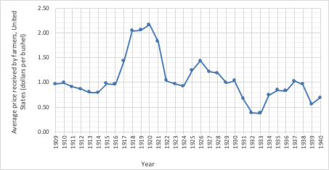  Source: The Wheat Yearbook, US Dept of Agriculture. https://www.ers.usda.gov/data-products/wheat-data/  Figure 2: Annual Rainfall in Wheat-Producing States (1910–1940)  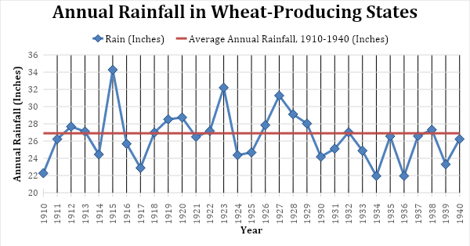  Source: The Wheat Yearbook, US Dept of Agriculture. https://www.ers.usda.gov/data-products/wheat-data/  Some historical notes to consider:  - High demand for wheat and government purchases occur during World War I 1917–1921.  - The stock market crash and onset of the Great Depression occur in 1929–1939.  - New Deal policies go into effect in 1933–1939.  - There were years of low rainfall from 1930–1940.  - After looking closely at each graph, describe the patterns that you observe.  - What does the data reveal about farming life? What appears to make it challenging?  - List some possible reasons for the data changing over time.  Discussion Questions  - List some of the economic and natural forces that made family farming difficult, and explain if farmers had any control over the impact of these forces.  - In 1933 the Roosevelt Administration began to help farmers by paying them to limit how much food they produced, which in turn led to higher crop prices. Do you think this government support for farmers was fair? If so,why?  - The federal government continues to support farms today, providing them billions of dollars in subsidies, even as most food in the United States is produced by large corporate-owned “factory farms” rather than small family farms. Based on what you know from the game, what are some pros and cons of continuing to support farms in this way? | Time: At least 25 minutes  Instructions  Goal/Intent: Building on their game knowledge, students analyze charts and data about wheat prices and rainfall during the Dust Bowl-era as they answer the guiding question:  What are some economic and natural forces that make farming difficult, and how did families in the 1920s cope with these challenges?  A. Document Analysis (10 min)  This document shows two graphs, one that tracks the average price of wheat and the other that tracks annual rainfall over time. Ask students to look closely at each graph, including the historical notes, and then answer the questions provided on page 2.  If your students need additional support in interpreting the data, you might guide them by asking the following questions:  - If you were a farmer selling your wheat, which year would you have been happiest? Saddest?  - Tell me a story about the price of wheat between 1910 and 1940. “It starts out in 1910 at about $1 a bushel, then dips a little, then in 1916…” finish the story.  Then, help students to look beyond the obvious fluctuation of both prices and rainfall to see some additional patterns such as:  How many years is the price of wheat at $1 or less per bushel versus how many years over $1 or over $1.50?  Similarly for rainfall, how many years is rainfall at or below the average versus how many years is it above average?  B. Discussion (15 min)  Have students share their responses, and prompt them to think about the impact of the data on the lives of farm families, such as the Dunns. You might extend the discussion by posing the following questions:  While the price of wheat fluctuates and often moves downward, do you assume the prices for farm expenses (e.g., fuel for tractors, fertilizer, and feed for livestock) follow the same pattern or not? What happens if those expenses go up while the price of wheat goes down?  What challenges do the changing price of wheat and the varying amount of rainfall impose on farm families? What strategies can they use to plan for their futures?  Suggestions:  Use class time to begin the Document Analysis; have students work in small groups to “jigsaw” the charts.  Have students complete the analysis and respond to the questions for homework.  Discussion Question #3 is complex and requires some contemporary context to answer fully. You might briefly research today’s federal farm subsidies with your students or, alternatively, make this question optional.

