Guiding Question: What actions did people take to cope with the economic hardship of the Great Depression?
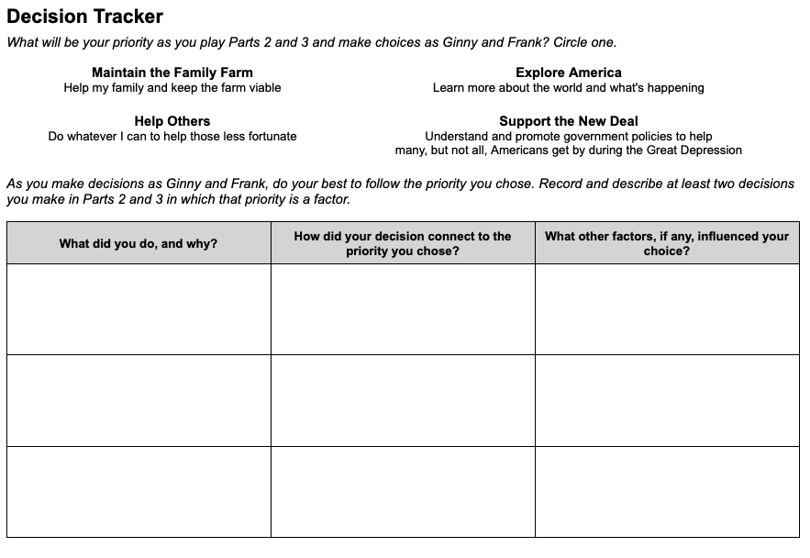 | Time: At least 20 minutes  Instructions  Explain to students that Ginny and Frank face more complicated choices as they balance their obligations to their family farm, their desire to support others in the community, and their hunger to explore life outside of Dalhart. As students guide Ginny and Frank, they will have to weigh conflicting priorities and sometimes make difficult trade offs.  Choosing a Priority  Give students copies of the Parts 2 and 3 Decision Tracker, and walk through the instructions with them. Instead of reflecting on priorities after recording their decisions on the handout (as they did previously), students will now choose a priority before they play Parts 2 and 3. Encourage them to try to follow that priority in the choices they make in the game.  On the handout, students will record at least two decisions they made in which their chosen priority came into play. (The graphic organizer provides space for three examples.) We recommend that students record their decisions as they play Parts 2 and 3 rather than after they have completed them.  The Complexity of Decision Making  As they play the game, students will likely realize that consistently pursuing one priority will force them to make difficult compromises, and they may even choose to abandon their chosen priority at times for this reason. The goal is not to test or evaluate students’ abilities to stick with their priority - rather, it is to help them experience and reflect on the complexity of decision making.  Scaffolding  Unlike the Prologue-Part 1 Decision Tracker, this version is open-ended and does not suggest which situations in the game should be the focus of the actions and choices they describe. If your students need more guidance about what to record, you can provide them one or more of the following situations:  - Trading at Huff’s store…  - While riding the rails…

