*Much of “Up from the Dust” is based on actual events, places, and people. While some characters are fictional and serve to illustrate the various experiences of the Americans during the Great Depression, others are based on actual historical figures. Brief background information is included here on the MISSION’s fictional characters, biographical information on the historical figures, and background on the real places featured in the game.*

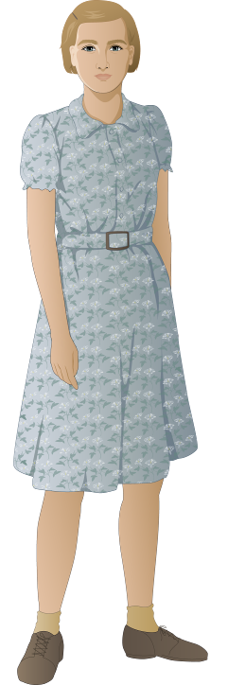

**Virginia (Ginny) Dunn (fictional character)**

Ginny (Frank’s twin sister) is thirteen when “Up from the Dust” begins. She lives with her family on a wheat farm in the Panhandle of Texas a few miles outside of Dalhart. She goes to school in Dalhart and helps out on the farm taking care of the chickens and making butter. She is active in the 4-H Club and is close friends with her neighbor Thelma.

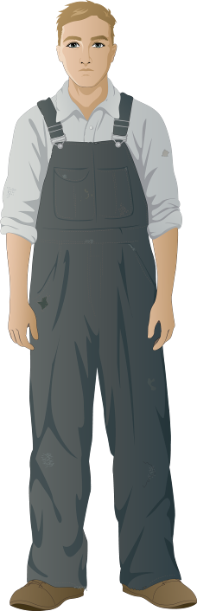

**Frank Dunn (fictional character)**

Frank (Ginny’s twin brother) is thirteen when “Up from the Dust” begins. He lives with his family on a wheat farm in the Panhandle of Texas a few miles outside of Dalhart. He goes to school, helps take care of the beef and milk cows on the farm, and enjoys reading adventure stories in his spare time. He doesn’t always get along with his older brothers, but is close to Ginny. He’s raising a calf on his own and hoping she will win a ribbon at the county fair.

**Trudy Dunn (Ma) (fictional character)**

Trudy Dunn has lived in the southern Texas Panhandle her whole life. Her father homesteaded land in the 1870s and began planting a hardy strain of wheat that could survive the harsh climate. After marrying Raymond Dunn, they took over her family’s wheat farm and expanded it.

**Raymond Dunn (Pa) (fictional character)**

Raymond Dunn farms wheat and raises a few head of cattle on 640 acres in the Texas Panhandle. His father was a ranch hand on the XIT ranch in the Texas panhandle and Raymond hoped to become a cattle rancher. But a wheat boom during World War I encouraged him to switch to wheat farming and to teach his sons all he’s learned about raising wheat.



**Bill and Bud Dunn (fictional characters)**

Bill and Bud are Ginny and Frank’s older brothers. They are 17 and 18 when the game begins and have finished high school. They both want to start up their own farm soon and spend most of their time tending the crops. Neither of them has much tolerance for the young twins.

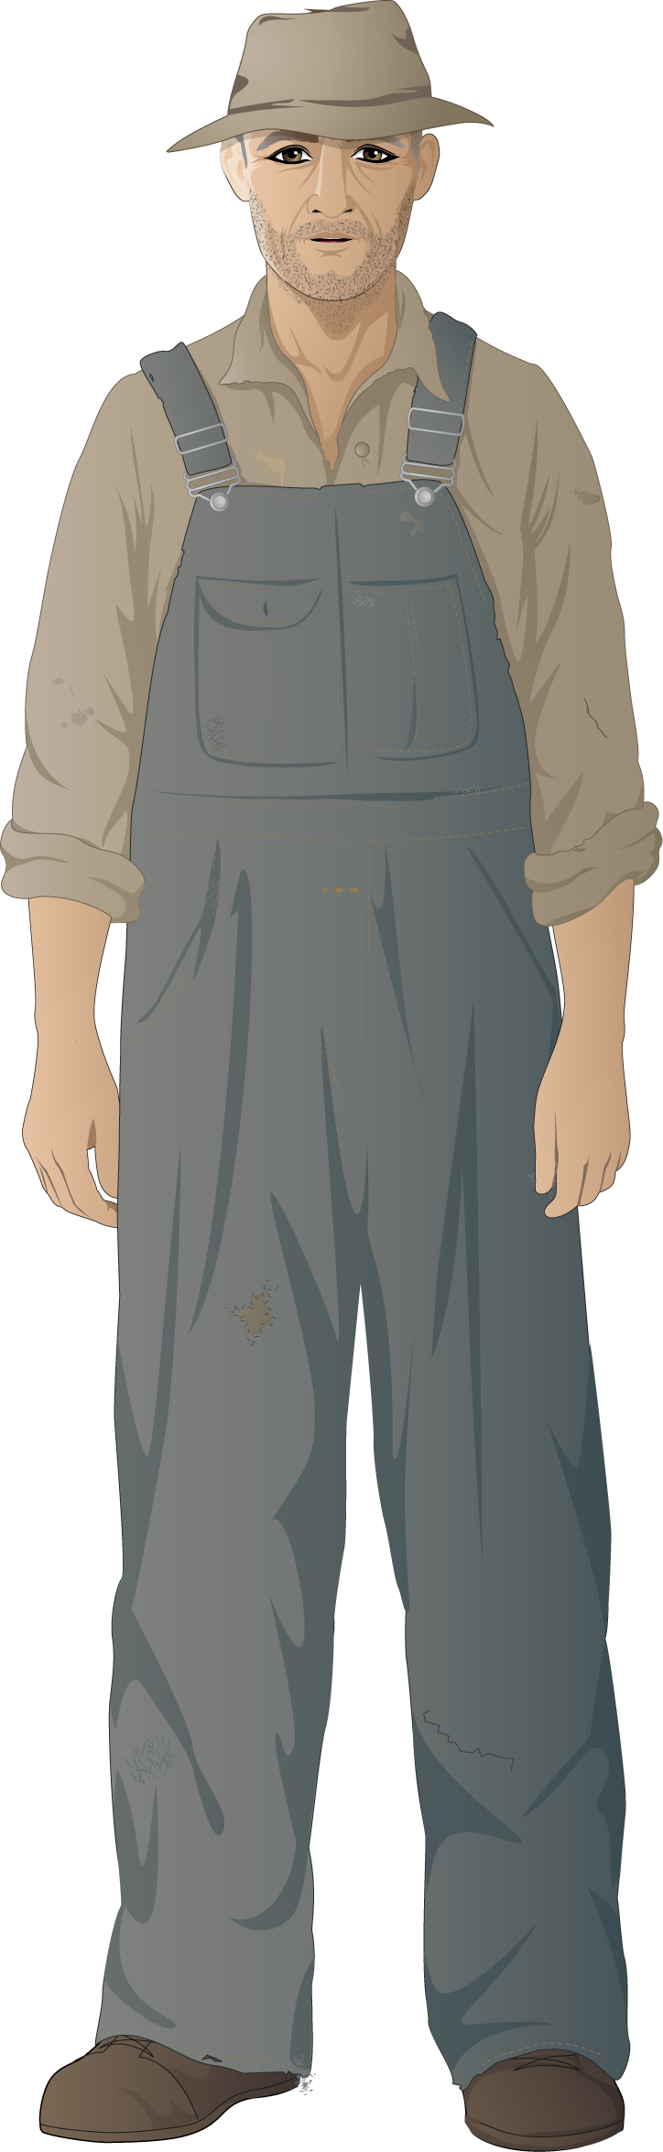

**Tom Mitchell (fictional character)**

Mr. Mitchell is a tenant farmer who lives with his wife and two daughters, near the Dunns. He works on land owned by a businessman in Dalhart to whom he pays a portion of his wheat crop as rent. After World War I, he moved his family from Arkansas to the Texas Panhandle, hoping to make enough money growing wheat to buy his own land. With declining wheat prices, it hasn’t worked out that way.

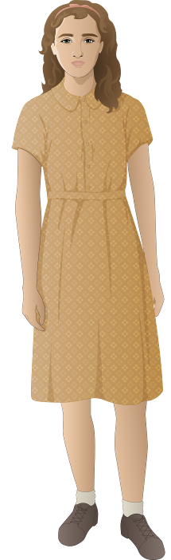

**Thelma Mitchell (fictional character)**

Thelma is Ginny’s best friend and is also thirteen years old at the start of “Up from the Dust.” Her family are tenant farmers, so they do not own their own land. When hard times hit, they are unable to borrow money and more likely to go deeper into debt. Thelma goes to school with Ginny and Frank and is also active in the 4-H Club.

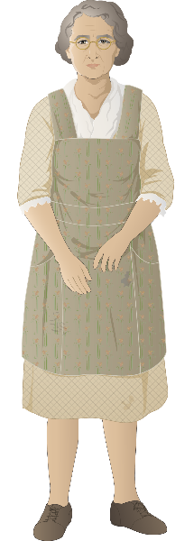

**Mrs. Evelyn Huff (fictional character)**

Mrs. Evelyn Huff runs a general store near the Dunn farm. She knows everybody who farms nearby and will barter eggs, butter, homemade jams, and other farm goods for necessities such as sugar, flour, and salt. She also allows most of the local families to pay on credit while they wait to sell their yearly crop.

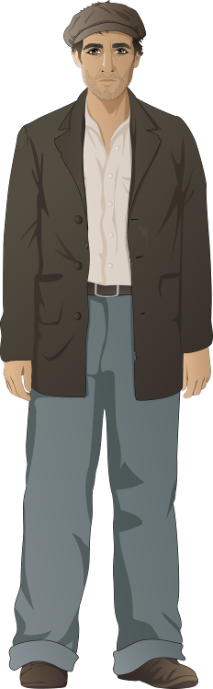

**Charlie, a Bonus Army veteran (fictional character)**

Charlie fought in World War I and was promised an additional payment for his military service. With the high unemployment after the stock market crash, he was laid off from his factory job and has not been able to find any work. Along with thousands of other World War I veterans, he is traveling to Washington DC to ask the government to pay veterans the bonus now.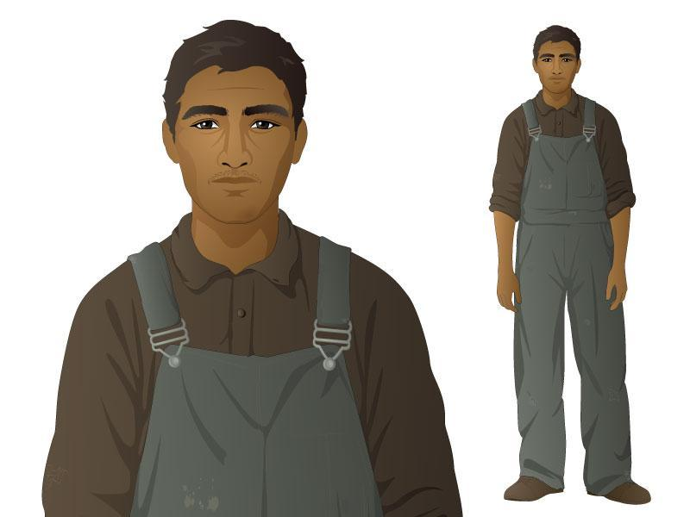

**Roberto Lopez (fictional character)**

Roberto Lopez is a Rock Island Railroad line worker. He works in a small group to maintain the railroad tracks and keep them clear and level, cleans freight cars, and helps load and unload freight. His family came from Chihuahua, Mexico, where his father worked on a large ranch, but the Mexican Revolution caused the ranch owner to flee. His father was recruited by the railroad 20 years ago to work laying tracks.

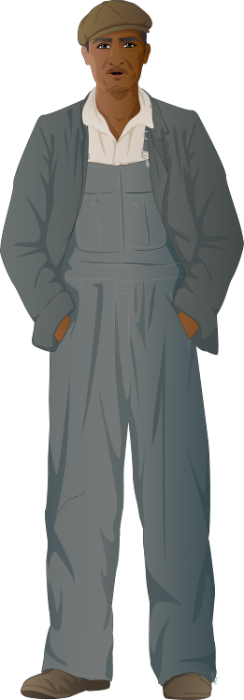

**Edward “Ned” Shaw (fictional character)**

Ned Shaw is a sharecropper from Arkansas who has decided to move his family to Los Angeles, California in search of better economic and social conditions. Shaw worked the land and gave most of his cotton crop to the landowner as payment for seed and rent. When cotton prices dropped during the Depression, his landlord demanded his entire crop as payment, forcing the family to leave in search of employment.

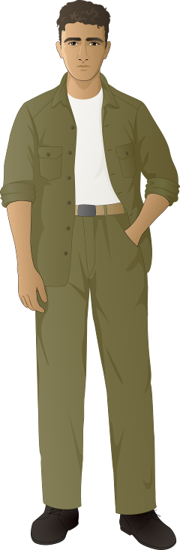

**Tony Amato (fictional character)**

Tony Amato is 19 years old and becomes friends with Frank Dunn when they are in the CCC together. The son of Italian immigrants, he grew up in the Bronx in New York City. His father is an unemployed laborer and bricklayer, and his mother takes care of his three younger siblings. His first CCC assignment was in upstate New York planting trees. He then transferred to the camp in Texas where he met Frank.

**Franklin Delano Roosevelt (historical figure, 1882-1945)**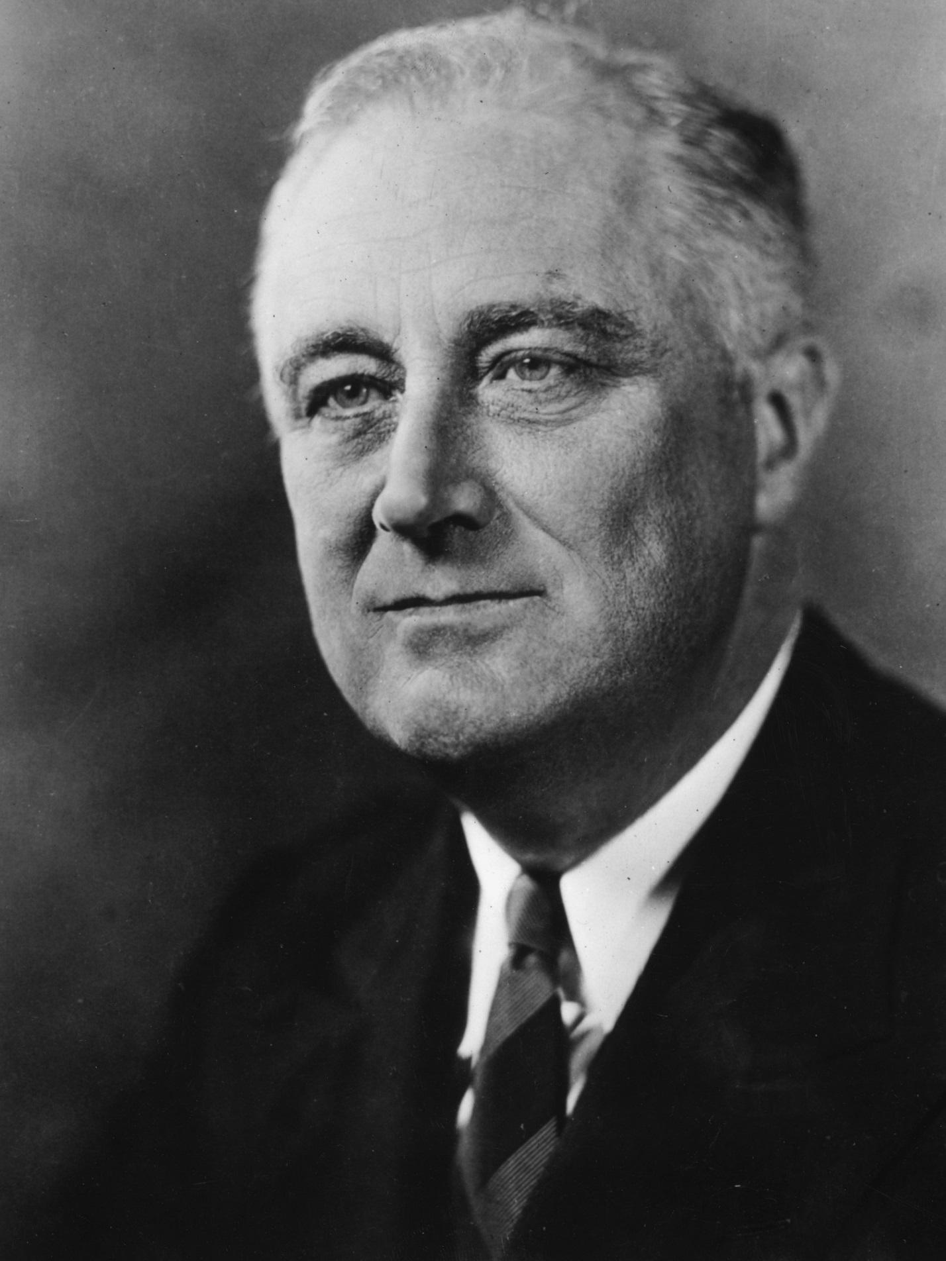

President Franklin Delano Roosevelt (known colloquially as “FDR”) served as President of the United States during the Great Depression and the early years of World War II. Born into a wealthy New York family, Franklin Delano Roosevelt used his charm, money, and social prominence to climb the political ladder, serving as assistant Secretary of the Navy and Governor of New York before being elected President in 1932. Roosevelt contracted polio in 1921 and lost the use of both legs. He would never walk again without heavy braces and much assistance, but Roosevelt’s misfortune probably made him more expansive, mature, and socially concerned. As President during the Great Depression, Roosevelt was beloved by some Americans for the active steps he took to provide a wide variety of relief programs, though he was also a target of critics who opposed his expansion of the federal government’s role in social welfare. Roosevelt served almost four complete terms in office, the most of any U.S. President. 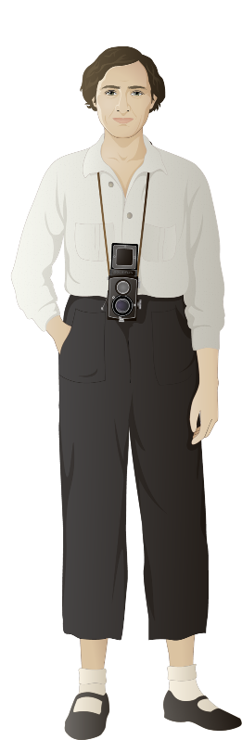

**Dorothea Lange (historical figure, 1895-1965)**

Dorothea Lange was a documentary photographer best known for her images of American hardship during the Great Depression. Born in New Jersey, she moved to northern California when she was in her 20s and lived there for the rest of her life. Lange worked for a variety of federal agencies from 1935-1945, traveling around the country to photograph the Dust Bowl, conditions in migrant labor camps, rural poverty, wartime defense industry workers, and imprisoned Japanese Americans.

**Locations in MISSION 5: “Up from the Dust”**

**Dalhart, Texas**

Located in the far northwest corner of Texas, an area bordering on Oklahoma and known as “the panhandle,” Dalhart was home to 4,691 people in 1930. Dalhart had a newspaper, school, courthouse, post office, railroad station, grain elevator, and shops that served not only the town’s residents but also the farm families of the surrounding rural counties of Dallam and Hartley.

**family wheat farm**

Farm families met most of their needs through the farm itself. In addition to growing and selling wheat, they grew or raised most of their food by tending small vegetable gardens and keeping chickens and cows; the livestock also supplied the family with products (such as eggs and butter) to sell or trade at the local store.

**grain elevator**

Grain elevators played an important role in the economies of farming regions, providing farmers with a place to store their harvested grain prior to it being shipped to distant markets. Grain elevators were operated as private businesses and sometimes as farmer-owned cooperatives, and were usually located near railroad lines.

**country store**

For rural residents who lived far from each other and from the nearest town, country stores served an important role in the community. Small store owners were usually willing to provide credit when their customers needed it, and trade with farm families for eggs, butter, and other products from their farm.

**Hooverville**

The unemployment rate soared in the U.S. during the Great Depression (peaking at 25% in 1933), while wages for those who still had jobs fell sharply. Many people fell behind on their rent or mortgage payments and lost their homes. In many cities, the growing homeless population gathered in groups of temporary, poorly constructed shacks and tents. These encampments became known as “Hoovervilles,” a name started by the Democratic Party to focus the blame for the Great Depression on President Herbert Hoover, a Republican.

**Civilian Conservation Corps (CCC) camp**

CCC camps housed the young men who participated in the Civilian Conservation Corps. Constructed in areas where CCC members were doing conservation work and other projects and modeled on military camps, CCC camps included a barracks (where the corps members slept), mess hall (where corps members ate), a medical dispensary (where corps members were treated if they became ill), and buildings for classrooms and recreational activities.

**Imperial Valley fields and migrant labor camp**

The Imperial Valley is located in southern California. Low-wage agricultural workers who traveled from place to place planting, tending, and harvesting crops have long been part of the agricultural economy. But the mass unemployment and drought of the Great Depression caused more people than ever before to seek this kind of work, driving down wages for it even further. As a seasonal, migratory workforce, these workers were often forced to live in inadequate, unsanitary camps provided by growers. During the early years of the New Deal, the Farm Security Administration built and maintained much better camps for migrant workers.

**Railyards and trains**

During the 1930s, more than 200,000 miles of railroad tracks crisscrossed the United State. Rail transport became the primary means of transporting the nation’s people, products, and raw materials. All but the smallest communities had a railroad station where passengers could purchase tickets and get on and off trains, and railyards provided a place where workers loaded and unloaded freight trains. To prevent theft and keep people from riding the freight cars for free, railroad companies hired security officers (known as “bulls”) to patrol railyards.

**New Deal Relief Office in Dalhart**

While New Deal relief programs originated in Washington, D.C., they were administered locally throughout the country. Local relief officials decided who was eligible for relief, how much each person or family would receive in direct aid (such as cash, food, and clothing), and who to place in work programs. Relief offices were located in schools and other local government buildings. Many Americans were deeply ashamed that they needed relief, so the public act of standing in line at the relief office and being interviewed about their dire circumstances could be humiliating.